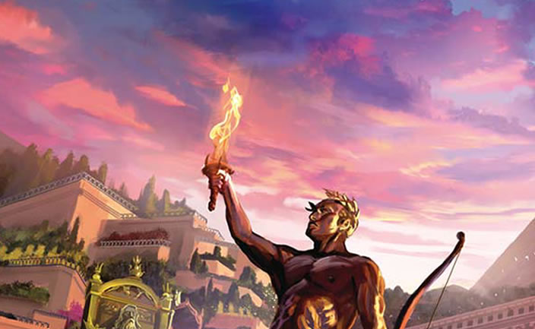

ONLINE

Board Game by Antoine Bauza
Table of Contents

1 Introduction | 3
1.1 – Motivation | 3
1.2 – Terminology | 3
2 Game Rules | 5
3 Requirements | 15
3.1 – Functional Requirements | 15
3.2 – Non-Functional Requirements | 19
3.3 – Assumptions | 19
4 Use Cases | 21
4.1 – Use Case Diagram | 21
4.2 – Use Cases | 22
4.3 – Responsibilities | 26
4.4 – Unbound Use Case Maps | 28
4.5 – Bound Use Case Maps | 32
5 Design Decisions | 35
5.1 – Decisions | 35
5.2 – Structural Model (7 Wonders) | 37
5.3 – Structural Model (Bots) | 38
6 Object Specifications | 39
7 Interaction Diagrams | 81

1
Introduction

Designed by Antoine Bauza, 7 Wonders is a card-based board game for a group of up to seven players. The players, all assigned with distinct Wonders, are pitted against each other in a contest to build the most successful civilization by the end of three Ages.

1.1 – Motivation

Outlined in this document are a brief introduction to the project, functional and non-functional requirements for the software, as well as use cases and assumptions made throughout the process. A proposal for the game's interface is also given.

This project aims to transform Seven Wonders into an online multiplayer game, allowing people to play at distances using their computers. The official board game rules will be followed, with additions to accommodate network play on the computer platform. Therefore, the modeling process of coming up with requirements and use cases would be necessary in building a solid program.

1.2 – Terminology

A number of key terms are used throughout this document, which are listed alphabetically in this section. Definitions are included to aid with referential use. Terms covered in the official rules of 7 Wonders itself are not described here – refer instead to the Game Rules section.

Term | Definition
Artificial Player | A player controlled by the system. Artificial players can be used in place of human players.
Board | See the definition for Wonder (terms used interchangeably).
Bot | See the definition for Artificial Player (terms used interchangeably).
Discard | The act of disposing a card into an exclusive pile. The contents of discarded cards are hidden from players.
Game | This most often refers to the software or game content in general.
Guest Player | A player that is connecting to the host player, i.e., a player that joins an existing game.
Host Player | The player who creates a game to play with others or by himself (with artificial players). The host player is always human.
Human Player | A player that is not controlled by the system, and plays using their machine.
Interface | The means of which the system communicates information to the player on their screen. May be referred to as the graphical user interface.
Session | A game that has started, running and active with players.
Structure | Each card in the game represents something that can be built. This term can essentially be substituted with the word “card”.
System | The software implementation of 7 Wonders itself.
Wonder | The board that a player uses, with its own unique starting resource, building requirements, and special effects. This term may be substituted with the word “board”.

2
Game Rules

Below are scanned pages of the official game rules for 7 Wonders. Pages that were irrelevant to the project, such as two-player games, became omitted.

Each section has been given identifiers to use with requirements traceability, which can be seen as boxes next to the appropriate section. The notation for the identifiers, which will be used later on, begins with GR, followed by an abbreviation for the section (e.g., QR for Quick Rules), then a number for the subsection. If necessary, these identifiers will also include a number representing the approximate paragraph line for ease of traceability.

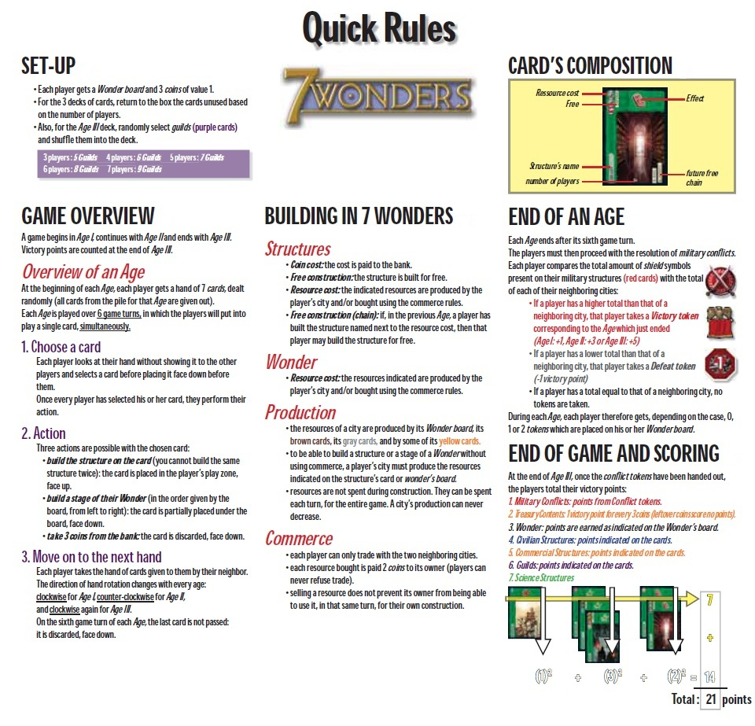
GR-QR-01
GR-QR-02
GR-QR-03
GR-QR-04
GR-QR-05
GR-QR-06
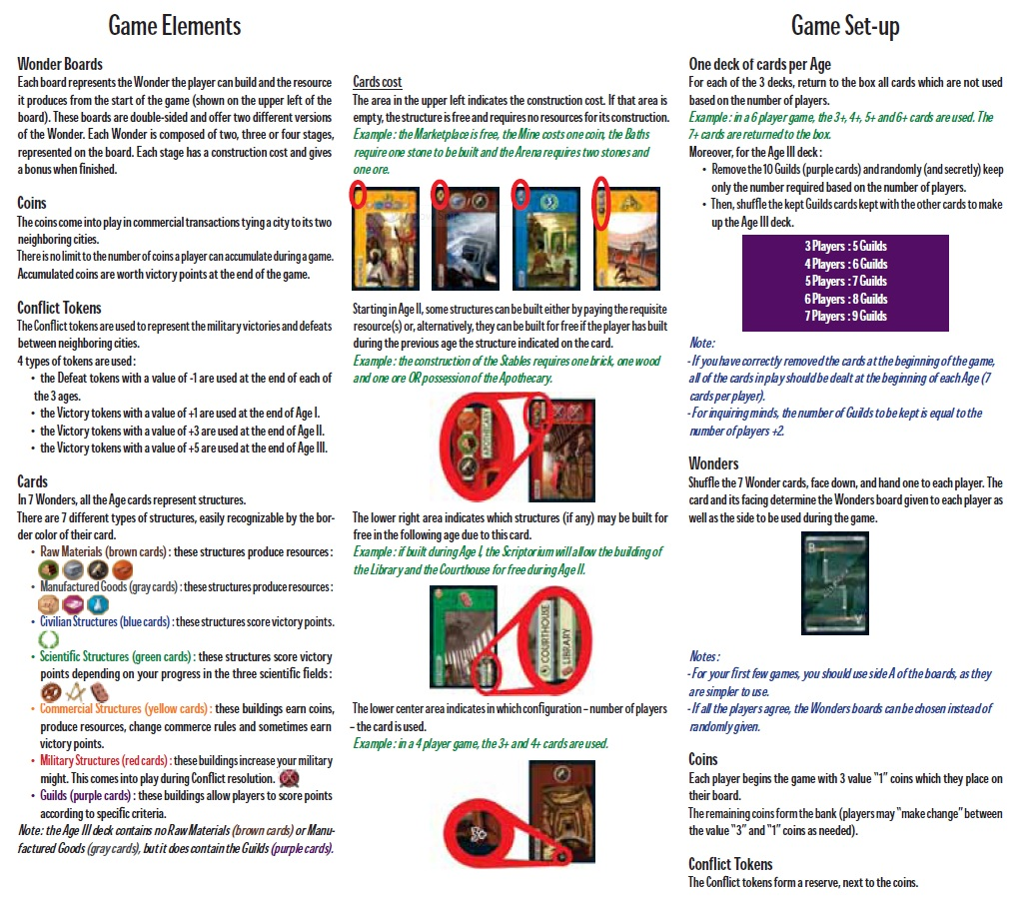
GR-GE-01
GR-GS-01
GR-GE-02
GR-GE-03
GR-GE-04
GR-GS-02
GR-GS-03

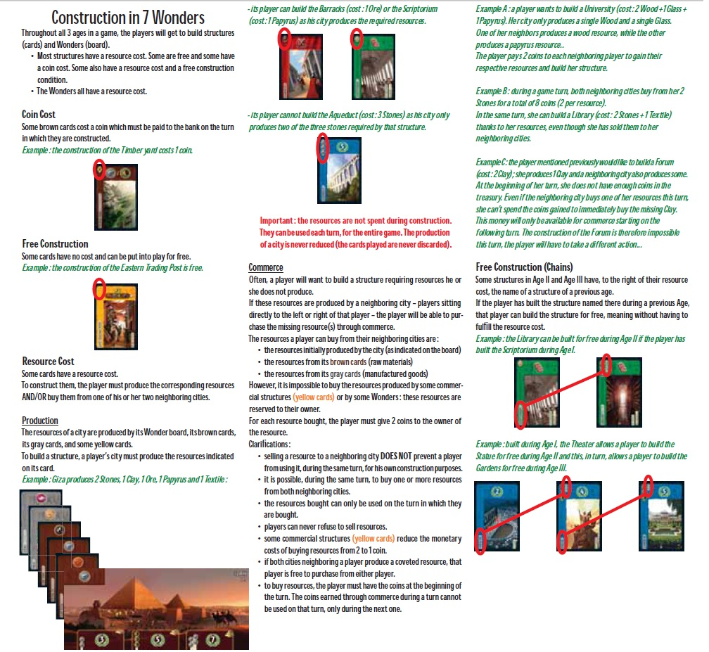
GR-CO-01
GR-CO-02
GR-CO-03
GR-CO-04
GR-CO-05
GR-CO-07
GR-CO-06
GR-CO-06

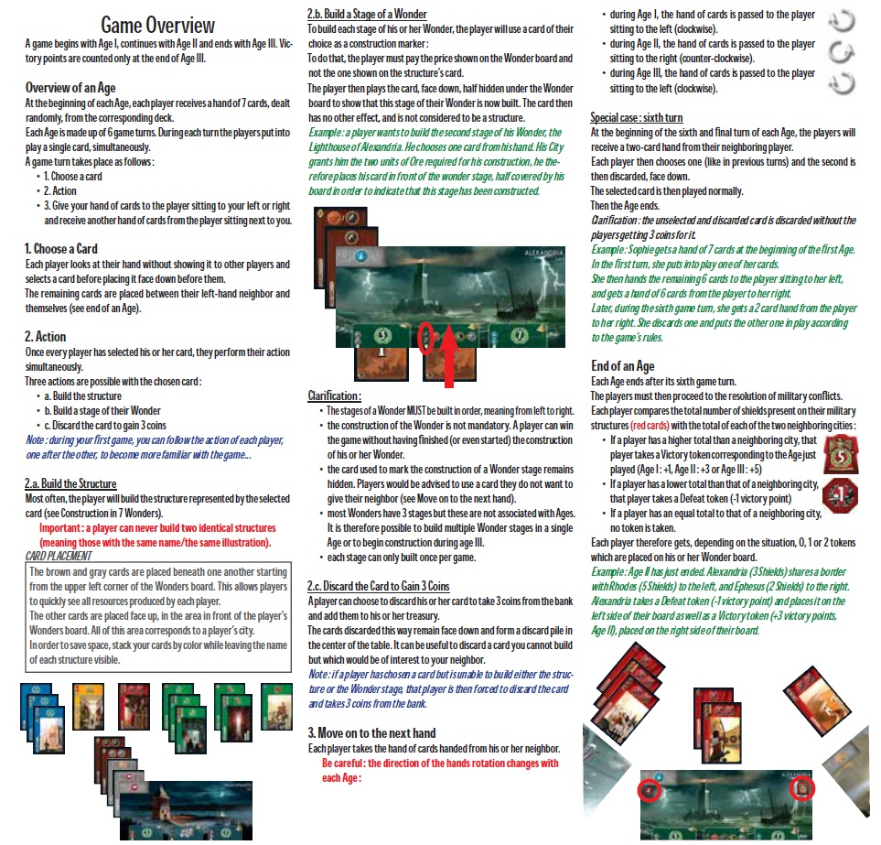
GR-GO-10
GR-GO-09
GR-GO-08
GR-GO-07
GR-GO-06
GR-GO-05
GR-GO-04
GR-GO-03
GR-GO-02
GR-GO-01
GR-GO-11

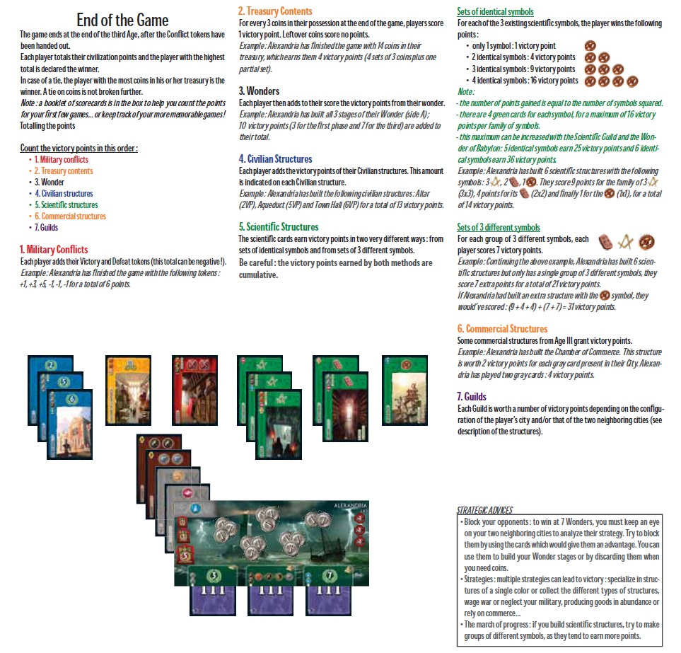
GR-EG-01
GR-EG-09
GR-EG-03
GR-EG-08
GR-EG-07
GR-EG-06
GR-EG-05
GR-EG-04
GR-EG-02
GR-EG-10
GR-EG-11

GR-DW-01
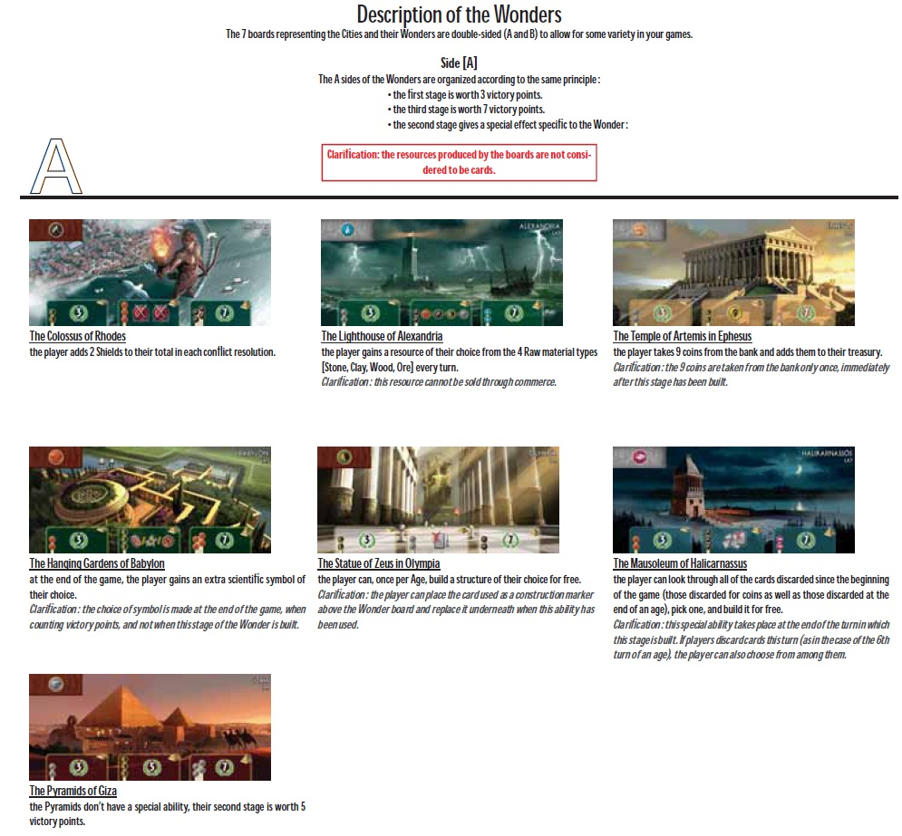
GR-DW-02
GR-DW-03
GR-DW-04
GR-DW-05
GR-DW-06
GR-DW-07
GR-DW-09

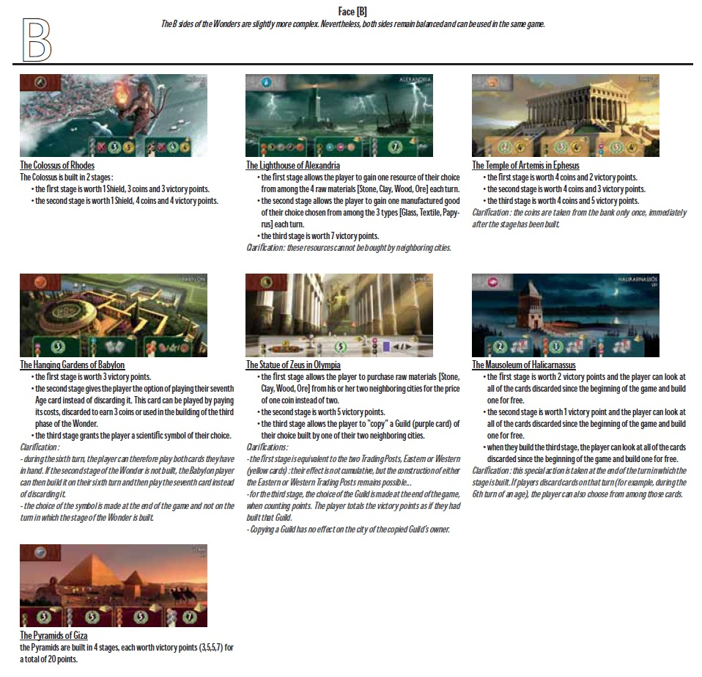
GR-DW-10
GR-DW-11
GR-DW-12
GR-DW-13
GR-DW-14
GR-DW-15
GR-DW-16
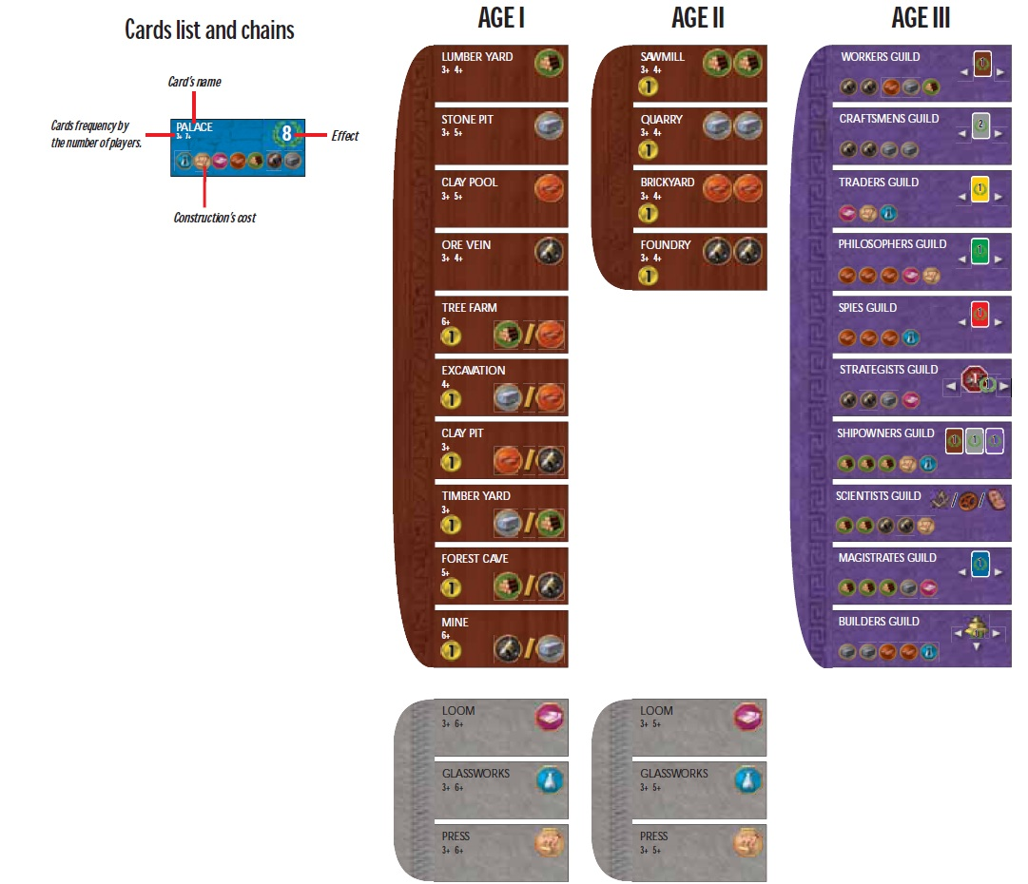
GR-CL-01
GR-CL-02
GR-CL-03
GR-CL-01
GR-CL-04
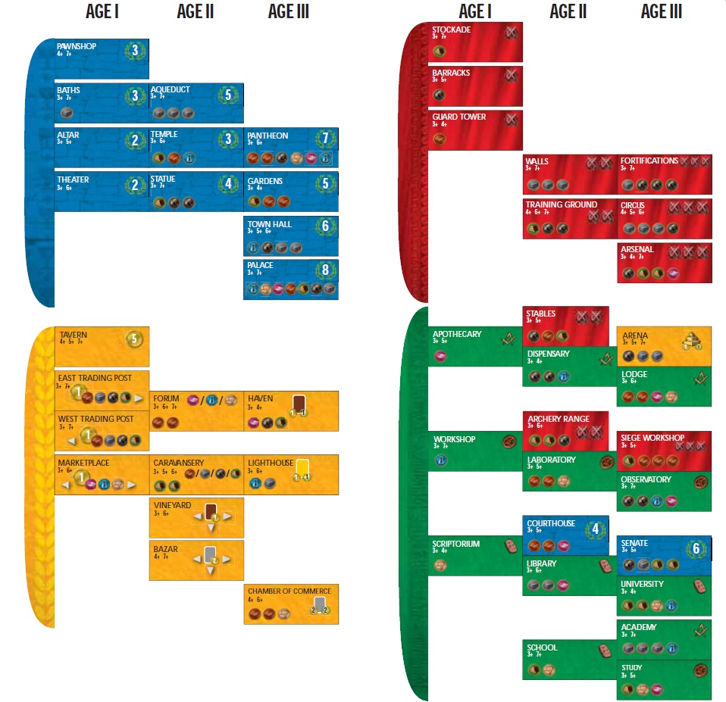
GR-CL-05
GR-CL-06
GR-CL-07
GR-CL-08

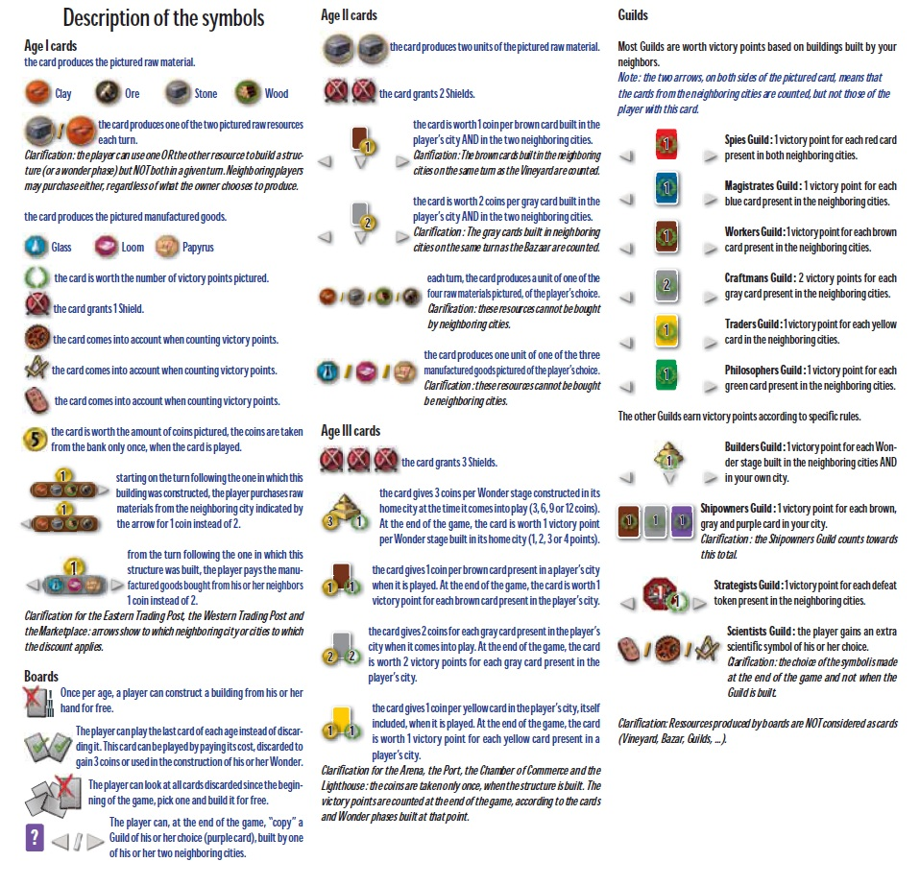
GR-DS-01
GR-DS-02
GR-DS-03
GR-DS-04
GR-DS-05

3
Requirements

This section contains what features must be implemented. Each requirement has its own unique identifier, description, plus where the decision to come up with it can be traced to. The source of traceability may either be from the official game rules (see Game Rules for notation information), assumptions, other requirements, or team decisions.

3.1 – Functional Requirements

Functional requirements define what behavior and functionality the software must have. They have been categorized appropriately below, based on different game states or areas of functionality.

ID | Functional Requirement | Traceability
Pre-Session
FR-PS-01 | The system prevents starting of a session under three players or over seven players. | GR-QR-01  A-01
FR-PS-02 | Players can choose their own Wonder or have the system randomly select for them. | GR-GS-02
FR-PS-03 | The player can choose which side (A or B) they would like to play for their Wonder. | GR-GS-02
FR-PS-04 | The game decides which cards will be used and not used, based on the number of players in the session. | GR-QR-01  GR-GS-01
FR-PS-05 | Human players must be able to connect to a host player if they wish to join a game. | A-06
FR-PS-06 | The host player may start the session when their desired participants have joined. | A-06
FR-PS-07 | The host player can wait for human players to join before starting the session. | A-06
FR-PS-08 | The host player can add artificial players before the session begins. | A-03
FR-PS-09 | A player can freely exit before the session starts. | A-08
FR-PS-10 | A host player can exit before the session begins, closing the game for others. | A-08
FR-PS-11 | Each player begins the session with three coins of value one. | GR-QR-01
Player Turn
FR-PT-01 | Once a player reaches a stage of their Wonder that rewards Shields, coins, and/or victory points (depending on their specific Wonder), they receive them immediately. | GR-DW-01  through  GR-DW-16
FR-PT-02 | Once each player has chosen their card(s) to play, the rest of the hand is passed to the neighbour either to the left or the right, based on the Age. | GR-GO-07
FR-PT-03 | A player can build a structure by selecting the card from their hand if they have enough resources or satisfy the requirements (e.g., other cards in play, buying resources from neighbours). | GR-GO-05
FR-PT-04 | A player's turn decision is kept hidden from everyone else until all have finished making their choices. | GR-GO-03
FR-PT-05 | A card can be discarded to gain three coins. | GR-GO-08
FR-PT-06 | A card cannot be played if the player has an identical card active. | GR-GO-05
FR-PT-07 | If a player has enough resources for the next stage of building their Wonder, they can choose to build it by discarding any card from their hand. | GR-GO-06
FR-PT-08 | A player with enough coins can choose to buy resources from a neighbouring player to play a card. By default, the player gives two of their coins to their neighbour per resource. | GR-CO-06
FR-PT-09 | The game facilitates the effect(s) of a structure if it has been built, based on the card's symbols. | GR-DS-01  through  GR-DS-04
FR-PT-10 | A player may exit an ongoing session. | A-08
FR-PT-11 | A player is able to build a structure in Age II or III for free, requiring zero resources, if they have previously played a card that specifies the name of the new structure (a la Card Chaining). | GR-CO-07
FR-PT-12 | Scientific structures with the same scientific symbols can be stacked in play, providing for exponentially more victory points based on the size of the stack is. | GR-EG-06
Age-Related
FR-AR-01 | The session begins in Age I. | GR-GO-01
FR-AR-02 | When an Age begins, each player is dealt a hand of seven random cards from the associated deck. | GR-GO-02
FR-AR-03 | On the sixth turn of an an Age, each player will receive two cards from their neighbour. After choosing the card they wish to play, the leftover is discarded. | GR-GO-10
FR-AR-04 | After the sixth turn of an Age, the system calculates military conflict points for each player and their neighbour, depending on the amount of Shields and the current Age. | GR-GO-11
FR-AR-05 | After the military conflicts have been resolved, the subsequent Age begins (unless the last Age was III). | GR-GO-01  GR-GO-11
End-Game
FR-EG-01 | Once the military conflicts of Age III have been resolved, the session is considered over and each player's victory points are calculated. | GR-EG-01
FR-EG-02 | The system calculates victory points in a specific order: military conflicts, treasury contents (one point for every three coins), Wonder, civilian structures, scientific structures, commercial structures, and then guilds. | GR-EG-01
FR-EG-03 | The rankings based on each player's points are displayed after the game ends. | A-05
Interface-Related
FR-IR-01 | The interface allows for the player to view the Wonder, resources, and active cards of every other player. | A-07
FR-IR-02 | A player can view all the details of a card that is active or in their hand. | GR-QR-06  GR-GO-03  A-07
FR-IR-03 | The interface lets the player choose which neighbour to buy resources from. | GR-CO-06
FR-IR-04 | Every other player is notified when a player leaves. | A-08
FR-IR-05 | Every other player is notified if an artificial player replaces an exiting player. | A-04  A-08
FR-IR-06 | An artificially intelligent bot is indicated as such to any other human players in the game. | A-03
FR-IR-07 | Once a player reaches a stage of their Wonder that has a choice of bonus or special ability (depending on their specific Wonder), the interface offers the corresponding options for player usage. | GR-DW-01  through  GR-DW-16
FR-IR-08 | The interface indicates which cards cannot be played (due to lack of resources, for example). | A-07
FR-IR-09 | There will be a list which displays all the cards that have been played during the session. | A-07
FR-IR-10 | The interface will display the resources available to the player. | A-07
FR-IR-11 | Players are notified about the beginning of an Age. | GR-GO-02  A-09
FR-IR-12 | Players are notified of the events that occur at the end of an Age. | GR-GO-11  A-09
FR-IR-13 | The system offers a scoreboard for players to view the session's statistics. | A-05
FR-IR-14 | The interface lets the player choose either to host a new game or join another host's game. | A-06
Artificial Players
FR-AP-01 | A human player who exits a session prematurely is replaced by an artificial player that will resume controlling the Wonder. | A-03  A-04
FR-AP-02 | An artificial player decides on its own how it should make its moves, choosing an action each turn just as every other player does. | A-03
FR-AP-03 | All artificial players present in a game session disappear once it ends. | A-02
3.2 – Non-Functional Requirements

Non-functional requirements deal with the quality of which the program must satisfy. These concern aspects such as accessibility, usability, and maintainability.

ID | Non-Functional Requirement | Traceability
NFR-01 | The system responds instantaneously as the player makes actions, such as selecting cards and making menu decisions. | A-10
NFR-02 | The system successfully facilitates network connections between players. | A-06
NFR-03 | The system calculates victory points after Age III instantaneously. | GR-EG-01  A-10
NFR-04 | The system advances Ages after the sixth turn instantaneously. | GR-GO-11  A-10

3.3 – Assumptions

Throughout figuring out the problem space, assumptions needed to be made in order to capture software requirements. Many of the requirements above will therefore trace back to items below. The following table identifies them along with their justifications.

ID | Assumption | Justification
A-01 | Games must be played with no less than three players. | The two-player version differs significantly, so the software need only cover games from three to seven players.
A-02 | If a human player exits a session that contains no other human players, the game session ends. | There is no point in continuing a game with no human players.
A-03 | The game allows for play with artificially players. | The player can play with the computer in case there are no available human opponents.
A-04 | The session will continue with at least one human player, even if another human exits. | If a human player exits, removing their Wonder would disrupt the game flow.
A-05 | The players wish to be able to see a ranked scoreboard. | Players will want to easily know how well they and others are doing.
A-06 | The game allows for human players to play together from separate machines. | The game is for up to seven players. People may be able to play from a distance instead of just playing on the same machine.
A-07 | The player may be able to view any card, Wonder, and resources that are active during the game. | The player should be able to have the information they need to make the informed decisions.
A-08 | A player can exit the game if they wish. | Players need not be forced to stay in a game if they are unable.
A-09 | Players wish to know the current state of the game. | The board game itself displays important game information.
A-10 | The players wish to play the game without unnecessary slowdown. | The use of a software should smooth out the experience of the original board game.

4
Use Cases

A use case depicts a scenario, the system's interactions from “actors”, and the paths of events that may follow. In the case of 7 Wonders, the external actors include the player and the system.

4.1 – Use Case Diagram

The following diagram corresponds to the use cases in Section 4.2. Actors are depicted as stick figures. Ellipses represent use cases, dashed arrows with an <<include>> stereotype represent an “includes” relationship, and regular lines represent association.

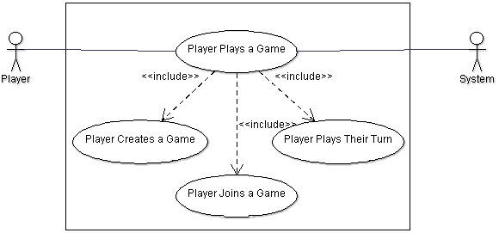

4.2 – Use Cases

Each use case is detailed in its own table, describing their sequence of events.

ID | Name | Description
UC-01  UC-01 | Player  Plays a Game  Player  Plays a Game | A player starts and plays a game of 7 Wonders.
  Actors: | - Player  - System
  Triggering Event: | A new game of 7 Wonders is started.
  Pre-Condition(s): | The player is not in a game.
  Main Sequence: | - Player arranges a game with three to seven players (execute UC-03 if player chooses to host, or UC-04 if player chooses to be a guest)  - Until all three Ages have been played:  - System deals the cards out appropriately for the current game and current Age to each player  - Until everyone has played six turns  - System displays the current game state  - Every player plays their turn (execute UC-02)  - The system passes the player's hand to the next player over in the direction as determined by the Age  - System applies combat victory points to players for winning or losing battles, notifying them  - System advances to the next Age and notifies Players  - System notifies the players that the game is over, presents the players with the final scoreboard and statistics, and waits for them to leave the game  - Player leaves the game
  Post-Condition(s): | - Game has ended  - The player is not in a game
  Resulting Event: | The player leaves the game.
  Alternative Scenarios:  Alternative Scenarios: | - System is halted or terminated unexpectedly:  - The system that has been halted or terminated enters an undefined state  - For all other players' 7 Wonders systems, treat it as if a player has ended the game early and skip to Step 3 in the Main Sequence
  - Player Leaves Game Early
    - Can happen at any time during Step 2
    - For the player leaving, skip to Step 4
    - The player who leaves is replaced with an artificial player, and the other players are notified
    - If the last human player is leaving, the game is forcibly ended
    - Alternative Post-Condition: game may not have ended
  Traceability: | - FR-PS-04, FR-PS-11  - FR-PT-01, FR-PT-02, FR-PT-10, FR-PT-12  - All FR-AR  - All FR-EG  - All FR-IR  - All FR-AP  - All NFR  - A-01, A-02, A-04, A-05, A-06, A-08, A-09,  A-10
UC-02  UC-02 | Player Plays Their Turn  Player Plays Their Turn | During a game of 7 Wonders, a player takes their turn.
  Actors: | - Player  - System
  Triggering Event: | The system enters a player turn round.
  Pre-Condition(s): | - The player is in a game  - It is a player turn round
  Main Sequence:  Main Sequence: | - If the player has unlocked an optional passive ability, the system asks if they would like to use it now  - Until the player has played the proper number of cards for their current turn:  - The system applies remaining applicable passive effects that will affect the player's turn  - The player selects a card to play  - The system notifies the player about their options for playing the selected card and describes the effects that each selection would apply  - The player selects an option  - The system takes the selected card from the player's hand and updates some of the game state to reflect the in-progress turn  - The system displays the partially updated game state  - If not every player is finished their turn, the system waits for every other player to be finished, and then the player is notified
  Post-Condition(s): | It is no longer the player's turn to move.
  Resulting Event: | The game state has been advanced.
  Alternative Scenarios: | - Player deselects a card  (Alternative Step 2.4.b)  2.4.b. Player deselects the card (return to the  most recent Step 2.2 in the Main  Sequence)
  Traceability: | - All FR-PT except FR-PT-10  - FR-IR-01 through FR-IR-11  - FR-AP-02  - NFR-01, NFR-02
UC-03 | Player Creates a Game | A player sets up a game of 7 Wonders.
  Actors: | - Player  - System
  Triggering Event: | The player chooses to host a new game of 7 Wonders.
  Pre-Condition(s): | The player is not in a game.
  Main Sequence: | - At their discretion, the host player waits for guest players to join their game, or adds artificial players to his game.  - By default, the player can choose to be given a random Wonder. Alternatively, they can specifically select their own.  - Once there are between three to seven players, the host player may choose to begin the session.
  Post-Condition(s): | The player is in a session.
  Resulting Event: | The players begin the session.
  Traceability: | - FR-PS-01 through FR-PS-10  - FR-IR-14
UC-04 | Player  Joins a Game | A player joins a game of 7 Wonders as a guest.
  Actors: | - Player  - System
  Triggering Event: | The player chooses to join a game of 7 Wonders as a guest.
  Pre-Condition(s): | The player is not in a game.
  Main Sequence:  Main Sequence: | - The player finds and specifies a game to join that is available, i.e., has not already began as a session and has not been filled.  - The guest player waits in the lobby for the host to initialize the session.  - While waiting, the player can choose to be given a random Wonder. Alternatively, they can specifically select their own.
  Post-Condition(s): | The player is in a session.
  Resulting Event: | The players begin the session.
  Traceability: | - FR-PS-01 through FR-PS-10  - FR-IR-14

4.3 – Responsibilities

These responsibilities are derived from the use cases, and are used with the use case maps further on. The use cases from which they come from are shown in the right-most column.

ID | Responsibility | Use Case(s)
RESP-01 | The system decides what cards will be used for the current Age and the number of players. | UC-01
RESP-02 | The system randomly deals the cards to each player. | UC-01
RESP-03 | The system displays the current game state. | UC-01
RESP-04 | The system passes the player's hand to their neighbour. | UC-01
RESP-05 | The system applies combat victory points to the players. | UC-01
RESP-06 | The system checks for any human players that have exited. | UC-01
RESP-07 | The system replaces any exiting human players with an artificial player. | UC-01
RESP-08 | The player is notified that any exiting human player has been replaced by artificial players. | UC-01
RESP-09 | The system determines whether six turns have been played. | UC-01
RESP-10 | The system notifies the player that the game has terminated unexpectedly. | UC-01
RESP-11 | The system discards the seventh card of each player's hand if it was unused. | UC-01
RESP-12 | The system determines whether Age III has ended. | UC-01
RESP-13 | The system advances to the next Age. | UC-01
RESP-14 | The system displays the scoreboard to each player. | UC-01
RESP-15 | The player exits the game. | UC-01
RESP-16 | The system determines if the player has unlocked a optional passive ability. | UC-02
RESP-17 | The player decides to activate their passive ability. | UC-02
RESP-18 | The system applies remaining applicable passive effects to the player. | UC-02
RESP-19 | The system displays the cards in the player's hand. | UC-02
RESP-20 | The player selects a card to play. | UC-02
RESP-21 | The system notifies the player about their options in playing the chosen card. | UC-02
RESP-22 | The player selects an option for how they wish to play their card. | UC-02
RESP-23 | The system takes the chosen card from the player's hand. | UC-02
RESP-24 | The system displays the partially updated game state. | UC-02
RESP-25 | The system checks for whether the player has finished choosing their card(s) to play. | UC-02
RESP-26 | The system determines whether every player has completed their turn. | UC-02
RESP-27 | The system advances the game state. | UC-02
RESP-28 | The player decides on being given a random Wonder or selecting a specific one to play. | UC-03  UC-04
RESP-29 | The host player waits for a guest player to join. | UC-03
RESP-30 | The host player adds an artificial player. | UC-03
RESP-31 | The host checks that there are enough players. | UC-03
RESP-32 | The host begins the session. | UC-03
RESP-33 | The system presents to the player games they can choose to join. | UC-04
RESP-34 | The player specifies an available game to join. | UC-04
RESP-35 | The system verifies whether or not the game to be joined is accessible. | UC-04
RESP-36 | The system connects the player to the game as a guest. | UC-04
RESP-28 | The player decides on being given a random Wonder or selecting a specific one to play. | UC-03  UC-04
RESP-37 | The guest player waits for the host player to begin the session. | UC-04
RESP-38 | The system initializes the session on behalf of the host player. | UC-04
4.4 – Unbound Use Case Maps

The unbound use case maps here correspond to their counterparts in Section 4.2. Triggering and resulting events are labeled in each following table, as well as the associated responsibilities for ease of viewing.

UUCM-01

UC-03
UC-02
UC-04
X
X
X
X
X
X
X
X
X
X
X
X
TE-01A
RE-01
RESP-01
RESP-
RESP-02
RESP-03
RESP-04
RESP-05
RESP-06
RESP-09
RESP-11
RESP-12
RESP-13
RESP-14
RESP-15

X
X
RESP-07
RESP-08

X
X
X
TE-01B
RE-01
RESP-10
RESP-14
RESP-15

TE-01A | A new game of 7 Wonders is started.
TE-01B | The system is halted or terminated unexpectedly.
RE-01 | The player leaves the game.
ID | Responsibility | Use Case(s)
RESP-01 | The system decides what cards will be used for the current Age and the number of players. | UC-01
RESP-02 | The system randomly deals the cards to each player. | UC-01
RESP-03 | The system displays the current game state. | UC-01
RESP-04 | The system passes the player's hand to their neighbour. | UC-01
RESP-05 | The system applies combat victory points to the players. | UC-01
RESP-06 | The system checks for any human players that have exited. | UC-01
RESP-07 | The system replaces any exiting human players with an artificial player. | UC-01
RESP-08 | The player is notified that any exiting human player has been replaced by artificial players. | UC-01
RESP-09 | The system determines whether six turns have been played. | UC-01
RESP-10 | The system notifies the player that the game has terminated unexpectedly. | UC-01
RESP-11 | The system discards the seventh card of each player's hand if it was unused. | UC-01
RESP-12 | The system determines whether Age III has ended. | UC-01
RESP-13 | The system advances to the next Age. | UC-01
RESP-14 | The system displays the scoreboard to each player. | UC-01
RESP-15 | The player exits the game. | UC-01

UUCM-02

X
X
X
X
X
X
X
X
X
X
X
TE-02
RE-02
X
RESP-16
RESP-17
RESP-18
RESP-19
RESP-20
RESP-21
RESP-22
RESP-23
RESP-24
RESP-25
RESP-26
RESP-27

TE-02 | The system enters a player turn round.
RE-02 | The game state has been advanced.
ID | Responsibility | Use Case(s)
RESP-16 | The system determines if the player has unlocked a optional passive ability. | UC-02
RESP-17 | The player decides to activate their passive ability. | UC-02
RESP-18 | The system applies remaining applicable passive effects to the player. | UC-02
RESP-19 | The system displays the cards in the player's hand. | UC-02
RESP-20 | The player selects a card to play. | UC-02
RESP-21 | The system notifies the player about their options in playing the chosen card. | UC-02
RESP-22 | The player selects an option for how they wish to play their card. | UC-02
RESP-23 | The system takes the chosen card from the player's hand. | UC-02
RESP-24 | The system displays the partially updated game state. | UC-02
RESP-25 | The system checks for whether the player has finished choosing their card(s) to play. | UC-02
RESP-26 | The system determines whether every player has completed their turn. | UC-02
RESP-27 | The system advances the game state. | UC-02

UUCM-03

X
X
X
RESP-28
TE-03
RE-03
RESP-31
RESP-32
X
RESP-30
X
RESP-29

TE-03 | The player chooses to host a new game of 7 Wonders.
RE-03 | The players begin the session.
ID | Responsibility | Use Case(s)
RESP-28 | The player decides on being given a random Wonder or selecting a specific one to play. | UC-03  UC-04
RESP-29 | The host player waits for a guest player to join. | UC-03
RESP-30 | The host player adds an artificial player. | UC-03
RESP-31 | The host checks that there are enough players. | UC-03
RESP-32 | The host begins the session. | UC-03

UUCM-04

X
X
RE-04
TE-04
RESP-38
RESP-37
RESP-28
X
X
RESP-33
RESP-34
X
X
X
RESP-35
RESP-36

TE-04 | The player chooses to join a game of 7 Wonders as a guest.
RE-04 | The players begin the session.
ID | Responsibility | Use Case(s)
RESP-33 | The system presents to the player games they can choose to join. | UC-04
RESP-34 | The player specifies an available game to join. | UC-04
RESP-35 | The system verifies whether or not the game to be joined is accessible. | UC-04
RESP-36 | The system connects the player to the game as a guest. | UC-04
RESP-28 | The player decides on being given a random Wonder or selecting a specific one to play. | UC-03  UC-04
RESP-37 | The guest player waits for the host player to begin the session. | UC-04
RESP-38 | The system initializes the session on behalf of the host player. | UC-04

4.5 – Bound Use Case Maps

The bound use case maps below correspond to the previous unbound ones. Following each map are descriptions for triggering and resulting events.

BUCM-01
UC-03
UC-04
TE-01A
X
X
X
X
X
X
X
X
UC-02
X
X
X
X
X
X
X
TE-01B
RE-01
RESP-01
RESP-02
RESP-03
RESP-04
RESP-05
RESP-06
RESP-07
RESP-08
RESP-09
RESP-10
RESP-11
RESP-12
RESP-13
RESP-14
RESP-15
LobbyScreen
JoinGameScreen
NetworkManager
Deck
SevenWonders
HUD

TE-01A | A new game of 7 Wonders is started.
TE-01B | The system is halted or terminated unexpectedly.
RE-01 | The player leaves the game.

BUCM-02

RE-02
X
X
X
X
X
X
X
X
X
X
X
RESP-16
TE-02
RESP-17
RESP-18
RESP-19
RESP-20
RESP-21
RESP-22
RESP-23
RESP-24
RESP-25
RESP-26
X
RESP-27
SevenWonders
HUD

TE-02 | The system enters a player turn round.
RE-02 | The game state has been advanced.

BUCM-03

NetManager
SevenWonders
TE-03
X
RESP-28
X
RESP-29
X
RESP-30
RESP-31
X
X
RESP-32
RE-03
LobbyScreen

TE-03 | The player chooses to host a new game of 7 Wonders.
RE-03 | The players begin the session.
BUCM-04
X
X
RE-04
TE-04
RESP-38
RESP-37
RESP-28
X
X
RESP-33
RESP-34
X
X
X
RESP-35
RESP-36
JoinGameScreen
SevenWonders
NetManager
LobbyScreen

TE-04 | The player chooses to join a game of 7 Wonders as a guest.
RE-04 | The players begin the session.

5
Design Decisions

This section documents design decisions that have been taken with respect to classes and objects chosen for the system. Included is a Unified Modeling Language (UML) diagram in Section 5.2.

5.1 – Decisions

ID | Design Decision | Traceability
DD-01 | Use a peer-to-peer model for networking  We decided to use a peer-to-peer model for simplicity. Rather than implement a server to relay messages, we can create a complete mesh between each of our peer nodes and simply send every message directly to everyone. This simplifies coding, since we do not need to handle hosting a game differently with extra server code. | Group Decision
DD-02 | Computer Players connect over the network as a separate client  Rather than have specialty cases in the game code for computer players, we can write them as separate clients that connect and handle their own actions. This is simpler to implement and easier to test, since there is a clear divide using a common interface. The divide allows us to ensure that game code is not broken or made messy in the process of creating the computer players – each project with their separate requirements can implement what they need how they need them and be designed around the common network interface. | Group Decision
DD-03 | Singletons  It made sense that some key main system classes (Game, EntityManager, RenderManager) be Singletons. Only one instance of each of these should ever exist, only one is needed, and access to their instances is required across the code. The code and design is more straight-forward thanks to this decision. | Group Decision
DD-04 | Cards, Boards, Behaviours, and the Strategy Pattern  The Strategy Pattern is extremely useful for implementing the game Cards and their Behaviours. We wanted to be able to reuse a generic Card class, rather than implement the various cards specifically. Using the Strategy pattern, we could do this and keep the code very clean and simple, organizing each Card's individual action into a class called Behaviour.  On top of this, the Behaviour class and Strategy pattern could be used again in implementing the Wonder Stages on the various Boards. | Group Decision
DD-05 | StrategyBot and the Strategy Pattern  In order to provide a bot which allowed the user to choose and switch between game strategies, we used the Strategy pattern again. In addition to allowing us to mix and match, this pattern allows the bot to be easily expandable, as it makes strategies more modular. | Group Decision
DD-06 | Dragging and dropping cards in order for play  To make an action with a card, the player must select a card from their hand with the mouse and drag it to a slot according to what move they wish to make. The basis of this design decision was from playing the board game in reality: the player would hold a card and place it in front of them to signify that they made their turn. This seemed more natural than selecting cards and actions with the keyboard, or even having to click upon a series of menus to make an action. Implementation-wise, this simplified the process by not needing to create said menus. The player just needs to drop the card in the appropriate place to play. | Group Decision
DD-07 | Graphical display of relevant statistics for each player  The game displays all the resources, victory points, shields, and other statistics at the top of the screen with a tallies of how much the player has accumulated for each. This decision reduces interface clutter, and lets the player instantly view how many of a type of resource they have instead of trying to count all the symbols they have. Card chaining information is hidden until the player selects a card that can be chained, which helps in cleaning the interface up. | Group Decision
DD-08 | Testing of bot behaviours and strategies  We were able to test how our bots were behaving and what strategies they were using. To do this, we added instances of them into a running game and looked at how they were playing their cards. As they were active debugging information was printed through their consoles, aiding us greatly in fixing their implementations. | Group Decision

5.2 – Structural Model (7 Wonders)

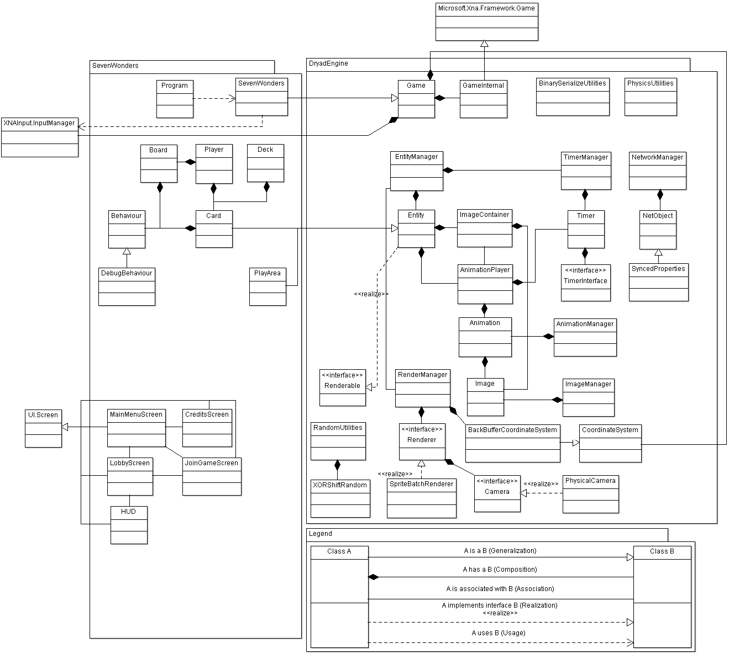
5.3 – Structural Model (Bots)

This diagram involves the implementation of bots (artificial players) in the software.
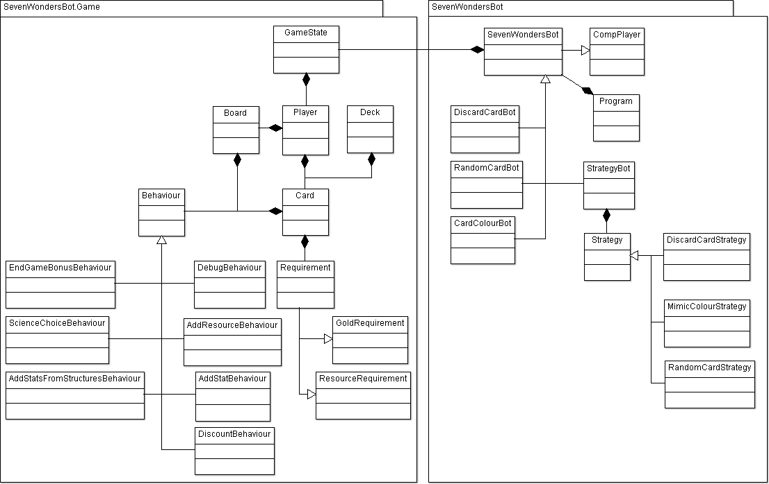
6
Object Specifications

NetObject

Name | ID | Description | Inheritance
NetObject | OS-01 | Used in networking process, used to make sure that everyone is up to date, and also handles overflow | None

Data Member Dictionary
Variable Name | Type | Status | Procedures
ownerID | Private int | Read/write | setOwnerID()  getOwnerID()
uid | Private int | Read/write | getUID()  setUID()
nextUpdateID | Private int | Read/write | getNetUpdate()  getNextUpdateID()  updateResponse()
cachedUpdate | Private byte[] | Read/write | getNetUpdate()  updateResponse()
cachedUpdateID | Private int | Read/write | getNetUpdate()  updateResponse()
cachedUpdateResponseCount | Private byte | Read/write | getNetUpdate()  updateResponse()

Procedure Dictionary
Procedure Name | Return Type | Parameter Name | Parameter Type | Responsibilities
getOwnerID | int | -- | -- | Returns the current value of the ownerID variable
setOwnerID | void | ownerID | int | Sets the value for the ownerID variable
getUID | int | -- | -- | Returns the current value of the uid variable
setUID | void | uid | int | Sets the value for the uid variable
createNetUpdate | Byte[] | -- | -- | Returns the next update this object wants to send over the netgame to its respective counterparts
handleNetUpdate | void | update | Byte[]
updateSuccessful | void | update | Byte[] | Notifies the NetObject that the byte[] update was successfully updated across all games
getNetUpdate | Byte[] | -- | --
getNextUpdateID | int | -- | -- | Returns the value for the next ID to be updated
updateResponse | void | updateResponseID | int | If the update was successful, calls the updateSuccessful procedure

Network Manager

Name | ID | Description | Inheritance
Network Manager | OS-02 | Used to handle everything to do with the networking of the game. Located in the game engine | None

Data Member Dictionary
Variable Name | Type | Status | Procedures
GameMessageType | Enum | Read | Connect()  sendMessage()  sendEventMessage()  setupPendingConnection()  handleIncomingMessage()
inNetGame | Boolean | Read/write | Disconnect()  isInNetGame()  setInNetGame()  handleIncomingMessage()
clientID | Int | Read/write | getClientID()  setupPendingConnection()  handleIncomingMessage()
nextFreeClientID | Int | Read/Write | handleIncomingMessage()  sendUpdates()
nextFreeUID | Int | Read/Write | claimUID()  handleIncomingMessage()
peerNode | NetPeer | Read/write | NetworkManager()  Connect()  Disconnect()  refreshAvailableGames()  sendMessage()  handleIncomingMessage()  handleUpdates()
connectedClients | HashDictionary<int, NetConnection> | Read/write | Disconnect()  getNumConnectedClients()  sendEventMessage()  setupPendingConnection()  handleIncomingMessage()  sendUpdates()
pendingConnections | HashedLinkedList<NetConnection> | Read/write | Disconnect()  handleIncomingMessage()  sendUpdates()
pendingConnectionClientID | Int | Read/write | setupPendingConnection()  handleIncomingMessage()
pendingConnectionHandshakeCount | Int | Read/write | handleIncomingMessage()
pendingConnectionMessageSent | boolean | Read/write | handleIncomingMessage()  sendUpdates()
pendingConnectionWaitTime | Double | Read/write | handleIncomingMessage()  sendUpdates()
netObjects | HashDictionary<Tuple<int,int>, NetObject> | Read/write | registerNetObjects()  deregisterNetObjects()  sendUpdates()
Registered | hashedLinkedList<NetObject> | Read/write | registerNetObject()  deregisterNetObject()  registerNetObjects()
deregistered | hashedLinkedList<NetObject> | Read/write | deregisterNetObject()  deregisterNetObjects()
availableGames | LinkedList<Tuple<IPEndPoint, byte[]>> | Read/write | refreshAvailableGames()  getKnownAvailableGames  handleIncomingMessage()

Procedure Dictionary
Procedure Name | Return Type | Parameter Name | Parameter Type | Responsibilities
NetworkManager | -- | appID | String | Constructor
getClientID | Int | -- | -- | Returns the current value of the clientID variable
claimUID | Int | -- | -- | Returns the current value of the nextFreeID variable
Connect | Void | Host | String | Calls the appropriate connect procedure given the parameter type
Connect | Void | endpoint | IPEndPoint | Calls the appropriate connect procedure given the parameter type
Connect | NetConnection | endpoint, gmt, data | IPEndPoint, GameMessageType, byte[] | Connects
Connect | NetConnection | Host, port, gmt, data | String, int, GameMessageType, byte[]
Disconnect | Void | -- | -- | Terminates all of the connections with the clients and terminates and pending connections
isInNetGame | Boolean | -- | -- | Returns the current value of the inNetGame variable
setInNetGame | Void | inNetGame | Boolean | Allows the inNetGame variable to be set to a true or false value
getNumConnectedClients | Int | -- | -- | Returns an integer representing how many clients are connected
refreshAvailableGames | Void | -- | -- | Clears the current available games and does another search to see what games are available at the current time
getKnownAvailableGames | LinkedList<Tuple<IPEndpoint, byte[]>> | -- | -- | Returns the current value of the availableGames variable
registerNetObject | Void | netObj | NetObject | Adds the netObj to the HashedLinkedList of netObjects
deregisterNetObject | Void | netObj | NetObject | Removes all the copies of the netObj from the HashedLinkedList of netObjects
registerNetObjects | Void | -- | --
deregisterNetObjects | Void | -- | --
sendMessage | Void | Data, destinations, gmt, ndm | Byte[], list, GameMessageType, NetDeliveryMethod
sendMessage | Void | Data, destination, gmt, ndm | Byte[], NetConnection, GameMessageType, NetDeliveryMethod
sendEventMessage | Void | Data | Byte[] | Sends event messages in reliable order
setupPendingConnection | Void | pendingConnection | NetConnection | Sets up the new connection and adds the client to the list of already connected clients
handleIncomingMessage | Void | Msg | NetIncomingMessage | Stores the game info, approves the connection, handles errors,
handleUpdates | Void | -- | -- | Checks for registering/deregistering netObjects and also checks for incoming messages
sendUpdates | Void | elapsedTime | Double | Handles pending connections, if there is nothing to be updated it will skip the current netObject

Renderer

Name | ID | Description | Inheritance
Renderer | OS-03 | Responsible for rendering the images/text/anything that wants to be displayed on screen | None

Data Member Dictionary
Variable Name | Type | Status | Procedures
-- | -- | -- | --
Procedure Dictionary
Procedure Name | Return Type | Parameter Name | Parameter Type | Responsibilities
Begin | Void | -- | -- | Begins the rendering process
End | Void | -- | -- | Ends the rendering process
renderImage | Void | Image, position | Image, Vector2 | Renders the image passed in with the image variable at the position designated by the position parameter
renderText | Void | Text, position, font, color | String, Vector2, SpriteFont, Color | Renders the text specified by the text parameter, at the designated location with the assigned font and colour

Entity

Name | ID | Description | Inheritance
Entity |  | Used to store and control the information for all the entities to be used in the game. Located in the game engine | Renderer

Data Member Dictionary
Variable Name | Type | Status | Procedures
Health | Int | Read/write | getHealth()  setHealth()  update()
Body | Body | Read/write | getBody()  setBody()  init()  cleanup()  dispose()  render()
Visible | Boolean | Read/write | isVisible()  setVisible()  render()
renderLayer | Float | Read/write | getRenderLayer()  setRenderLayer()  update()
Scale | Vector2 | Read/write | getScale()  setScale()  render()
Flip | SpriteEffects | Read/write | getFlip()  setFlip()  render()
imageContainer | ImageContainer | Read/write | setImage()  render()
animationPlayer | AnimationPlayer | Read/write | setImage()  getAnimationPlayer()  cleanup()

Procedure Dictionary
Procedure Name | Return Type | Parameter Name | Parameter Type | Responsibilities
isVisible | Boolean | -- | -- | Returns the true or false value of the visible variable
setVisible | Void | Visible | Boolean | Allows the visible variable to be set to true or false
getRenderLayer | Float | -- | -- | Returns the current value for the renderLayer variable
setRenderLayer | Void | renderLayer | Float | Allows the renderLayer variable to be set to a float value
getScale | Vector2 | -- | -- | Returns the current value of the scale variable
setScale | Void | Scale | Vector2 | Allows the scale variable to be set to a Vector2 value
onScaleChange | Void | -- | -- | Currently does nothing but can be overwritten when you want to handle scale change events
getFlip | SpriteEffects | -- | -- | Returns the value of the flip variable
setFlip | Void | Flip | SpriteEffects | Allows the flip variable to be set to a SpriteEffects value
setImage | Void | imagePath | String | Sets the image variable to the value passed into the imagePath parameter
onImageChange | Void | -- | -- | Does nothing right now, but can be overwritten to handle image change events
getAnimationPlayer | AnimationPlayer | -- | -- | Returns the current value for the animationPlayer variable
getHealth | Int | -- | -- | Returns the health of the entity
setHealth | Void | Health | Int | Allows the health variable to be set to the value of the health parameter
getBody | Body | -- | -- | Returns the body of the entity
setBody | Void | B | Body | Sets the body of the entity
Init | Void | -- | -- | Enables the entity body and initializes the user data
cleanup | Void | -- | -- | Disables the entity body and destroys all user data. Also pauses the animations
Dispose | Void | -- | -- | Removes this instance of the entity from the game
onDispose | Void | -- | -- | Does nothing right now
Update | Void | elapsedTime | Double | Checks to see if the entity still exists. If it doesn’t then remove it from the game
Render | Void | R | Renderer | Renders the entity in the game

Game

Name | ID | Description | Inheritance
Game | OS-04 | Holds and controls the basic setup and executable information for the game. Located in the game engine | None

Data Member Dictionary
Variable Name | Type | Status | Procedures
gameInternal | GameInternal | Read/write | Content()  Game()  Initialize()  Exit()  Run()
Instance | Game | Read/write | getInstance()  setInstance()
Args | String[] | Read/write | getArgs()  run()
viewableArea | CoordinateSystem | Read/write | Game()  getViewableArea()
viewableAreanInPixels | CoordinateSystem | Read/write | Game()  getViewableAreaInPixels()
physicsWorld | World | Read/write | Game()  getPhysicsWorld()
inputManager | InputManager | Read/write | Game()  getInputManager()
networkManager | NetworkManager | Read/write | Game()  getNetworkManager()

Procedure Dictionary
Procedure Name | Return Type | Parameter Name | Parameter Type | Responsibilities
getArgs | String[] | -- | -- | Returns the value of the args variable
getViewableArea | CoordinateSystem | -- | -- | Returns the viewableArea variable for the game
getViewableAreaInPixels | CoordinateSystem | -- | -- | Returns the viewableAreaInPixels variable for the game
getPhysicsWorld | World | -- | -- | Returns the physics world being used for the game
getInputManager | InputManager | -- | -- | Returns the input manager being used to play the game
getNetworkManager | NetworkManager | -- | -- | Returns the networkmanager used to connect all the clients
Initialize | Void | -- | -- | Sets up the input, controls and game
loadContent | Void | -- | -- | Will load in any content needed in the running of the game
unloadContent | Void | -- | -- | Will destroy any content previously loaded into the game
Update | Void | gameTime | GameTime | Updates the cycles of the game
Render | Void | gameTime | GameTime | Calls the renderer to do any rendering that needs to be done for the game
canPlayersJoinGame | Boolean | -- | -- | Returns a true or false value that determines if more players are able to join the game
getGameMetaData | Byte[] | -- | -- | Returns any meta data from within the game
handleEventMessage | Void | Data | Byte[] | Will handle any event messages passed through the game
Exit | Void | -- | -- | Exits the game
Run | Void | Args | String[] | A game can only be run once. This runs the game
Seven Wonders

Name | ID | Description | Inheritance
SevenWonders | OS-05 | This is no longer engine related, this is pure game related material. | DryadEngine.Game

Data Member Dictionary
Variable Name | Type | Status | Procedures
randomNumberGenerator | XORShiftRandom | Read/Write | getRandomNumberGenerator()
inGame | Boolean | Read/write | startGame()  handleEventMessage()
Players | LinkedList<Player> | Read/write | startGame()  getPlayer()  getCurrentPlayer()  getNumPlayers()
currentPlayerIndex | int | Read/write | startGame()  getCurrentPlayer()  getCurrentPlayerIndex()

Procedure Dictionary
Procedure Name | Return Type | Parameter Name | Parameter Type | Responsibilities
getInstance | SevenWonders | -- | -- | Returns the instance of the game that will be running
Initialize | Void | -- | -- | Initializes all of the rendering and materials that will be needed for the game
loadContent | Void | -- | -- | Loads in all the content that will be used with the game
unloadContent | Void | -- | -- | Unloads all the content that was previously loaded in, to be done after the game
handleEventMessage | Void | Data | Byte[] | Handles any debugging messages necessary
Update | Void | gameTime | GameTime | Updates the game loop, will handle all requirements necessary for running the game
Render | Void | gameTime | GameTime | Renders everything to do with the game
StartGame | void | -- | -- | This is called when a new game starts. Handles setting up the new players and initializing the GUI
getPlayer | Player | index | int | Returns the player in the list specified by the index provided to the method
getCurrentPlayer | Player | -- | -- | Returns the player that the game is currently focusing on
getCurrentPlayerIndex | int | -- | -- | Returns the index number of the player that the game is currently focusing on
getNumPlayers | Int | -- | -- | Returns the number of players that are in the game
getRandomNumberGenerator | XORShiftRandom | -- | -- | Returns a random number
advanceToNextRound | void | -- | -- | Passes the hand to the next player (direction is based on age)
advanceToNextAge | void | -- | -- | Increases the age and gets rid of the remaining cards. Also tabulates the scores for every player

Player
Name | ID | Description | Inheritance
Player | OS-06 | Used to control all actions and data pertaining to the player | None

Data Member Dictionary
Variable Name | Type | Status | Procedures
ResourceType | Enum | Read/write | getResourceCount()  setResourceCount()  getTotalResourceCount()
board | Board | Read/write | getBoard()  setBoard()
hand | LinkedList<Card> | Read/write | getHand()  setHand()
resources | Byte[] | Read/write | getResourcesCount()  setResourcesCount()

Procedure Dictionary
Procedure Name | Return Type | Parameter Name | Parameter Type | Responsibilities
getBoard | Board | -- | -- | Returns the board that is assigned to the player
setBoard | Void | board | Board | Assigns a board to the player
getHand | LinkedList<Card> | -- | -- | Returns the current card hand that is in the player’s possession
setHand | Void | hand | LinkedList<Card> | Sets the players hand to the hand that was passed to the method
getResourceCount | Byte | Resource | ResourceType | Returns the number of the specified resource
setResourceCount | Void | Resource, count | ResourceType, byte | Sets the amount of resources to the specified resource type
getTotalResourceCount | Byte | Resource | ResourceType | Returns the total resource count of the player
Card
Name | ID | Description | Inheritance
Card | OS-07 | Used to control all actions and data that can be applied to the cards in the game | Entity

Data Member Dictionary
Variable Name | Type | Status | Procedures
frontImagePath | String | Read/write | Card()
backImagePath | String | Read/write | Card()
behaviour | Behaviour | Read/write | Card()  Play()
outOfPlay | Boolean | Read/write | Card()  Select()  Play()  Discard()  Update()
collidingPlayArea | PlayArea | Read/write | Deselect()  onCollisionHandler()  onSeperationHandler()
cardSelected | Boolean | Read/write | Select()  Deselect()  Update()
fixedMouseJoint | FixedMouseJoint | Read/write | Select()  Deselect()  Update()
originalPosition | Vector2 | Read/write | Select()  Deselect()

Procedure Dictionary
Procedure Name | Return Type | Parameter Name | Parameter Type | Responsibilities
prepareResources | Void | -- | -- | Loads the images for all of the cards
Select | Void | -- | -- | Sets the card to being selected, sets the original position, and fixes it to the mouse for movement
Deselect | Void | -- | -- | Sets the card to being not selected, and releases the card from the mouse. If the card was over the “Play area” then it attaches the card to that area, or does the same for the “Discard” area. If it is over neither of these areas then it returns the card to its original position
Play | Void | owner | Player | Handles whatever action needs to be done when a card is played (depending on which card was played)
Discard | Void | owner | Player | Handles when a card is discarded. Adds gold to the player’s resources and gets rid of the card
onCollisionHandler | Bool | F1, f2, f3 | Fixture, Fixture, Contact | Handles the collision between a card and the play areas where cards can be placed
onSeperationHandler | Void | F1, f2 | Fixture, Fixture | Handles the separation between a card and the play areas
update | Void | elapsedTime | Double | Updates the mouse’s target world position and moving the card with the mouse. Also handles scrolling through cards

HUD

Name | ID | Description | Inheritance
HUD | OS-08 | Used to display the Heads Up Display of the game, including the displaying of resources, backgrounds, cards, etc. | UI.Screen

Data Member Dictionary
Variable Name | Type | Status | Procedures
playedCards | String[] | Read/write | Update()
viewedPlayer | Player | Read/write | setViewedPlayer()  update()
bundleIndex | Int | Read/write | prepareResources()
g | UI.WidgetGraphic | Read/write | HUD()  update()
homeIcon | UI.WidgetGraphic | Read/write | HUD()  update()
leftArrow | UI.WidgetGraphic | Read/write | HUD()  update()
rightArrow | UI.WidgetGraphic | Read/write | HUD()  update()
cityName | UI.WidgetGraphic | Read/write | HUD()  update()
cardsTitle | UI.WidgetGraphic | Read/write | HUD()  update()
Attack | UI.WidgetGraphic | Read/write | HUD()  update()
Clay | UI.WidgetGraphic | Read/write | HUD()  update()
Glass | UI.WidgetGraphic | Read/write | HUD()  update()
Lumber | UI.WidgetGraphic | Read/write | HUD()  update()
MathResource | UI.WidgetGraphic | Read/write | HUD()  update()
Ore | UI.WidgetGraphic | Read/write | HUD()  update()
Parchment | UI.WidgetGraphic | Read/write | HUD()  update()
Silk | UI.WidgetGraphic | Read/write | HUD()  update()
Stone | UI.WidgetGraphic | Read/write | HUD()  update()
Tablet | UI.WidgetGraphic | Read/write | HUD()  update()
VictoryPoints | UI.WidgetGraphic | Read/write | HUD()  update()
Wheel | UI.WidgetGraphic | Read/write | HUD()  update()
Coin | UI.WidgetGraphic | Read/write | HUD()  update()
strip | UI.WidgetGraphic | Read/write | HUD()  update()
attackNum | UI.WidgetText | Read/write | HUD()  update()
clayNum | UI.WidgetText | Read/write | HUD()  update()
coinNum | UI.WidgetText | Read/write | HUD()  update()
glassNum | UI.WidgetText | Read/write | HUD()  update()
lumberNum | UI.WidgetText | Read/write | HUD()  update()
mathNum | UI.WidgetText | Read/write | HUD()  update()
oreNum | UI.WidgetText | Read/write | HUD()  update()
parchmentNum | UI.WidgetText | Read/write | HUD()  update()
silkNum | UI.WidgetText | Read/write | HUD()  update()
stoneNum | UI.WidgetText | Read/write | HUD()  update()
tabletNum | UI.WidgetText | Read/write | HUD()  update()
victoryNum | UI.WidgetText | Read/write | HUD()  update()
wheelNum | UI.WidgetText | Read/write | HUD()  update()
AlgerianfontStyle | UI.FontStyle | Read/write | prepareResources()
CentaurfontStyle | UI.FontStyle | Read/write | prepareResources()

Procedure Dictionary
Procedure Name | Return Type | Parameter Name | Parameter Type | Responsibilities
prepareResources | Void | -- | -- | Loads the fonts and images to be used when creating the heads up display
setViewedPlayer | Void | p | Player | Used for setting which player that the HUD is currently viewing
Update() | Void | -- | -- | Adds all of the elements of the HUD. Also makes any changes necessary to the HUD (updating resource counts, updating the list of played cards, updating the view depending on which player’s board is being viewed)
OnProcessInput | Void | input | Input | Will handle the input on the HUD, things like the home button and list of played cards

Board

Name | ID | Description | Inheritance
Board | OS-09 | Used to control the behaviours and data specific to the different boards that the player can use | None

Data Member Dictionary
Variable Name | Type | Status | Procedures
owner | Player | Read/write | buildWonderStage()
boardName | String | Read/write | getBoardName()
boardTextureName | String | Read/write | getBoardTextureName()
wonderStagesBuilt | byte | Read/write | buildWonderStage()
behaviours | Behaviour[] | Read/write | buildWonderStage()

Procedure Dictionary
Procedure Name | Return Type | Parameter Name | Parameter Type | Responsibilities
getBoardName | String | -- | -- | Returns the name of the board
getBoardTextureName | String | -- | -- | Returns the name that is used to represent the board texture. Useful for displaying the board in the HUD
buildWonderStage | void | -- | -- | Calls the behaviour to build the next available wonder then increments how many wonders have been built on the board

JoinGameScreen

Name | ID | Description | Inheritance
JoinGameScreen | OS-10 | This is the menu screen that appears after the player selects to join a game. It handles showing the available games and selecting a game from those available | UI.Screen

Data Member Dictionary
Variable Name | Type | Status | Procedures
gamesMenu | UI.WidgetMenuScroll | Read/write | onUpdate()
displayedGames | LinkedList<Tuple<IPEndPoint, byte[]>> | Read/write | onUpdate()

Procedure Dictionary
Procedure Name | Return Type | Parameter Name | Parameter Type | Responsibilities
onPostInit | void | -- | -- | Refreshes the list of available games
onProcessInput | void | input | Input | Handles the input of button pressing when selecting from the list of games, or the back button to return to the main menu screen
onUpdate | void | frameTime | float | Handles displaying the available games and highlighting the options as the user scrolls through them

CreditsScreen

Name | ID | Description | Inheritance
CreditsScreen | OS-11 | This screen displays the names of the students who worked on creating the game | UI.Screen

Data Member Dictionary
Variable Name | Type | Status | Procedures
header | UI.WidgetText | Read/write | --(only in constructor)
creditsText | UI.WidgetText | Read/write | --(only in constructor)
backText | UI.WidgetText | Read/write | --(only in constructor)

Procedure Dictionary
Procedure Name | Return Type | Parameter Name | Parameter Type | Responsibilities
onProcessInput | void | input | Input | Handles the pressing of the back button which results in going back to the main menu page

MainMenuScreen

Name | ID | Description | Inheritance
MainMenuScreen | OS-12 | This is the menu screen that first appears to the user. It allows them to choose from different options with regards to starting a game, seeing the credits, or exiting the game | UI.Screen

Data Member Dictionary
Variable Name | Type | Status | Procedures
menuItems | String[] | Read | -- (only in constructor)
mainMenu | UI.WidgetMenuScroll | Read/write | onProcessInput()

Procedure Dictionary
Procedure Name | Return Type | Parameter Name | Parameter Type | Responsibilities
prepareResources | void | -- | -- | Prepares the font and background image to be used
OnProcessInput | void | input | Input | Handles the button presses of the different menu options and sends the game to the appropriate screen depending on the menu option selected

LobbyScreen

Name | ID | Description | Inheritance
LobbyScreen | OS-13 | This is the menu screen that appears after a player decides to start a game. It allows the player to select a board and start the game | UI.Screen

Data Member Dictionary
Variable Name | Type | Status | Procedures
gameInfoText | UI.WidgetText | Read/write | OnUpdate()
selectedBoard | int | Read/write | OnProcessInput()  OnUpdate()
boards | string[] | Read/write | OnUpdate()

Procedure Dictionary
Procedure Name | Return Type | Parameter Name | Parameter Type | Responsibilities
OnProcessInput | void | input | Input | Handles the input from the player. Handles scrolling through the game boards, selecting a game board, starting a game, and quitting back to the main menu
OnUpdate | void | frameTime | float | Updates the list of boards as the player scrolls through it

Deck

Name | ID | Description | Inheritance
Deck | OS-14 | Contains the shuffled cards for each age | None

Data Member Dictionary
Variable Name | Type | Status | Procedures
AGE | byte | Read | -- (only constructor)
HAND_SIZE | int | read | dealHand()
AGE_1_CARDS | Card[] | Read | -- (only constructor)
AGE_2_CARDS | Card[] | Read | -- (only constructor)
AGE_3_CARDS | Card[] | Read | -- (only constructor)
cards | ArrayList<Card> | Read/write | dealHand()

Procedure Dictionary
Procedure Name | Return Type | Parameter Name | Parameter Type | Responsibilities
dealHand | LinkedList<Card> | -- | -- | Responsible for going through the deck of cards at each age and randomly selecting cards to go to each player. This simulates the dealing process

StrategyBot

Name | ID | Description | Inheritance
StrategyBot | OS-15 | The central hub for the strategies, handles selecting which strategies to use in the game | SevenWondersBot

Data Member Dictionary
Variable Name | Type | Status | Procedures
DELIMETERS | Char[] | read | Update()
strategies | LinkedList<strategy> | Read/write | handleCardPlayed()  handleCardDiscarded()  handleAdvanceToNextRound()  handleAdvanceToNextAge()  update()
playedThisRound | boolean | Read/write | hasPlayedThisRound()  setPlayedThisRound()
readLineDelegate | ReadLineDelegate | Read/write | readInput()
readLineResult | IAsyncResult | Read/write | readInput()

Procedure Dictionary
Procedure Name | Return Type | Parameter Name | Parameter Type | Responsibilities
handleCardPlayed | void | Player, card | Player, Card | This procedure handles what to do when a card is played. Calls itself for every strategy
handleCardDiscarded | void | Player, card | Player, Card | This procedure handles what to do when a card is discarded. Calls itself for every strategy
handleAdvanceToNextRound | void | -- | -- | Handles advancing to the next card round. Calls itself for every strategy
handleAdvanceToNextAge | void | -- | -- | Handles advancing to the next age of the game. Calls itself for every strategy
hasPlayedThisRound | bool | -- | -- | Returns the value of the boolean ‘playedThisRound’
setPlayedThisRound | Void | playedThisRound | bool | Sets the value of ‘playedThisRound’ to whatever is passed in the parameter
readInput | String | -- | -- | Reads and returns whatever was input, to then be used to pick a strategy in the update method
update | void | elapsedTime | double | Uses the input to select which strategy to use/remove. Also allows user to list the strategies, and in an extreme case where the chosen strategy doesn’t allow the bot to move, it allows the user to force a move from the bot (discard a card)

SevenWondersBot

Name | ID | Description | Inheritance
SevenWondersBot | OS-16 | The game area for the bot players | compPlayer

Data Member Dictionary
Variable Name | Type | Status | Procedures
currentGameState | GameState | Read/write | getCurrentGameState()  getCurrentPlayer()  handleEventMessage()  update()
currentPlayerIndex | int | Read/write | getCurrentPlayer()  getCurrentPlayerIndex()  handleEventMessage()
inGame | boolean | Read/write | handleEventMessage()  update()

Procedure Dictionary
Procedure Name | Return Type | Parameter Name | Parameter Type | Responsibilities
getCurrentGameState | GameState | -- | -- | Returns the current state of the game
getCurrentPlayer | Player | -- | -- | Returns the player that the game is currently focusing on
getCurrentPlayerIndex | int | -- | -- | Returns the index number of the player that the game is currently focusing on
handleEventMessage | void | data | Byte[] | On a very high level this handles playing a card, discarding a card, and building a wonder
handleCardPlayed | void | Player, card | Player, Card | This procedure does nothing in this class. It is virtual and is intended to be overwritten.
handleCardDiscarded | void | Player, card | Player, Card | This procedure does nothing in this class. It is virtual and is intended to be overwritten.
handleAdvanceToNextRound | void | -- | -- | This procedure does nothing in this class. It is virtual and is intended to be overwritten.
handleAdvanceToNextAge | void | -- | -- | This procedure does nothing in this class. It is virtual and is intended to be overwritten.
sendGameEventMessage | void | eventMessagetype, data | EventMessageType, byte[] | Handles sending messages over the network
update | void | elapsedTime | double | Updates the game state, and checks to see if anyone has quit. If someone has quit then exit the game

RandomCardBot

Name | ID | Description | Inheritance
RandomCardBot | OS-17 | Handles the actions for the AI that chooses the cheapest cards to play at random | SevenWondersBot

Data Member Dictionary
Variable Name | Type | Status | Procedures
playedThisRound | boolean | Read/write | doMove()  reset()

Procedure Dictionary
Procedure Name | Return Type | Parameter Name | Parameter Type | Responsibilities
handleCardPlayed | void | Player, card | Player, Card | Calls the doMove procedure when a card is played
handleCardDiscarded | void | Player, card | Player, Card | Calls the doMove procedure when a card is discarded
handleAdvanceToNextRound | void | -- | -- | Calls reset to allow the bot to move again
handleAdvanceToNextAge | void | -- | -- | Calls reset to allow the bot to move again
doMove | void | -- | -- | If the bot has not already played this round, evaluate the cheapest card to play in terms of cost and play that. Also sends this message across the network to the other players. If there are no available cards then discard a card
reset | void | -- | -- | Sets the ‘playedThisRound’ value to false so that the bot will be able to play again

DiscardCardBot

Name | ID | Description | Inheritance
DiscardCardBot | OS-18 | Handles the actions for the AI that discards cards at random to gain as much money as possible | SevenWondersBot

Data Member Dictionary
Variable Name | Type | Status | Procedures
playedThisRound | boolean | Read/write | doMove()  reset()

Procedure Dictionary
Procedure Name | Return Type | Parameter Name | Parameter Type | Responsibilities
handleCardPlayed | void | Player, card | Player, Card | Calls the doMove procedure when a card is played
handleCardDiscarded | void | Player, card | Player, Card | Calls the doMove procedure when a card is discarded
handleAdvanceToNextRound | void | -- | -- | Calls reset to allow the bot to move again
handleAdvanceToNextAge | void | -- | -- | Calls reset to allow the bot to move again
doMove | void | -- | -- | If the bot has not already played this round, selects a card at random and discards it
reset | void | -- | -- | Sets the ‘playedThisRound’ value to false so that the bot will be able to play again

ColouredCardBot

Name | ID | Description | Inheritance
ColouredCardBot | OS-19 | AI that prioritizes the resource cards over other cards | SevenWondersBot

Data Member Dictionary
Variable Name | Type | Status | Procedures
ColourPriorities | byte | read | doMove()
priorities | IEnumerable<ColourPriorities> | Read/write | doMove()
playedThisRound | bool | Read/write | doMove()  reset()

Procedure Dictionary
Procedure Name | Return Type | Parameter Name | Parameter Type | Responsibilities
handleCardPlayed | void | Player, card | Player, Card | Calls the doMove procedure when a card is played
handleCardDiscarded | void | Player, card | Player, Card | Calls the doMove procedure when a card is discarded
handleAdvanceToNextRound | void | -- | -- | Calls reset to allow the bot to move again
handleAdvanceToNextAge | void | -- | -- | Calls reset to allow the bot to move again
addColouredCardsToList | void | List, colour | LinkedList<Card>, Card.CardColour | Adds the card to a certain list of specifically coloured cards to be used to determine rank of importance
doMove | void | -- | -- | Prioritizes the resource cards (brown and gray cards) over the other cards and always plays those (if they are available). If no resource cards are available then it plays another card which it can afford. If it cannot afford any then a card is randomly discarded
reset | void | -- | -- | Sets the ‘playedThisRound’ value to false so that the bot will be able to play again

CompPlayer

Name | ID | Description | Inheritance
CompPlayer | OS-20 | Handles networking tasks | NetGameInfo, NetEventHandler

Data Member Dictionary
Variable Name | Type | Status | Procedures
SLEEP_MILLIS | int | Read | run()
networkManager | NetworkManager | Read/write | getNetworkManager()  updateInternal()
exiting | boolean | Read/write | Exit()  Run()
tickerTapeClock | TickerTapeClock | Read/write | Run()
args | String[] | Read/write | getArgs()  run()

Procedure Dictionary
Procedure Name | Return Type | Parameter Name | Parameter Type | Responsibilities
getGameMetaData | Byte[] | -- | -- | Returns null
canPlayersJoinGame | bool | -- | -- | Returns whether or not more players can join the game
exit | void | -- | -- | Sets the ‘exiting’ variable to true to allow the game to exit
getArgs | String[] | -- | -- | Returns the ‘args’ variable
getNetworkManager | NetworkManager | -- | -- | Returns the network manager
handleEventMessage | void | data | Byte[] | This procedure is empty in this class. It is virtual and intended to be overwritten
updateInternal | void | elapsedTime | double | Updates the network manager, and sends the updates across the network
update | void | elapsedTime | double | This procedure is empty in this class. It is virtual and intended to be overwritten
run | void | args | String[] | This procedure does not return until the CompPlayer is finished executing everything that it needs to

DiscountBehaviour

Name | ID | Description | Inheritance
DiscountBehaviour | OS-21 | Handles what to do in the case that a resource can be acquired at a discounted price | Behaviour

Data Member Dictionary
Variable Name | Type | Status | Procedures
targets | TargetedPlayers | Read/write | doAction()
discountedResources | Byte[] | Read/write | doAction()

Procedure Dictionary
Procedure Name | Return Type | Parameter Name | Parameter Type | Responsibilities
doAction | void | owner | Player | This handles discounting resources from either the player to the owner’s right, the owner’s left, or both neighbours

AddStatBehaviour

Name | ID | Description | Inheritance
AddStatBehaviour | OS-22 | Handles the event where a player can add a ‘stat’ at the end of the round/game (stats are victory points, gold, sciences, etc) | Behaviour

Data Member Dictionary
Variable Name | Type | Status | Procedures
stat | StatType | Read/write | doAction()
statAmount | byte | Read/write | doAction()

Procedure Dictionary
Procedure Name | Return Type | Parameter Name | Parameter Type | Responsibilities
doAction | void | owner | Player | Increases the specified stat count of the owner

AddResourceBehaviour

Name | ID | Description | Inheritance
AddResourceBehaviour | OS-23 | Handles the event where a player can add a ‘resource’ at the end of the round/game (resources are ore, wood, silk, etc) | Behaviour

Data Member Dictionary
Variable Name | Type | Status | Procedures
resource | resourceType | Read/write | doAction()
resourceAmount | byte | Read/write | doAction()

Procedure Dictionary
Procedure Name | Return Type | Parameter Name | Parameter Type | Responsibilities
doAction | void | owner | Player | Increases the specified resource count of the owner

ResourceRequirement

Name | ID | Description | Inheritance
ResourceRequirement | OS-24 | Determines whether or not a player meets the resource requirements to play a card | Requirement

Data Member Dictionary
Variable Name | Type | Status | Procedures
costs | Byte[] | Read/write | getCosts()  meetsRequirement()

Procedure Dictionary
Procedure Name | Return Type | Parameter Name | Parameter Type | Responsibilities
getCosts | Byte[] | -- | -- | Returns the costs
meetsRequirement | bool | player | Player | Returns whether or not the player meets the resource requirements required

GoldRequirement

Name | ID | Description | Inheritance
GoldRequirement | OS-25 | Determines if the player has enough gold to purchase whatever they are attempting to purchase | Requirement

Data Member Dictionary
Variable Name | Type | Status | Procedures
costAmount | byte | Read/write | getCostAmount()  meetsRequirement()

Procedure Dictionary
Procedure Name | Return Type | Parameter Name | Parameter Type | Responsibilities
getCostAmount | byte | -- | -- | Returns the cost amount
meetsRequirement | bool | player | Player | Returns whether or not the player has enough money to purchase whatever they are attempting to purchase
meetsChain | bool | player | Player | Returns whether or not a chain will be fulfilled
applyCost | void | player | Player | Updates the player’s gold count by subtracting the costAmount from their current gold amount

TradeDialog

Name | ID | Description | Inheritance
TradeDialog | OS-26 | The UI for the player when making a trade (resources for gold) | UI.Screen

Data Member Dictionary
Variable Name | Type | Status | Procedures
COST_TEXT_PREFIX | String | read | showNextTrade()
TOTAL_COST_TEXT_PREFIX | String | read | tradeLeft()  tradeRight()
card | Card | Read/write | Cancel()  Accept()
costForPrev | byte | Read/write | tradeLeft()  tradeRight()  accept()  shownextTrade()
costForNext | byte | Read/write | tradeLeft()  tradeRight()  accept()  shownextTrade()
remainingResources | Byte[] | Read/write | tradeLeft()  tradeRight()  shownextTrade()
leftCostText | UI.WidgetText | Read/write | shownextTrade()
rightCostText | UI.WidgetText | Read/write | shownextTrade()
totalCostText | UI.WidgetText | Read/write | tradeLeft()  tradeRight()
Backtext | UI.WidgetText | Read/write | OnProcessInput()
acceptText | UI.WidgetText | Read/write | OnProcessInput()  accept()  shownextTrade()
resourceGraphic | UI.WidgetGraphic | Read/write | shownextTrade()
leftArrow | UI.WidgetGraphic | Read/write | OnProcessInput()
rightArrow | UI.WidgetGraphic | Read/write | OnProcessInput()

Procedure Dictionary
Procedure Name | Return Type | Parameter Name | Parameter Type | Responsibilities
prepareResources | void | -- | -- | Adds all the required textures to the texture bundle
OnProcessInput | void | input | Input | Handles what action to take based on where the user clicks on the screen
cancel | void | -- | -- | Resets the position of the card that had been moved
tradeLeft | void | -- | -- | Using the player to the user’s left, subtracts one resource from what is required (trades for the resource) and shows the updated cost of the card
tradeRight | void | -- | -- | Using the player to the user’s right, subtracts one resource from what is required (trades for the resource) and shows the updated cost of the card
accept | void | -- | -- | Sends the message across the network to play the card, and plays the card
showNextTrade | void | -- | -- | Checks to see if there still needs to be trades made. If there is then it shows the available trades to the user

GameOverScreen

Name | ID | Description | Inheritance
GameOverScreen | OS-27 | Displays the game over screen to the players once the game is completed | UI.Screen

Data Member Dictionary
Variable Name | Type | Status | Procedures
BG | UI.WidgetGraphic | Read/write | --
header | UI.WidgetText | Read/write | --
creditsText | UI.WidgetText | Read/write | --
backText | UI.WidgetText | Read/write | --

Procedure Dictionary
Procedure Name | Return Type | Parameter Name | Parameter Type | Responsibilities
prepareResources | void | -- | -- | Adds the necessary textures to the texture bundle
OnProcessInput | void | input | Input | Handles the interaction of pressing backspace to return to the main menu

7
Interaction Diagrams

Contained below are UML 2.0 Interaction Diagrams as Message Sequence Charts. Each correspond to the previous bound use case maps.

MSC-01
Corresponds to UC-01.

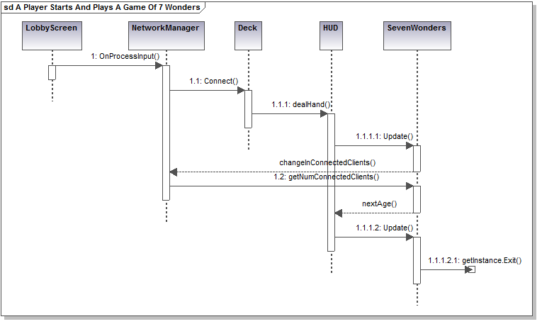
MSC-02
Corresponds to UC-02.

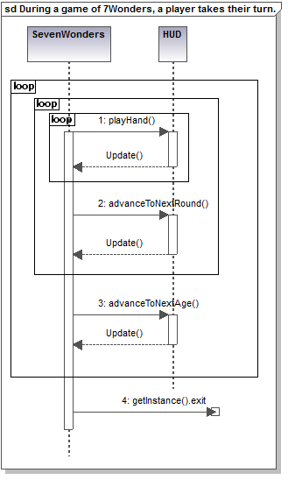

MSC-03
Corresponds to UC-03.

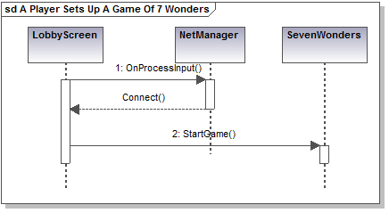

MSC-04
Corresponds to UC-04.



