Documentation for Team xx

Note: Traceability values refer to 3rd edition rulebook.

Functional requirements
Display correct tiles on board
- Description: The board can be viewed in the correct placement as given.
- How it was tested: Appeared on screen. No further testing required.
- Internal traceability: FR-01
- Ruleset traceability: 3.2 (pg 13)
Board is scrollable for each client
- Description: Each client views a section of the board at any time which they can scroll across the entire map.
- How it was tested: Appeared on screen. Spawned multiple clients. No further testing required.
- Internal traceability: FR-02
- Ruleset traceability: N/A
Support for network
- Description: The game can be played via network where one player initiates the game which can be joined by other players playing as characters not yet selected. As the game progresses, each player is updated on the actions done by others (moving, hiding).
- How it was tested: Map and sidebar update with information regarding other players connected at end of phase. Connected up to 16 players at once with no syncing issues.
- Internal traceability: FR-03
- Ruleset traceability: N/A
Initial character selection offers two or more distinct players
- Description: Upon joining the game, players can select from any of the game’s characters not yet being played
- How it was tested: Character was selected and new game started. Character inventories and internal model match selected character’s stats.
- Internal traceability: FR-04
- Ruleset traceability: 3.3 (pg 14)
Sound and warning chits are correctly displayed to clients
- Description: Upon moving into a tile, the contents of the tile are made visible to the player; it’s sound(warning) chit and treasure/site chit appear (the site chit only if it has been found through locate).
- How it was tested: Sound chits are displayed in each tile (clearing if located). Entering combat displays the correct monsters associated with the chits.
- Internal traceability: FR-05
- Ruleset traceability: 4.5 (pg 20)
Support selection of starting location for characters
- Description: After picking their character, players select from a list of all the starting locations available to their character.
- How it was tested: Starting location was selected and new game started. The player appears next to the selected dwelling on the map.
- Internal traceability: FR-06
- Ruleset traceability: 3.3 (pg 14)
Support legal character moves within and across tiles
- Description: Players may only move to clearings that are connected to the one they are in, whether it is within the same tile or connected to an adjacent tile. They cannot move into a cave unless they have found the entrance or travel along a secret path unless it was revealed to them.
- How it was tested: Clicked on non-clearing and non-adjacent clearings. Also clicked on cave clearings with and without searching for secret path first.
- Internal traceability: FR-07
- Ruleset traceability: 7.3 (pg 33)
Support for Captain’s special abilities
- Description: The captains AIM ability will subtract 1 from his missile rolls. His REPUTATION ability is not implemented and does not give him an extra phase.
- How it was tested: Engaged combat with another character and use print statements to check internal dice roll.
- Internal traceability: FR-08
- Ruleset traceability: N/A
Support Amazon’s extra move
- Description: Players with the Amazon may make an extra move action after playing their first 4 phases.
- How it was tested: Amazon-only characters are allowed to use an extra action exclusively towards movement.
- Internal traceability: FR-09
- Ruleset traceability: N/A
Support manual dice result for hiding
- Description: Players with cheat mode enabled can choose the result of their hide action roll.
- How it was tested: Cheat mode was activated and a dialog appears with all possible dice values. Setting the value to 6 makes hiding unsuccessful.
- Internal traceability: FR-10
- Ruleset traceability: 7.4 (pg 36)
Support for hiding unsuccessfully (setting dice to 6)
- Description: Players that roll a 6 on their hide result have their hidden/unhidden status unchanged.
- How it was tested: Cheat mode was activated and a dialog appears with all possible dice values. Setting the value to 6 makes hiding unsuccessful.
- Internal traceability: FR-11
- Ruleset traceability: 7.4 (pg 36)
Support for hiding successfully
- Description: Players that roll anything other than 6 on a hide roll become hidden.
- How it was tested: Cheat mode was activated and a dialog appears with all possible dice values. Setting the value to anything other than 6 makes hiding successful.
- Internal traceability: FR-12
- Ruleset traceability: 7.4 (pg 36)
Support selection of fight and move counters for combat
- Description: (Option 1) Players select their FIGHT and MOVE chits for their maneuvers, after which combat is resolved.
- How it was tested: Combat is started and a separate window appears asking for all required combat variables. Fight and move counters are one of the variables needed.
- Internal traceability: FR-13
- Ruleset traceability: 8.4.5.e (pg 55)
Can choose shield location
- Description: If a shield is in the player’s inventory, they must select the direction that it will protect.
- How it was tested: Combat is started and a separate window appears asking for all required combat variables. If the character has an active shield, an extra section of the dialog is made available to select.
- Internal traceability: FR-14
- Ruleset traceability: 8.4.5.i.2 (pg 56)
Can choose to play or not any armor
- Description: Players may put armor in their inactive inventory when not in combat, this removing it from play. They can bring it back at any time outside combat when rearranging belongings.
- How it was tested: Combat is started (with and without active armour) and print statements confirm the armour’s status in combat.
- Internal traceability: FR-15
- Ruleset traceability: 4.3.7 (pg 19)
Support 1 round of combat two characters
- Description: Players may engage in one round of combat with one another with the following outcomes: one of their deaths, both of their deaths, or no death.
- How it was tested: Combat is started and a separate window appears asking for all required combat variables. Once all variables are filled in and confirmed by all players, combat is resolved. Players may disconnect to confirm this.
- Internal traceability: FR-16
- Ruleset traceability: 5.2 (pg 28)
Support 2* limit during combat
- Description: Players in combat may only play up to 2* worth of effort for their FIGHT and MOVE chits used in their maneuvers.
- How it was tested: Combat is started and a separate window appears asking for all required combat variables. Selecting a 2* fight chit first and 2* move chit second will not allow the move chit to be played.
- Internal traceability: FR-17
- Ruleset traceability: 8.4.5.f.2 (pg 55)
Support swordsman special ability to play when he wants
- Description: As players execute phases concurrently, the swordsman’s ability to play when he wants cannot be implemented in this system.
- Internal traceability: FR-18
- Ruleset traceability: N/A
Support black/white knights as available characters
- Description: The Black and White knight can be selected to play in the game.
- How it was tested: We ran the game with the characters
- Internal traceability: FR-19
- Ruleset traceability: 3.3 (pg 14)
Support berserker going berserk
- Description: The Berserker has the ability to play his berserk chit which is tremendous.
- How it was tested: We ran the combat with the berserker
- Internal traceability: FR-20
- Ruleset traceability: 4.2.2 (pg 18)
Support separate display for multiple ‘things’ in one clearing
- Description: Seeing things on a clearing are done by multiple systems. Players can see other players on the map while items on the clearing are only seen when looting.
- How it was tested: We ran the GUI
- Internal traceability: FR-21
- Ruleset traceability: N/A
Support alerting weapons
- Description: Players that make an alert action will have their weapon change stats, thus affecting their combat results. The player’s map icon will change to red when alerted.
- How it was tested: We ran combat as alerted.
- Internal traceability: FR-22
- Ruleset traceability: 7.9 (pg 42)
Can combat with an non-alerted weapon
- Description: Players with a non-alerted weapon can still do combat with a non-alerted weapon.
- How it was tested: We ran combat.
- Internal traceability: FR-23
- Ruleset traceability: N/A
Visually support fatiguing counters
- Description: Fatigued chits are placed in the fatigued inventory section of their belongings.
- How it was tested: The chits appeared
- Internal traceability: FR-24
- Ruleset traceability: N/A
Rules respected for fatiguing
- Description: When a player plays 2* worth of effort for their actions in combat, they fatigue one chit. The chit that is fatigued is a ** if they played one or one of the * chits they played for either FIGHT or MOVE. They cannot choose one of their other active chits. The chit is put in the fatigued inventory section of their belongings.
- How it was tested: We ran the combat.
- Internal traceability: FR-25
- Ruleset traceability: 8.5.1 (pg 63)
Visually support wounding counters
- Description: Wounded chits are placed in the wounded inventory section of their belongings.
- How it was tested: Wounded chits appeared in inventory
- Internal traceability: FR-26
- Ruleset traceability: N/A
Rules respected for fatiguing
- Description: When a player is hit by an attack that does not exceed their vulnerability, they can select any active or fatigued chit to wound. That chit is placed in the wounded inventory section of their belongings.
- Internal traceability: FR-27
- Ruleset traceability: 8.5.3 (pg 63)
Rules respected for resting counters
- Description: When a player makes a rest action, they can take one fatigued chit and make it active or take one wounded chit and make it fatigued. Chits move to their correct inventory section.
- How it was tested: We ran the rest button.
- Internal traceability: FR-28
- Ruleset traceability: 7.8 (pg 42)
Support berserker/white knight having an extra REST
- Description: The Berserker and White Knight has their abilities that gives them an extra rest phase they can make after their 4 standard phases are played.
- How it was tested: We ran the characters
- Internal traceability: FR-29
- Ruleset traceability: N/A
Support players being able to discover treasure site chit on tiles
- Description: Players can use the locate ability when searching to roll to discover a site chit if it exists on the map tile they are on.
- How it was tested: Ran the locate button
- Internal traceability: FR-30
- Ruleset traceability: 7.5 (pg 30)
Support use of search table to discover treasure site
- Description: The results on makes on their locate/peer roll is dictated by the results listed on the search table. If there are multiple results then they all occur.
- How it was tested: We the peer/locate functionality
- Internal traceability: FR-31
- Ruleset traceability: 7.5 (pg 30)
Support for great treasures
- Description: Great treasure is implemented in the game and rewards players with a victory point if applicable.
- How it was tested: The great treasures appeared in the game, and performed their task.
- Internal traceability: FR-32
- Ruleset traceability: 2.3.7 (pg 8)
Current gold, fame, notoriety, great treasures, and victory points are shown
- Description: Players can view their current fame, notoriety, gold, and great treasures as they progress through the game. The numbers will be updated as they complete actions.
- How it was tested: Added a view character and ran it successfully
- Internal traceability: FR-33
- Ruleset traceability: 2.6.2 (pg 10)
Support appearance of one treasure site guard monster
- Description: Players that end their turn on a treasure site location will combat the a monster that is assigned to that site.
- How it was tested: The player ended his turn on the clearing and the monster attacked during the combat phase.
- Internal traceability: FR-34
- Ruleset traceability: N/A
Support treasure looting (with manual spec of roll)
- Description: Looting from a site has the player roll to take a treasure from the pile. If cheat mode is active, the player can input the specific result for their roll.
- How it was tested: Players select a site chit and loot from it, taking a random (or specified) treasure. Subsequent lootings select different treasure within the pile.
- Internal traceability: FR-35
- Ruleset traceability: 7.5.5 (pg 37)
Support for hidden paths and secret passages
- Description: Hidden paths and secret passages have been grouped together as a simplification. Players can only travel through them after having found them with a successful peer roll when searching.
- How it was test: Player will not able to go through hidden paths and secret passages until they discover them. Upon making a successful peer action, the player can then travel through the hidden path.
- Internal traceability: FR-36
- Ruleset traceability: 7.5.4 (pg 36)
Support for hidden enemies
- Description: Players can use the hide action. When doing so, they cannot be targeted during combat until they reveal themselves. Players that are hidden can be found with a successful peer roll during a search action.
- How it was tested: Set up 2 clients. One player makes a hide action. When entering combat with both players in the same clearing, the unhidden player cannot see the hidden player. During the next round, the unhidden player used a peer action while searching and found the hidden player. During the next combat phase he could target the player he found.
- Internal traceability: FR-37
- Ruleset traceability: 7.5.5 (pg 37)
Support for simplified Lost Castle and Lost City
- Description: Lost Castle & Lost City function just as site chits and do not contain any sound or treasure/site chits within them. They are distributed randomly throughout the M and C tiles with the other site chits
- How it was tested: Finding Lost Castle or Lost City and then looting them shows that they do not contain any site chits within them to loot but you loot from it itself.
- Internal traceability: FR-38
- Ruleset traceability: 3.5 (pg 16)
Support for cloak of mist
- Description: Players can find this item; using gives the player an extra hide phase after they play their standard 4.
- How it was tested: Added them as a default inventory item for testing, tested out using up all 4 actions and then making an extra hide.
- Internal traceability: FR-39
- Ruleset traceability: N/A
Support for magic spectacles
- Description: Players can find this item; using gives the player an extra search phase after they play their standard 4.
- How it was tested: Added them as a default inventory item for testing, tested out using up all 4 actions and then making an extra search.
- Internal traceability: FR-40
- Ruleset traceability: N/A
Support for deft and handy gloves
- Description: Players can find these items; using the deft gloves gives the player a FIGHT L2 chit and using the handy gloves gives them a FIGHT M3
- How it was tested: Added them as a default inventory item for testing, initiated combat with them to see extra chits available for use.
- Internal traceability: FR-41
- Ruleset traceability: N/A
Support for shoes of stealth and 7 league boots
- Description: Players can find these items; using the shoes of stealth gives the player a MOVE L3 chit and using the 7 league boots gives them a MOVE T5
- How it was tested: Added them as a default inventory item for testing, initiated combat with them to see extra chits available for use.
- Internal traceability: FR-42
- Ruleset traceability: N/A
Support cost of moving in mountain clearing
- Description: Players that attempt to move into a mountain clearing must take 2 move actions to do so. If they only have 1 action remaining in the day they cannot make this move. An amazon with 3 actions done can use her extra move action to take one final move action into a mountain clearing.
- How it was tested: After starting a game, tested moving in normal clearings and then moving onto/between a mountain clearing(s).
- Internal traceability: FR-43
- Ruleset traceability: 7.3.1.c.1 (pg 34)
Support random placement of all chits
- Description: Treasure site and sound(warning) chits are placed randomly at the start of the game. Their placement is only done in legal areas - sound chits go to their appropriate map tiles (C in caves, W in woods) and site chits are only distributed to M and C tiles.
- How it was tested: Travelling around map tiles after game board is set up shows that all the sound(warning) chits are placed correctly on their tile types. Multiple game board construction shows random placement
- Internal traceability: FR-44
- Ruleset traceability: 3.5 (pg 16)
Support for random rolls
- Description: Character actions (searching, hiding, etc) and other events that require dice rolls can all be made according to the game rules - roll 2 dice and take the highest result (with the exception of certain character abilities).
- How it was tested: Print statements made to show us our internal dice results.
- Internal traceability: FR-45
- Ruleset traceability: 4.1 (pg 18)
Support selling to natives at garrison
- Description: Players can sell their belongings to natives located at the dwellings.
- How it was tested: When a trade action is made at a garrison, players can sell to natives placed there.
- Internal traceability: FR-46
- Ruleset traceability: 7.6.4 (pg 39)
Support buying from natives at garrison
- Description: Players can buy items from natives located at the dwellings
- How it was tested: When a trade action is made at a garrison, players can buy from natives placed there.
- Internal traceability: FR-47
- Ruleset traceability: 7.6.5 (pg 39)
Support 1 round of combat with one monster and one player
- Description: A player may enter combat against a monster for 1 round.
- How it was test: The monster appear on the combat screen and attacked the player.
- Internal traceability: FR-48
- Ruleset traceability: 8.0 (pg 48)
Support several rounds of combat with one monster and one player
- Description: Combat with a monster can only last 1 round, it cannot run for several rounds.
- Internal traceability: FR-49
- Ruleset traceability: 8.0 (pg 48)
Support 1 round of combat with one player and several monsters
- Description: Players may enter combat against several monsters for 1 round.
- How it was tested: Initiate combat with a single player on a tile with several monsters, all monsters appear as targets for the player to attack and they all can attack the player.
- Internal traceability: FR-50
- Ruleset traceability: 8.0 (pg 48)

Extra features
Support a lot of non-gold treasure
- Description: Plenty of treasures have special qualities beyond having gold amounts.
- How it was tested: Alot of treasure gives extra move, rest, locate, search
- Internal traceability: EX-01
- Ruleset traceability: 4.4 (pg 19)
Support for treasure with conditions
- Description: Treasure sites like Cairns and Pool don’t have special conditions that apply to them.
- Internal traceability: EX-02
- Ruleset traceability: N/A
Original stuff with respect to treasures
- Description: The Ancient Telescope was added as a new treasure
- Internal traceability: EX-03
- Ruleset traceability: N/A
Support most monsters
- Description: All of the games monsters have been implemented with their correct fight and move numbers.
- How it was tested: They appeared.
- Internal traceability: EX-04
- Ruleset traceability: N/A
Original stuff with respect to monsters
- Description: Original implementation of monster heads and clubs.
- Internal traceability: EX-05
- Ruleset traceability: N/A
Dazzling UI
- Description: The interface communicates information clearly to the player and is very easy to understand.
- Internal traceability: EX-06
- Ruleset traceability: N/A
Support for multiple character combat
- Description: More than 2 players can combat each other in the same clearing.
- How it was tested: We ran combat with multiple characters
- Internal traceability: EX-07
- Ruleset traceability: N/A
Support for several combats within the same day
- Description: Combat occurs in multiple clearings across the board every sunset.
- How it was tested: We ran combat.
- Internal traceability: EX-08
- Ruleset traceability: N/A
Support for multiple character-monster combat
- Description: Multiple characters in a clearing can combat monsters that appear there as well.
- How it was tested: Multiple characters and monsters appeared and attacked on combat screen.
- Internal traceability: EX-09
- Ruleset traceability: N/A
Support for hiring natives
- Description: Natives can be hired by players.
- How it was tested: We ran the hire button
- Internal traceability: EX-10
- Ruleset traceability: 7.7 (pg 40)
Support for follow
- Description: You can follow players and travel across the map as they do.
- How it was tested: We tested the follow button, and the follower mimicked the actions
- Internal traceability: EX-11
- Ruleset traceability: 7.11 (pg 43)
Support for natives in combat
- Description: Natives participate in combat when hired by a player.
- How it was tested: Natives appeared and attacked on combat screen
- Internal traceability: EX-12
- Ruleset traceability: 8.2 (pg 48)

Simplifications

Each day has 4 phases to record any action. simultaneous gameplay. moving in a cave is not like climbing a mountain. weapon speed is not taken into account to reorder combat actions. Lost castle and Lost city only contain gold. no curses implemented, so taking an item from within crypt of the knight does not result in cursing. site chits and sound chits are randomly spread out through the board, they are what provide clues as to what monsters can be generated, or what loot you may find.

Simplifications
Can assign manually Lost Castle AND 4 of 8 remaining red/orange chits to M tiles
Can assign manually Lost City AND 4 remaining red/orange chits to C tiles
- we could have took the time to implement this in cheatmode, but found that it took longer to manually assign locations then to actually test it out.
Can set up the 5 chits (red/sound and orange/treasures) manually for Lost Castle
Can set up the 5 chits (red/sound and orange/treasures) manually for Lost City
Lost Castle/City treasures and monster generation simplified.

Can warning (yellow chits) be assigned be assigned to specific tiles
No chit can be assigned to specific tiles. Instead their locations are randomly generated

Use Cases
Basic use case descriptions:
Use Case Name | Description
NewGameManagement  (UC-01) | The user makes important character decisions. He must select a character, starting location and victory points conditions. The user then chooses when to join the game.
CharSelection  (UC-02) | The user selects his/her character to be used in-game.
DwellingSelection  (UC-03) | The player chooses a starting position based on the dwellings available for each character.
VPSelection  (UC-04) | The player selects his/her victory conditions for the character.
PhasePlay  (UC-05) | The player chooses 4 actions (or more, depending on items carried and special abilities) to be carried out during the phase, ie Hide, Alert, Search, Trade. The user ends the phase by clicking on the Done button (UC-11).
HideManagement  (UC-06) | The player is given the opportunity to hide.
AlertManagement  (UC-07) | The player can become alert, which will change their weapon’s stats during combat.
TradeManagement  (UC-08) | The player can trade with other players or natives.The trade parties can accept reject each others offers.
SearchManagement  (UC-09) | The player is given the ability to select weather they would like to peer, locate or loot in their current location.
CombatManagement  (UC-10) | The player can manage a combat encounter by choosing to run or fight by choosing the appropriate options in the combat screen.
MoveCharacter  (UC-11) | The player clicks on an adjacent clearing to move during normal gameplay.
RestManagement  (UC-12) | The player sets a character to hide during normal gameplay.
WoundManagement  (UC-13) | The player sets a weapon or spell to alert during normal gameplay.
DoneAction  (UC-14) | The player confirms his phase actions with the server. The player then waits until the phase is over. (every other player in the game must also confirm their moves)
LootAction  (UC-15) | The player can see and take any loot, treasure and gold found at any given location.
LocateAction  (UC-16) | The player can discover hidden players and cave entrances.
PeerAction  (UC-17) | The player can discover a site chit location and/or secret passages.
GameOver  (UC-18) | The player chooses to hit continue (and is taken to the character management screen) or quit (to exit the game) on the game over screen.
HireAction  (UC-19) | The player can hire a group of natives by buying the group a drink which costs gold.
ViewCharacter  (UC-20) | The player can click on their own username or another players’ username anywhere in the game to see information about that player.
ViewItem  (UC-21) | The player can right-click on an item anywhere in the game to see information about the item.
ActivateItem  (UC-22) | The player activates an inactive item to be used by the character.
DeactiveItem  (UC-23) | The player deactivates an activated item on the character.
ServerNotUP  (UC-24) | This error will occur if the user runs the game with no server running.
InventoryManagement  (UC-25) | The player is able to activate deactivate and view their item’s information
FollowManagement  (UC-26) | The player is able to follow other players ie. mimic their actions.
ChatManagement  (UC-27) | The player is able to communicate with other players via text.

Use Case Descriptions

Use case Identifier | UC-01
Use case name | NewCharacterManagement
Participating actors | Initiated by Player
Flow of events | 1. The game does initial game setup and gives the user some options  a. Allow the user to create a character for this game session and confirm their choice, accessing the Character selection system (UC-02)
Entry condition | When the system starts.
Exit condition | Once a game has started
Quality requirements
Traceability | (UC-02) (UC-03) (UC-04)

Use case Identifier | UC-02
Use case name | CharSelection
Participating actors | Initiated by Player
Flow of events | 1. The game gives the option to either view an existing character and choose one  2. If the player chooses a character, that another player has already chosen, they will be given an error message
Entry condition | When the game starts
Exit condition | Once a player has chosen an unused character
Quality requirements
Traceability | UC-05

Use case Identifier | UC-03
Use case name | DwellingSelection
Participating actors | Initiated by Player
Flow of events | 1. The game asks the user to choose a starting location  2. The user selects the starting location  3. The game assigns the character the selected starting location
Entry condition | When the user wants to choose an initial dwelling
Exit condition | Once the user has confirmed the selection
Quality requirements | **Add something here**
Traceability | UC-05

Use case Identifier | UC-04
Use case name | VPSelection
Participating actors | Initiated by Player
Flow of events | 1. The game asks the user to choose their victory conditions  2. The user us  2. Once the game has begun, the game gives the players more options:  a. Give the user the ability to input their day-to-day options as the rounds progresses.  b. Allow the user to view their character’s belongings and interact with them, accessing the inventory management system. (UC-18)  c. Allow the user to view the combat action chits they have and which ones are fatigued or wounded.  d. Player is given the option to defend/attack during sunset of each day.
Entry condition | When the game starts.
Exit condition | Once the user has confirmed the selection
Quality requirements
Traceability | UC-05

Use case Identifier | UC-05
Use case name | PhasePlay
Participating actors | Initiated by Server
Flow of events | 2. Once the game has begun, the game gives the player more options:  a. Give the user the ability to input their day-to-day options as the rounds progress, using the Task Management System (UC-06)  b. Allow the user to view their character’s belongings and interact with them, accessing the inventory management system (UC-18)  c. Allow the user to view the combat action chits they have and which ones are fatigued or wounded
Entry condition | When game starts sunset phase.
Exit condition | Once each player presses OK to send their combat actions.
Quality requirements
Traceability | (UC-06) (UC-07) (UC-08) (UC-09) (UC-10) (UC-25) (UC-12)  (UC-11) (UC-14) (UC-19) (UC-20)

Use case Identifier | UC-06
Use case name | HideManagement
Participating actors | Initiated by Player
Flow of events | 1) The player enters in the Hide action  2) A random die is rolled to determine if the player’s hide action will be successful.
Entry condition | When the player selects the command
Exit condition | When the action is confirmed by the player.
Quality requirements
Traceability | UC-05

Use case Identifier | UC-07
Use case name | AlertManagment
Participating actors | Initiated by Player
Flow of events | 1. The player is given the option to alert  2. The player appears alerted on the board  3.When the player enters combat and chooses a weapon that weapon shall become alerted.
Entry condition | When the player selects alert
Exit condition | Once the player pick a weapon during combat.
Quality requirements
Traceability | UC-05

Use case Identifier | UC-09
Use case name | TradeManagement
Participating actors | Initiated by Player
Flow of events | 1. The player is given the option to choose a trading party (players or natives).  2. You choose what to offer your trading party and you receive their offer  3. Both parties are given the option to accept or reject the offer.  4. Trade is passed if both parties accept, and not passed otherwise
Entry condition | when the player click on rest
Exit condition | when the rest action happens
Quality requirements
Traceability | UC-05

Use case Identifier | UC-10
Use case name | SearchManagement
Participating actors | Initiated by Player
Flow of events | 1. The player is given the option to search a clearing  2. The player can peer (UC-17), loot (UC-15), locate(UC-16)
Entry condition | When the player chooses to search
Exit condition | Once they have found or not found an object.
Quality requirements
Traceability | UC-17 UC-16 UC-15 UC-05

Use case Identifier | UC-11
Use case name | CombatManagement
Participating actors | Initiated by Player
Flow of events | 1. Once all the day-to-day options from all players have been received, the server sends a message to each client to initiate combat.  a. Allow the user to attack/defend from attacks from other characters, npcs and monsters, or attack no one.  2. To initiate combat, a combat management screen lends itself to give the player more options:  a. Give the user the ability to plan attacks and defences against specific characters/monsters/npcs  b. Allow the user to view their character’s belongings and interact with them.  c. Allow the user to view the combat action chits they have and which ones are fatigued or wounded
Entry condition | Start of the Sunset Round
Exit condition | Once one round is finished
Quality requirements
Traceability | UC-18

Use case Identifier | UC-12
Use case name | MoveCharacter
Participating actors | Initiated by Player
Flow of events | 1) The player chooses a clearing on the board  2) The server checks the selected spot for validity (path is available, phase actions are available, etc.)  3) If the move is valid, the action is entered it. Once the actions for the phase are confirmed by the user, the player is moved to the selected location.  4) If the move is not valid, the action is not entered in and the relevant error message is thrown.
Entry condition | When the user selects the command
Exit condition | Once the user confirms the actions for the phase or the server determines the move is invalid, throwing the relevant error.
Quality requirements
Traceability | UC-05

Use case Identifier | UC-13
Use case name | RestManagement
Participating actors | Initiated by Player
Flow of events | - The player is given the option to rest either fatigued or wounded chits. If it is wounded it will become fatigued, if it is fatigued it will become active.
Entry condition | once a round a of combat has begun
Exit condition | Once combat has ended.
Quality requirements | **Add something here**
Traceability | UC-05

Use case Identifier | UC-14
Use case name | WoundManagement
Participating actors | Initiated by Player
Flow of events | - If a player has been hit in combat, the game will request which chit that will be wounded
Entry condition | When the game starts.
Exit condition | Once a game has started
Quality requirements | **Add something here**
Traceability | UC-10

Use case Identifier | UC-14
Use case name | DoneMove
Participating actors | Initiated by Player
Flow of events | 1. The player can declare that his/her turn is over
Entry condition | When the player’s turn is done
Exit condition | When the next player’s turn starts
Quality requirements
Traceability | UC-05

Use case Identifier | UC-16
Use case name | LootAction
Participating actors | Initiated by Player
Flow of events | - The player can see and choose which found item to add to to his inventory
Entry condition | When the player’s search
Exit condition | Once the item has been added to his inventory
Quality requirements
Traceability | UC-09

Use case Identifier | UC-17
Use case name | LocateAction
Participating actors | Initiated by Player
Flow of events | 1. The player will roll 2 dice. (or one depending on items and special abilities)  2. If the roll is successful, the player will discover either a cave entrance or a hidden player. If unsuccessful they will not find anything.
Entry condition | When the player selects the search command
Exit condition | Once the player has discovered or not discovered an object
Quality requirements
Traceability | UC-09

Use case Identifier | UC-18
Use case name | PeerAction
Participating actors | Initiated by Player
Flow of events | 1. The player will roll 2 dice. (or one depending on items and special abilities)  2. If the roll is successful, the player will discover a site chit. If unsuccessful they will not find anything.
Entry condition | When the player’s chooses the search command
Exit condition | Once the player has discovered or not discovered an object
Quality requirements
Traceability | UC-09

Use case Identifier | UC-19
Use case name | GameOverAction
Participating actors | Initiated by Player
Flow of events | The system will check if the victory conditions have been met on the last day  The player will be asked whether he wants to start a new game.
Entry condition | When the player dies after combat
Exit condition | Once a player chooses a command.
Quality requirements
Traceability | UC-05

Use case Identifier | UC-20
Use case name | HireAction
Participating actors | Initiated by Player
Flow of events | A player chooses a native to hire.
Entry condition | When the game starts.
Exit condition | Once a game has started
Quality requirements
Traceability | UC-05

Use case Identifier | UC-21
Use case name | ViewCharacter
Participating actors | Initiated by Player
Flow of events | A user is given information about the selected player
Entry condition | When the user double clicks on another character’s name any list except in while in CharacterManagement (UC-01).
Exit condition | Once the player closes the window
Quality requirements
Traceability | UC-05

Use case Identifier | UC-22
Use case name | ViewItem
Participating actors | Initiated by Player
Flow of events | A user is given information about the selected item.
Entry condition | When the user right clicks on an item in any list except while in CharacterManagement (UC-01).
Exit condition | Once a game has started
Quality requirements
Traceability | UC-05 UC-25

Use case Identifier | UC-23
Use case name | ActivateItem
Participating actors | Initiated by Player
Flow of events | A selected deactivated item becomes active and is moved to the active inventory.
Entry condition | When the game starts.
Exit condition | Once a game has started
Quality requirements
Traceability | UC-05 UC-25

Use case Identifier | UC-24
Use case name | DeactivateItem
Participating actors | Initiated by Player
Flow of events | An activated item becomes inactive and is moved to the inactive inventory.
Entry condition | When the game starts.
Exit condition | Once a game has started
Quality requirements
Traceability | UC-05 UC-25

Use case Identifier | UC-25
Use case name | ServerNotUP
Participating actors | Initiated by Player
Flow of events | If the server is not up while the player is in PhasePlay (UC-5), then the player is unable to perform any actions.
Entry condition | When the game starts.
Exit condition | Once a game has started
Quality requirements
Traceability | UC-05

Use case Identifier | UC-25
Use case name | InventoryManagement
Participating actors | Initiated by Player
Flow of events | - The player can activate deactivate, and view their item.
Entry condition | When the game starts.
Exit condition | Once a game has started
Quality requirements
Traceability | UC-05

Use case Identifier | UC-26
Use case name | FollowManagement
Participating actors | Initiated by Player
Flow of events | 1.The player requests the follow action  2. The system shall produce a list of potential players to follow.  3. The player can choose to follow anyone on the same clearing as him/her.
Entry condition | When the player uses the follow action
Exit condition | Once the follow action has been completed.
Quality requirements
Traceability | UC-05

Use case Identifier | UC-27
Use case name | ChatManagement
Participating actors | Initiated by Player
Flow of events | 1.The player send a text message  2. The system shall send the message to the chatbox
Entry condition | When the player uses the follow action
Exit condition | Once the follow action has been completed.
Quality requirements
Traceability | UC-05

Use Case Diagrams

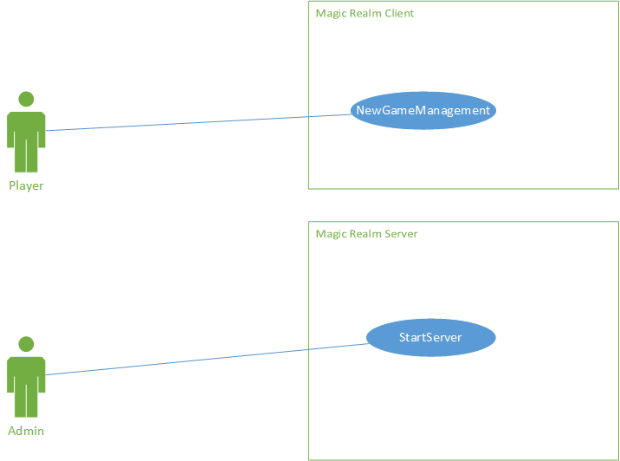

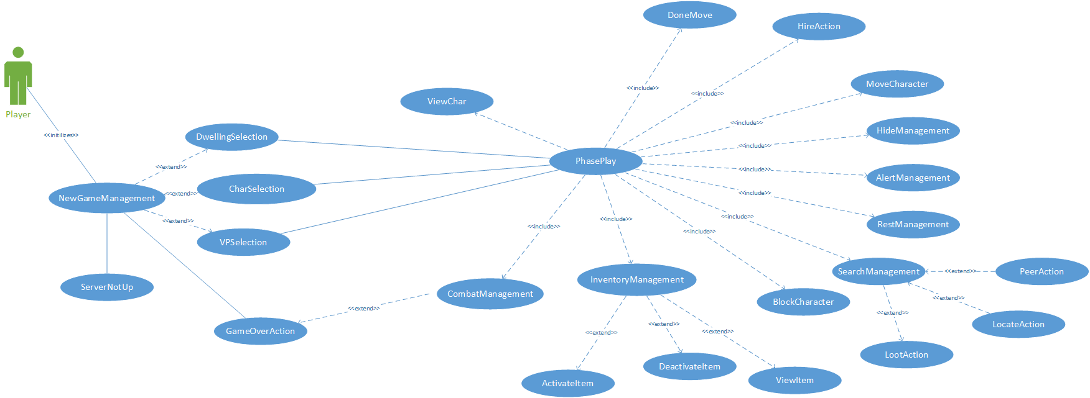

Use Cases Map Responsibilities
Responsibilities descriptions:

TradeManagement
(UC-08)
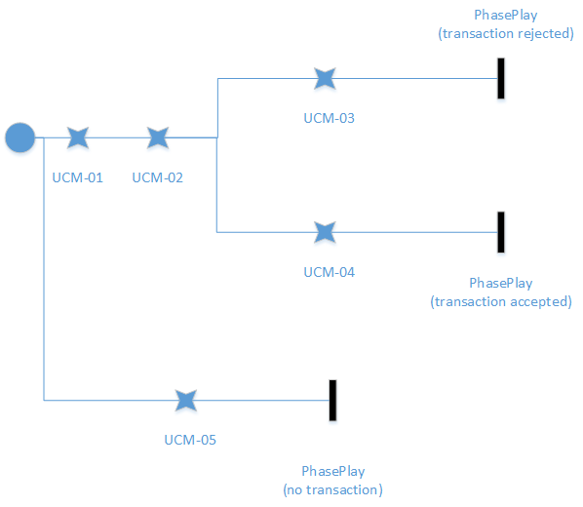
Use Case Map Responsibility | Description
UCM-01 | The user can select a trading party
UCM-02 | Both users their declare offer
UCM-03 | One of the trading parties decline the offer
UCM-04 | Both parties have accepted the offer
UCM-05 | One of the parties have canceled the trade

HideManagement
(UC-06)
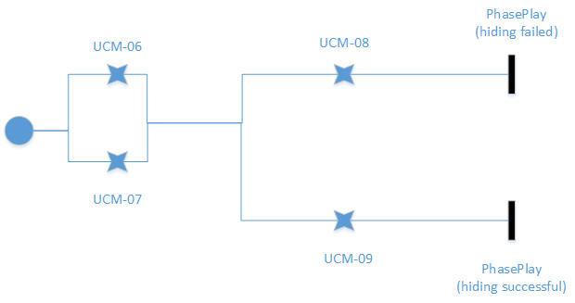
Use Case Map Responsibility | Description

UCM-06 | An internal die is rolled
UCM-07 | If cheat is active, manually set number
UCM-08 | Hide successful
UCM-09 | Hide unsuccessful

MoveCharacter
(UC-11)
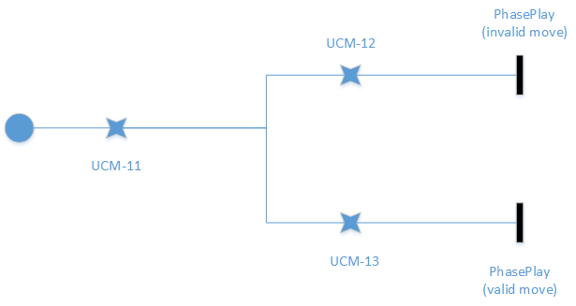
Use Case Map Responsibility | Description

UCM-11 | Check for move restrictions
UCM-12 | If move restrictions apply send error message
UCM-13 | If there are no move restrictions move character

HireAction
(UC-19)
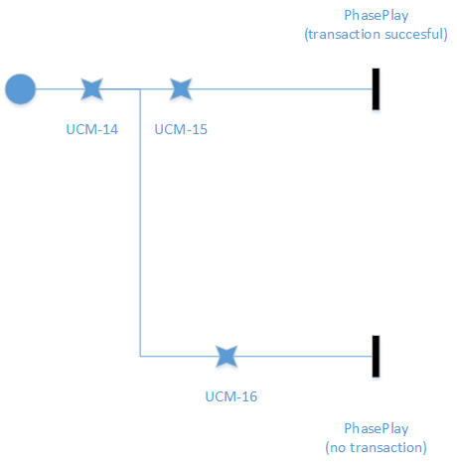
Use Case Map Responsibility | Description

UCM-14 | Check friendly status with all natives
UCM-15 | The player can select natives to hire, and hires natives
UCM-16 | Hire transaction unsuccessful

CombatManagement
(UC-10)
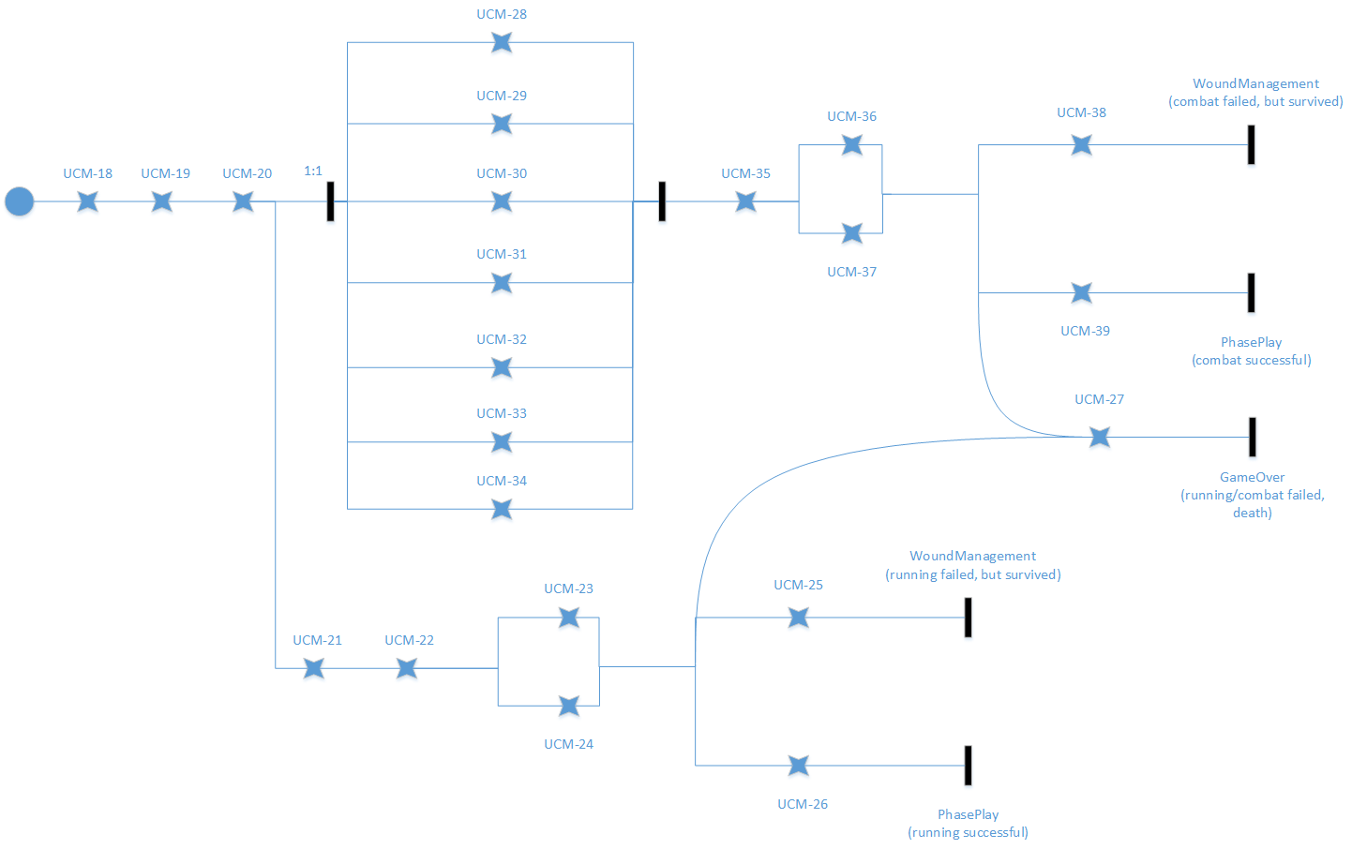
Use Case Map Responsibility | Description

UCM-18 | The game will add enemies
UCM-19 | Add the active inventory
UCM-20 | Apply any special abilities of the character.
UCM-21 | The player chooses to run away
UCM-22 | The player uses a move chit from the active inventory to run away with
UCM-23 | An internal die is rolled for running away
UCM-24 | If cheat mode is on, the value is chosen by the user.
UCM-25 | Running failed, and you are wounded. Lose a chit
UCM-26 | Running away is successful
UCM-27 | You lost all your health

UCM-28 | The player must choose someone to target.
UCM 29 | The player chooses an attack direction
UCM-30 | The player selects a weapon from active inventory
UCM-31 | The player selects a move direction
UCM-32 | The player selects a fight chit from active inventory
UCM-33 | The player selects a move chit from active inventory
UCM-34 | if applicable the player must select the direction the shield will be facing
UCM-35 | The user confirms their actions
UCM-36 | Multiple die are rolled for random aspects such range, attacks, monster attributes etc.
UCM-37 | Cheat mode manually set dice
UCM-38 | You’ve become wounded
UCM-39 | You were unharmed during combat

InventoryManagement
(UC-25)
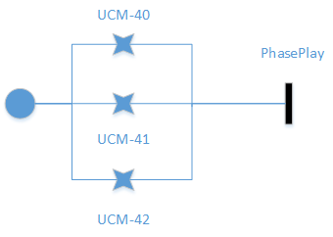
Use Case Map Responsibility | Description

UCM-40 | Take an item from the deactive list to the active list
UCM-41 | Take an item from the active list to the deactive list
UCM-42 | View an item’s details

FollowManagement
(UC-26)
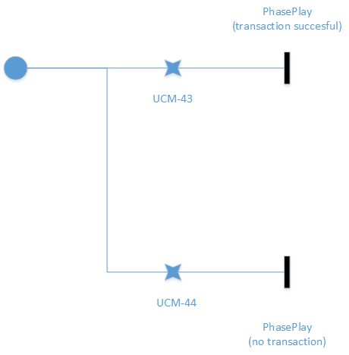
Use Case Map Responsibility | Description

UCM-43 | You have chosen a character to follow
UCM-44 | You have canceled the follow option

RestManagement
(UC-12)
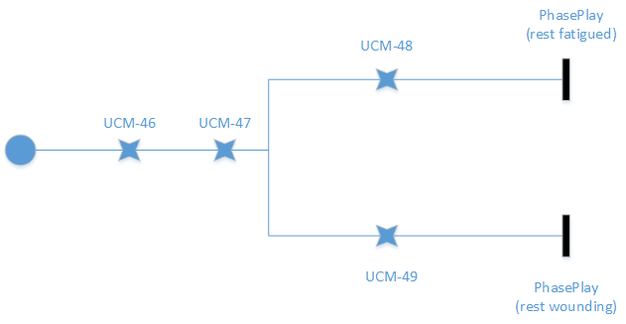
Use Case Map Responsibility | Description

UCM-46 | Add the wounded inventory
UCM-47 | Add the fatigued inventory
UCM-48 | Resting wounded, take them and add to fatigued inventory
UCM-49 | Resting fatigued, take item and add to active inventory

WoundManagement
(UC-13)
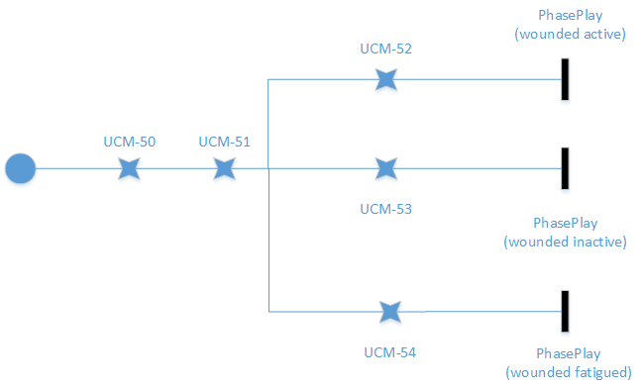
Use Case Map Responsibility | Description

UCM 50 | Gets all inventory list except wounded
UCM-51 | The player selects a chit to be wounded
UCM-52 | The active item selected move to wounded
UCM-53 | The inactive item moves to wounded
UCM-54 | The fatigued item moves to wounded.

SearchManagement
(UC-09)
(UC-15)
(UC-16)
(UC-17)
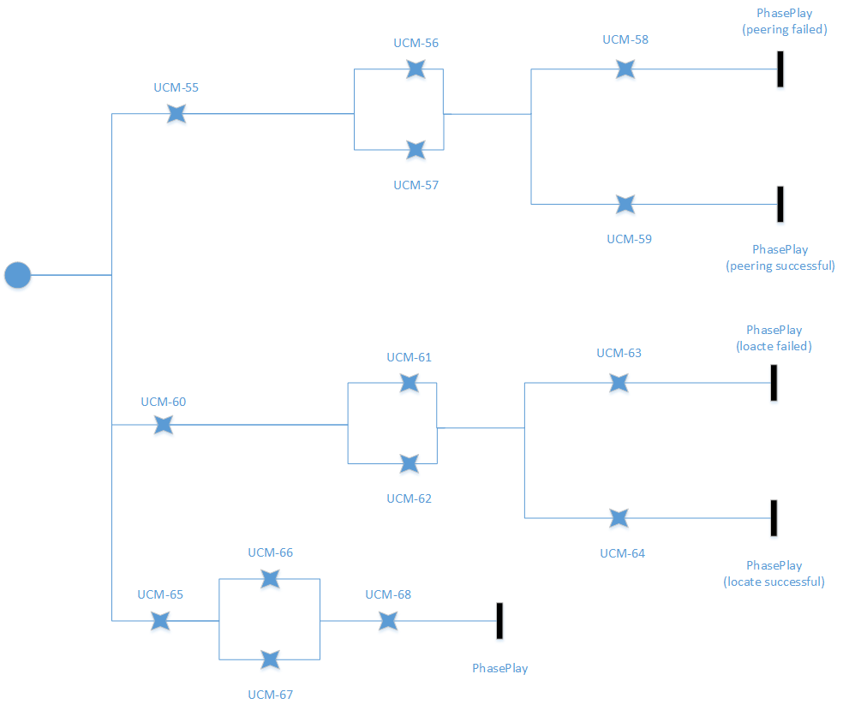
Use Case Map Responsibility | Description

UCM-55 | The player chose peer
UCM-56 | An internal die is rolled
UCM-57 | If cheat mode is on, the player selects their die number
UCM-58 | Peer Unsuccessful
UCM-59 | Peer Successful
UCM-60 | The player selects locate
UCM-61 | An internal die is rolled
UCM-62 | If cheat mode is on, the player selects their die number
UCM-63 | Locate unsuccessful
UCM-64 | Locate successful
UCM-65 | The player selects loot
UCM-66 | If the player is using cheat mode, get the full list of treasures.
UCM-67 | Get list of discovered treasures
UCM-68 | The player selects the treasure he/she wants.

ChatManagement
(UC-27)
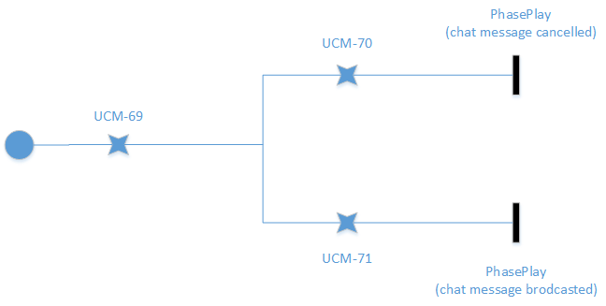
Use Case Map Responsibility | Description

UCM-69 | User types text into chatbox
UCM-70 | User deletes all text in box.
UCM-71 | User confirms the message.

GameOver
(UC-18)
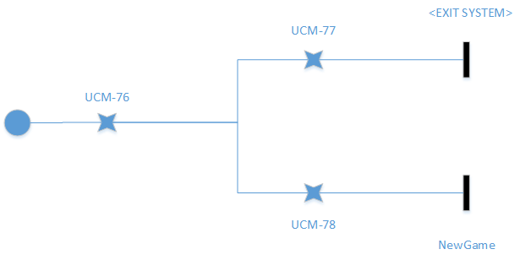
Use Case Map Responsibility | Description

UCM-76 | Player is removed from game
UCM-77 | The user does not want to rejoin/start new game
UCM-78 | Player wants to rejoin/start new game

NewGameManagement
(UC-01)
(UC-02)
(UC-03)
(UC-04)

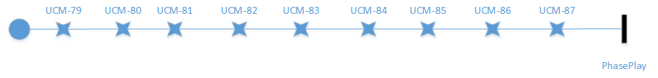
Use Case Map Responsibility | Description

UCM-79 | If available, establish connection with server
UCM-80 | User selects the select character action
UCM-81 | If available player selects character, otherwise display error message
UCM-82 | player selects the dwelling command
UCM-83 | the system checks character information and displays available dwellings
UCM-84 | the player selects a dwelling
UCM-85 | player selects the victory points command
UCM-86 | the player sets his/her own victory points
UCM-87 | The system loads the map screen.

PhasePlay
(UC-05)

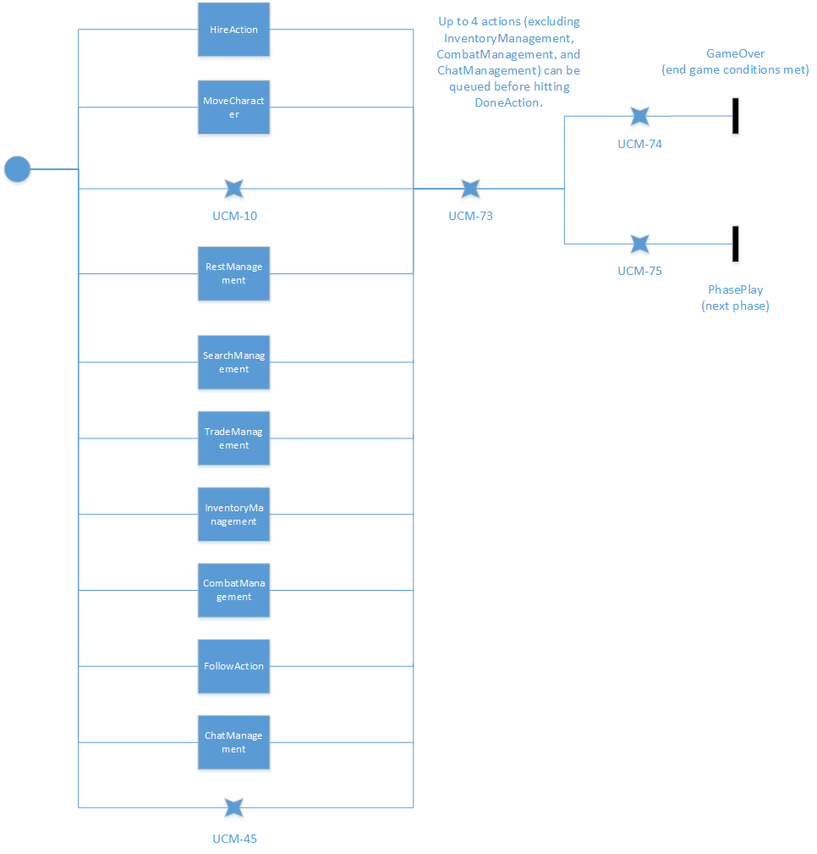
Use Case Map Responsibility | Description

UCM-73 | This ends the players turn
UCM-74 | Either a player has reached their victory condition or the day limit has been reached.
UCM-75 | Day limit has not been reached and no player have earned their victory conditions
UCM-10 | The “Alert” command gets applied to the user.
UCM-45 | The player can view either your own or other’s character.

Why We Chose This Pattern

Our project’s ability to quickly progress is based on the fact that we used the Model-View-Controller pattern. Not only did this pattern allow us to quickly understand where to make changes when we needed to implement something, but sticking to this pattern allowed us to debug without being confused or worried about where the errors where coming from. This saved us time and allowed us to implement more features. The The fewer classes to edit the better. Main components of our front-end design are easily traceable and scoping was never an issue. Our model is a placeholder for all our important game-related variables, the View - the front end of our design, the Controller - sets variables in the model and changes elements in the view and finally, a Server.

Our server holds no variables except for an array list of players connected. This allows for a lightweight and dependable server. If the server crashes, our game would not be able to run and so preserving the simplicity of the server is a priority… we try to maintain the complexity of the game client-side, so each client could come across an error without affecting the server or the other clients. The idea is simply to pass a message around. Things like updating each client whether someone would join or leave in the middle of a game would be left to the clients to do between themselves. The latter was done simply by adding a signature in a list signifying you did not need to be up to speed with the games’ state anymore.

The “client” in this case is a controller. Therefore it and only it is meant to talk to the server. The mathematical complexity of combat, and removing items from clearings are dedicated to it. This allowed for more individual contribution and more recycling of code.

The view is a collection of frames that are used throughout the game’s lifespan. While extremely bulky in file size, this design leaves everything input and output related to the view. This meant that all frames were aware of each other and could communicate and allowed us the luxury of knowing exactly where to find all the gui elements and variables that were gui related.

The variables file we call our model, contains the game’s data that is not strictly related to game functionality, that is, every player’s location, every type of item and their properties, etc.
In conclusion, our design may lack the ability to scale up. Although the current design is speedy enough for our current needs, many classes have been omitted.This was done in order to keep a simple and flexible design we needed. Yet a map generating class and a dice class are the sole perversions to the true model view controller pattern we have in our design. A simple game like Magic Realm needed a more robust pattern.

