CAN COM 10-05
September 2001: English
UIT - Secteur de la normalisation des télécommunications
ITU - Telecommunication Standardization Sector
UIT - Sector de Normalización de las Telecomunicaciones

Commission d'études ) Contribution tardive )
Study Group ) 10 Delayed Contribution ) D.@@
Comisión de Estudio ) Contribución tardia )

Geneva, 6 September - 14 September 2001
Texte disponible seulement en )
Text available only in ) E
Texto disponible solamente en )
________________________________

Question: 12/10
Source*: CANADA
Title: Draft Specification of the Goal-oriented Requirement Language (Z.151)
_________________________

ABSTRACT

The attached document entitled, Draft Recommendation Z.152: Languages for Telecommunication Applications - URN-NFR: Goal-oriented Requirement Language, is the second draft specification of the User Requirements Notation, Non-Functional Requirements (URN-NFR). As suggested in the Ottawa SG 10 meeting (April 2001), this document has been split from the original Z.URN contribution (November 2000). The Goal-oriented Requirement Language (GRL) language, which meets a number of criteria for the required notation specified in the definition of URN, is proposed as the notation for URN-NFR. This document specifies the GRL language, which now includes an improved graphical notation and support for qualitative evaluations.

PROPOSAL

It is proposed that the attached document be used as a starting base document for Question 12.

__________________________________________________________________________________________________

* Contact: - Don Cameron, Tel: +1 613 763 4486
Nortel Networks Corporation Fax: +1 613 763 8080
e-mail: dcameron@nortelnetworks.com

 | TELECOMMUNICATION UNION  TELECOMMUNICATION COM 10-@@-E  STANDARDIZATION SECTOR September 2001  Original: English  STUDY PERIOD 2001-2004

STUDY GROUP 10 - CONTRIBUTION @@

SOURCE *: RAPPORTEUR, QUESTION 12/10
TITLE: DRAFT RECOMMENDATION Z.151: LANGUAGES FOR TELECOMMUNICATION APPLICATIONS — URN-NFR: GOAL-ORIENTED REQUIREMENT LANGUAGE
_________________________

This document contains the specification of the Goal-oriented Requirement Language (GRL), the proposed non-functional requirements notation (URN-NFR) for the draft Recommendation Z.150: User Requirements Notation.

____________________________________________________________________

* Contact: - Don Cameron, Tel: +1 613 763 4486
Nortel Networks Corporation Fax: +1 613 763 8080
e-mail: dcameron@nortelnetworks.com
NEW RECOMMENDATION Z.151: LANGUAGES FOR TELECOMMUNICATIONS APPLICATIONS —
URN-NFR: GOAL-ORIENTED REQUIREMENT LANGUAGE

SUMMARY
Scope-objective
This Recommendation defines the Goal-oriented Requirement Language (GRL) intended for describing Non-Functional Requirements and user non-functional aspects in the User Requirements Notation (URN-NFR). The so-called quality attributes will be handled by this notation while keeping an eye on some functional aspects and their future integration.
Coverage
GRL has concepts for the specification of non-functional requirements. This document presents requirements for URN-NFR, textual and graphical representations of URN-NFR constructs, and an assessment of conformity of the current URN-NFR representations to the requirements for URN.
Applications
URN-NFR is applicable within standard bodies and industry. The main applications areas, which URN-NFR has been designed for are stated in Section 2.8 of Z.150 document, but URN-NFR is generally suitable for describing reactive systems. The range of application is from requirement description to high-level design.
Status/Stability
This Recommendation is a draft reference manual.
The main text is accompanied by the following:
- Annex A GRL Document Type Definition
- Annex B Goal-oriented Requirement Language Tutorial
- Appendix I Tool issues
- Bibliography
- GRL Change Request Form
Associated work
This work is associated with the general URN framework (Z.150), the functional requirements language for URN (Z.152: Use Case Maps Notation — UCM), and relations to other SG 10 languages (Z.153).
Keywords
Goals, non-functional requirements specification, graphical notation, hierarchical decomposition, specification technique, qualitative evaluation.
FOREWORD
ITU (International Telecommunication Union) is the United Nations Specialized Agency in the field of telecommunications. The ITU Telecommunication Standardization Sector (ITU-T) is a permanent organ of the ITU. The ITU-T is responsible for studying technical, operating and tariff questions and issuing Recommendations on them with a view to standardizing telecommunications on a worldwide basis.
The World Telecommunication Standardization Assembly (WTSA) meets every four years to establish the topics for study by the ITU-T Study Groups, which produce Recommendations on these topics.
The approval of Recommendations by the Members of the ITU-T is covered by the procedure laid down in WTSA Resolution No. 1.
In some areas of information technology, which fall within ITU-T’s purview, the necessary standards are prepared on a collaborative basis with ISO and IEC.

NOTE
In this Recommendation the term recognized operating agency (ROA) includes any individual, company, corporation or governmental organization that operates a public correspondence service. The terms Administration, ROA and public correspondence are defined in the Constitution of the ITU (Geneva, 1992).

INTELLECTUAL PROPERTY RIGHTS
The ITU draws attention to the possibility that the practice or implementation of this Recommendation may involve the use of a claimed Intellectual Property Right. The ITU takes no position concerning the evidence, validity or applicability of claimed Intellectual Property Rights, whether asserted by ITU members or others outside of the Recommendation development process.
As of the date of approval of this Recommendation, the ITU had/had not received notice of intellectual property, protected by patents, which may be required to implement this Recommendation. However, implementers are cautioned that this may not represent the latest information and are therefore strongly urged to consult the TSB patent database.

© ITU 2001
All rights reserved. No part of this publication may be reproduced or utilized in any form or by any means, electronic or mechanical, including photocopying and microfilm, without permission in writing from the ITU.
TABLE OF CONTENTS

1 Scope 1
2 References 1
3 Definitions 1
4 Abbreviations and acronyms 1
5 Conventions 1
5.1 BNF grammar definition 1
5.2 Graphical grammar definition 2
5.3 XML definitions 2
6 URN-NFR:Goal-oriented Requirements Language specification 2
7 Element definitions, models, and actors 3
7.1 Non-Intentional Element Definition 3
7.1.1 Textual notation 3
7.1.2 XML definition 4
7.2 Goal model construction 4
7.2.1 Textual notation 4
7.2.2 XML definition 5
7.3 Actors 5
7.3.1 Textual notation 5
7.3.2 Graphical notation 5
7.3.3 XML definition 6
7.3.4 Example 6
8 Intentional elements 7
8.1 Overview 7
8.1.1 Textual notation 7
8.1.2 XML definition 7
8.2 Goal 7
8.2.1 Textual notation 7
8.2.2 Graphical notation 7
8.2.3 XML definition 9
8.2.4 Example 9
8.3 Task 10
8.3.1 Textual notation 10
8.3.2 Graphical notation 10
8.3.3 XML definition 10
8.3.4 Example 10
8.4 Resource 11
8.4.1 Textual notation 11
8.4.2 Graphical notation 11
8.4.3 XML definition 11
8.4.4 Example 11
8.5 Softgoal 11
8.5.1 Textual notation 12
8.5.2 Graphical notation 12
8.5.3 XML definition 12
8.5.4 Example 12
8.6 Belief 13
8.6.1 Textual notation 13
8.6.2 Graphical notation 13
8.6.3 XML definition 13
8.6.4 Example 13
9 Intentional Relationships (Links) 13
9.1 Overview 13
9.1.1 Textual description 14
9.1.2 XML definition 14
9.2 Means-ends Relationship 14
9.2.1 Textual notation 14
9.2.2 Graphical notation 14
9.2.3 XML definition 15
9.2.4 Examples 15
9.3 Decomposition Relationship 16
9.3.1 Textual notation 16
9.3.2 Graphical notation 16
9.3.3 XML definition 17
9.3.4 Example 17
9.4 Contribution Relationship 17
9.4.1 Textual notation 18
9.4.2 Graphical notation 18
9.4.3 XML definition 19
9.4.4 Example 20
9.5 Dependency 20
9.5.1 Textual notation 21
9.5.2 Graphical notation 21
9.5.3 XML definition 22
9.5.4 Example 22
9.6 Correlations 22
9.6.1 Textual notation 22
9.6.2 Graphical notation 23
9.6.3 XML definition 23
9.6.4 Example 23
10 Requirement knowledge base 24
11 Compliance statement 25
Annex A GRL Document Type Definition 26
Annex B Goal-oriented Requirement Language Tutorial 31
Appendix I Tool issues 41
Bibliography 42

ITU-T Draft Recommendation Z.151

Goal-oriented Requirement Language (GRL)

Scope
The document defines and illustrates the Goal-oriented Requirement Language (GRL). It also presents how GRL satisfies the requirements of URN-NFR ((User Requirements Notation — Non-Functional Requirements) the language describing non-functional requirements, as defined in Z.150.

References
The following ITU-T Recommendations and other references contain provisions, which, through reference in this text, constitute provisions of this Recommendation. At the time of publication, the editions indicated were valid. All Recommendations and other references are subject to revision; users of this Recommendation are therefore encouraged to investigate the possibility of applying the most recent edition of the Recommendations and other references listed below. A list of the currently valid ITU-T Recommendations is published regularly.
- ITU-T, Draft Recommendation Z.110, Guidelines on the Use of Description Techniques
- ITU-T, Draft Recommendation Z.150, User Requirements Notation
- ITU-T, Draft Recommendation Z.152, URN-FR: Use Case Map Notation
- ITU-T, Draft Recommendation Z.153, URN: Methodological Approach
- ITU-T, Draft Recommendation Z.160, Quality Aspects of Protocol-related Recommendations
- W3C Recommendation, Extensible Markup Language (XML) 1.0 (Second Edition).

Definitions
This Recommendation uses the terms defined in the Definitions section in Z.150 (clause 3).

Abbreviations and acronyms
This Recommendation uses the abbreviations and acronyms defined in Z.150 (clause 4).

Conventions
The GRL notation is a graphical notation that supports annotations. Each element of the notation has a textual representation, an XML definition, and where applicable a graphical representation.

BNF grammar definition
Note: The convention used here is informal at the moment. ITU-T Study Group 17 is in the process of considering a standard for specifying textual representation of its languages. Once this standard is available, it will be applied to GRL’s textual language.

Graphical grammar definition
Note: The convention used here is informal at the moment. ITU-T Study Group 17 is in the process of considering a standard for specifying the graphical representation of language elements. Once this standard is available, it will be applied to GRL’s graphical elements.

XML definitions
XML (W3C's eXtensible Markup Language) is used for the textual representation of GRL’s elements. The textual representation is contained in a URN-NFR Document Type Definition (DTD). XML DTDs describe the syntax of languages in terms of elements and their attributes. Elements define the document structure by describing containment rules, and attributes describe mandatory and optional variables and their data types for further qualifying elements and references to elements. See Appendix I.1 in Z.150 for a brief tutorial on XML.
XML is an appropriate language for describing the integration of the URN-NFR language with the URN-FR language, as well as layout information when necessary. Also, XML supports a simple evolution path towards the integration of URN with UML through technologies such as OMG's Meta-Object Facility (MOF) and XML Metadata Interchange (XMI).
URN-NFR DTD elements and attributes will be described inside shaded boxes using the Courier font. XML elements use lowercase characters (element) whereas XML attributes are in lowercase-italic (attribute) and XML keywords are in uppercase-bold (KEYWORD).

URN-NFR:Goal-oriented Requirements Language specification
The URN-NFR language specified here is GRL (Goal-oriented Requirement Language), which is a language for supporting goal-oriented modelling and reasoning of requirements, especially for dealing with non-functional requirements. It provides constructs for expressing various types of concepts that appear during the requirement process. There are three main categories of concepts: actors, intentional elements, and links. The intentional elements in GRL are goal, task, softgoal, resource and belief. They are intentional because they are used for models that allow answering questions such as why particular behaviours, informational and structural aspects were chosen to be included in the system requirement, what alternatives were considered, what criteria were used to deliberate among alternative options, and what the reasons were for choosing one alternative over the other.
This kind of modelling is different from the detailed specification of what is to be done. Here the modeller is primarily concerned with exposing "why" certain choices for behaviour and/or structure were made or constraints introduced. The modeller is not yet interested in the "operational" details of processes or system requirements (or component interactions). Omitting these kind of details during early phases of analysis (and design) allows taking a higher level (sometimes called a strategic stance) towards modelling the current or the future software system and its embedding environment. Modelling and answering "why" questions leads us to consider the opportunities stakeholders seek out and/or vulnerabilities they try to avoid within their environment by utilising capabilities of the software system and/or other stakeholders, by trying to rely upon and/or assign capabilities and by introducing constraint how those capabilities ought to be performed.
URN-NFR/GRL provides support for reasoning about scenarios by establishing correspondences between intentional GRL elements and non-intentional elements in scenario models of URN-FR. Modelling both goals and scenarios is complementary and may aid in identifying further goals and additional scenarios (and scenario steps) important to stakeholders, thus contributing to the completeness and accuracy of requirements.
An NFR has a type, e.g. Safety, and a topic to which this NFR applies, e.g. Room (in such a case as a light control software), meaning that a room must be safe. In GRL, non-functional requirements are faced as softgoals. Each softgoal will be decomposed into sub-goals represented by a graph structure inspired by the and/or trees used in problem solving. This process continues until the requirements engineer considers the goal satisficed (also referred as operationalized), so these satisficing goals can be faced as operationalizations of the NFR

Element definitions, models, and actors

Non-Intentional Element Definition
The language provides syntax for defining non-intentional elements. A non-intentional element may be imported from an external model. The main concern of these clauses is not to capture the syntax and semantics of the external model but to serves as references to the external model only. Non-intentional elements definition is used to navigate through the non-intentional model. The following statement defines a non-intentional element.
ELEMENT <Element name> [<Informal Textual Description>]
[IS <External Type><External Name> FROM <Model Type><Model Name>]

Textual notation
<GRL Specification> ::=
[<Non-Intentional Element Definitions>]
<Goal Model Definition>
<Non-Intentional Element Definitions>::=
< Element Definition> { < Element Definition> }₀ ^{n}
<Element Definition> : :=
ELEMENT <Element Name>
[<Informal Textual Description>]
[IS <External Type><External Name>
FROM <Model Type><Model Name>]
<Model Type> ::= URN-FR | UML | SDL | <Model Type Name>

XML definition
<!ELEMENT nfr-definitions (element-definitions, device-directory?,
data-store-directory?)>

<!ELEMENT urn-nfr-spec (grl-spec)>

<!ELEMENT grl-spec (goal-model)>

<!ELEMENT element-definitions (element)* >

<!ELEMENT element (model-type?, model-name?, external-type?,
external-name?) >

<!ATTLIST element
element-id ID #REQUIRED
name CDATA #IMPLIED
description CDATA #IMPLIED>

<!ELEMENT model-name EMPTY >

<!ATTLIST model-name
model-id ID #REQUIRED
name CDATA #IMPLIED
description CDATA #IMPLIED
type IDREF #IMPLIED >

<!ELEMENT model-type EMPTY >

<!ATTLIST model-type
id ID #REQUIRED
name CDATA #IMPLIED
description CDATA #IMPLIED>

<!ELEMENT external-type EMPTY >

<!ATTLIST external-type
id ID #REQUIRED
name CDATA #IMPLIED
description CDATA #IMPLIED>

<!ELEMENT external-name EMPTY >

<!ATTLIST external-name
id ID #REQUIRED
name CDATA #IMPLIED
description CDATA #IMPLIED
type IDREF #IMPLIED >

Goal model construction
A Goal-Oriented Requirement Model named <Model Name> can either be composed of a global goal model, or a series of goal models distributed in several actors.
If the model includes more than one actors, then there might exist <Dependency Series>, which represent the intentional dependency relationships between agents.

Textual notation
<GRL Model Definition>::=
GRL-MODEL <Model Name>
<Model Constructors>
END-GRL-MODEL.

<Model Constructors>::= <Model Constructor> { <Model Constructor>}₀ ^{n}
<Model Constructor>::=
[<Actors>]
<Intentional Elements>
<Intentional Relationships>

XML definition
<!ELEMENT goal-model (model-constructors)>

<!ATTLIST goal-model
goal-model-id ID #REQUIRED
goal-model-name CDATA #IMPLIED
description CDATA #IMPLIED >

<!ELEMENT model-constructors (model-constructor)+ >

<!ELEMENT model-constructor (actors?, intentional-elements,
intentional-relationships ) >

Actors
An actor statement defines an actor and its attributes.
ACTOR <Actor Name> <Actor Description> [<Attributes>]
An actor is an active entity that carries out actions to achieve goals by exercising its know-how. Graphically, an actor may optionally have a boundary, with intentional elements inside.

Textual notation
<Actors>::= <Actor > { <Actor>}₀ ^{n}
<Actor>::= ACTOR <Actor Name> [<Informal Textual Description>]
[ ATTRIBUTE <Attributes>]

Graphical notation
<Actor> : :=
<Actor Symbol>
CONTAINS <Actor Name>
[IS ASSOCIATED WITH
<Actor Boundary Symbol>
CONTAINS<Intentional Elements > <Intentional Links>]
<Actor Symbol> ::=


<Actor Boundary Symbol>::=

XML definition
<!ELEMENT actors (actor)+ >

<!ELEMENT actor (attributes?)>

<!ATTLIST actor
actor-id ID #REQUIRED
actor-name CDATA #IMPLIED
description CDATA #IMPLIED>

Example
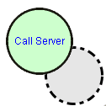
Actors are shown as a circle with the name of the actor inside in graphical representations. The boundary of an actor is shown as a grey shadow with the actor icon inside or nearby. For example, within a VoiceLAN environment, an actor “Call Server” on the LAN provides the call control functionality normally provided by a PBX. Figure 1./Z.151 is an example of actor structure.
In the component base, each intentional element has an attribute named as “HOLDER” by default:
… …
HOLDER: <Actor Name>
… …
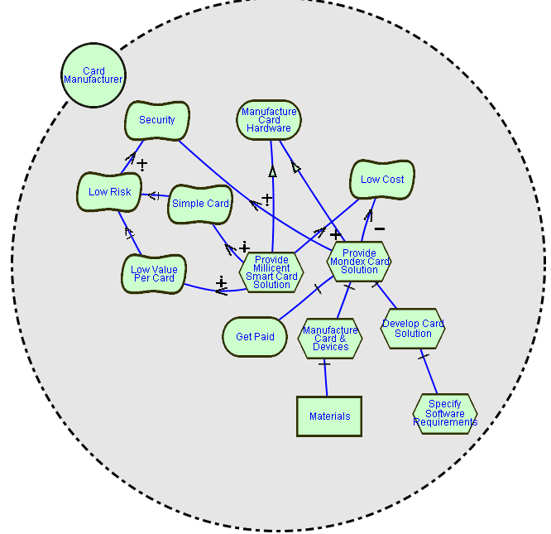
- Actor with intentional elements and links

Intentional elements

Overview
An intentional element can be a task, a goal, a resource, a softgoal, or a belief.

Textual notation
< Intentional Elements>::= < Intentional element > { < Intentional element >}₀ ^{n}
< Intentional element> ::= <Task> | <Goal> | <Resource> | <Softgoal> | <Belief>

XML definition
<!ELEMENT intentional-elements (intentional-element)+ >

<!ELEMENT intentional-element (goal | softgoal | task | resource | belief)>

Goal
A goal is a condition or state of affairs in the world that the stakeholders would like to achieve. How the goal is to be achieved is not specified, allowing alternatives to be considered.
A goal can be either a business goal or a system goal. A business goal express goals regarding the business or state of the business affairs the individual or organisation wishes to achieve. System goal expresses goals the target system should achieve, which, generally, describe the functional requirements of the target information system.

Textual notation
<Goal> ::= GOAL<Goal Name> [<Informal Textual Description>]
[ HAS <Criticality> PRIORITY]
[ IS EVALUATED AS <Evaluation Label>]
[ ATTRIBUTE <Attributes>]
[HOLDER <Actor Name>]
<Attributes > ::= <Attribute > { “,”<Attribute >}₀ ^{n}
<Attribute> ::= <Attribute Name> “:” <Attribute Value>
<Attribute Value> ::= <Element Name> | <Expressions>
<Criticality> = Open | Critical
<Evaluation Label> = Satisficed | Denied | WeaklySatisficed | WeaklyDenied | Undecided | Conflict

Graphical notation
In the Graphical notation, the following keywords are used to denote specific graphical meanings:
- CONTAINS: indicates that its right-hand argument should be placed within its left-hand argument.
- IS CONNECTED TO… BY: means that its right-hand argument is connected to its left-hand argument by the kind of link type referred to by the argument after keyword “BY”.
- IS ASSOCIATED WITH indicates that its right-hand argument should be positioned next to its left-hand argument.

< Goal > : := < Goal Symbol>
CONTAINS < Goal Name > [ “[” <Parameters> “]” ]
[ IS ASSOCIATED WITH <Criticality Symbol > ]
[ IS ASSOCIATED WITH <Evaluation Symbol > ]
< Goal Symbol> : :=

<Criticality Symbol > : := O | X
<Evaluation Symbol >: :=

Satisficed Weakly Satisficed Denied Weakly Denied
Conflict Undecided

XML definition
<!ELEMENT goal (attributes?, criticality?, evaluation-label?, actor-ref?)>

<!ATTLIST goal
goal-id ID #REQUIRED
goal-name CDATA #IMPLIED
description CDATA #IMPLIED>

<!ELEMENT criticality EMPTY>

<!ATTLIST criticality
criticality-type (open |
critical) #REQUIRED>

<!ELEMENT evaluation-label EMPTY>

<!ATTLIST evaluation-label
label-type (satisficed |
denied |
weakly-satisficed |
weakly-denied |
undecided |
conflict) #REQUIRED>

<!ELEMENT actor-ref EMPTY>

<!ATTLIST actor-ref
actor-id-ref IDREF #REQUIRED>

<!ELEMENT attributes (attribute)*>

<!ELEMENT attribute EMPTY>

<!ATTLIST attribute
attribute-name CDATA #REQUIRED
element-id-ref IDREF #REQUIRED>

Example
A goal is shown as rounded rectangle. For example, “Voice Connection Be Setup” is one basic goal to be achieved with any telecommunication system, especially for those incoming calls considered as urgent. How a voice connection is to be set up (such as how reliable, over what medium) – may be done differently by each telecommunication provider.
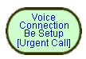
In textual description, this goal would be defined with following statement:
GOAL VoiceConnectionBeSetup
ATTRIBUTE
Object: UrgentCall
Time-constrain: “in 1 minute”
HOLDER IncomingCallServiceProvider

Task
A task specifies a particular way of doing something. When a task is specified as a sub-component of a (higher-level) task, this restricts the higher-level task to that particular course of action.
Tasks can also be seen as the solutions in the target system, which will address goals and softgoals (called operationalizations in NFR). These solutions provide operations, processes, data representations, structuring, constraints and agents in the target system to meet the needs stated in the goals and softgoals.

Textual notation
<Task> ::= TASK<Task Name> [<Informal Textual Description>] [ATTRIBUTE <Attributes>]
[ HAS <Criticality> PRIORITY]
[ IS EVALUATED AS <Evaluation Label>]
[HOLDER <Actor Name>]

Graphical notation
< Task > : := < Task Symbol>
CONTAINS < Task Name > [ “[” <Parameters> “]” ]
[ IS ASSOCIATED WITH <Criticality Symbol > ]
[ IS ASSOCIATED WITH <Evaluation Symbol > ]
< Task Symbol> : :=


XML definition
<!ELEMENT task (attributes?, criticality?, evaluation-label?, actor-ref?)>

<!ATTLIST task
task-id ID #REQUIRED
task-name CDATA #IMPLIED
description CDATA #IMPLIED>

Example
A task is shown as a hexagon. Make Voice-over-LAN is one particular way of setting up a voice connection for incoming call.
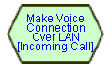
In textual description, this task would be defined with following statement:
TASK MakeVoiceConnectionOverLAN
ATTRIBUTE
Object: IncomingCall
HOLDER IncomingCallServiceProvider

Resource
A resource is an (physical or informational) entity, with which the main concern is whether it is available.

Textual notation
<Resource> ::= RESOURCE <Resource Name> [<Informal Textual Description>] [<Attributes>]
[ HAS <Criticality> PRIORITY]
[ IS EVALUATED AS <Evaluation Label>]
[HOLDER <Actor Name>]

Graphical notation
<Resource> : :=< Resource Symbol>
CONTAINS < Resource Name > [ “[” <Parameters> “]” ]
[ IS ASSOCIATED WITH <Criticality Symbol > ]
[ IS ASSOCIATED WITH <Evaluation Symbol > ]
<Resource Symbol>::=


XML definition
<!ELEMENT resource (attributes?, criticality?, evaluation-label?,
actor-ref?)>

<!ATTLIST resource
resource-id ID #REQUIRED
resource-name CDATA #IMPLIED
description CDATA #IMPLIED >

Example
Resources are shown as rectangles. In the voice-on-the-LAN architecture, bandwidth is a resource that must be available.
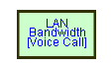
In textual description, this resource would be defined with following statement:
RESOURCE LANBandwidth
ATTRIBUTE
Object: VoiceCall
HOLDER IncomingCallServiceProvider

Softgoal
A softgoal is a condition or state of affairs in the world that the actor would like to achieve, but unlike in the concept of (hard) goal, there are no clear-cut criteria for whether the condition is achieved, and it is up to subjective judgement and interpretation of the developer to judge whether a particular state of affairs in fact achieves sufficiently the stated softgoal.

Textual notation
<Softgoal> ::= SOFTGOAL [<Softgoal Name> IS]
<Softgoal Type Name> [OF <Softgoal Topic> ]
[<Informal Textual Description>]
[ HAS <Criticality> PRIORITY]
[ IS EVALUATED AS <Evaluation Label>]
[ATTRIBUTE<Attributes>]
[HOLDER <Actor Name>]
<Softgoal Topic> ::= <Element Name>

Graphical notation
<Softgoal>::=< Softgoal Symbol>
CONTAINS <Softgoal Name> [OF <Softgoal Topic>] [ “[” <Parameters> “]” ]
[ IS ASSOCIATED WITH <Criticality Symbol > ]
[ IS ASSOCIATED WITH <Evaluation Symbol > ]
<Softgoal Symbol> : :=


XML definition
<!ELEMENT softgoal (attributes?, criticality?, evaluation-label?,
actor-ref?)>

<!ATTLIST softgoal
softgoal-id ID #REQUIRED
softgoal-name CDATA #IMPLIED
description CDATA #IMPLIED>

Example
A softgoal, which is “soft” in nature, is shown as an irregular curvilinear shape. For instance, performance of router is a softgoal to be achieved during the design of a telecom system.
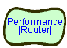
In textual description, this softgoal would be defined with following statement:
SOFTGOAL Performance OF Router
ATTRIBUTE
Transmission-delay: “less than 10ms”
Response-time: “<= 0.5 s”
HOLDER IncomingCallServiceProvider
or
SOFTGOAL Performance
ATTRIBUTE
Object: Router
Transmission-delay: “less than 10ms”
Response-time: “<= 0.5 s”
HOLDER IncomingCallServiceProvider

Belief
Beliefs are used to represent design rationale. Beliefs make it possible for domain characteristics to be considered and properly reflected into the decision making process, hence facilitating later review, justification and change of the system, as well as enhancing traceability.

Textual notation
<Belief> ::= BELIEF <Belief Name> [<Informal Textual Description>] [ATTRIBUTE <Attributes>]
[HOLDER <Actor Name>]

Graphical notation
<Belief>::=< Belief Symbol>
CONTAINS < Belief Name> [ “[” <Parameters> “]” ]
<Belief Symbol> : :=

XML definition
<!ELEMENT belief (attributes?, actor-ref?)>

<!ATTLIST belief
belief-id ID #REQUIRED
belief-name CDATA #IMPLIED
description CDATA #IMPLIED>

Example
A belief is shown as an ellipse. In the following is an argument supporting that the task of VoiceLAN is lowering costs.

Convergence of media reduces cost of ownership [Voice Call, LAN]

Intentional Relationships (Links)

Overview
Each model structure is a link connecting two elements. These structures together constitute the overall goal model. So they are seen as the basic building blocks of models.

Textual description
<Intentional Relationships>::= < Intentional relationship > { < Intentional relationship>}₀ ^{n}
< Intentional relationship>::= <Decomposition> | <Means-ends >
| <Contribution > | <Correlation >
| <Dependency>

XML definition
<!ELEMENT intentional-relationships (intentional-relationship)+ >

<!ELEMENT intentional-relationship (means-ends
|decomposition
|contribution
|correlation
|dependency)>

Means-ends Relationship
GRL uses the MEANS-END statement to describe how goals are in fact achieved. Each task provided is an alternative means for achieving the goal. Normally, each task would have different types of impacts on softgoals, which would serve as criteria for evaluating and choosing among each task alternative.
MEANS-END < Means-Ends Identifier > FROM <Means element name> TO <Ends element name>
Graphically, a means-ends link connects an end node with the means node achieving it. In GRL, only goals are originally applicable to means-ends links. See Figure 2./Z.151 as an example. However, for convenience, in short hand forms for a combined structure, tasks and resources could also be connected by means-ends links.
A Task Means_Ends Structure connects a task with the means (tasks) to achieve it directly, which is a short hand form of one Task Decomposition Structure and the related Goal Means_Ends Structure. See Figure 3./Z.151 as an example.
A Resource Means_Ends Structure connects a resource with the means (tasks) to make it available, which is a short hand form of one <softgoal Contribution Structure>. See Figure 4./Z.151 as an example.

Textual notation
<Means-Ends> ::= MEANS-ENDS [<Means-Ends Identifier>]
FROM <Means Element > TO <End Element >
<End Element> ::= <Goal Reference> | <Task Reference> | <Resource Reference>
<Resource Reference> ::= RESOURCE <Resource Name>
<Means Element> ::= <Task Reference>
<Task Reference> ::= TASK <Task Name>
<Goal Reference>::= GOAL <Goal Name>
<Resource Reference> ::= RESOURCE <Resource Name>

Graphical notation
<Means-Ends> : :=
<Means Element>
{IS CONNECTED TO]<End Element>
BY < Means-Ends Link >}₀ ^{n}
<Means-Ends Link > : :=

XML definition
<!ELEMENT means-ends (means-element, end-element)>

<!ATTLIST means-ends
means-ends-id ID #REQUIRED>

<!ELEMENT means-element (task-ref)>

<!ELEMENT end-element (goal-ref | task-ref | resource-ref)>

Examples

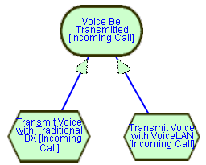
- Goal means-ends structure

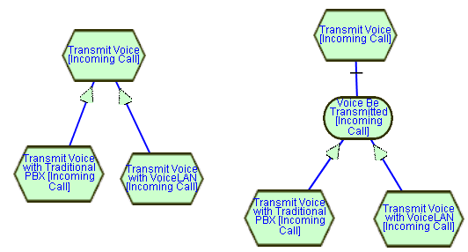
- Task means-ends structure

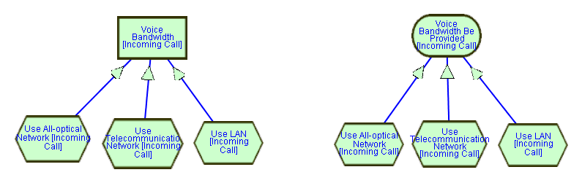
- Resource means-ends structure

Decomposition Relationship
The GRL DECOMPOSITON statement provides the ability to define what other elements need to be achieved or available in order for a task to perform.
DECOMPOSITION <Decomposition Identifier> FROM <sub-element >
TO < Decomposed Element >
Graphically, a decomposition link connects a node with its sub-components. In GRL, only tasks are originally decomposable, but for convenience, in short hand forms for a combined structure goals could also be connected by decomposition links. The sub-components of a task can be goal, task, resource, and softgoal.
A Task Decomposition Structure shows the essential components of a task, which include subtasks that must be performed, subgoals that must be achieved, resources that must be accessible, and softgoals that must be satisfied. See Figure 5./Z.151 as an example.
A Goal Decomposition Structure connects a goal with its sub-goals directly, which is a short hand form of one Goal Means_Ends Structure and the related Task Decomposition Structure. See Figure 6./Z.151 as an example.

Textual notation
<Decomposition> ::= DECOMPOSITION [<Decomposition Identifier> ]
FROM < Sub-Element > TO <Decomposed Element >
<Decomposed Element> ::= <Task Reference> | <Goal Reference>
<Sub-Element> ::= <Task Reference>
| <Goal Reference>
| <Resource Reference>
| <Softgoal Reference>

Graphical notation
<Decomposition> : :=
< Decomposed Element >
{IS CONNECTED TO < Sub-Element >
BY < Decomposition Link >}₀ ^{n}
<Decomposition Link> : :=

XML definition
<!ELEMENT decomposition (decomposed-element, sub-element)>

<!ATTLIST decomposition
decomposition-id ID #REQUIRED>

<!ELEMENT decomposed-element (task-ref | goal-ref)>

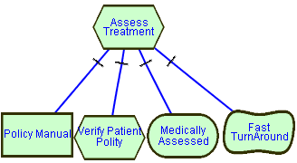
<!ELEMENT sub-element (goal-ref | task-ref | resource-ref | softgoal-ref)>

Example
- Task decomposition structure
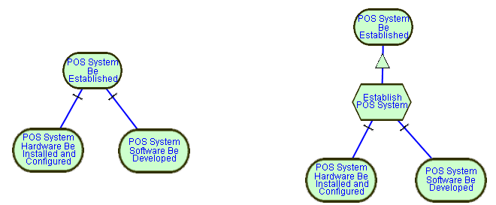
- Goal decomposition structure

Contribution Relationship
The CONTRIBUTION relationship statement describes how softgoals, task, believes, or links contribute to others. A contribution is an effect that is a primary desire during modelling.

CONTRIBUTION [<Contribution Identifier > IS]
<Contributor> HAS <Contribution type> CONTRIBUTION-TO <Contributee>

Graphically, a contribution link describes how one intentional element contributes to the satisficing of another intentional element.
- AND contribution: The relations between the contributing elements are “AND”. Each of the sub-components is positive and necessary.
- OR contribution: The relations between the contributing elements are “OR”. Each of the sub-components is positive and sufficient.
- MAKE contribution: The contribution of the contributing element is positive and sufficient.
- BREAK contribution: The contribution of the contributing element is negative and sufficient.
- HELP contribution: The contribution of the contributing element is positive but not sufficient.
- HURT contribution: The contribution of the contributing element is negative but not sufficient.
- SOME+ contribution: The contribution is positive, but the extent of the contribution is unknown.
- SOME- contribution: The contribution is negative, but the extent of the contribution is unknown.
- EQUAL contribution: There is equal contribution in both directions.
- UNKNOWN contribution: There is some contribution, but the extent and the sense (positive or negative) of the contribution is unknown.
A Softgoal Contribution Structure shows the contributions of softgoals or tasks towards a softgoal. See Figure 7./Z.151 as an example.
An argumentation structure could attach a belief to any link or node of a model, which denotes the contribution of a belief node to the link or node it attached to, and give some argument for future review and justification. See Figure 8./Z.151 as an example.

Textual notation
<Contribution> ::= CONTRIBUTION [<Contribution Identifier> IS]
<Contributors> HAS <Contribution type> CONTRIBUTION-TO <Contributee>
<Contributors>::= <Contributor > {“,” <Contributor>}₀ ^{n}
<Contributee > ::= <Softgoal Reference> | <Link Reference> |<Belief Reference>
<Contributor > ::= <Softgoal Reference> | <Task Reference>
| <Link Reference> | <Belief Reference>
<Softgoal Reference> ::= SOFTGOAL <Softgoal Name>
<Belief Reference>::= BELIEF <Belief Name>
<Link Reference> ::= <Decomposition link Reference> | <Means-ends link Reference>
| <Contribution link Reference> | <Correlation link Reference>
| <Dependency link Reference>
<Decomposition link Reference> ::= DECOMPOSITION-LINK< Decomposition Identifier >
<Means-ends link Reference> ::= MEANS-ENDS-LINK <Means-Ends Identifier>
<Contribution link Reference> ::= CONTRIBUTION-LINK <Contribution Identifier>
<Correlation link Reference> ::= CORRELATION-LINK <Correlation Identifier>
<Dependency link Reference> ::= DEPENDENCY-LINK <Dependency Identifier>
< Contribution Type> ::= Break | Hurt | Some- | Unknown | Equal
| Some+ | Help | Make | And | Or

Graphical notation
< Contribution> : :=
<Contributee Element>
{IS CONNECTED TO <Contributor Element>
BY < Contribution Link >}₀ ^{n}
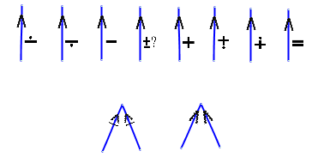
<Contribution Link> : :=
BREAK HURT SOME⁻ UNKNOWN SOME⁺ HELP MAKE EQUAL
AND OR

XML definition
<!ELEMENT contribution (contributee, contributor, contribution-type)>

<!ATTLIST contribution
contribution-id ID #REQUIRED>

<!ELEMENT contributee (softgoal-ref | belief-ref | link-ref)>

<!ELEMENT contributor (task-ref | softgoal-ref| belief-ref | link-ref)>

<!ELEMENT contribution-type EMPTY>

<!ATTLIST contribution-type
contri-type (break |
hurt |
some-negative |
unknown |
equal |
some-positive |
help |
make |
and |
or) #REQUIRED>

<!ELEMENT goal-ref EMPTY>
<!ATTLIST goal-ref
goal-id-ref IDREF #REQUIRED>

<!ELEMENT softgoal-ref EMPTY>
<!ATTLIST softgoal-ref
softgoal-id-ref IDREF #REQUIRED>

<!ELEMENT task-ref EMPTY>
<!ATTLIST task-ref
task-id-ref IDREF #REQUIRED>

<!ELEMENT resource-ref EMPTY>
<!ATTLIST resource-ref
resource-id-ref IDREF #REQUIRED>

<!ELEMENT belief-ref EMPTY>
<!ATTLIST belief-ref
belief-id-ref IDREF #REQUIRED>

<!ELEMENT link-ref (means-ends-ref | decomposition-ref
| contribution-ref | correlation-ref
| dependency-ref)>

<!ELEMENT means-ends-ref EMPTY>
<!ATTLIST means-ends-ref
means-ends-id-ref IDREF #REQUIRED>

<!ELEMENT decomposition-ref EMPTY>
<!ATTLIST decomposition-ref
decomposition-id-ref IDREF #REQUIRED>

<!ELEMENT contribution-ref EMPTY>
<!ATTLIST contribution-ref
contribution-link-id-ref IDREF #REQUIRED>

<!ELEMENT correlation-ref EMPTY>
<!ATTLIST correlation-ref
correlation-link-id-ref IDREF #REQUIRED>

<!ELEMENT dependency-ref EMPTY>
<!ATTLIST dependency-ref
dependency-id-ref IDREF #REQUIRED>

Example
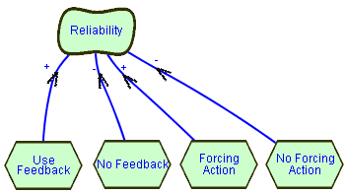
- Softgoal contribution structure
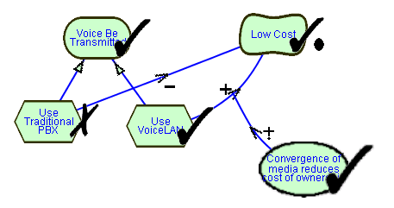
- Argumentation structure and evaluation labels

Dependency
The Dependency statement of GRL describes an intentional relationship between two actors, i.e., one actor (<Depender>) depends on another actor (<Dependee>) on something (<Dependum>).
DEPENDENCY [<Dependency Identifier>] <Depender> DEPENDES-ON <Dependee> FOR <Dependum>

A dependency link connects (an intentional element of) the depender actor with (the intentional element of) another actor it depends on.

Textual notation
<Dependency> ::= DEPENDENCY [<Dependency Identifier> IS]
<Depender> DEPENDES-ON <Dependee> FOR <Dependum>

<Depender> : := DEPENDER <Actor Name> [“.”<Sub-Element>]

<Dependee> : := DEPENDEE <Actor Name> [“.” <Sub-Element >]

<Dependum> : := DEPENDUM <Sub-Element>

Graphical notation
<Dependency Link> : :=
<Depender> IS CONNECTED TO <Dependum>
IS CONNECTED TO <Dependee>
BY <Dependency Link>
[IS ASSOCIATED WITH <Criticality Symbol > ]

<Depender> : := <Actor > | <Intentional element>

<Dependee> : := <Actor > | <Intentional element>

<Dependum> : := <Intentional element>

<Dependency Link> : :=

XML definition
<!ELEMENT dependency (depender, dependum, dependee)>
<!ATTLIST dependency
dependency-id ID #REQUIRED>

<!ELEMENT depender
(goal-ref | softgoal-ref | task-ref | resource-ref)?>
<!ATTLIST depender
actor-id-ref IDREF #REQUIRED>

<!ELEMENT dependum
(goal-ref | softgoal-ref | task-ref | resource-ref)>

<!ELEMENT dependee
(goal-ref | softgoal-ref | task-ref | resource-ref)?>
<!ATTLIST dependee
actor-id-ref IDREF #REQUIRED>

Example
In Figure 9./Z.151 , a model composed of many actors, and with dependencies is shown. With this kind of model, the intentional relationships between actors can be better captured and analyzed. There are altogether four types of dependencies, which permit different degree of freedom for the depended actor to make decision.
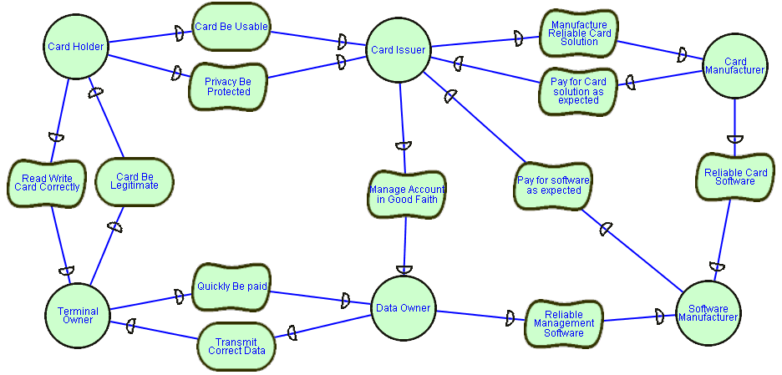
- A model composed of many actors and their dependencies

Correlations
Correlations allow for expressing knowledge about interactions between intentional elements in different categories, and to encode such knowledge. A correlation link is the same as a contribution link except that the contribution is not an explicit desire, but is a side effect. This type of relationship is captured by a CORRELATION statement, which is defined as follows:

CORRELATION <Correlation Identifier> IS
<Correlator > HAS <Correlation Type> CONTRIBUTION-TO <Correlatee>

The effect of all incoming correlation links on a softgoal may need to be evaluated by the user on a case-by-case basis.

Textual notation
<Correlation> ::= CORRELATION [<Correlation Identifier> IS]
<Correlator > HAS <Correlation Type> CONTRIBUTION-TO <Correlatee>
<Correlatee> ::= <Softgoal Reference>
<Correlator> ::= <Softgoal Reference> | <Task Reference>
<Correlation Type> ::= Break | Hurt | Some- | Some+ | Help | Make | Equal

Graphical notation
<Correlation> : :=
<Correlatee> IS CONNECTED TO <Correlator>
BY <Correlation Link>

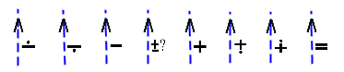
<Correlation Link> : :=
BREAK HURT SOME- UNKNOWN SOME+ HELP MAKE EQUAL

XML definition
<!ELEMENT correlation (correlatee, correlator, correlation-type)>

<!ATTLIST correlation
correlation-id ID #REQUIRED>

<!ELEMENT correlatee (softgoal-ref)>

<!ELEMENT correlator (task-ref | softgoal-ref)>

<!ELEMENT correlation-type EMPTY>

<!ATTLIST correlation-type
correlation-type (break |
hurt |
some-negative |
unknown |
some-positive |
help |
make |
equal) #REQUIRED>

Example
In Figure 10./Z.151 , a model of basic model structure is given, which is made up of one softgoal structure, it can also made up of several model structures. Each of these structures is a category of requirement. They interact through <Correlation Structure Series>. See Figure 11./Z.151 as an example.

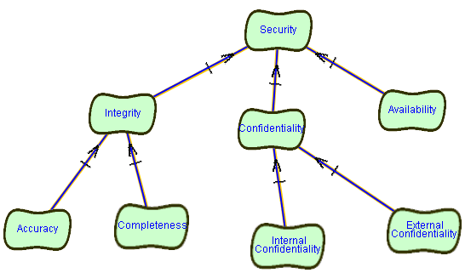
- A Model composed of basic model structure

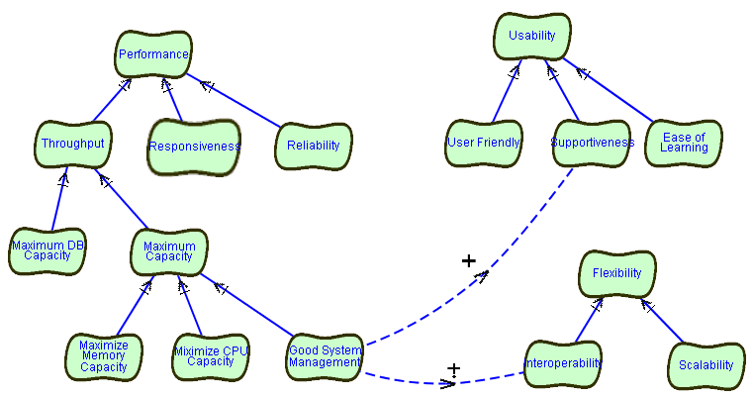
- Model structure series connected with correlations

Requirement knowledge base
TO BE PROVIDED.
Besides expressing requirement model of an enterprise, GRL are also used to express general or domain-specific knowledge on NFRs and architectural design. General knowledge includes the NFRs and architecture design rules that fit into any application domain, such as “Encryption contributes to Security positively”, “Responsiveness is necessary for a good system performance”, etc. In contrast, domain-specific knowledge only fits into certain application domain. For example, the performance of a telecommunication system means the speed and capacity during peak data traffic periods, but the performance of an information system for library management is its responsiveness and availability. Establishing a knowledge base in various conceptual layers makes it possible to reuse existing requirement models and engineering experiences.
Requirement models are composed of elements and some basic building structures, accordingly, the reusable knowledge in a knowledge base can be classified into two categories: concept base and rule base. The concept base stores the reusable concepts, and their relationships; while the rule base stores the reusable model construction rules. In the concept base, as the accumulated knowledge increases, the generalization and specialization of concepts is unavoidable. Thus, two mechanisms: class inheritance and attributes, serve this aim.
The representation of concept and rules, the approaches to manage and use goal-oriented requirement knowledge are to be completed in the future.

Compliance statement
TO BE COMPLETED
The following table describes the requirements for URN-FR as described in Z.150, together with an assessment of how well the UCM notation conforms to these requirements.
- URN-NFR compliance table
ID | Requirement | Type | R/O | Depends On | Conf  Status | Explanation
02200 | Cross-reference operationalizations in the NFR model to responsibilities in the FR model | B | R |  | C | Through attributes and non-intentional elements which are responsibilities.
02300 | Cross-reference performance constraints identified in the NFR model to responsibilities or scenarios in the FR model | B | R |  | C | Through attributes of performance softgoal and non-intentional elements which are responsibilities and scenarios.
90100 | Specify ill-defined, tentative quality requirements | NFR | R |  | C
90200 | Specify satisficing of quality requirements | NFR | R |  | C
90300 | Specify refinement of quality requirements | NFR | R |  | C
90400 | Specify alternative refinement of quality requirements | NFR | O |  | C
90500 | Specify alternative functional requirements | NFR | R |  | C
90600 | Specify quality requirement priorities | NFR | R |  | C | A priority attribute is added to goals, softgoals.
90700 | Specify synergies and conflicts among quality requirements | NFR | R |  | C
90800 | Specify argumentation during modeling | NFR | R |  | C
90900 | Specify multiple stakeholders’ interests | NFR | R |  | C
91000 | Specify business objectives | NFR | R |  | C
91100 | Specify links between high-level objectives and lower-level specifications | NFR | O |  | C
91200 | Support requirements change traceability | NFR | R |  | C
91300 | Support requirements priority traceability | NFR | R |  | C
91400 | Integrate quality and functional requirements | B | R |  | C | Reflected in 02200,02300
91500 | Specify quantitative quality requirements | NFR | R |  | P | Attributes provide partial support. Further support will be needed
91600 | Support incremental commitments of requirements | NFR | R |  | C
91700 | Knowledge base support | NFR | O |  | N | This belongs to methodology, so it is not required for the notation.
91800 | Support detection of conflicting and synergistic quality requirements | NFR | O |  | N | Needs knowledge base and Correlation catalogue support
91900 | Ease of use but also precision | NFR | R |  | C | Supported be current level of formality.

- GRL Document Type Definition

<!-- This part from Z.150 / URN -->

<!ELEMENT urn-spec (definitions?, urn-nfr-spec?, urn-fr-spec?,
annotations?)>
<!ATTLIST urn-spec
spec-id ID #REQUIRED
dtd-version NMTOKEN #REQUIRED
spec-name CDATA #IMPLIED
component-notation NMTOKEN "Buhr-UCM"
data-language NMTOKEN "none"
width NMTOKEN "1320"
height NMTOKEN "1100"
description CDATA #IMPLIED >

<!ELEMENT definitions (component-definitions?, responsibility-definitions?,
nfr-definitions?)>

<!-- This part is new, from Z.151 / GRL -->

<!ELEMENT nfr-definitions (element-definitions, device-directory?,
data-store-directory?)>

<!ELEMENT urn-nfr-spec (grl-spec)>

<!ELEMENT grl-spec (goal-model)>

<!ELEMENT element-definitions (element)* >

<!ELEMENT element (model-type?, model-name?, external-type?, external-name?) >

<!ATTLIST element
element-id ID #REQUIRED
name CDATA #IMPLIED
description CDATA #IMPLIED>

<!ELEMENT model-name EMPTY >

<!ATTLIST model-name
model-id ID #REQUIRED
name CDATA #IMPLIED
description CDATA #IMPLIED
type IDREF #IMPLIED >

<!ELEMENT model-type EMPTY >

<!ATTLIST model-type
id ID #REQUIRED
name CDATA #IMPLIED
description CDATA #IMPLIED>

<!ELEMENT external-type EMPTY >

<!ATTLIST external-type
id ID #REQUIRED
name CDATA #IMPLIED
description CDATA #IMPLIED>

<!ELEMENT external-name EMPTY >

<!ATTLIST external-name
id ID #REQUIRED
name CDATA #IMPLIED
description CDATA #IMPLIED
type IDREF #IMPLIED >

<!ELEMENT goal-model (model-constructors)>

<!ATTLIST goal-model
goal-model-id ID #REQUIRED
goal-model-name CDATA #IMPLIED
description CDATA #IMPLIED >

<!ELEMENT model-constructors (model-constructor)+ >

<!ELEMENT model-constructor (actors?, intentional-elements,
intentional-relationships ) >

<!ELEMENT actors (actor)+ >

<!ELEMENT actor (attributes?)>

<!ATTLIST actor
actor-id ID #REQUIRED
actor-name CDATA #IMPLIED
description CDATA #IMPLIED>

<!ELEMENT intentional-elements (intentional-element)+ >

<!ELEMENT intentional-element (goal | softgoal | task | resource | belief)>

<!ELEMENT goal (attributes?, criticality?, evaluation-label?, actor-ref?)>

<!ATTLIST goal
goal-id ID #REQUIRED
goal-name CDATA #IMPLIED
description CDATA #IMPLIED>

<!ELEMENT criticality EMPTY>

<!ATTLIST criticality
criticality-type (open |
critical) #REQUIRED>

<!ELEMENT evaluation-label EMPTY>

<!ATTLIST evaluation-label
label-type (satisficed |
denied |
weakly-satisficed |
weakly-denied |
undecided |
conflict) #REQUIRED>

<!ELEMENT actor-ref EMPTY>

<!ATTLIST actor-ref
actor-id-ref IDREF #REQUIRED>

<!ELEMENT attributes (attribute)*>

<!ELEMENT attribute EMPTY>

<!ATTLIST attribute
attribute-name CDATA #REQUIRED
element-id-ref IDREF #REQUIRED>

<!ELEMENT task (attributes?, criticality?, evaluation-label?, actor-ref?)>

<!ATTLIST task
task-id ID #REQUIRED
task-name CDATA #IMPLIED
description CDATA #IMPLIED>

<!ELEMENT resource (attributes?, criticality?, evaluation-label?, actor-ref?)>

<!ATTLIST resource
resource-id ID #REQUIRED
resource-name CDATA #IMPLIED
description CDATA #IMPLIED >

<!ELEMENT softgoal (attributes?, criticality?, evaluation-label?, actor-ref?)>

<!ATTLIST softgoal
softgoal-id ID #REQUIRED
softgoal-name CDATA #IMPLIED
description CDATA #IMPLIED>

<!ELEMENT belief (attributes?, actor-ref?)>

<!ATTLIST belief
belief-id ID #REQUIRED
belief-name CDATA #IMPLIED
description CDATA #IMPLIED>

<!ELEMENT intentional-relationships (intentional-relationship)+ >

<!ELEMENT intentional-relationship (means-ends
|decomposition
|contribution
|correlation
|dependency)>

<!ELEMENT means-ends (means-element, end-element)>

<!ATTLIST means-ends
means-ends-id ID #REQUIRED>

<!ELEMENT means-element (task-ref)>

<!ELEMENT end-element (goal-ref | task-ref | resource-ref)>

<!ELEMENT decomposition (decomposed-element, sub-element)>

<!ATTLIST decomposition
decomposition-id ID #REQUIRED>

<!ELEMENT decomposed-element (task-ref | goal-ref)>

<!ELEMENT sub-element (goal-ref | task-ref | resource-ref | softgoal-ref)>

<!ELEMENT contribution (contributee, contributor, contribution-type)>

<!ATTLIST contribution
contribution-id ID #REQUIRED>

<!ELEMENT contributee (softgoal-ref | belief-ref | link-ref)>

<!ELEMENT contributor (task-ref | softgoal-ref| belief-ref | link-ref)>

<!ELEMENT contribution-type EMPTY>

<!ATTLIST contribution-type
contri-type (break |
hurt |
some-negative |
unknown |
equal |
some-positive |
help |
make |
and |
or) #REQUIRED>

<!ELEMENT goal-ref EMPTY>
<!ATTLIST goal-ref
goal-id-ref IDREF #REQUIRED>

<!ELEMENT softgoal-ref EMPTY>
<!ATTLIST softgoal-ref
softgoal-id-ref IDREF #REQUIRED>

<!ELEMENT task-ref EMPTY>
<!ATTLIST task-ref
task-id-ref IDREF #REQUIRED>

<!ELEMENT resource-ref EMPTY>
<!ATTLIST resource-ref
resource-id-ref IDREF #REQUIRED>

<!ELEMENT belief-ref EMPTY>
<!ATTLIST belief-ref
belief-id-ref IDREF #REQUIRED>

<!ELEMENT link-ref (means-ends-ref | decomposition-ref
| contribution-ref | correlation-ref
| dependency-ref)>

<!ELEMENT means-ends-ref EMPTY>
<!ATTLIST means-ends-ref
means-ends-id-ref IDREF #REQUIRED>

<!ELEMENT decomposition-ref EMPTY>
<!ATTLIST decomposition-ref
decomposition-id-ref IDREF #REQUIRED>

<!ELEMENT contribution-ref EMPTY>
<!ATTLIST contribution-ref
contribution-link-id-ref IDREF #REQUIRED>

<!ELEMENT correlation-ref EMPTY>
<!ATTLIST correlation-ref
correlation-link-id-ref IDREF #REQUIRED>

<!ELEMENT dependency-ref EMPTY>
<!ATTLIST dependency-ref
dependency-id-ref IDREF #REQUIRED>

<!ELEMENT dependency (depender, dependum, dependee)>
<!ATTLIST dependency
dependency-id ID #REQUIRED>

<!ELEMENT depender
(goal-ref | softgoal-ref | task-ref | resource-ref)?>
<!ATTLIST depender
actor-id-ref IDREF #REQUIRED>

<!ELEMENT dependum
(goal-ref | softgoal-ref | task-ref | resource-ref)>

<!ELEMENT dependee
(goal-ref | softgoal-ref | task-ref | resource-ref)?>
<!ATTLIST dependee
actor-id-ref IDREF #REQUIRED>

<!ELEMENT correlation (correlatee, correlator, correlation-type)>

<!ATTLIST correlation
correlation-id ID #REQUIRED>

<!ELEMENT correlatee (softgoal-ref)>

<!ELEMENT correlator (task-ref | softgoal-ref)>

<!ELEMENT correlation-type EMPTY>

<!ATTLIST correlation-type
correlation-type (break |
hurt |
some-negative |
unknown |
some-positive |
help |
make |
equal) #REQUIRED>

- Goal-oriented Requirement Language Tutorial

This informative annex contains a tutorial and illustrative examples that supplement the specifications of the URN-NFR.
The tutorial shows how the GRL language can be used to analyse Non-Functional Requirement within an application domain. A brief description of the example application domain is given first, then GRL is used to describe how NFRs are dealt with in this domain. Note that this example provides for one particular way GRL can be used, which emphasizes softgoals during modelling. There are other ways GRL can be used such as placing emphasis on actors, or on task and goals during the modelling.
  - Application Description
An information system at Financial Institution provides support for point of sale systems for financial transactions. Security issues in such system concerns both the system developer and the system user. The remote input systems are located at Retailers sites (in the “field” outside of the financial institution itself) and are used by the Retailers to allow their customers to pay for their purchases. Other pertinent financial services are provided to the Retailers that can be done through the system. The system itself consists of a Base Station (BS) and a set of Terminals, and a Host computer. Terminals are connected to the Base Station via a LAN, while the Base Station in connected through a leased or dial-up line to the host computer located at the financial institutions. A software development contractor develops the financial transaction software that resides at the Retailers and on the Host computer. The hardware is purchased externally from a Manufacturer. There are two "business processes" relevant for this example: 1. When the system is newly deployed. 2. When Terminal software need to be updated.
Case 1: When the system is newly deployed:
The developers receive hardware from the manufacturer, and load the initial version of the software into the system. The system is then provided to the financial institution where it is validated. The financial institution then provides the system to retailers and keeps track of what software and hardware was provided to whom, and other pertinent information relevant to the Retailer (such as special configuration data). Finally, the Retailer operates the system.
Case 2: When the system is updated:
Developers provide updates to the financial institution. The Financial institution uploads the updates to their host computer. Maintainers in the field download the updates into the base station, from where they then transfer it to the terminals.
There is a need to address security needs when producing, deploying and updating the financial software at the financial institution and at the Retailers site. The basic problem to be addressed is, how to keep the software code secure both in its source code form during development, and when the software is deployed as object code, and related parameter tables. For example, how to ensure that only authorised personnel can upload new updates to the Host, download updates from the Host and install them onto the base station and terminals, how to ensure that only authorised terminals are used. These and other security issues need to be addressed during the specification and development of the financial software itself and the software that facilitate the maintenance processes. Security touches on ease of use, performance, and cost; these attributes need to be considered and traded off among each other.
  - GRL Definitions
We will start by defining the existing modelling elements imported from an external model in some modelling notation (e.g. UML):
ELEMENT POS_Software
ELEMENT TerminalSoftware
ELEMENT BaseStationSoftware
ELEMENT HostComputerSoftware
These statements provide a definition of the kind of elements that need to be secured. These elements were imported from an external model.
The following statement defines a softgoal on the security of the software of the system:
SOFTGOAL Security OF POS_Software
where “Security” is a softgoal type, and “POS_Software” is a softgoal topic. For the purpose of referencing this softgoal, a default name is automatically generated, which is the concatenation of the softgoal type, “OF” and the topic, e.g. “Security_OF_POS_Software”. The user can override the default name with this alternative form of the statement:
SOFTGOAL SoftwareSecured IS Security OF POS_Software
Let us now refine that softgoal to more specific ones. Refining the softgoal clarifies what we mean by Security of Software, and it may be achieved.
SOFTGOAL Operational_Security OF POS_Software
SOFTGOAL Developmental_Security OF POS_Software
CONTRIBUTION
Operational_Security_OF_POS_Software,
Developmental_Security_OF_POS_Software
HAS And CONTRIBUTION-TO Security_OF_POS_Software
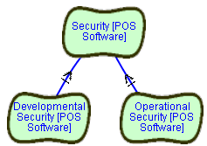
These statements refine what “Security OF POS_Software” means. It means security of POS software during operational activities, that is all activities related to the provision, updating, and regular working of the software, and it means security of software during development activities. The contribution statement also states that both (“And”) are needed in order to ensure security of software. Security is not dealt with well when having stringent security for operations, while having “free” access to the source code during development.
Next, we recognise that for operational security, one should distinguish between operations that take place within financial institution and the development site, and operations that take place outside of these boundaries, such as at the Retailers site. This distinction can be shown as follows:
SOFTGOAL Internal_Operational_Security OF POS_Software
SOFTGOAL External_Operational_Security OF POS_Software
CONTRIBUTION
Internal_Operational_Security_OF_POS_Software,
External_Operational_Security_OF_POS_Software
HAS And CONTRIBUTION-TO Operational_Security_OF_POS_Software
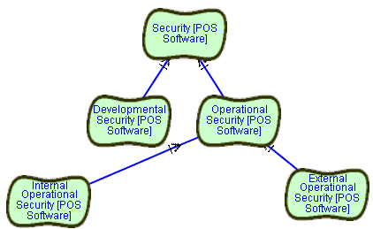
We now also wish to distinguish among security that is related to the securing of the Terminal and of the Base Station and security measures related to the host computer that might be attached through activities performed externally. These considerations are expressed by the following definitions:
SOFTGOAL ExternalOperationalSecurity OF TerminalSoftware
SOFTGOAL ExternalOperationalSecurity OF BaseStationSoftware
SOFTGOAL ExternalOperationalSecurity OF HostComputerSoftware
CONTRIBUTION
ExternalOperationalSecurityOFTerminalSoftware,
ExternalOperationalSecurityOFBaseStationSoftware,
ExternalOperationalSecurityOFHostComputerSoftware
HAS And CONTRIBUTION-TO ExternalOperationalSecurityOFSoftware
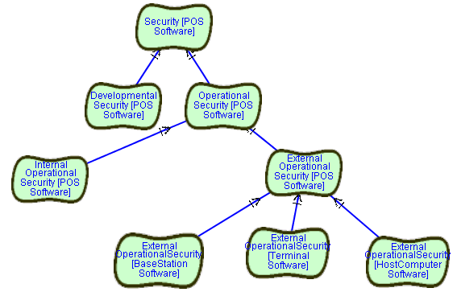
We could now make another distinction between securing application related software and operating system software, if we wish to deal with them differently. Perhaps operating system software for the pieces of equipment needs at least as stringent security measures as the financial applications running on top of them. However, we will not introduce this distinction here.
Let us now further focus on the TerminalSoftware and refine security into confidentiality, integrity and Availability. Confidentiality is protection against unauthorized disclosure. Integrity is protection against unauthorized update or tampering, and availability is protection against interruption of service through outside attacks. This refinement makes the meaning of security more particular in that we know what aspects of security we would further like to address. This refinement is expressed by the following definitions:
SOFTGOAL ExternalOperationalConfidentiality OF TerminalSoftware
SOFTGOAL ExternalOperationalIntegrity OF TerminalSoftware
SOFTGOAL ExternalOperationalAvailability OF TerminalSoftware
CONTRIBUTION
ExternalOperationalConfidentialityOFTerminalSoftware,
ExternalOperationalIntegrityOFTerminalSoftware,
ExternalOperationalAvailabilityOFTerminalSoftware
HAS And CONTRIBUTION-TO ExternalOperationalSecurityOFTerminalSoftware
We will now focus on the operation of update, download and storage provided by the terminal software for which we wish to have confidentiality ensured. This is shown by the following statements. Note that in order to shorten the names of the softgoal we will override the internally generated name. We will use the acronym EOC standing for “ExternalOperationalConfidentiality”:
SOFTGOAL EOC_OFTerminalSoftwareForStorage IS
ExternalOperationalConfidentialityForStorage OF TerminalSoftware
SOFTGOAL EOC_OFTerminalSoftwareForDownload IS
ExternalOperationalConfidentialityForDownload OF TerminalSoftware
SOFTGOAL EOC_OFTerminalSoftwareForUpdate IS
ExternalOperationalConfidentialityForUpdate OF TerminalSoftware
CONTRIBUTION
EOC_OFTerminalSoftwareForStorage,
EOC_OFTerminalSoftwareForDownload,
EOC_OFTerminalSoftwareForUpdate
HAS And CONTRIBUTION-TO EOC_OFTerminalSoftware
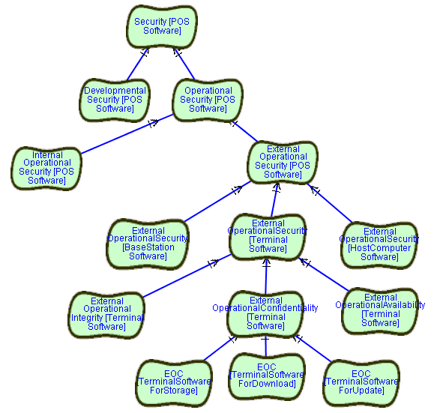
Up until now we have only provided refinements for making the softgoal of having secure software more precise, and found that, among other things, it means to find a way to have storage, download and update of terminal software made confidential, i.e. have the software in now way disclosed to unauthorised parties. We will now focus on the various means we could employ for achieving these goals. Let us now focus on the different means we can employ for achieving confidentiality for the updates of terminal software. Three means are discussed: providing access authorisation, providing some kind of encryption, and providing limited exposure to accessing the software. Each one of these means does have additional alternatives. Let us model one at the time:
TASK AccessAuthorization
TASK LimitExposure
TASK Encryption
CONTRIBUTION
AccessAuthorization,
LimitExpose,
Encryption
HAS Make CONTRIBUTION-TO EOC_OFTerminalSoftwareForDownload
The Task AccessAuthorization has two subtasks: Authentication and Identification while each subtask provides a few alternatives ways. Since both of these tasks provide alternatives we will model them using the GOAL construct, and then provide for each alternative a task together with a means end link to its goal.
GOAL Authentication
GOAL Identification
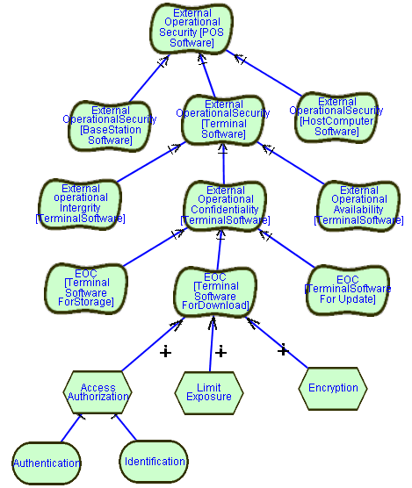
Authentication can be done by using digital signatures, biometrics, card key and card reader equipment or password protection. Let us describe those alternative uses.
TASK DigitalSignatureAuthenication
TASK BiometricsAuthenication
TASK CardkeyAuthenication
TASK PasswordAuthentication
MEANS-END FROM DigitalSignature TO Authentication
MEANS-END FROM BiometicsAuthentication TO Authentication
MEANS-END FROM CardkeyAuthentication TO Authentication
MEANS-END FROM PasswordAuthenication TO Authentication
The GOAL Identification can also be provided in two different ways:
TASK OneSidedID
TASK MutualID
MEANS-END FROM OneSidedID TO Identification
MEANS-END FROM MutualID TO Identification
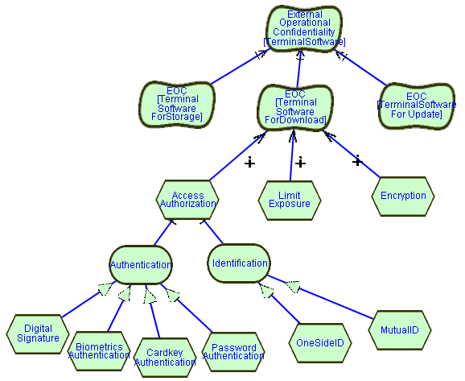
Each one of the alternatives discussed is able to address the confidentiality requirements for updating the terminal software. However, each alternative has a different set of tradeoffs among other quality requirements that might be of importance. For example, using BiometricsAuthentication would provide a high-level of security, however, would be very expensive to provide. On the other hand, using a Cardkey Authentication is less expensive, but still needs some equipment and very user friendly. Finally, using password protection is the least expensive but has not the same user friendliness as the cardkey reader. We would model this kind of reasoning through correlation links to other softgoals.
Finally, in order to demonstrate the Belief construct, let us add a justification for our claim that using Biometrics has very negative impact on the purchase cost of the terminal. We support the very negative impact by the belief that “Biometrics is no regular off-the-shelf technology” and thus still very expensive to provide. Since the Belief is linked to a correlation link, we override the machine-generated identifier and provide a correlation link identifier of our own. This identifier is then used in the BELIEF clause.
ELEMENT TerminalSystem
SOFTGOAL PurchaseCost OF TerminalSystem

ELEMENT TerminalSystemUserInterface
SOFTGOAL UserFriendliness OF TerminalSystemUserInterface
Note that we specify here the correlation link identifier and name it BiometricAuthentication-CorrelationLink. This name is then used when declaring the Belief intentional element.
CORRELATION BiometricAuthenticationCorrelationLink IS
BiometricsAuthentication
HAS Break CONTRIBUTION-TO PurchaseCostOFTerminalSystem
CORRELATION
CardKeyAuthentication
HAS Some- CONTRIBUTION-TO PurchaseCostOFTerminalSystem
CORRELATION
CardKeyAuthentication
HAS Make CONTRIBUTION-TO UserFriendlinessOFTerminalSystemUserInterface
CORRELATION
PasswordAuthentication
HAS Make CONTRIBUTION-TO PurchaseCostOFTerminalSystem
CORRELATION
PasswordAuthentication
HAS Some- CONTRIBUTION-TO UserFriendlinessOFTerminalSystemUserInterface
This Belief link is added at the bottom of the following diagram.
The textual description of this link is:
BELIEF BiometricAuthenticationCorrelationLink “Biometric is no regular off-the-shelf technology”.

All the correlations described provide a basis for evaluating the alternative approaches that may be taken to ensure confidentiality, i.e., unauthorised disclosure of update and related information of the terminal software updates.
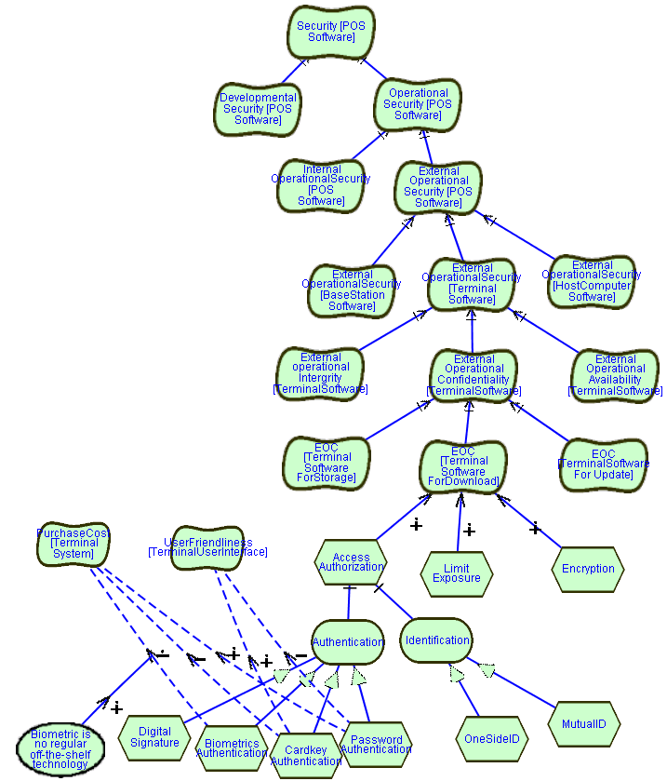

In order to illustrate actor related features of GRL, let us consider the following diagram. We wish to show two Actors participating in the deployment process described in case 1. Both Actors are concerned about security; however, each one may make different choices, based on actor context-dependent considerations.
The first diagram shows the Developer actor (i.e. the people within the development organisation), and parts of the process to deploy the software system to the financial institution. During this process, first the developed software is loading onto special purpose hardware (that was supplied by the manufacturer), and then the system deliverables (both software and hardware) is provide to the financial institution.
The diagram shows that there are security concerns related to the deploying of the system. This security requirement is addressed by requiring authentication before loading of the software onto the hardware can commence. The AuthenticateLoader GOAL shows that two alternatives authentication options are considered: use Biometrics or use a Card Reader. As we have seen in the previous example each alternative has different tradeoffs. Biometrics authentication provides very good security. This is denoted by the Make contribution link from BiometricAuthentication Task to the Security Softgoal. It is, however very costly, which is denoted by the Hurt correlation link from the BiomtricAuthentication Task to the Cost Softgoal. The CardRead authentication provides good security, albeit to a lesser extent than Biometric authentication. This is denoted by the Some+ contribution link between CardReaderAuthentication Task and the Security Softgoal. Card Reader technology is, however, less expensive. This is denoted by the Some- correlation link between CardReaderAuthentication Task and the Cost Softgoal. Note that a Belief node is added to explain why Card Reader Authentication is less secure, since cards can be stolen, which introduces a concern not applicable to Biometric Authentication.
Note that contribution links are used to denote the primary reason for the choice of Tasks, while correlation links denote “side-effects” that relate to these Tasks. Finally, the diagram also adds the Belief “Card can be stolen” to support the fact that CardReaders are only providing “some+” contribution to the Security Softgoal.
This diagram illustrates that reasoning related to Softgoals may be “context dependent” and needs to be considered within the boundaries of an Actor. For the Developer Actor, we can argue that the Development organization is very concerned about Security. It may even be an important factor to being chosen a supplier of the financial institution. They would therefore rather choose Biometric Authentication than Card Readers, although it is the more expensive authentication method.
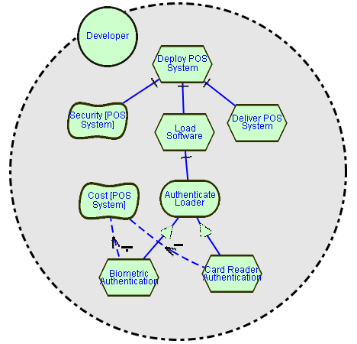
The next diagram shows the Financial institution Actor now receives the system deliverables and wishes to deploy the system further to its Retailer clients. During its deployment process the financial institution first verifies the system deliverables. This is denoted by the VerifySystem Task. Note that this task is dependent on receiving the system deliverables from the Developers. This dependency is denoted by the TheSystemDeliverable Resource dependency link between the Developer actor and the Financial Institution Actor. The next step in the financial institutions’ deployment process, is to data relate to the distribution of the system. This data involves among others handling of the systems software to be distributed. Similarly to the Developers Actor, the Financial Institution is concerned with Security, and wishes to Authenticate users who deal with the tracking system. In this example, the same alternatives for authentication are considered. However, the financial institution may argue, that since its premises are rigorously secured anyway, Biometrics would be “overkill”, while a CardReader authentication system might be enough for securing the access to the software code that is uploaded for further distribution (within the tracking system). Note that if the Security Institution would already have Card Readers installed on site, then using a card reader would have a synergistic effect on the costs involved for authentication. Since such systems are already widely used anyway. This consideration was, however, omitted from the diagram, and would have involved a correlation link between the CardReaderAuthentication Task and the Cost Softgoal of some positive extent.

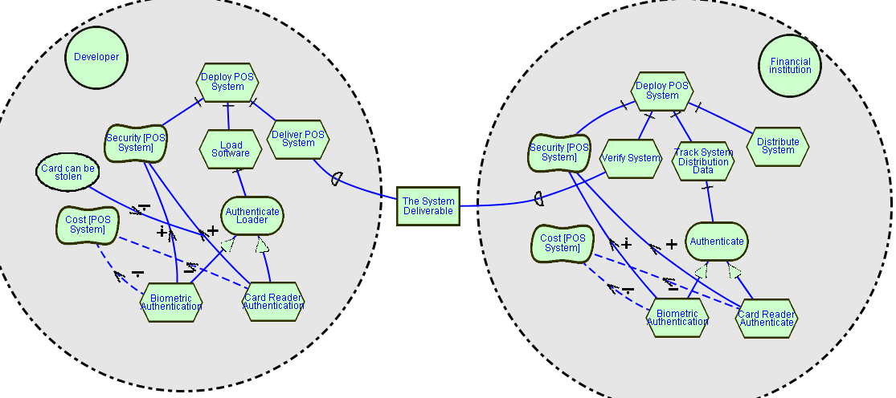
- Tool issues
TO BE DONE.
This informative appendix is intended to include lessons learned and issues observed while using a prototype tool supporting the Goal-oriented Requirements Language (GRL).
Currently, GRL support is provided by the OME tool (Organization Modelling Environment). OME, developed at the University of Toronto, is available at http://www.cs.toronto.edu/km/ome. More information on how to use the tool to create GRL models can be found on the GRL Web site: http://www.cs.toronto.edu/km/GRL/ .

Bibliography
This informative bibliography contains references to books, journal papers, and conference papers dealing with GRL, goal modelling and non-functional requirements.
- Chung, L. and Nixon, B.A. (1995) "Dealing with Non-Functional Requirements: Three Experimental Studies of a Process-Oriented Approach". In: Proc, IEEE 17th International Conference on Software Engineering (ICRE'95), Seattle, USA, pp. 25-37.
- Chung, L., Nixon, B.A. and Yu, E. (1995) "Using non-functional requirements to systematically select among alternatives in architectural design". In: Proceedings of the First International Workshop on Architecture for Software Systems. Seattle, Washington.
- Chung, L., Nixon, B.A. and Yu, E. (1997) "Dealing with Change: An Approach Using Non-Functional Requirements". In: Requirement Engineering, Springer-Verlag, vol. 1, no. 4, pp. 238-260.
- Chung, L., Gross, D., and Yu, E. (1999) "Architectural Design to Meet Stakeholder Requirements". In: P. Donohue (ed.) Software Architecture, Kluwer Academic Publishers. pp. 545-564. Also in: First Working IFIP Conference on Software Architecture (WICSA1), February 1999, San Antonio, Texas, USA. http://www.cs.toronto.edu/pub/eric/WICSA99.pdf
- Chung, L., Nion, B.A., Yu, E., and Mylopoulos, J. (2000) Non-Functional Requirements in Software Engineering. Kluwer Academic Publishers. ISBN 0-7923-8666-3.
- Gross, D. and Yu, E. (2001) "From Non-Functional Requirements to Design through Patterns". In: Requirements Engineering, 6:18-36. Springer-Verlag. http://www.cs.toronto.edu/~gross/rej/rejWithAuthorNames.pdf
- Lee, J. (1991) "Extending the Potts and Bruns model for recording design rationale". In: Proc. 13th International Conf. on Software Engineering. Austin, Texas, 114-125.
- Liu, L. and Yu, E. (2001) "From Requirements to Architectural Design — Using Goals and Scenarios". In: From Software Requirements to Architectures Workshop (STRAW 2001), Toronto, Canada, May 2001. http://www.UseCaseMaps.org/pub/straw01.pdf
- Mylopoulos, J., Chung, L. and Nixon, B. (1992) "Representing and Using Non-Functional Requirements: A Process-Oriented Approach". In: IEEE Transactions on Software Engineering, Special Issue on Knowledge Representation and Reasoning in Software Development, 18(6), June 1992, pp. 483-497.
- Mylopoulos, J., Chung, L. and Yu, E. (1999) "From Object-Oriented to Goal-Oriented Requirements Analysis". In: Communications of the ACM, 42(1): 31-37, January 1999.
- Potts, C. and Bruns, G. (1988) "Recording the reasons for design decisions". In: Proc. 10th International Conf. on Software Engineering, 418-427.
- Yu, E. (1997) "Why Agent-Oriented Requirements Engineering". In: Proceedings of 3rd International Workshop on Requirements Engineering: Foundations for Software Quality, Barcelona, Catalonia, June 1997. http://www.cs.toronto.edu/pub/eric/REFSQ97.pdf
- Yu, E. (1997) "Towards Modelling and Reasoning Support for Early-Phase Requirements Engineering". In: Proceedings of the 3rd IEEE Int. Symposium on Requirements Engineering (RE'97), Washington D.C., USA, pp. 226-235. ftp://ftp.cs.toronto.edu/pub/eric/RE97.pdf
- Yu, E. and Mylopoulos, J. (1998) "Why Goal-Oriented Requirements Engineering". In: Proceedings of the 4th International Workshop on Requirements Engineering: Foundations of Software Quality, Pisa, Italy, June 1998, 15-22. http://www.cs.toronto.edu/pub/eric/REFSQ98.html

GRL Change Request Form

Please fill in the following details
Character of change: | ❑ error correction | ❑ clarification
 | ❑ simplification | ❑ extension
 | ❑ modification | ❑ decommission
Short summary of change request
Short justification of the change request
Have you consulted other users | ❑ yes | ❑ no
Is this view shared in your organization | ❑ yes | ❑ no
Is this view shared in your organization | ❑ 11-100 | ❑ over 100
How many users do you represent? | q 1-5 | q 6-10
How many users do you represent? | q 11-100 | q over 100
Your name and address
Please attach further sheets with details if necessary
URN (Z.150) Rapporteur, c/o ITU-T, Place des Nations, CH-1211, Geneva 20, Switzerland. Fax: +41 22 730 5853, e-mail: URN.rapporteur@itu.int.

