COMP 2406
Fundamentals of Web Programming

Course Notes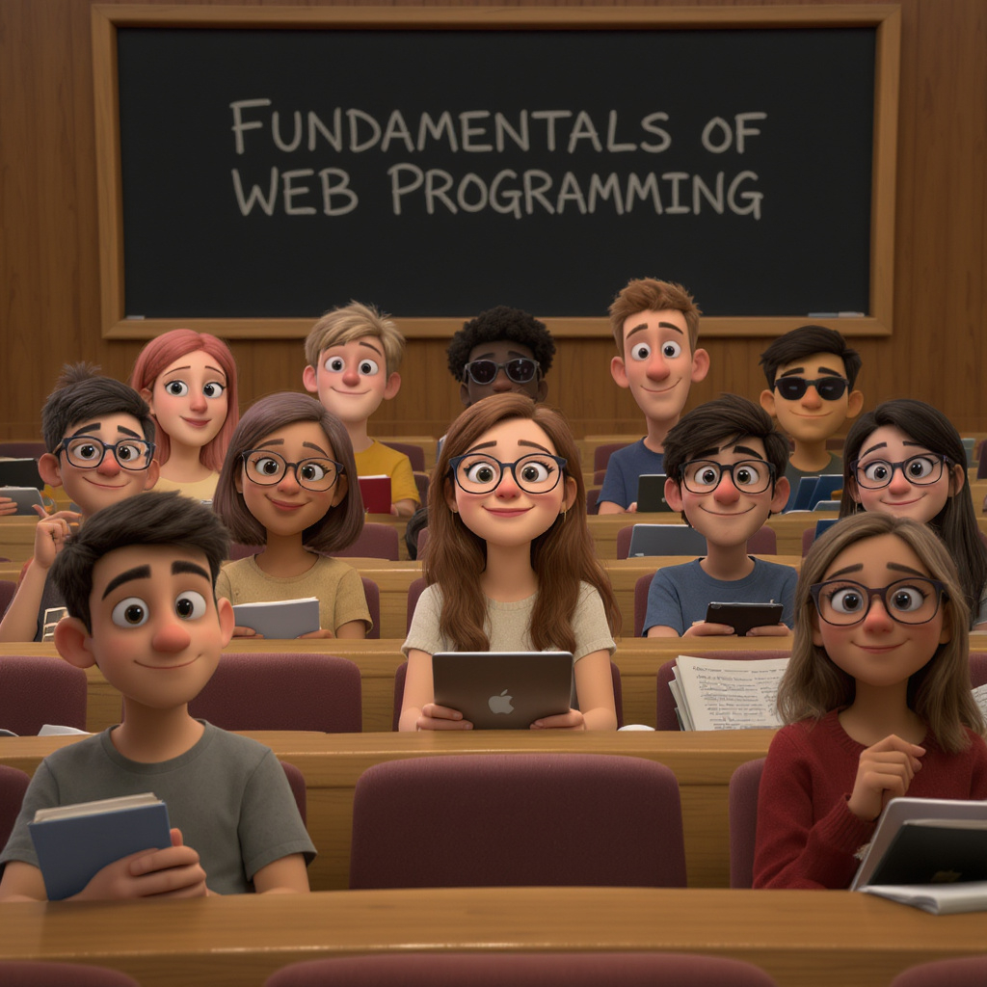

Notes by Mark Lanthier (W2026 version)

(This material is based on lectures slides from Alina Shaikhet as well as material
from Ava McKenney and Lou Nel. Some material has also been A.I. generated.)

Table of Contents

Chapter 1 - Fundamentals of Web Programming ………..…………………………..……………………. 1
1.1 Internet History ………………………………………………………………………………………………………... 2
1.2 Web Programming ……………………………………………………………………………………………………. 3
1.3 Course Overview …………………………………………………………………………………..…………………. 5

Chapter 2 – HTML ……………………………………………………………………………..………..……….. 7
2.1 The Basics …………………………………………………………………………………..………………………… 8
2.2 Other Common HTML Tags ……..……………………………………………………..…………………………… 17
2.3 Images, Links and Forms ……..……………………………………………………..……………………………… 22

Chapter 3 - Cascading Style Sheets …………………………………………………………………………. 29
3.1 The Basics ……..…………………………………………………………..……………………………................... 30
3.2 Our First Website – Content Only ……..…………………………………………………...………………………. 35
3.3 Our First Website – Appearance ……..…………………………………………………………..………………… 46

Chapter 4 – JavaScript ……………………………………………………………………………..………….. 54
4.1 The Basics ……..…………………………………………………………..…………………………….................... 55
4.2 Running JavaScript Code ……..……………………….……………………………………...…………………….. 57
4.3 Variables, Constants, Types and Conversion ……………………………….………………..…………………... 61
4.4 Strings, Arrays, Conditionals and Loops …………………………………..………………………………………. 65
4.5 Objects ………………………………………………………………………………….………………..……………. 68
4.6 Functions ……………………………………………………………………………….………………..……………. 69
4.7 Shallow and Deep Copies ……………………………………………………….………………..………………… 71
4.8 Variable Scoping …………………………………………………………………….………………..……………… 75
4.9 Higher-Order Functions ……………………………………………………….………………..……………………. 76
4.10 Synchronous vs Asynchronous Code …………………………………………….…………..………................. 78
4.11 Closures ……………………….…………………………………………………….………………..……………… 81

Chapter 5 – The Document Object Model ………………………………………...………..……………….. 85
5.1 The DOM .…………………………………………………………..…………………………………….................. 86
5.2 Changing Element Contents and Attributes ……..……………………….…………………..…..……................ 92
5.3 Reading and Changing CSS Classes & Styles ……..……………………….………………………….............. 94
5.4 Adding and Removing Elements ……..……………………….…………………………………………............... 97
5.5 Event Handling …………….………………..……………………………………………………………................ 99
5.6 Our First Website (continued) – Behavior …………….………………………………………...……….............. 106

Chapter 6 – Client-Server Communication ………….………………………..…………..………………… 116
6.1 Client-Server Architecture ……………………………………………..……………………………....................... 117
6.2 Communication Basics ……..……………………….……………………………………...……………................ 122
6.3 The Hypertext Transfer Protocol ……………………………….………………..………………………............... 127
6.4 Domain Name System (DNS) and URLs ………………………………………………………………................. 131
6.5 Structure of HTTP Requests and Responses ……………………………………………………........................ 135
6.6 URL Shortening & Caching …………..…………………………………………………………………................. 142

Chapter 7 – AJAX ……………………………………………………………….……………………..……….. 145
7.1 AJAX Basics ……..…………………………………………………………..……………………………................. 146
7.2 Promises ……..……………………….……………………………………...……………………………................. 151
7.3 Trivia Database Example ……………………………….………………..………………………………................ 158
7.4 Team Members Example ……………………………….………………..………………………………................ 163
7.5 Limitations ……………………………….………………..………………………………………………................. 169

Chapter 8 – Node.js and NPM …………………….………………………….…………………..…………… 171
8.1 Node.js Architecture ……..…………………………………………………………..……………………................ 172
8.2 Event Loop Processing ……..……………………….……………………………………...….…………............... 176
8.3 The Modules System of Node.js ……..……………………….…………………………………………................ 181
8.4 Creating Servers ……..……………………….……………………………………...……………………............... 185
8.5 Handling Request Data ……..……………………….………………………………………....…………............... 190
8.6 Node Package Manager (NPM) ……..……………………….………………………….…....…………............... 195

Chapter 9 – Template Engines …………………………………………………..…………………………… 201
9.1 Generating Dynamic HTML with JavaScript ……..…………..…..……………………………........................... 202
9.2 Embedded JavaScript Templates (EJS) ……..………………………………………………...….……............... 213
9.3 PUG ……..……………………….……………………………………...…………………………………................ 226
9.4 Updating the FutureTech Corp. Site ……..……………………….…………………………...……….................. 239

Chapter 10 – Express ……………………………………………………..….………………………………... 253
10.1 Express Intro ……..…………………………………………………………..…………………………................. 254
10.2 More About Middleware ……..……………………….……………………………………...…………................ 262
10.3 Bodies and Query Strings ……..……………………….……………………………………...………................ 268
10.4 A FutureTech Corp. Express PUG Server ……..……………………….…………………...………................. 277
10.5 Sample Store Site and the Postman Tool ………….……………………………………...…………................ 279

Chapter 11 – RESTful Web Design ……………………………………….………………………………….. 285
11.1 RESTful APIs ……..…………………………………………………………..…………………………................ 286
11.2 Designing RESTful APIs ……..……………………….……………………………………...…………............... 292
11.3 Practice Exercise - Date-a-Science Website API ……………...……………………………………................ 297

Chapter 12 – The MongoDB DBMS …………………………………….……………..……………………... 305
12.1 Database Introduction ……..…………………………………………………………..………………….............. 306
12.2 Working with Databases in a MongoDB Shell ……..…………………………………...……………................ 308
12.3 MongoDB in Node.js ……..…………………………………...…………………………………………............... 322
12.4 Products Management Site Example ……………………………….………………..………………................. 330

Chapter 13 – Authentication, Authorization & Sessions ………………………..……………….. ……... 339
13.1 Authentication and Authorization ……..………………………………………………………............................ 340
13.2 Sessions and Cookies ……..……………………….……………………………………...……………............... 342
13.3 Middleware: cookie-parser & express-session ………….……………………………………………............... 347
13.4 Example: Handling Login Sessions ……………………………….………………..…………………................ 353

Chapter 14 – Mongoose ………………………..…………………..………………………………..………… 358
14.1 Mongoose Connections ……..…………………………………………………………..………………............... 359
14.2 Data Validation Using Schemas ……..……………………….……………………………………….................. 360
14.3 Server Queries ……..……………………….……………………………………...……………………................ 370
14.4 Instance/Helper Methods and Populating ……..……………………………………...………………................ 378

Chapter 15 – Mobile Apps …………………………………..…….…………………………………………... 384
15.1 Mobile Vs. Desktop …………………………………………………..……………………………........................ 385
15.2 Responsive Web Design ……..……………………….……………………………………...…………............... 388
15.3 Chrome Dev Tool Device Simulation & Emulation ….……………………………………...……….................. 390
15.4 Viewports ……..……………………….……………………………………...…………………………................. 396
15.5 Media Queries ……..……………………….……………………………………...……………………................. 401
15.6 Responsive Images ……………………….……………………………………...……………………….............. 407

