Chapter 2

HTML

What is in This Chapter ?
This first chapter of the course explains how to use HTML to arrange content on a webpage. We will learn how to use headers, text, images and links. This is only a very basic introduction to HTML. There is a lot more that we can learn.



2.1 The Basics

In this section, we will explain how to create the simplest of webpages … which will be based solely on HTML … which is the standard language used to create webpages. It tells web browsers how to structure and organize the page content such as text, images, links, etc..

HTML stands for HyperText Markup Language.

The word hypertext simply means “text with links (or references) to other text”. That means that hypertext can be clicked-on by the user and it will take the user to another location, which could be:
- part of the same document/file
- a different document/file
- a webpage on the internet

The word markup refers to the symbols (or tags) used to annotate text so that the web browser can understand how to structure and display it. It is essentially a way of labelling text with additional information for the browser to take note of so that it knows what to do with the content. These tags are not visible on the webpage, although we can view the source code of a webpage to see them.

The word language can be confusing to computer science professionals because when we hear that word, we think “programming language”. However, HTML is not a “programming” language, it is a “markup” language which means something different. The term language is used because it follows a specific syntax, allows structured communication between the person and the browser, and in a way, it is how we “speak” to the browser to give it instructions.

An HTML file is just a text file and it has either a .html or a .htm extension. The default filename that most web servers look for when loading a website or folder is called index.html. So, for example, go to my personal webpage:

https://people.scs.carleton.ca/~lanthier/

The browser will automatically look for (and find) the index.html file that displays my webpage.

For now, let’s look at a file called basic.html to see what its components are like. Here is a basic template for a simple webpage:

<!DOCTYPE html>
<html lang="en">
<head>
<meta charset="UTF-8">
<title>My Simple Webpage</title>
</head>
<body>
<h1>Hello Everyone!</h1>
<p>This is our first-created COMP 2406 webpage.</p>
</body>
</html>

Notice that there are many things declared inside < > characters. These are called tags and they are identified as bold font in the above code. Here is a quick visual explanation of the contents:

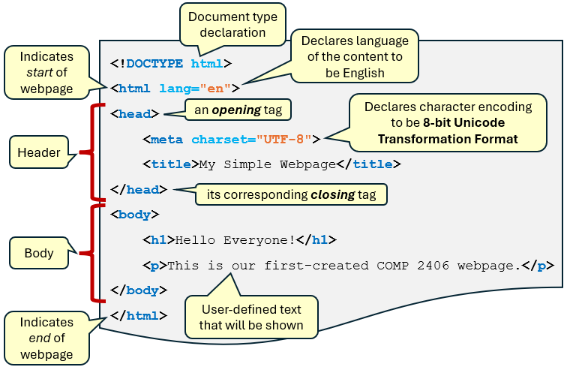

Notice the document type declaration at the top. This is a requirement for the HTML5 standard that is being used today by modern web browsers. It tells the browser that this document uses HTML5 instead of older versions like HTML4 or XHTML. HTML5 is the current version of the HTML language, as defined by the W3C (World Wide Web Consortium) and WHATWG (Web Hypertext Application Technology Working Group).

Next, we notice the first <html> tag and the last </html> tag. These are examples of an opening tag and a closing tag, respectively. Closing tags are identified by the </ sequence of characters. There are a couple of important rules about tags:

- Every opening tag MUST have a corresponding closing tag if the tag wraps content.
- Tags can be nested, but must open and close in the correct order.

How many pairs of opening/closing tags do we see in the above code?

We do not include the <!DOCTYPE> and <meta> tags in our count because those tags are self-contained and do not wrap content. Therefore, we have 6 pairs of opening/closing tags.

There are three opening/closing tag pairs that are important to explain:

- <html> </html>
    - defines the start and end of the webpage content.
    - tells the browser that everything between it is considered HTML code.
    - without this our page could break on older or stricter browsers, developer tools and validators will flag it as incorrect and assistive technologies (such as screen readers) may behave unexpectedly.

- <head> </head>
- contains metadata (i.e., information about the document), settings and resources that are needed before rendering the visible content of the webpage.
- tells the browser how to load and handle the page.
- metadata improves our website’s visibility and ranking.
- metatags in here controls how the page displays on phones and tablets.
- can contain links to CSS & JavaScript files that define the page’s look & interaction (It is interesting to note that an HTML file may also contain CSS and JavaScript code … we will discuss this later).

- <body> </body>
- contains all the visible content of the webpage such as text, images, links, buttons, videos, etc..

Notice the lang="en" inside of the <html> tag. There are advantages of making it clear that the language is English:

Accessibility:
  - Screen readers use it to choose the correct pronunciation or voice.

SEO (Search Engine Optimization):
  - Search engines use it to better understand and index the page.

Translation tools:
  - Helps auto-translators (such as Google Translate) to know the source language.

Browser behavior:
  - Some browsers may adjust features like spellcheck based on the language.

There are other language codes (see IETF language tag). Here are a few others:

Arabic (ar), Chinese (zh), French (fr), Spanish (es), German (de), Hindi (hi)

The <meta charset="UTF-8"> inside the header indicates that the Unicode Transformation Format - 8-bit character set is to be used.

There are other options here such as UTF-16, UTF-32, ISO-8859-1, Windows-1252, ASCII, Shift_JIS, KUC-KR, GB2312, etc..

However, UTF-8 is the most widely used encoding and it has these advantages:

Universal:
  - Can represent every character in every language

Efficient:
  - Uses just 1 byte for basic characters (e.g., English), more for others

Web Standard:
  - Used by over 95% of websites today

Prevents Display Errors:
  - Avoids weird symbols (�, Ã, etc.) when content has accents or special characters

We can take our code and save it in a file called basic.html. Then we can open it with a browser. Here is what it looks like using 4 different web browsers:

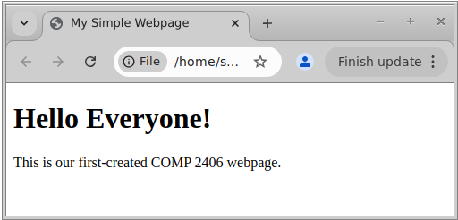  Google Chrome in Ubuntu Linux | 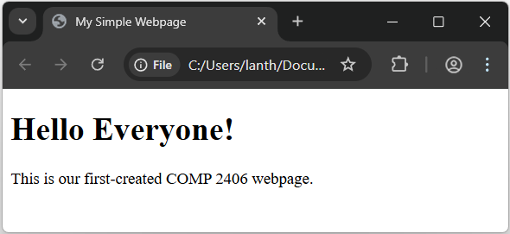  Google Chrome in Windows
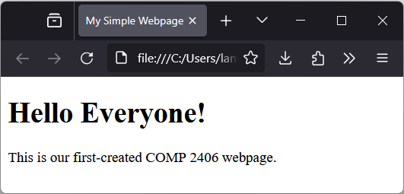  Mozilla Firefox in Windows | 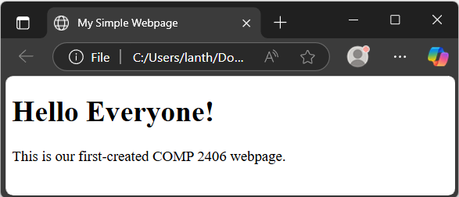  Microsoft Edge in Windows

Notice that the tab contains the title of the webpage that we provided in the header:

<title>My Simple Webpage</title>

Also notice that the Hello Everyone! text is darker and bigger … because it is within a header tag:

<h1>Hello Everyone!</h1>

While the regular text is in a paragraph tag:

<p>This is our first-created COMP 2406 webpage.</p>
There are six different header tags, each varying in their font size, appearance and spacing. They allow for a consistent structure to webpage content. The largest is <h1> and the smallest is <h6>. Here is what they are typically used for:

<h1> = Main title or page title (one per page)
<h2> = Major section heading
<h3> = Subtopics under each section
<h4> = Deeper detail in a subtopic
<h5> = Minor subheadings
<h6> = Side notes

Here is some useful advice:
- Use only one <h1> per page.
- Use the headings consistently as if we were writing a report with various sections and subsections so that a clear hierarchy is visible.
- Don’t skip levels (such as jumping from <h1> to <h4>) unless it makes sense semantically.

We can also use <hr> (i.e., horizontal rule) to make a visible horizontal line as a divider … which is good, for example, to add a section of notes at the end of the page.

Here is an example of how this can all be done in a file called dentalHygeine.html:

<!DOCTYPE html>
<html lang="en">
<head>
<meta charset="UTF-8">
<title>Dental Hygiene for Dolphins</title>
</head>
<body>

<h1>Dental Hygiene for Dolphins</h1>

<h2>Why Dolphin Dental Care Matters</h2>
<p>
Dolphins, like humans, rely on their teeth for everyday activities. Their teeth are
essential not just for eating, but also for grasping objects and communicating through jaw
movements.

In the wild, dental health can affect a dolphin's ability to hunt, socialize, and survive.

In captivity, poor dental care can lead to infection, loss of appetite, and serious health
complications. That’s why dental hygiene is an important part of dolphin care in marine
environments.
</p>

<h3>Differences from Human Teeth</h3>
<p>
Unlike humans, dolphins only grow one set of teeth in their lifetime. They do not chew
their food; instead, they swallow it whole. Most dolphins have between 80 to 100
conical-shaped teeth, depending on the species. Because they don’t replace lost teeth,
damage or decay can be particularly harmful. Their teeth are also used for social
behaviors, including displays of dominance or play.
</p>

<h2>How Dental Checkups Are Performed</h2>

<h3>Veterinary Techniques</h3>
<p>
Marine veterinarians regularly examine dolphin teeth as part of routine health assessments.
Dolphins in managed care are trained to voluntarily open their mouths, making it easier for
vets to inspect their gums and tooth surfaces. Tools like underwater cameras, soft brushes,
and dental mirrors are commonly used. In some cases, digital x-rays may be taken to check
for problems below the gumline.
</p>

<h4>Behavioral Training for Exams</h4>
<p>
Dolphins are trained using positive reinforcement to participate in their own health care.
Trainers reward dolphins with fish or tactile stimulation when they perform behaviors like
holding still or opening their mouths. This cooperative care reduces stress for the animal
and allows vets to detect issues early. It also strengthens the trust between dolphins and
their caretakers.
</p>

<h3>Common Dental Issues in Dolphins</h3>
<p>
Some dolphins experience tooth wear from rubbing their teeth on pool walls or chewing on
foreign objects. Others may suffer from broken or chipped teeth due to rough play or
catching prey. Gum disease, known as periodontal disease, can occur if bacteria build up
around the gumline. Untreated issues may lead to infection, abscesses, or even systemic
illness.
</p>

<h5>Preventive Measures</h5>
<p>
Providing environmental enrichment and a well-balanced diet can reduce harmful behaviors
and improve oral health. Caretakers may give dolphins toys designed to be tooth-safe or
frozen fish to gently clean the teeth. Regular monitoring and early intervention are key to
preventing long-term dental damage.
</p>

<hr> this will make horizontal line across the page

<h6>Note:</h6>
<p>
Research on dolphin dentistry is ongoing, and practices may vary between facilities and
regions. Marine mammal specialists continue to develop new tools and methods for improving
dental care. Ensuring dolphin welfare involves a team effort between trainers, vets, and
researchers.
</p>

</body>
</html>

Here is what it looks like:

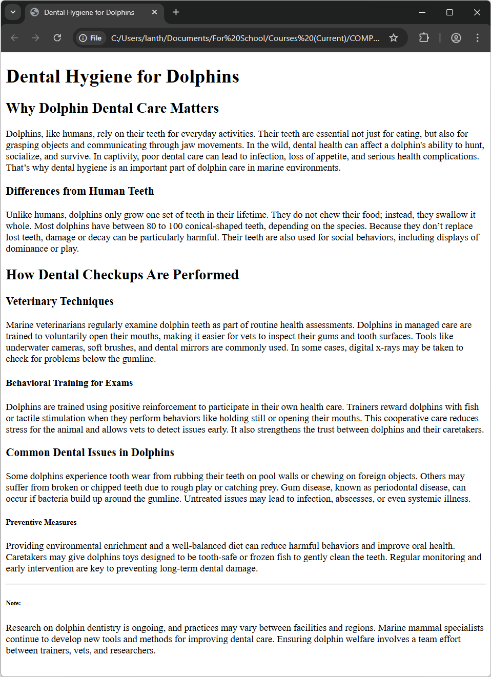

Notice something about the text in the first paragraph. The browser will automatically wrap text around and will ignore any extra blank spaces and blank lines that we add to the text. This allows the browser to have more freedom in laying out the content depending on the size of the view (e.g., pc, phone, tablet, etc..).

We can force a line break with a <br> tag and we can force single spaces by using &nbsp; (which stands for non-breaking space). So, we can do this:

<p>
Dolphins, like humans, rely on their teeth for everyday activities.
&nbsp; &nbsp; &nbsp; &nbsp; Their teeth are essential not just for eating, but also for
grasping objects and communicating through jaw movements.
<br> <br>

In the wild, dental health can affect a dolphin's ability to hunt, socialize, and survive.
<br> <br> <br>

In captivity, poor dental care can lead to infection, loss of appetite, and serious health
complications. That’s why dental hygiene is an important part of dolphin care in marine
environments.
</p>

Now, it will display like this:

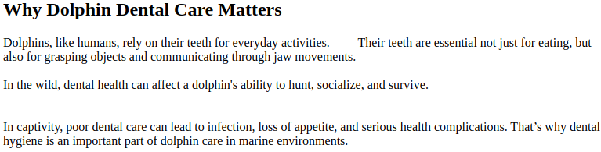

Notice the extra spaces and the extra lines. However, it is not considered good/proper HTML style to use <br> tags and &nbsp; for layout. We will see later how to use CSS for proper spacing.

Whenever we are structuring webpage content such as articles, reports or multi-part documents, it would be good to also use <section> … </section> tags. This allows us to group related content into logical blocks (e.g., chapters, subsections, topics, etc..). Really, any time we have content that belongs together thematically (i.e., represents a standalone idea or topic), we should use <section> tags. Some advantages to using them are that it is …

easier for browsers and screen readers to navigate
easier for search engines to understand content hierarchy
easier for us developers to maintain larger webpages

It is always best to use a heading tag (e.g., <h2>) for each section. In fact, if we don’t have a heading tag, then we likely shouldn’t be using a <section> tag. <section> tags should be used for logical divisions … not simply to wrap every paragraph in a section.

There is a similar tag called <div> … </div> that we will see later. It is also used to logically group together HTML code, but mainly for the purpose of styling. It is like saying “Everything within this tag will have the same style (e.g., color, font, alignment etc..)”.
Even though the appearance of the webpage will be the same, here is what the code looks like in a file called dentalHygieneSections.html:

<!DOCTYPE html>
<html lang="en">

<head>
<meta charset="UTF-8">
<title>Dental Hygiene for Dolphins</title>
</head>

<body>
<h1>Dental Hygiene for Dolphins</h1>

<section>
<h2>Why Dolphin Dental Care Matters</h2>
<p>
Dolphins, like humans, rely on their teeth for everyday activities. Their teeth are
essential not just for eating, but also for grasping objects and communicating
through jaw movements. In the wild, dental health can affect a dolphin's ability to
hunt, socialize, and survive. In captivity, poor dental care can lead to infection,
loss of appetite, and serious health complications. That’s why dental hygiene is an
important part of dolphin care in marine environments.
</p>

<section>
<h3>Differences from Human Teeth</h3>
<p>
Unlike humans, dolphins only grow one set of teeth in their lifetime. They do
not chew their food; instead, they swallow it whole. Most dolphins have between
80 to 100 conical-shaped teeth, depending on the species. Because they don’t
replace lost teeth, damage or decay can be particularly harmful. Their teeth
are also used for social behaviors, including displays of dominance or play.
</p>
</section>
</section>

<section>
<h2>How Dental Checkups Are Performed</h2>

<section>
<h3>Veterinary Techniques</h3>
<p>
Marine veterinarians regularly examine dolphin teeth as part of routine health
assessments. Dolphins in managed care are trained to voluntarily open their
mouths, making it easier for vets to inspect their gums and tooth surfaces.
Tools like underwater cameras, soft brushes, and dental mirrors are commonly
used. In some cases, digital x-rays may be taken to check for problems below
the gumline.
</p>
</section>

<section>
<h4>Behavioral Training for Exams</h4>
<p>
Dolphins are trained using positive reinforcement to participate in their own
health care. Trainers reward dolphins with fish or tactile stimulation when
they perform behaviors like holding still or opening their mouths. This
cooperative care reduces stress for the animal and allows vets to detect issues
early. It also strengthens the trust between dolphins and their caretakers.
</p>
</section>
</section>

<section>
<h3>Common Dental Issues in Dolphins</h3>
<p>
Some dolphins experience tooth wear from rubbing their teeth on pool walls or chewing on foreign objects. Others may suffer from broken or chipped teeth due to
rough play or catching prey. Gum disease, known as periodontal disease, can occur
if bacteria build up around the gumline. Untreated issues may lead to infection,
abscesses, or even systemic illness.
</p>

<section>
<h5>Preventive Measures</h5>
<p>
Providing environmental enrichment and a well-balanced diet can reduce harmful
behaviors and improve oral health. Caretakers may give dolphins toys designed
to be tooth-safe or frozen fish to gently clean the teeth. Regular monitoring
and early intervention are key to preventing long-term dental damage.
</p>
</section>

<hr>

<section>
<h6>Note:</h6>
<p>
Research on dolphin dentistry is ongoing, and practices may vary between
facilities and regions. Marine mammal specialists continue to develop new tools and methods for improving dental care. Ensuring dolphin welfare involves a team
effort between trainers, vets, and researchers.
</p>
</section>
</section>

</body>
</html>

Notice how much more readable the document is with the extra sections added and tabbed nicely … although it will display the same in the browser.

2.2 Other Common HTML Tags

Another often-used tag pair in HTML is <table> </table>, which allows us to organize our content into rows and columns. Within these tags, we can add a caption, a header and a body to the table using their own wrapping tags as follows:

<table>
<caption> ... </caption>
<thead> ... </thead>
<tbody> ... </tbody>
</table>

Then we use <tr> </tr> tag pair to indicate a row of the table. For each cell of the table, we can use the <th> </th> tag pair to wrap information that goes in the cell of the table’s header and the <td> </td> tag pair to wrap information that goes in a cell of the body of the table.

Here is an example (in the movieTable.html file) that shows a table of some movies and some statistics about the movie:

<!DOCTYPE html>
<html lang="en">

<head>
<meta charset="UTF-8">
<title>Movie List</title>
</head>

<body>
<table border="1">
<caption>Popular Movies and Their Ratings</caption>
<thead>
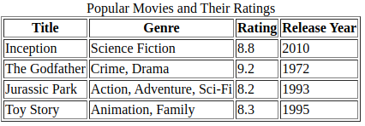
<tr>
<th>Title</th>
<th>Genre</th>
<th>Rating</th>
<th>Release Year</th>
</tr>
</thead>
<tbody>
<tr>
<td>Inception</td>
<td>Science Fiction</td>
<td>8.8</td>
<td>2010</td>
</tr>
<tr>
<td>The Godfather</td>
<td>Crime, Drama</td>
<td>9.2</td>
<td>1972</td>
</tr>
<tr>
<td>Jurassic Park</td>
<td>Action, Adventure, Sci-Fi</td>
<td>8.2</td>
<td>1993</td>
</tr>
<tr>
<td>Toy Story</td>
<td>Animation, Family</td>
<td>8.3</td>
<td>1995</td>
</tr>
</tbody>
</table>
</body>
</html>

As we can see, the table keeps things nicely organized into cells. Notice as well that we can specify the number of pixels of thickness for the table (and cell) borders. In HTML5, we don’t usually do this now, we will use CCS (more later).

The table header items are, by default, displayed in bold and centered, although this is all adjustable. It is interesting to note that it is not necessary to wrap the header cells within <thead> </thead> tags, but it is good to use it because:

Semantic clarity - it tells the browser and assistive tech: “This is the header”
Sticky headers - in some CSS/JS frameworks, it helps implement sticky table headers
Consistency when printing - browsers may repeat <thead> rows on each printed page for multi-page tables
Styling – we can easily style just the header rows via CSS (more later)

We can also specify that some data should span multiple rows or columns by inserting rowspan and colspan within the <td> tag. For example, how would we produce this table:

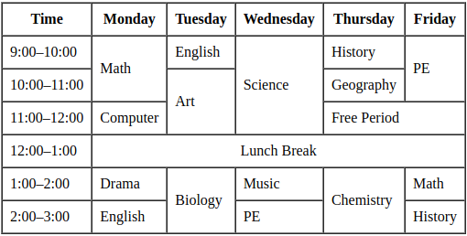

Well, we would need to indicate that Math, Art, Biology, PE and Chemistry all span 2 rows, Science spans 3 rows, Free Period spans 2 columns and Lunch Break spans 5 columns.

Here is the code (in a file called scheduling.html), with a few extra features as well:

<!DOCTYPE html>
<html lang="en">
<head>
<meta charset="UTF-8">
<title>Movie List</title>
</head>
<body>
<table border="1" cellpadding="8" cellspacing="0">
<thead>
<tr>
<th>Time</th>
<th>Monday</th>
<th>Tuesday</th>
<th>Wednesday</th>
<th>Thursday</th>
<th>Friday</th>
</tr>
</thead>
<tbody>
<tr>
<td>9:00–10:00</td>
<td rowspan="2">Math</td>
<td>English</td>
<td rowspan="3">Science</td>
<td>History</td>
<td rowspan="2">PE</td>
</tr>
<tr>
<td>10:00–11:00</td>
<td rowspan="2">Art</td>
<td>Geography</td>
</tr>
<tr>
<td>11:00–12:00</td>
<td>Computer</td>
<td colspan="2">Free Period</td>
</tr>
<tr>
<td>12:00–1:00</td>
<td colspan="5" style="text-align:center;">Lunch Break</td>
</tr>
<tr>
<td>1:00–2:00</td>
<td>Drama</td>
<td rowspan="2">Biology</td>
<td>Music</td>
<td rowspan="2">Chemistry</td>
<td>Math</td>
</tr>
<tr>
<td>2:00–3:00</td>
<td>English</td>
<td>PE</td>
<td>History</td>
</tr>
</tbody>
</table>
</body>
</html>

The rowspan and colspan values should be intuitive, according to what we needed. However, while the 9:00-10:00 timeslot row has 6 <td> tags, notice that the 10:00-11:00 timeslot row has only 3 <td> tags. That is because Math, Science and PE “extend into” the next row, so it is implied that there will be no data cells for those columns in the 10:00-11:00 timeslot row. Only Art and Geography are the data items for that row.

Notice at the beginning of the table we are using cellpadding="8". This allows 8 pixels of spacing all around the inside of the table cells, which spaces them out nicely. The cellspacing="0" allows no spacing around the outside of the cells, whereas the default was 2 pixels as we can see in our earlier movie ratings table.

Lastly, notice the use of style="text-align:center;" in the Lunch Break row. This allows the words to be centered across the 5 columns that it spans.

There are so many (other) options available. As it turns out, in HTML5, the border=, cellpadding= and cellspacing= are all deprecated, so it is not good to use them. Instead, we will use CSS options. The use of style="text-align:center;" is actually considered inline CSS. We will talk more about this soon.

Other useful formatting tags are ones used for creating lists. We can simply wrap our list items in the <ul> </ul> tags if we want an unordered (i.e., bulleted) list and <ol> </ol> if we want a numbered list. Then we wrap each list item with the <li> </li> tags . Here is cakeBake.html:

<!DOCTYPE html>
<html lang="en">
<head>
<meta charset="UTF-8">
<title>Cake Bake</title>
</head>
<body>
<h1>Vanilla Sponge Cake</h1>
<p>
This recipe is for a classic vanilla sponge cake. It's light, fluffy, and perfect for
any occasion. Whether you're serving it plain, dusted with powdered sugar, or topped
with your favorite frosting, this cake is a timeless treat that's easy to make and
always delicious.
</p>
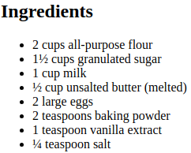
<h2>Ingredients</h2>
<ul>
<li>2 cups all-purpose flour</li>
<li>1½ cups granulated sugar</li>
<li>1 cup milk</li>
<li>½ cup unsalted butter (melted)</li>
<li>2 large eggs</li>
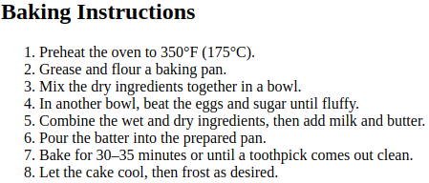
<li>2 teaspoons baking powder</li>
<li>1 teaspoon vanilla extract</li>
<li>¼ teaspoon salt</li>
</ul>

<h2>Baking Instructions</h2>
<ol>
<li>Preheat the oven to 350°F (175°C).</li>
<li>Grease and flour a baking pan.</li>
<li>Mix the dry ingredients together in a bowl.</li>
<li>In another bowl, beat the eggs and sugar until fluffy.</li>
<li>Combine the wet and dry ingredients, then add milk and butter.</li>
<li>Pour the batter into the prepared pan.</li>
<li>Bake for 30–35 minutes or until a toothpick comes out clean.</li>
<li>Let the cake cool, then frost as desired.</li>
</ol>

<h2>Serving</h2>
<p>
Allow the cake to cool completely before serving. For best results, slice with a
serrated knife to maintain the cake’s fluffy texture. Serve plain, dusted with
powdered sugar, or topped with whipped cream and fresh fruit. This cake pairs
wonderfully with tea or coffee and can also be layered with frosting or jam for
a more festive presentation.
</p>

<hr>

<h6> Disclaimer </h6>
<p>
This recipe is provided for informational purposes only. Cooking times and
results may vary depending on your equipment and ingredients. Please use
caution when handling hot ovens and sharp utensils. We are not responsible
for any accidents or damages that may occur while following this recipe.
</p>
</body>
</html>

2.3 Images, Links and Forms

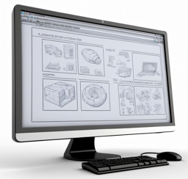
Text-only pages are boring. How do we add images to our webpages? We simply use the self-closing <img> tag which has this format:

<img src="imageFileName.jpg" alt="Description of image">

The src indicates the name of the file, which should also include the path to the file or the URL. Here are a common options for the src value:
- Relative URL (i.e., relative path) - points to an image file relative to current HTML file location
src="cake.jpg" file is in same folder as the html file
src="images/cake.jpg" file is in images subfolder from where the html file is
src="./images/cake.jpg" ./ means current directory, so same as above
src="../images/cake.jpg" back up one folder then go into images folder
src="../../images/cake.jpg" back up two folders then go into images folder

- Absolute URL (full web address) - points to an image hosted anywhere on the web
src="https://madeup-example.com/images/cake.jpg"

- Local file system path (not recommended for web) - points to a local file on computer
src="C:/Users/Me/Pictures/cake.jpg"

The alt is optional. It lets us specify alternative text to be shown if the image cannot load. We should always provide the alt description because it:

it improves accessibility for screen readers.
displays something if the image fails to load (e.g., URL is invalid or file type not supported).
helps with search engine optimization so that image shows up in image search results.
- provides text description if browser turns off image display .
(e.g., to reduce data cost when using a mobile plan or to speed up loading)

What goes into an alt description? We should try to keep it concise and yet informative, ensuring that it is descriptive and relevant to the image, yet avoid stuffing keywords together unnaturally.

Since images can vary greatly in size and resolution, it is common to adjust the size of an image on our webpage so that it fits into a specific area. We can use the width and height options withing our <img> tag to specify the number of pixels that the width and/or height of the image will be displayed with. We can also supply an optional title value that with be a descriptive text that will appear when the cursor hovers over the image.

In our cake-baking example, we can add an image of a finished cake right under the heading as follows:

<h1>Vanilla Sponge Cake</h1>

<img src="spongecake.jpg" width=200 height=200 title="Vanilla Sponge Cake"
alt="Vanilla sponge cake with icing and peach slice topping">

<p>
This recipe is for a classic vanilla sponge cake.
It's light, fluffy, and …

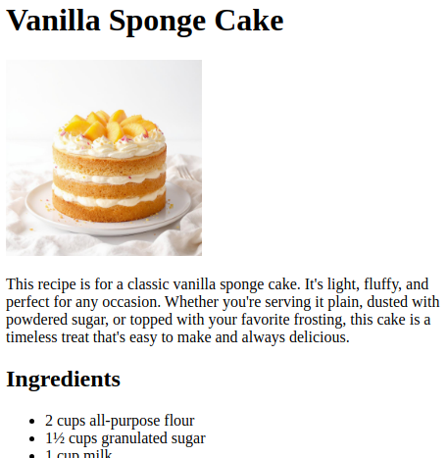
For this to work, we would need to ensure that the spongecake.jpg image is in the same directory as the cakeBake.html file. Otherwise, we would have to adjust the src= value to be the path that we would need to follow to get to the cake image.

The image will be displayed as shown here

We can also tell the browser to display a favicon (i.e., favorite icon) at the left of our webpage tab as shown here in the image below (i.e., spongecakeIcon.jpg):
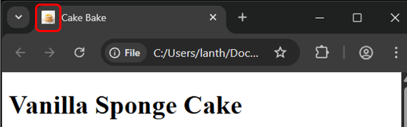

To add the favicon, we add a <link> tag in the <head> section of the webpage, often just below the <title> tag as follows (check it out in the cakeBakeImage.html file):

<head>
<meta charset="UTF-8">
<title>Cake Bake</title>
<link rel="icon" href="spongecakeIcon.png">
</head>

Here, the rel= attribute stands for the relationship between the current html document and the linked resource. In our case, we are specifying that we want to supply the icon for the webpage. The href= attribute stands for hypertext reference. In the case of specifying an icon, we should supply the path to the image file.

Icon images are typically one of three types:

- .ico - traditional, supported everywhere
- .png - modern, supports transparency
- .svg - scalable vector, newer browsers

The standard size of an icon is 16×16 pixels, but modern browsers support larger/responsive versions too … meaning that the icon can adapts well to different screen sizes, resolutions, and devices.

In the above example, we used href= to refer to an external image file. In general, we can refer to any file, which may not be an image.

Anywhere on our webpage file, we could insert a link to a resource that the user can click on. A link uses the anchor tag pair (i.e., <a> </a> ) which has this format:

<a href="pathToFilename.xxx">linkText</a>

Once again, the path to the filename/resource can be relative or absolute, just as with image files. The linkText is the text that appears on the webpage, which the user would click on to get to the resource.

Consider the following tree structure for folders and files being used by a website (directories / folders are shown in purple)  In the index.html file, how would we set up the favicon which is in the icons subdirectory?  <link rel="icon" href="icons/favicon.ico">  How would we include/display the logo.png image file as an image on the index.html webpage?  <img src="images/logo.png"  title="Company Logo"  alt="Delicious Food company logo">  Assume that we had the following code somewhere on the index.html webpage:  <body>  <h1>Products</h1>  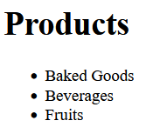  <ul>  <li>Baked Goods</li>  <li>Beverages</li>  <li>Fruits</li>  </ul>  </body> | ──── food-website  │ about.html ← about the food brand  │ contact.html ← contact page  │ index.html ← main homepage  │  ├─── icons ← favicons or SVG icon files  │ apple-touch-icon.png  │ favicon.ico  │  ├─── images ← images for main page  │ background-pattern.png  │ banner.png  │ logo.png  │  ├─── products ← product category pages  │ │ baked-goods.html  │ │ beverages.html  │ │ fruits.html  │ │  │ └─── details ← specific product detail pages  │ apple.html  │ chocolate-cake.html  │ lemonade.html  │  ├─── scripts ← JavaScript files  │ interactivity.js  │  └─── styles ← CSS files  main.css
Assume also, that we had separate webpages (i.e., .html files) for each of these products within a products subfolder as shown in the above hierarchy. How can we turn the three bullet items (in the list above) into links to each of these three webpages?

We would simply make use of the anchor <a> tags and reference each page accordingly:
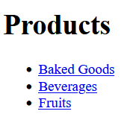
<body>
<h1>Products</h1>
<ul>
<li><a href="products/baked-goods.html">Baked Goods</a></li>
<li><a href="products/beverages.html">Beverages</a></li>
<li><a href="products/fruits.html">Fruits</a></li>
</ul>
</body>

What if the baked-goods.html page required the logo.png file to be used, which is in the images folder? What would the image src look like if we wanted to reference that same image file?
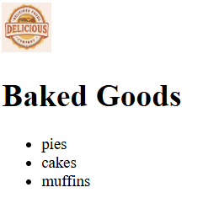

<img src="../images/logo.png" title="Company Logo"
width=50 height=50 alt="Delicious Food company logo">

What if we wanted the user to be able to click on the logo to go back to the main index.html page?

We could make a link from the image by supplying the logo image inside the link
instead of text as follows:

<a href="../index.html">
<img src="../images/logo.png" title="Company Logo"
width=50 height=50 alt="Delicious Food company logo">
</a>

Clicking on this link will allow the index.html file to open in the same tab/window as the baked-goods.html file. If we want the index.html file to open in a new window, we can set the target to "_blank" as follows:

<a href="../index.html" target="_blank">
<img src="../images/logo.png" title="Company Logo"
width=50 height=50 alt="Delicious Food company logo">
</a>

The default (to open in same tab/window) is target="_self", which we never have to specify.

FORMS

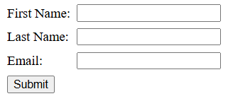
One last HTML item that we will mention is that of forms. An HTML form allows users to input data and submit it to a server for processing (e.g., signing up, logging in, searching, providing feedback, etc..). We will talk more about this later in the course but for now, how can we make a form like this shown here with 3 labels and their corresponding text fields along with a Submit button?

Here is the code:

<form action="https://example.com/apply" method="post">
<label for="first">First Name:</label>
<input type="text" id="first" name="firstname">

<label for="last">Last Name:</label>
<input type="text" id="last" name="lastname">

<label for="email">Email:</label>
<input type="email" id="email" name="email">

<input type="submit">
</form>

Unfortunately, it looks like this though? …
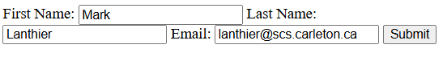

We need to use a table to contain all the input items as follows:

<form action="https://example.com/apply" method="post">
<table cellpadding="4" cellspacing="0">
<tbody>
<tr>
<td><label for="first">First Name:</label></td>
<td><input type="text" id="first" name="firstname"></td>
</tr>
<tr>
<td><label for="last">Last Name:</label></td>
<td><input type="text" id="last" name="lastname"></td>
</tr>
<tr>
<td><label for="email">Email:</label></td>
<td><input type="email" id="email" name="email"></td>
</tr>
<tr>
<td><input type="submit"></td>
</tr>
</tbody>
</table>
</form>

Getting back to the <form> tag … notice the action and method attributes. The action attribute lets us specify the URL where we want to send the form data to when the Submit button is pressed. The method is either "get" or "post" (more on this later in the course).

There are three label/input pairs in the body of the form. The value of the for= in the label should match the value of the id= in the input so that a connection is made between the two.

There are many options for the <input> tag type attribute:
- "text" – a regular text field
- "password" – a password text field (text will be hidden)
- "email" – an email address text field
- "checkbox" – a checkbox
- "radio" – a radio button
- "submit" – a submit button
- "file" – a file upload

What happens when we submit the form by pressing the Submit button?
- The data is collected from the form fields.
- The browser sends the data to the server using the specified method (i.e., get or post).
- The server processes the data and returns a response.
We will look much more at this later in the course.

MUCH MORE…


When it comes to HTML, there is a LOT more to know. We can look up online references when we are trying to do something specific that we have not discussed.

We should bookmark this website and use it throughout the course: https://www.w3schools.com

It contains tutorials, guides and references for HTML, CSS, Javascript … and many other things.

There is a nice style guide there for HTML. Please look that over because all submitted code in this course is expected to follow proper/valid HTML coding practices.

Here are some tips mentioned there:

- Use lowercase tag names (e.g., <body> … not <BODY>)
- Use lowercase names (e.g., <a href="…"> … not <a HREF="…">)
- Close all HTML tags that need to be closed (e.g., <p> … </p>)
- Always quote attribute values (e.g., <a src="logo.png">… not <a src=logo.png>)
- Use lowercase file names (e.g., logo.png … not … Logo.png)
- Always specify alt, width and height for images.
- Don’t put spaces around equal signs (e.g., <a href="…"> … not <a href = "…">)
- Do not add blank lines and indentation without a reason.
- For readability, add blank lines to separate large or logical code blocks.
- Make sure that we indent and align nested levels of tags.
- Always include the <title>, <html>, <head>, and <body> tags.

We can check all our HTML code to see if our code is valid by going to this website:

https://validator.w3.org/#validate_by_input+with_options


Now that we have learned the basics of HTML, we can think of it as the backbone (or “skeleton”) of every web page. That is … HTML gives structure and meaning to the content of our page. But a plain HTML page still looks pretty bare (and lame). To make those pages visually appealing and easier to read, we need a way to style and format what we’ve built. In the next chapter, we will explore how to control colors, fonts, layouts, and overall design so our pages won’t just “work” … they will actually look polished and professional.

