Chapter 6

Client-Server Communication

What is in This Chapter ?
This chapter explains the structure of the underlying communication that takes place between the client and the server. It explains how Web Apps differ from conventional applications that we have been working on in other courses. We will introduce important terms such as IP Addresses, URLs, HTTP, DNS and DNS Lookup. The chapter digs into how HTTP Requests and HTTP Responses are used to facilitate client/server communication. The chapter ends with a short discussion of URL shortening and Caching.

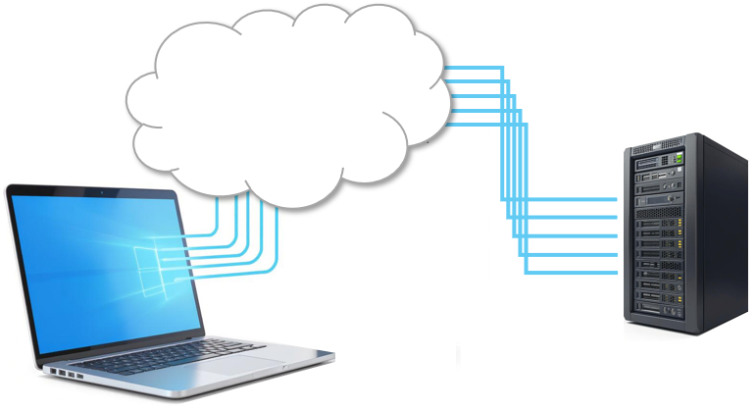
6.1 Client-Server Architecture

Recall that web apps differ from websites in that they are software built for interaction in a browser, as opposed to just information to be “browsed through”. Unlike traditional desktop applications, web apps do not need to be installed on a user's device. They are hosted on remote (perhaps multiple) servers and delivered through standard web technologies such as HTML, CSS, and JavaScript. They may connect to backend services or databases via APIs.

Web apps are platform-independent, meaning they can run on any device with a browser (i.e., PC, Mac, smartphone, tablet). They can range from simple tools (like a calculator) to complex systems (e.g., online banking platforms, multi-player games or collaborative tools like Google Docs). They are accessible via a URL using a web browser (e.g., Chrome, Firefox).

Web apps have advantages over installed (native) apps:

Cross-platform compatibility

- works on any device with a browser (Windows, macOS, Android, iOS, etc.)
- no need to develop separate versions for each operating system

No installation required
- users don’t need to download or install anything … just open a URL
- easier for users to access and try

Easy updates and maintenance
- changes are made on server, so all users get the latest version instantly
- no need for users to manually update the app

Lower development and deployment costs
- one codebase can serve all platforms
- hosting and deployment are often simpler than native apps

Scalability
- easier to scale for more users or expanded features through backend infrastructure

Of course, there are disadvantages of web apps as well …

Internet dependency
- requires an internet connection to function (or to function fully), although some can work offline with technologies like service workers
Limited access to device hardware
- restricted access to hardware features like GPS, camera, Bluetooth, etc., compared to native apps

Performance limitations

- generally slower than native apps, especially for graphics-heavy or real-time applications (e.g., games, video editing)
Security risks
- being online exposes them to web-based threats
- more effort is needed to secure web apps properly
Privacy concerns
- user data is stored on remote servers and may be exposed to third-party tracking, unauthorized access, or insufficient data protection practices
User experience
- may not feel as smooth or integrated as native apps, especially on mobile
- limited offline functionality compared to native apps
Development
- can be more difficult to develop and debug

How does the development of web apps differ from what we have been doing?

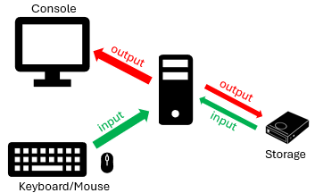
We are used to writing desktop applications which were mostly console-based, although most will have a GUI component. Our applications involved a single user doing one thing at a time, often based on prompts, but sometimes based on events from the GUI. There were no interacting resources.

This is the architecture that we are familiar with

In the case of web applications, we are working with a different kind of architecture … one that is distributed
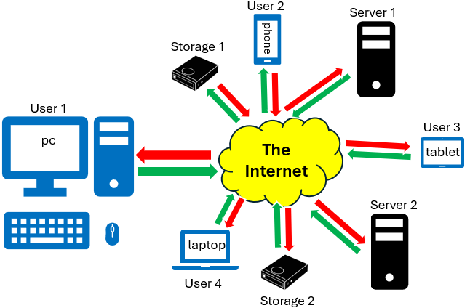
and decoupled. The client (the user's browser or app) is separate from the server (where the data and application logic live). Multiple clients can interact with the server simultaneously. Additionally, many resources and systems may interact behind the scenes, often across different computers or services. Web app behavior is typically event-driven, meaning the application responds to user actions or other triggers in real time.

Is the internet really a “cloud”?

We sometimes think of the internet as “the cloud”. However, the term “cloud”
?
in computer science, refers to remote computing resources that are accessible over the internet (e.g., servers, storage apps). When we use services like Google Drive or Dropbox, we are storing data "in the cloud" (i.e., on internet-connected servers). From the user's perspective, the location and infrastructure are abstracted away (i.e., just as we can see a cloud in the sky floating above us, but we don’t see all the air, water, and wind that hold it up … cloud computing gives us services without showing the servers, networks, and infrastructure that make them work).

In contrast, the internet is the global network (i.e., the infrastructure) that connects computers. The cloud refers more specifically to services and resources hosted on that network. So, not all the internet is “the cloud”, and not all cloud services are public (some are private or hybrid). So …

The internet is the global network that connects devices.
The cloud is the services and storage delivered via the internet.

How does the internet know how to connect one device to another?
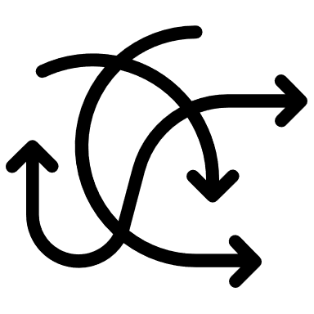
As it turns out, things are somewhat organized. Just as houses are organized by unique addresses, the devices on the internet also have somewhat unique addresses.

An IP address is a unique identifier for a device on a network.

IP is short for Internet Protocol. An IP address is a lot like a home address. It uniquely identifies a device on a network and provides its location so data can be sent to and from it correctly.

If we were to use the postal service as an analogy …
- IP address = mailing address
- data being sent = package being delivered
- internet = postal system.
And just as a package won’t arrive at its destination without a proper address, data won’t reach our device without its correct IP.

Here are two different IP protocols:

- IPv4 - most common, uses 4 numbers (each from 0 to 255) separated by dots.
192.168.0.1 limited at ~4.3 billion address combinations
- IPv6 - newer, more complex, supports more devices, uses 8 groups of 4 hex digits with colons.
2001:0db8:85a3:0000:0000:8a2e:0370:7334
essentially unlimited at 6 × 10²⁸ times more addresses than IPv4 😲
The IP is just the address, but a lot happens behind the scenes to make communication work. In fact, both the client and server go through several steps to send and receive data successfully. All these steps happen according to a framework called the TCP/IP model (short for Transmission Control Protocol / Internet Protocol), which provides the foundational set of communication rules (protocols) that makes the Internet and most modern networks work.

The TCP/IP model is made up of four layers … each handling part of the communication process:

- Application Layer - where the apps we use (e.g., our browser or email) talk to the internet and send or receive information.
- Transport Layer - makes sure our messages get sent safely and in the right order (like a reliable mail carrier).
- Network Layer - figures out the best route to send our data across the internet (like using a GPS for our messages).
- Link Layer - handles the actual physical connection (like our Wi-Fi or Ethernet cable, sending data between nearby devices).
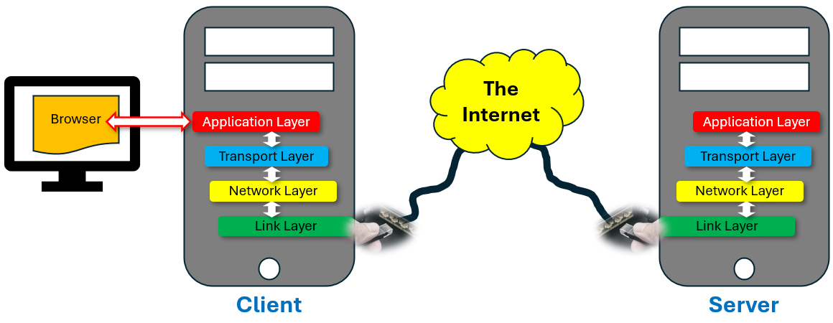

What happens when a client talks to a web server?

Here is what happens when we (the client) open a browser and type in a web address:

- Our device:

  - puts the message in a box (transport layer)
… like wrapping a package so it won’t get damaged or lost
  - writes the address on the box (network layer)
… like writing the website’s IP address so it knows where to go

- The box travels through the internet and arrives at the server.

- The server:
  - unpacks the box (transport layer, again).
  - reads the message … like saying “Hey, show me this web page!”.

- The server sends a reply back in the same way:
  - puts the web page in a box (transport layer).
  - writes our address on it (network layer).
  - sends it back to our device.
- Our device opens the “box” and shows us the web page!
Of course, just as delivering physical mail can have delays and issues … there can be latency issues involved with this whole process. There is always a bit of uncertainty as to whether data will get lost or be unavailable (i.e., website down). And of course, when dealing with such a large network of devices, there are scalability issues as well (i.e., server might crash or slow down if thousands of users try to access a website at the same time).

When it comes to each layer, there are specific protocols (i.e., tools or rules) that each layer uses to do its job. Here is a table of the most common ones:

TCP/IP Layer | Common Protocols Used | Intuitive Description
Application Layer | HTTP, HTTPS, FTP, DNS, SMTP, IMAP, SSH | the kind of message it is
Transport Layer | TCP, UDP | how safely or quickly we send it
Network Layer | IPv4, IPv6, ICMP, ARP, IGMP | putting the right destination on it
Link Layer | Ethernet, Wi-Fi (IEEE 802.11), PPP, DSL | how it travels (car, bike, plane)

Here are definitions of some of these protocols:
- HTTP (Hypertext Transfer Protocol) - to request/display web pages

- HTTPS (HTTP Secure) - to request/display web pages securely (i.e., encrypts data)

- FTP (File Transfer Protocol) - to upload/download files between computers

- DNS (Domain Name System) - to translate human-readable names into their IP addresses

- SMTP (Simple Mail Transfer Protocol) - to send mail

- IMAP (Internet Message Access Protocol) - to receive mail

- SSH (Secure Shell) - to securely access and control a remote computer

- TCP (Transmission Control Protocol) - a protocol that ensures data is delivered accurately and in the correct order (it’s like making phone call)

- UDP (User Datagram Protocol) - a faster but less reliable protocol that sends data without checking if it arrives correctly (it’s like sending physical mail)

6.2 Communication Basics

In this course, we will be doing both client-side and server-side programming. All communication between a client and a server happens through HTTP requests sent by the client and HTTP responses sent by the server.
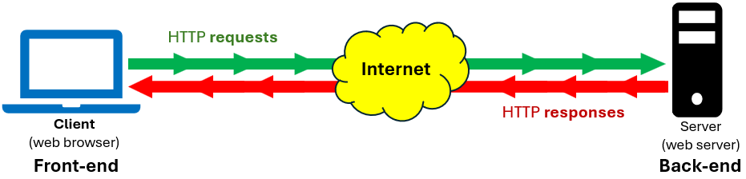

To make this work, we need software on both the client side as well as the server side:
Client-side software runs in the user’s browser … handling the visual layout and user interaction using HTML, CSS, and JavaScript, and requesting pages, scripts, or data from the server.
Server-side software runs on the web server … processes requests (e.g., by accessing a database or performing logic), and then sends back the appropriate resources (e.g., web pages, files, or data).


In this course, we will learn what is involved in being …

- A front-end developer - proficient in client-side technologies (i.e., the parts of a web application that users interact with directly, such as HTML, CSS, and JavaScript).
- A back-end developer - proficient in server-side technologies (i.e., handles things like database interactions, server logic, APIs, and authentication).
- A full-stack developer - has expertise across all major parts of web development, including both front-end and back-end technologies.

The “stack” in “full-stack” refers to the different layers or components of a web application … from the user interface down to the database. As tech stacks have become more complex, even full-stack developers often specialize in certain tools or layers while understanding the full picture.

You may not realize, but a simple request (e.g., to look at a webpage) actually requires a lot of interaction between the client and the server.

For example, assume that we want to watch some YouTube videos on our browser (or app). Let’s walk through what happens, where the USER is “us”, the CLIENT is our browser (or app) and the SERVER is YouTube’s web server:
- USER: Enters www.youtube.com into the browser’s address bar.
- CLIENT: Contacts the Domain Name System (DNS) to find the IP address of YouTube.com.
- CLIENT: Starts a connection to the server using the HTTPS protocol, using the IP address.
- CLIENT: Sends an HTTP request to the SERVER saying: "Please send me the homepage"
- SERVER: Receives the request, checks details like our location, account status, preferences, etc., and gathers the needed web page content.
- SERVER: Sends back the response (usually includes HTML, CSS, JavaScript, Thumbnails, logos, images, etc.)
- CLIENT: Builds (“renders”) the web page using all the pieces it received, and displays it in the browser.
- LOOP:
CLIENT: Sends more requests for dynamic content (e.g., video thumbnails, ads, autoplay previews, personalized suggestions).
SERVER: Receives each request and sends back more data as needed.
ENDLOOP

Requests for information are usually initiated by user actions or client-side JavaScript. In the above example, it was the action of pressing the ENTER key (after typing in the URL into the browser’s address bar) that initiated the communication with the server.

Of course, for client and server communication to work successfully, both sides must agree on how to communicate and how to interpret each other’s requests and responses. This is why we use standard communication protocols (like HTTP), consistent naming and URL structures, and clearly defined web APIs (Application Programming Interfaces) to ensure both sides understand what to send and expect.

Example

Let’s look at an example of what is involved in understanding communication protocols. Consider going to a bank to perform some transactions. There are some things that need to be decided:

What kinds of transactions will we perform?
- deposit, withdraw, get a bank card, take out a loan, update personal info, etc..

What kind of information will the bank employee want from us?
- proof of identity, account numbers, amounts, etc..

Our interaction with the bank employee can be captured by the following diagram:

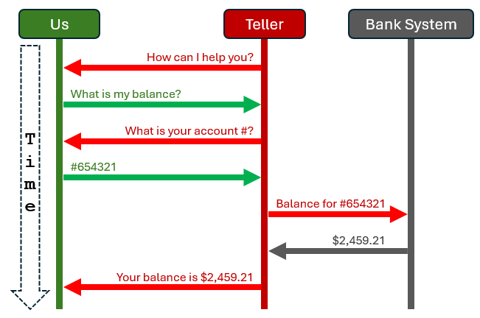
Through the browser, we end up with the same back-and-forth kinds of communication. When logging in, for example, we would see this kind of interaction:

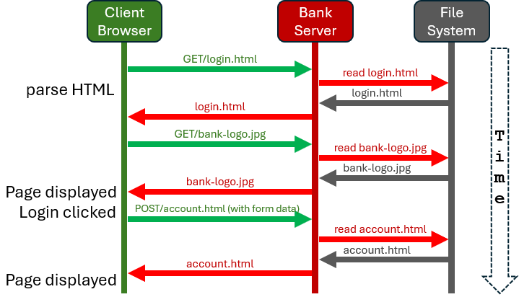
Sometimes a request is triggered by user interaction (e.g., clicking an Accept Payment button):

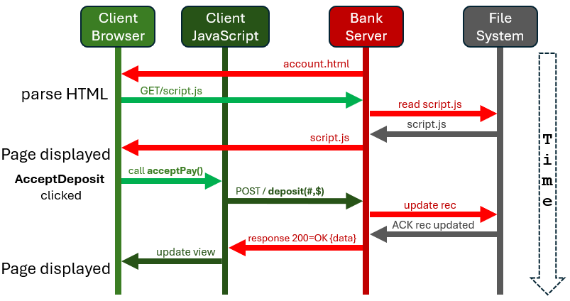

Of course, things could fail …

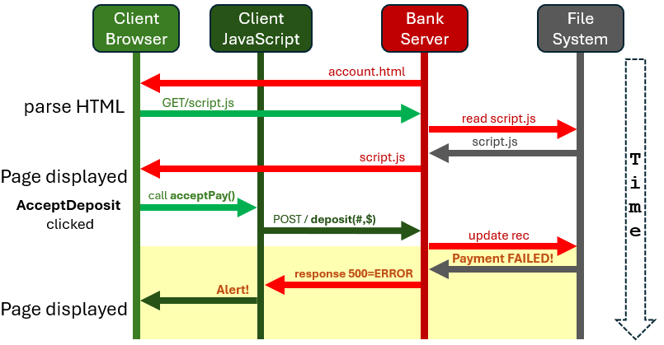

The point is, transactions are asynchronous and must deal with unexpected results.

There is a lot to think about when it comes to the design of client-side & server-side software:

What Resources Are Necessary?
- define which parts of the app the client will request (e.g., account details, transaction history, statements, or payment features).
- also includes static resources (like HTML, CSS, JavaScript) and dynamic data (like balances or alerts).

What Should Be the Naming Scheme?
- The URLs or API endpoints need to follow a clear and consistent naming pattern so that the system is kept organized, predictable, and easy to maintain (e.g., /api/accounts, /api/transactions, /api/users/login)

What Are the Data Requirements?
- define what data the client needs to send or receive so that the client and server understand each other clearly and securely
  - input formats (e.g., amount: number, accountID: string)
  - required fields
  - validation rules
  - JSON structures for requests/responses

How do we Handle the Requests and Responses?
- Need to determine:
- What HTTP methods to use (e.g., GET, POST, etc.)
- How to structure responses (e.g., with status codes, success/error messages)
- How to handle errors, timeouts, or failed transactions
- How to authenticate and authorize users (e.g., using tokens or sessions)

We should also think of the resources the bank will provide. For example, we can use the naming scheme shown on the left for transactions described on the right:

/  /login  /api/login  /api/accounts/{id}  /api/accounts/{id}/deposit  /api/accounts/{id}/withdraw  /api/transactions | - Home page  - Login page (UI)  - API endpoint to handle login  - Account info for a specific user  - Deposit money into an account  - Withdraw money from an account  - View or create transaction records

We will talk more about this later.

6.3 The Hypertext Transfer Protocol


For the average internet user, HTTP appears at the start of a web address (e.g., http://) in the browser’s address bar, indicating how the browser should communicate with the website’s server. Every time we click a link, submit a form, or visit a site, HTTP works behind the scenes to handle that connection. It is the foundational protocol of the web, enabling clients to make requests and servers to respond, facilitating all communication and data exchange online.

HTTP uses a request/response model:

An HTTP request is a message sent from a web browser to the web server, usually asking for a resource such as an HTML file, image, CSS stylesheet, JavaScript file, or video.

The HTTP response is the message the server sends back, often containing the resource we requested.

HTTP is stateless, meaning the server doesn’t remember anything about us or our previous requests each time we interact with it. Every time we send a request, all the information the server needs to understand and respond must be included within that request … nothing is carried over from before.
Like most things in life, there are advantages and disadvantages of statelessness:

Simplicity - Since the server doesn’t have to keep track of past interactions, the protocol stays simple and easier to implement.
Scalability - Servers can handle many more requests since they don’t need to store session data, making it easier to distribute requests across multiple servers.
Resilience to Failure: - The server isn’t concerned with the client once a request is completed, so failures in one request don’t impact others, improving overall stability.
Reliability - With no stored state, there’s less risk of errors related to outdated or lost session information, making each request independent and predictable.

Extra Data in Each Request: Since the server doesn’t remember previous interactions, clients have to send ALL necessary information with EVERY request, which can add overhead.
More Complex Client-Side Handling: To maintain things like user login sessions or shopping carts, extra mechanisms (e.g., cookies, tokens) need to be added on top of HTTP.
Less Efficient for Some Applications: Statelessness can make certain tasks less efficient because the server can’t rely on stored context and must process each request fully on its own.

HTTP transmits data in plain text, meaning that any information sent between the browser and the web server (e.g., login credentials, personal details, or financial data) can be intercepted and read by third parties. This makes HTTP inherently insecure, especially on public or untrusted networks (e.g., Wi-Fi in a coffee shop or airport).

HTTPS (Hypertext Transfer Protocol Secure) adds a critical layer of security by using SSL/TLS encryption to protect data during transmission. This encryption ensures that:
- The data is confidential - third parties can’t read it.
- The data is authentic - it hasn’t been tampered with.
- The communication is verified - the server is who it claims to be.

By using HTTPS, sensitive information such as passwords, credit card numbers, account details, and personal messages is securely encrypted. This protects users from eavesdropping, man-in-the-middle (MITM) attacks, and data breaches. Modern browsers also warn users when they’re visiting a site that uses HTTP instead of HTTPS, particularly if the page contains login forms or other sensitive inputs.

For now, we will just discuss HTTP.

An HTTP request or response consists of two main parts: a header and an optional body. While the headers are always plain text, the body can contain either plain text or binary data depending on the type of content being transmitted. Plain text is easy for humans to read, which makes debugging web communications straightforward. However, this also means that anyone who intercepts the data can read it, including people with bad intentions. HTTPS can be used to make transmission safe.

The header provides key information that helps both the client and server understand how to process the message.
The request’s body is optional (e.g., not used for a GET request), but it is typically included when the client (i.e., browser or app) needs to send data to the server. This may be submitted form data from the user, JSON data sent to an API, or file uploads.

The response’s body is also optional, but it’s typically present when the server sends back content to the client. This may be in the form of a webpage (e.g., HTML), data (e.g., JSON, XML), or files (e.g., images, videos, documents).

The most common example of interaction is when we visit a website by typing a web into the address bar and pressing ENTER. The browser sends an HTTP request message to the web server, typically asking for the main HTML of that page (e.g., index.html). This initial request usually has an empty body. The server responds with an HTTP response where the body contains the HTML content of the webpage and the header indicates the content (i.e., Content-Type: text/html). After receiving the HTML, the browser parses it and discovers additional resources it needs, such as CSS stylesheets, JavaScript files, images, and videos. It then sends separate HTTP requests for EACH of these resources. This creates a flurry of back-and-forth communication between the browser and the server, all happening in the background, just from the simple action of visiting a website:

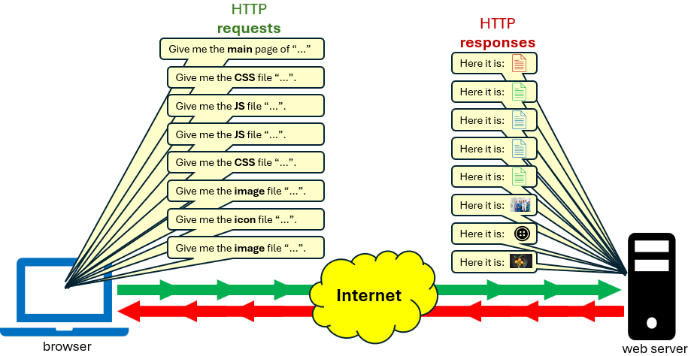

Let’s look at an example. Follow these instructions:
- Using the google chrome browser, lets go to the Carleton.ca website
- Right click to get the context menu … the select Inspect to open the Web Dev tools.
- Select the Network tab on the top row of tabs.
- Press the Shift key while clicking the reload button to the left of the address bar.

We will see a lot of things happening quickly, but it will settle after a few seconds. We should see something like this screen snapshot if we scroll the vertical scroll bar to the top:
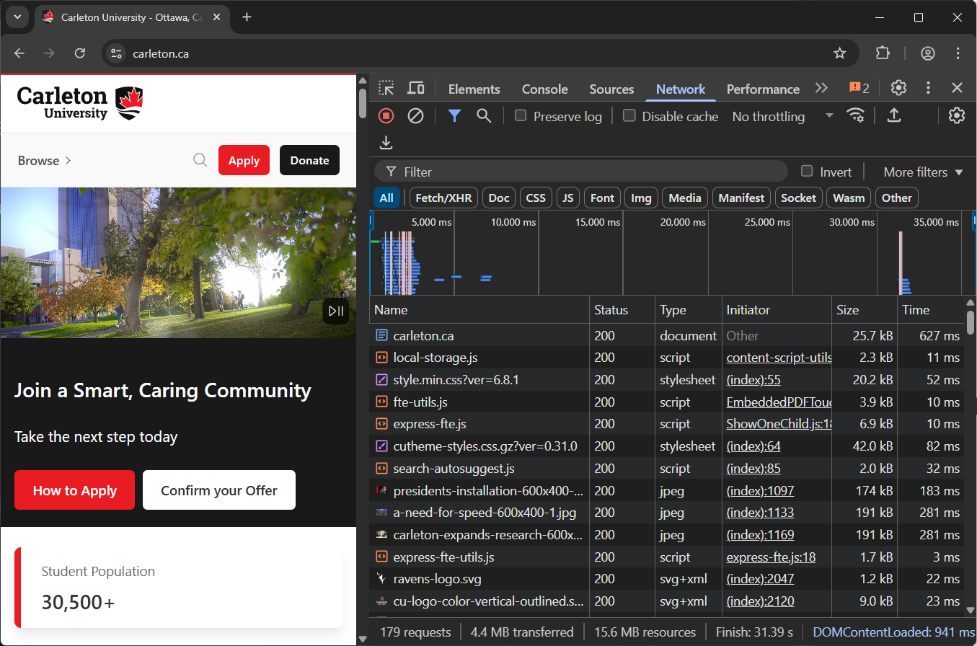

It shows a list of all the requests that were sent to the server, the first being the request for the carleton.ca webpage. Then we will see requests for various JavaScript files, style sheets and images … 155 requests in total at the time these notes were created.

The Status column tells us how the request turned out (e.g., 200 = the request was successful, 204 = there was no content, 302 = the resource is temporarily located at a different URL, etc..).

The Type column indicates the type of “thing’ returned. Other information includes the Size of the “thing” returned, how much Time it took to load etc.. Regarding loading, there is a timeline graphic above the list that gives us an idea as to how long it takes to load everything.

We can click on a request to examine the header. Try this:
- Scroll down to the favicon-32x32.png file (hopefully the page has not changed since these notes were written).
- Scroll down to the Request Headers section.
- Select the Raw checkbox (you may have to 1st check off the Disable cache under the top menu bar).
We will see the raw request data that will look something like this:
GET /rds/assets/favicons/favicon-32x32.png HTTP/1.1
Accept: image/avif,image/webp,image/apng,image/svg+xml,image/*,*/*;q=0.8
Accept-Encoding: gzip, deflate, br, zstd
Accept-Language: en-US,en;q=0.9
Cache-Control: no-cache
Connection: keep-alive
Cookie: _tt_enable_cookie=1; _ttp=pzoF7Jc82dR9h1G73JfnFUVV7at.tt.1; _ga_QZQG9H9WS9=GS1.2.1736453813.3.1.1736454206.60.0.0; _ga_JNCSQWNYYS=GS1.1.1741365158.4.0.1741365158.0.0.0; _gcl_au=1.1.465567102.1751743898; _scid=B3VAnXyYCT1ZWve80dMu2RcKDBnFi3KhnMs7Hg; _ga=GA1.1.698271906.1712855254; _ScCbts=%5B%5D; _fbp=fb.1.1751743898858.683354044531652541; _sctr=1%7C1751688000000; cookieConsent=true; TS012103f9=0169a005069a5ddbd0fbd8cb53593f6584ed5e888a23d42adb4e9c562b2672b1fbcc3714b079479d00a3cbccf79999626dfc913090; _scid_r=AnVAnXyYCT1ZWve80dMu2RcKDBnFi3KhnMs7KA; ttcsid=1751743898723::67y9Gj0cOYgbQ22CtFD1.1.1751744881344; _ga_GPRE4N72YN=GS2.1.s1751743898$o5$g1$t1751744881$j42$l0$h0; _ga_BDW6WNFPJQ=GS2.1.s1751743898$o4$g1$t1751744881$j42$l0$h0; _ga_755K5XM3HX=GS2.1.s1751743898$o1$g1$t1751744881$j42$l0$h0; _ga_9NTBQTVYKG=GS2.1.s1751743898$o4$g1$t1751744881$j42$l0$h0; ttcsid_CJNP7KJC77U5TJETM050=1751743898722::xG8sQVePVXHVlRvdzqe_.1.1751744881752
Host: cdn.carleton.ca
Pragma: no-cache
Referer: https://carleton.ca/
Sec-Fetch-Dest: image
Sec-Fetch-Mode: no-cors
Sec-Fetch-Site: same-site
User-Agent: Mozilla/5.0 (Windows NT 10.0; Win64; x64) AppleWebKit/537.36 (KHTML, like Gecko) Chrome/138.0.0.0 Safari/537.36
sec-ch-ua: "Not)A;Brand";v="8", "Chromium";v="138", "Google Chrome";v="138"
sec-ch-ua-mobile: ?0
sec-ch-ua-platform: "Windows"

Notice the GET request at the start, along with the requested favicon image. The Accept: line indicates the types of files the browser would like for this image. */* indicates I’ll accept anything and try to make it work … but the preferred image types are listed first. The Accept-Encoding: line lets the browser tell the server the types of encodings it can understand and handle.

Now, scroll up a bit and select the Response Headers and check the Raw checkbox. Notice … 200 OK was returned, indicating that all went well. Another common result could be 404 Not Found … if we, for example, spelled the file name wrong. The Last-Modified: line tells the client when the requested resource (in this case the favicon image) was last changed on the server. The browser can use this information for caching or conditional requests.

If we hit the browser’s reload button again (without the Shift pressed), then click on the Status heading at the top of the list, it will sort by status. Uncheck the Disable cache under the top menu bar if it is checked off. Scroll to the bottom and we will see some 304 status values … indicating that the resource hasn't changed (i.e., Not Modified) since the last request (i.e., it was locally cached), and so it is telling us that it did not need to be reloaded (saves time). If we reload again with the Shift key pressed, it will go back to 200 again, because the Shift+reload indicates a forced reload of everything, regardless of whether it was cached.

Over time, we will get to know a little more about the attributes shown here. Browse around a little and see if we can make sense of some of the attributes and interactions going on.

6.4 Domain Name System (DNS) and URLs


DNS stands for Domain Name System. It's like the phonebook of the internet. When we type a website address (e.g., www.google.com) into our browser, our computer doesn't know where that is. The DNS helps translate that human-friendly name into an IP address (e.g., 142.250.73.142) that computers use to find each other on the internet.

As a developer, when we put a website online, it is hosted on a server with an IP address. But users don’t want to type numbers to visit our site. DNS lets people visit our site using a domain name (e.g., my-amazing-site.com) which is not some kind of confusing IP address. It is nice to have as well because if we ever move our site to a new hosting provider, we don’t have to change our domain. We just update the DNS records to point to the new server. The domain stays the same for users.

When a client (usually a web browser) sends an HTTP request to a server, it needs to know the server's IP address. Here is where the DNS “fits in” in the context of an HTTP request:

- The user enters a URL (e.g., https://www.google.com) into the browser.
- DNS lookup occurs to resolve www.google.com to an IP address (e.g., 142.250.73.142).
- The browser opens a TCP connection (or possibly TLS for HTTPS) to that IP address.
- An HTTP request is sent over that connection:
GET / HTTP/1.1
Host: www.google.com
- The server responds with an HTTP response (HTML, JSON, etc.).

But how does this DNS lookup (in step 2 above) actually work? Here is what goes on behind the scenes:

- The user types in a website (e.g., google.com) into their browser.
- The browser checks its local cache. If the IP address is already known (from a recent visit), it uses that right away.
- Otherwise, it asks the DNS resolver (usually set by our Wi-Fi, ISP, or a public DNS like Google’s 8.8.8.8)
- The resolver checks the DNS hierarchy:
- Root server → points to the right Top-Level Domain (TLD) server (for .com, .org, etc.)
- TLD server → points to the domain’s authoritative name server
- Authoritative name server → holds the actual IP address for the domain
- The IP address is returned to the browser.
- The browser uses the IP to connect to the correct web server and load the website.

Intuition: This is all a bit like asking a series of people where someone's house is, starting with a general address book (root), then a neighborhood (TLD), then a specific person (authoritative server) who tells us the exact house number (IP address).

The good thing is that our computer already knows which DNS server to query because this information is specified in the network settings, so no manual action is required by the user.

There are millions of DNS servers (globally), and they are managed by different organizations. The whole system is fault-tolerant … with redundant servers, caching, anycast routing (i.e., traffic directed to nearest server), and multiple layers of fallback. So, if one server goes down, others can take over.


Here is a website that lets us find the IP address of a domain, server or website:

https://www.site24x7.com/tools/find-ip-address-of-web-site.html


We can go to this site to find out what our IP address is:
https://whatismyipaddress.com/

What happens if I type in a URL that does not have an IP address (e.g., spelling the website name wrong) …
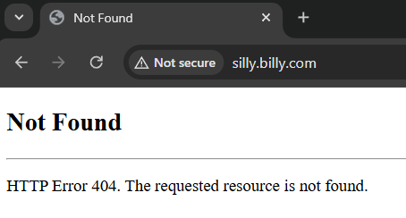

We would see the above message, for example, if we click on a link that is no longer valid. Overtime, sites go offline and links become invalid. This is called link rot.

The internet Archive (https://archive.org ) is one of many organizations around the world that fights link rot by archiving the web for posterity.

Also, the Wayback Machine on that site is interesting … it can often show users what a particular URL looked like at different times in history.

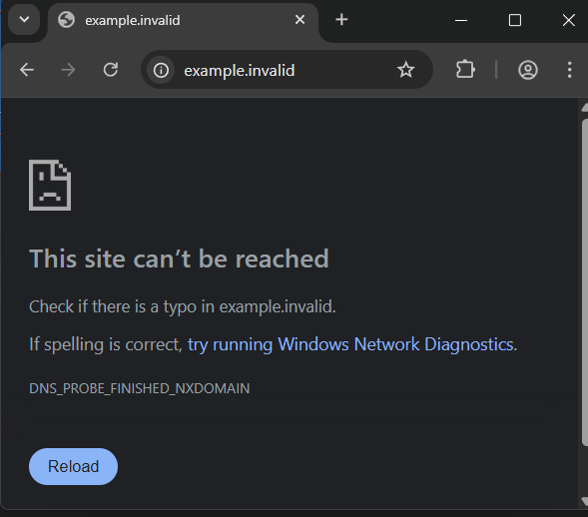
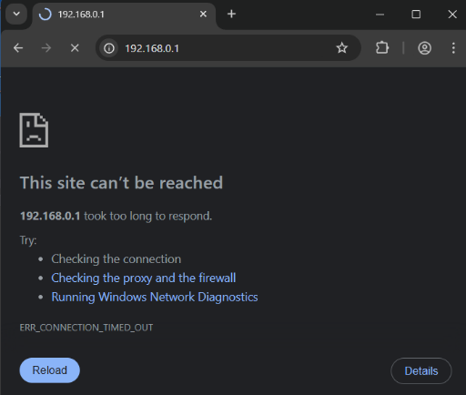
If the DNS is resolved to an IP address, but the server is off line at the moment, the chrome browser will give an error message as shown here on the left. And if it is a website that is not responding quick enough, we will get something like what is shown here on the right.

Alternatively, we can open a shell window and type ping followed by the domain name:

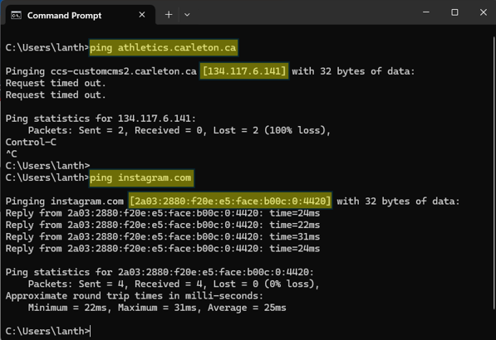

Domain Name Structure:

Understanding how domain names are structured helps when setting up websites, managing DNS records, or troubleshooting domain-related issues.

Domain names are hierarchical, organized in levels separated by dots. Each dot indicates a more specific part within the hierarchy. For example, the following is a three-level domain name:
athletics.carleton.ca
- .ca = the top-level domain (TLD). It is always the rightmost part and indicates the category or location of the domain e.g., .com, .org, .net, .edu, .gov or country codes such as .ca, .uk

- carleton = the second-level domain just to the left of the TLD. It is usually the name of a company, organization, or project.

- athletics = a subdomain or third-level domain. This can be used to organize or separate different sections of a website (e.g., athletics a subdomain of carleton.ca and points to the athletics department).

URL Structure:

Let’s look more into the structure of the URLs that we type into an address bar. Consider this:

https://www.example.com:443/blog/article?id=123&col=255#comments
This can be broken up into its components as follows:

https://www.example.com:443/blog/article?id=123&col=255#comments

Here is the explanation:

https:// is the protocol, which determines how the request will be transmitted. (e.g., http or https for websites, ftp for transferring files, file for retrieving files from the local computer, mailto to create an email link that opens the user's default email app)

www.example.com is the domain (or host) name (may also be an IP address). (e.g., google.ca, localhost, en.wikipedia.org, www.w3schools.com)

:443 is the port number, which allows info to be directed to a specific program within the server. If using our own, choose port numbers > 1023. A default port is used if we do not specify one: port 80 (for HTTP), 443 (for HTTPS).

/blog/article is the path, which is the location of a specific page or file on the site. It is generally the first part of the URL our server application cares about.

?id=123&col=255 is the query string, which is an optional collection of key=value pairs. It always starts with a ? and pairs are separated with an &. This string should be “URL Encoded” (i.e., spaces and special characters are replaced). JavaScript has encodeURIComponent(str) to do this (note: URI stands for (Uniform Resource Identifier)).

#comments - is a fragment, which is an anchor (i.e., bookmark) to a specific section on the page. It is only used in the browser and is not passed to the server).

When working with URLs in JavaScript, we can create a URL object and access each of its parts. Here is a coding example that we can run in node.js:

let url = require("url");
let urlString = 'http://localhost:3000/index.html?year=2022&month=october#content';
let q = url.parse(urlString, true); // true indicates to parse the query into an object

console.log("href: ", q.href); // http://localhost:3000/index.html?year=2022&month=october#content
console.log("host: ", q.host); // localhost:3000
console.log("hostname: ", q.hostname); // localhost
console.log("port: ", q.port); // 3000
console.log("path: ", q.path); // /index.html?year=2022&month=october
console.log("pathname: ", q.pathname); // /index.html
console.log("search: ", q.search); // ?year=2022&month=october
console.log("hash: ", q.hash); // #content

let qdata = q.query; // returns the query portion of the URL
console.log(qdata); // { year: 2022, month: 'october' }
console.log(qdata.month); // october

for (x in qdata) {
console.log(x + ": " + qdata[x]); // year: 2022 and month: october
}

The require() function, at the top, will return a URL module object, which is built into node.js and contains many methods for parsing, formatting and resolving URL strings and objects. Two common ones are:
- url.parse() - parse URL strings (older API)
- url.format() - format URL objects back to strings

Notice how we can access the various attributes/components of the URL by simply using the dot operator followed by the attribute name. The query attribute returns the parse query string as a JavaScript object that we can iterate through.

6.5 Structure of HTTP Requests and Responses
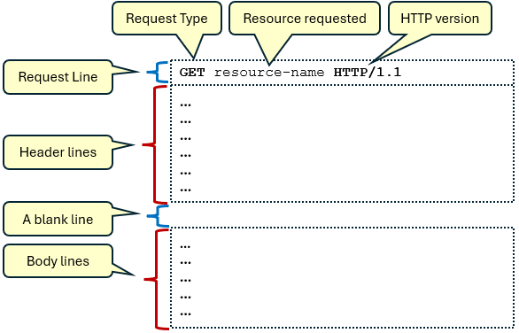
As we discussed, all client/server communication occurs through HTTP Requests and HTTP Responses. We will dig a bit more here to see what these are made of. Each request is simply a bunch of lines of text with this format

The first line indicates the type of request, the resource (e.g., webpage) being requested, and the HTTP version.

The HTTP request consists of a header, which contains multiple lines of information, followed by a blank line. After that, there may be a body containing textual data (usually absent in GET requests).
The most common request types are:
- GET - request data from the server (e.g., loading a webpage, searching with parameters).
- POST - submit data to the server (e.g., login credentials, creating a new user, uploading a file).
- HEAD - like GET, but retrieve just the headers (e.g., check if a webpage has been updated).
- PUT - store a new resource or replace one (e.g., updating an email address or profile pic).
- DELETE - remove a specific resource (e.g., deleting a post or comment, removing a file).

Let’s look at some specific examples. Here is a webpage that connects to my path planning research overview page on my webpage:

https://people.scs.carleton.ca/~lanthier/research/PathPlanning/researchPath.html

When we enter this in the browser address bar and press ENTER, the following HTTP Request is sent to the server (we can go to Dev Tools in Chrome to see it):

GET /~lanthier/research/PathPlanning/researchPath.html HTTP/1.1
Accept: text/html,application/xhtml+xml,application/xml;q=0.9,image/avif,image/webp,image/apng,*/*;q=0.8,application/signed-exchange;v=b3;q=0.7
Accept-Encoding: gzip, deflate, br, zstd
Accept-Language: en-US,en;q=0.9
Cache-Control: max-age=0
Connection: keep-alive
Cookie: _tt_enable_cookie=1; _ttp=pzoF7Jc82dR9h1G73JfnFUVV7at.tt.1; _ga_QZQG9H9WS9=GS1.2.1736453813.3.1.1736454206.60.0.0; _ga_JNCSQWNYYS=GS1.1.1741365158.4.0.1741365158.0.0.0; _gcl_au=1.1.465567102.1751743898; _scid=B3VAnXyYCT1ZWve80dMu2RcKDBnFi3KhnMs7Hg; _ga=GA1.1.698271906.1712855254; _ScCbts=%5B%5D; _fbp=fb.1.1751743898858.683354044531652541; _sctr=1%7C1751688000000; cookieConsent=true; _scid_r=BnVAnXyYCT1ZWve80dMu2RcKDBnFi3KhnMs7LA; ttcsid=1751743898723::67y9Gj0cOYgbQ22CtFD1.1.1751746213119; ttcsid_CJNP7KJC77U5TJETM050=1751743898722::xG8sQVePVXHVlRvdzqe_.1.1751746213382; _ga_BDW6WNFPJQ=GS2.1.s1751743898$o4$g1$t1751746242$j21$l0$h0; _ga_GPRE4N72YN=GS2.1.s1751743898$o5$g1$t1751746317$j60$l0$h0; _ga_755K5XM3HX=GS2.1.s1751743898$o1$g1$t1751746317$j60$l0$h0; _ga_9NTBQTVYKG=GS2.1.s1751743898$o4$g1$t1751746317$j60$l0$h0
Host: people.scs.carleton.ca
If-Modified-Since: Wed, 05 Nov 2014 19:10:38 GMT
If-None-Match: "3cc5-5072155c76780"
Sec-Fetch-Dest: document
Sec-Fetch-Mode: navigate
Sec-Fetch-Site: none
Sec-Fetch-User: ?1
Upgrade-Insecure-Requests: 1
User-Agent: Mozilla/5.0 (Windows NT 10.0; Win64; x64) AppleWebKit/537.36 (KHTML, like Gecko) Chrome/138.0.0.0 Safari/537.36
sec-ch-ua: "Not)A;Brand";v="8", "Chromium";v="138", "Google Chrome";v="138"
sec-ch-ua-mobile: ?0
sec-ch-ua-platform: "Windows"
Notice the request line. The browser uses the GET request when accessing a webpage.

Notice next, that there are many components in the header, which consists of key: value pairs. We will not discus all header options, but here is an explanation of a few of the common ones:

Key | Value
Accept | Specifies media types the client is willing to receive
Accept-Encoding | Informs the server which content-encoding methods are supported
Accept-Language | Preferred languages
Cache-Control | Tells caches whether to revalidate before serving
Content-Type | Specifies the media type of the data being sent in the body
Content-Length | Indicates the size (in bytes) of the request body
Host | Specifies the domain name of the server being requested
User-Agent | Identifies the browser (or client) and OS making the request

Since this was a GET request, there is no body. Therefore, we do not see key: value pairs for Content-Type nor Content-Length.

Go here https://www.iana.org/assignments/http-fields/http-fields.xhtml for a more thorough list of header fields.

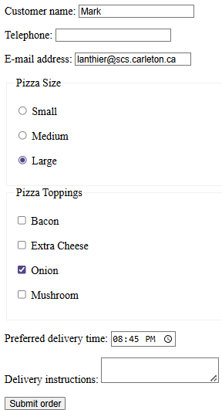
Now let’s try a POST request. We will go to this test website and fill out
a few values in a form and then submit the form:

https://httpbin.org/forms/post

Here is what was sent to the server (check Request Headers in Dev Tools):

:authority httpbin.org
:method POST
:path /post
:scheme https
Accept text/html,application/xhtml+xml,application/
xml;q=0.9,image/avif,image/webp,image/apng,
*/*;q=0.8,application/signed-exchange;v=b3;q=0.7
accept-encoding gzip, deflate, br, zstd
accept-language en-US,en;q=0.9
cache-control max-age=0
content-length 111
content-type application/x-www-form-urlencoded
origin https://httpbin.org
priority u=0, i
referrer https://httpbin.org/forms/post
sec-ch-ua "Chromium";v="140", "Not=A?Brand";
v="24", "Google Chrome";v="140"
…
upgrade-insecure-requests 1
user-agent Mozilla/5.0 (Windows NT 10.0; Win64; x64) AppleWebKit/537.36
(KHTML, like Gecko) Chrome/140.0.0.0 Safari/537.36
The Content-Type: is now set to application/x-www-form-urlencoded, which indicates it is URI-encoded text. The Content-Length: is also set to the total encoded characters of 111.

And here is the body of the request now (check Payload in Dev Tools):

custname=Mark&custtel=&custemail=lanthier%40scs.carleton.ca&size=large&topping=onion&delivery=20%3A45&comments=

Notice the encoding puts the key, an = character and the value for each form field and that the data for each field is separated by a & character.

The Content-Type helps the receiving end know how to interpret and handle the data properly. Here are some common content types:

text/plain - plain text  text/html - HTML documents (webpages)  text/css - CSS stylesheets  text/javascript - JavaScript code  image/png - PNG images  image/jpeg - JPEG images  image/gif - GIF images  image/svg+xml - SVG vector images | application/javascript - JavaScript code  application/json - JSON data  application/xml - XML data  application/pdf - PDF documents  application/octet-stream - generic binary data  application/x-www-form-urlencoded - form data  audio/mpeg - MP3 audio  video/mp4 - MP4 video

It is also possible to send data along with a GET request. We would just need to append the URI-encoded text after the resource with a ? in between:

GET /post?custname=Mark&custtel=&custemail=lanthier%40scs.carleton.ca&
size=large&topping=onion&delivery=20%3A45&comments= HTTP/1.1
Host: httpbin.org
Accept:text/html
User-Agent: Mozilla/5.0
etc..

However, some old browsers do not support URLs with more than ~2000 characters. So, even though we can use GET to send data (if we are writing the client code), it is generally not a good idea to do that. Instead, follow these guidelines:

Use GET to:
- Fetch or read data. We can include small amounts of non-sensitive data (be aware that the URL line is visible to everyone).
- Make requests that can be bookmarked or cached and remain in the browser history. POST requests are never cached, cannot be bookmarked, and do not remain in the browser history.
Use POST to:
- Send sensitive data or large amounts of data (e.g., login credentials, file uploads).
- Perform operations that modify server state (create/update/delete).

Now, what does an HTTP Response look like? It has a similar format to a request being sent, except that there is no request line. Instead, the first line of the header indicates a Status Code and a Status Text that explains what happened.
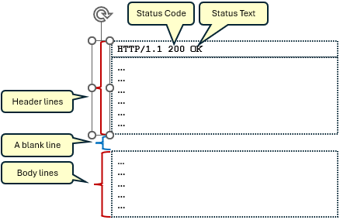

For our GET request, we were requesting an HTML page that represents my path planning research overview page on my webpage. So, the response will look like this:

HTTP/1.1 200 OK
Date: Tue, 30 Sep 2025 00:24:22 GMT
Server: Apache
Last-Modified: Wed, 05 Nov 2014 19:10:38 GMT
ETag: "3cc5-5072155c76780"
Accept-Ranges: bytes
Content-Length: 15557
Connection: close
Content-Type: text/html; charset=UTF-8

<!DOCTYPE doctype PUBLIC "-//w3c//dtd html 4.0 transitional//en">
<html> … </html>

Notice that the body is the entire HTML page requested (I cut out everything between the <html> tags to save space). Also notice that the Content-Type: is set to text/html and that the Content-Length: is the size of the HTML file.

Now what about the HTTP Response from our POST to https://httpbin.org/forms/post? Here is what it looks like:

HTTP/1.1 200 OK
Access-Control-Allow-Credentials: true
Access-Control-Allow-Origin: https://httpbin.org
Content-Length: 1414
Content-Type: application/json
Date: Tue, 30 Sep 2025 00:08:40 GMT
Server: gunicorn/19.9.0

{
"args": {},
"data": "",
"files": {},
"form": {
"comments": "",
"custemail": "lanthier@scs.carleton.ca",
"custname": "Mark",
"custtel": "",
"delivery": "20:45",
"size": "large",
"topping": "onion"
},
"headers": {
"Accept": "text/html,application/xhtml+xml,application/xml;q=0.9,image/avif,image/webp,image/apng,*/*;q=0.8,application/signed-exchange;v=b3;q=0.7",
"Accept-Encoding": "gzip, deflate, br, zstd",
"Accept-Language": "en-US,en;q=0.9",
"Cache-Control": "max-age=0",
"Content-Length": "111",
"Content-Type": "application/x-www-form-urlencoded",
"Host": "httpbin.org",
"Origin": "https://httpbin.org",
"Priority": "u=0, i",
"Referer": "https://httpbin.org/forms/post",
…
},
"json": null,
"origin": "174.114.92.200",
"url": "https://httpbin.org/post"
}

Notice that the response body is a JSON object that contains the form data within it. It also contains header information from the request that we sent as well as the URL used etc..

When it comes to getting responses, the status codes tell the browser (i.e., the client) what happened. Here is a table showing common Status Codes, Status Text and their Descriptions:
Informational:
100 |  | Continue |  |  | Client may continue with request
101 |  | Switching Protocols |  |  | Server is switching protocols
Success:
200 |  | OK |  |  | Request succeeded
201 |  | Created |  |  | Resource successfully created
202 |  | Accepted |  |  | Request accepted for processing
204 |  | No Content |  |  | Request succeeded, no content returned
Redirection:
301 |  | Moved Permanently |  |  | Resource has been moved permanently
302 |  | Found |  |  | Temporary redirect
303 |  | See Other |  |  | Redirect for GET after POST
304 |  | Not Modified |  |  | Resource hasn't changed (cached version valid)
307 |  | Temporary Redirect |  |  | Temporary redirect (method must not change)
308 |  | Permanent Redirect |  |  | Permanent redirect (method must not change)

Client Errors:
400 | Bad Request | Request malformed or invalid
401 | Unauthorized | Authentication required or failed
403 | Forbidden | Authenticated, but access is not allowed
404 | Not Found | Resource not found
405 | Method Not Allowed | Method is not allowed on this resource
408 | Request Timeout | Client took too long to send request
429 | Too Many Requests | Client sent too many requests (rate limit)
Server Errors:
500 | Internal Server Error | Generic server error
501 | Not Implemented | Method not supported by server
502 | Bad Gateway | Invalid response from upstream server
503 | Service Unavailable | Server is overloaded or down
504 | Gateway Timeout | Upstream server didn't respond in time

Look here https://www.restapitutorial.com/httpstatuscodes or here https://en.wikipedia.org/wiki/List_of_HTTP_status_codes for a more thorough list.

What will the response look like if I go to a page that does not exist:

www.carleton.ca/junk

Below is the response. Notice the 404 response. Also notice that there is a body returned … which is an HTML document that will be displayed on the client browser:

HTTP/1.1 404 Not Found
Date: Tue, 30 Sep 2025 00:44:13 GMT
Pragma: no-cache
Expires: Wed, 11 Jan 1984 05:00:00 GMT
Cache-Control: no-cache, must-revalidate, max-age=0, no-store, private
Link: <https://carleton.ca/wp-json/>; rel="https://api.w.org/"
X-Content-Type-Options: nosniff
Strict-Transport-Security: max-age=31536000; includeSubDomains
Content-Type: text/html; charset=UTF-8
Keep-Alive: timeout=5, max=100
Connection: Keep-Alive
Transfer-Encoding: chunked

<!doctype html>
<html class="no-js" lang="en-US">
<head>
<meta charset="UTF-8"/>
<!-- Prefetching dns's -->
<link rel="dns-prefetch" href="//ajax.googleapis.com"/>
<link rel="dns-prefetch" href="//google-analytics.com"/>
<link rel="dns-prefetch" href="//www.google-analytics.com"/>
<!-- FavIcon -->
…

6.6 URL Shortening & Caching

URL shortening is the process of taking a long, complex URL and converting it into a much shorter and simpler one that redirects to the original URL. There are benefits to doing this:


- Easier to share: Short URLs are easier to copy, paste, tweet, or text, especially when space is limited (like on Twitter).
- Cleaner links: Long URLs with lots of parameters can look messy; short ones look neat and professional.
- Tracking: Many URL shorteners offer click analytics (how many times the link was clicked, where, when, etc.).

How does it work?

- We take a long URL like this:
https://www.example.com/articles/2025/07/07/how-to-use-url-shortening-effectively?utm_source=newsletter&utm_campaign=july

- We submit it to a URL shortening service (e.g., bit.ly or tinyurl.com).

- The service generates a unique short code (e.g., https://bit.ly/3aBcD9X )

- When someone clicks on the short URL, they get redirected (via an HTTP Response with a 301 Moved Permanently or 302 Found redirection code) to the original long URL.

The shortening service maintains a database mapping short codes to original long URLs. The short URL typically has this format: [domain]/[shortcode]. So, when accessed, the service looks up the shortcode and sends the browser to the original URL.

Behind the scenes, browsers will use caching to cut down on the amount of information being sent to and from the server. For example, if the browser requests a webpage using GET and the server indicates that the page has not been modified since the last time it was accessed by that browser, then the browser can simply load the local copy from its cache. This reduces the need for the server to send the exact same webpage back as the local cache version.

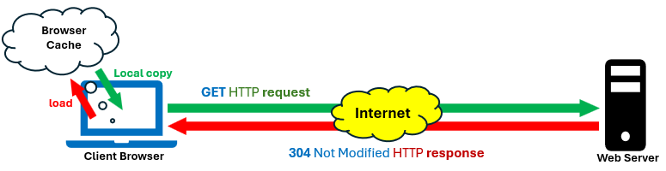
Caching can significantly reduce the amount of data transmitted between the server and client, leading to faster load times. Static resources (e.g., images, CSS stylesheets, and JavaScript files) typically do not change often.

Once these assets have been downloaded, it's inefficient to resend them with every subsequent request if they haven't changed. Additionally, if the same image is used across multiple pages of a website, caching allows the browser to reuse the image without re-downloading it, improving overall performance.

HTTP headers such as Cache-Control, Last-Modified, Expires and ETag control how long and under what conditions resources are cached. Here are a few options for the Cache-Control key:

Directive | Description
public | content can be cached by any cache (browser, ContentDeliveryNetwork, etc.)
private | content is intended for a single user & must not be stored by shared caches
no-cache | cache must check with the server before using the cached copy
no-store | do not store any part of the response or request (used for sensitive data like banking or login pages)
max-age=N | specifies how long (in seconds) content can be reused before it must be revalidated (e.g., max-age=3600 … which is 1 hour)
must-revalidate | cache must revalidate the content with the origin server after it becomes stale
no-transform | intermediate caches or proxies should not modify the content (e.g., image compression)

The Last-Modified header specifies the date and time that the content was last changed, while the Expires header indicates when the content should be considered no longer fresh and must be revalidated or re-fetched. (Note: Expires is now mostly replaced by the more flexible Cache-Control: max-age in modern HTTP/.)

Conditional headers are HTTP headers that let clients make requests based on the state of a resource. They are used for caching efficiency, optimistic concurrency control, and bandwidth savings. Here are some:

Header | Method | Description
If-Modified-Since | GET | Only returns the resource if it was modified after the specified date (works with Last-Modified)
If-Unmodified-Since | PUT, DELETE | Performs the action only if the resource has not been modified since the given date
If-None-Match | GET, HEAD | Returns the resource only if the ETag does not match (used to validate cache)
If-Match | PUT, DELETE | Proceeds only if the ETag matches (prevents conflicting updates)
If-Range | GET (with Range) | Sends a partial response only if the resource is unchanged since the provided ETag or date

The ETag: (entity tag) mentioned in the above table, is a unique identifier (i.e., an ID). When our browser caches a file, it stores the ETag. Later, instead of re-downloading the whole resource, the browser can ask If-None-Match: "3cc5-5072155c76780" in its request. If the content has not changed (i.e., the modified date has not changed and the ETag is the same), then the browser is informed with a 304 Not Modified status code and text to inform it that it can used the cached version. This saves bandwidth by avoiding unnecessary downloads and improves speed by leveraging the browser cache.

As an example, assume that we sent this HTTP Request for a logo.png file:

GET /logo.png HTTP/1.1
If-Modified-Since: Tue, 01 Jul 2025 10:00:00 GMT

If the image has not changed since that date, the server responds with:

HTTP/1.1 304 Not Modified

If it has changed, the new image is sent with a status of 200 OK.

We will talk much more about HTTP requests and responses after we discuss Node.js in a later chapter.

