Chapter 9

Template Engines


What is in This Chapter ?
This chapter begins by discussing the need to be able to generate
dynamic HTML and gives an example of how to do it by combining
HTML and JavaScript manually. It then discusses Template Engines
and the embedded JavaScript template engine called EJS. The
manually generated HTML website example is then modified to
use EJS. Code connected to this chapter is also available to
examine how the FutureTech site can be converted to use
EJS to allow dynamic content. We end the chapter with a
discussion of the PUG template engine and apply it to our
FutureTech website.

9.1 Generating Dynamic HTML with JavaScript

At this point in the course, we can make dynamic webpages on the client side, we can make basic HTTP servers and we can serve static HTML. But sometimes we need to customize a page's contents because websites often display content that changes based on user interactions, preferences, or data from a server (e.g., user profiles, product lists, blog posts, search results, etc.) We cannot realistically write static HTML for every possible scenario, so we need to generate HTML content dynamically.

Dynamically generated HTML makes it possible for websites to show different content to different users or change what’s on the page based on live data. For example, a social media website can show your feed, messages, and notifications, while someone else sees theirs. Instead of creating hundreds of separate pages by hand, developers use templates that fill in the blanks with the right information at the right time. This keeps websites flexible, easier to manage, and more interactive.

One way to create dynamic HTML is to manually write out HTML code as plain text in JavaScript and add variables:

const user = {
name: "Anastasia",
age: 23,
bio: "Loves hiking, coffee, pizza and coding."
};

let html = "";
html += "<div class='profile'>\n"; // \n is not needed but allows string to be displayed nicely
html += " <h2>" + user.name + "</h2>\n "; // spaces at start are not needed either
html += " <p>Age: " + user.age + "</p>\n ";
html += " <p>Bio: " + user.bio + "</p>\n ";
html += "</div>";

This will produce the HTML code as follows:

<div class='profile'>
<h2>Anastasia</h2>
<p>Age: 23</p>
<p>Bio: Loves hiking, coffee, pizza and coding.</p>
</div>

This approach works for simple cases but there are downsides:
- Error-prone - it's easy to forget a closing tag or misplace a variable.
- Hard to maintain - mixing logic and HTML makes code messy and difficult to read.
- Unsafe - can create security problems (e.g., hackers can run harmful scripts on our site)

Recall that back in chapter 4.4, we discussed the use of template literals by using the backtick character and we compared this with string concatenation using the + operator.
As we can see from the table below, the code is very similar, but the template literal is more readable, easier to maintain and less prone to syntax error (i.e., we are more likely to miss " or + when doing string concatenation).

With + Concatenation | With Template Literals
let user = {  name: "Anastasia",  age: 23,  bio: "Loves hiking, coffee, pizza & coding."  };  let html =  "<div class=\"profile\">" +  "<h2>" + user.name + "</h2>" +  "<p>Age: " + user.age + "</p>" +  "<p>Bio: " + user.bio + "</p>" +  "</div>"; | let user = {  name: "Anastasia",  age: 23,  bio: "Loves hiking, coffee, pizza & coding."  };  let html = `  <div class="profile">  <h2>${user.name}</h2>  <p>Age: ${user.age}</p>  <p>Bio: ${user.bio}</p>  </div>  `;


With template literals, we can actually do a lot. We could add functions to read files and then replace specific sections of those files with provided variable values.

Example

Let’s look at an example of using template literals for a fake dating site called “Date-a-Science” that has a main homepage that looks like what is shown here on the right.

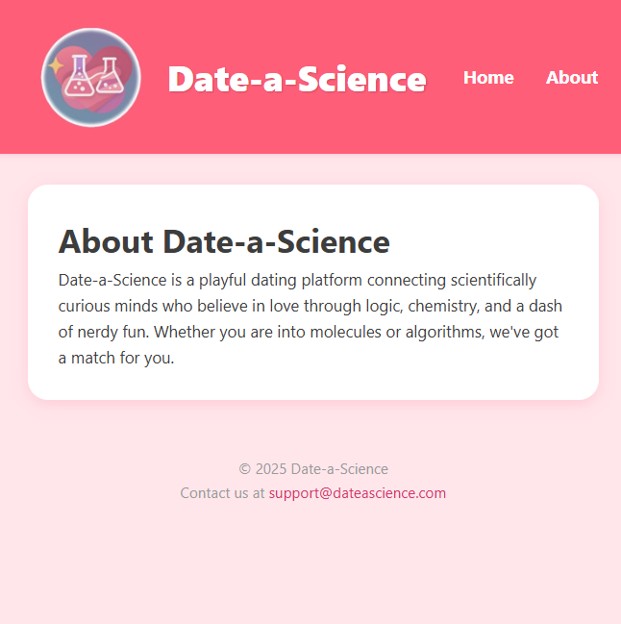
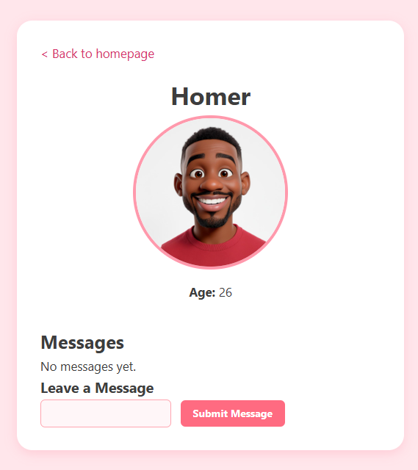
When the user clicks on a member name, it goes to their profile page, and the about goes to another page (see below):

We can also add a member to the list by creating a new profile by entering a name and pressing the Submit Profile button. And then from within a member’s profile page, we can also enter a message and press the Submit Message button to leave a message for that person.
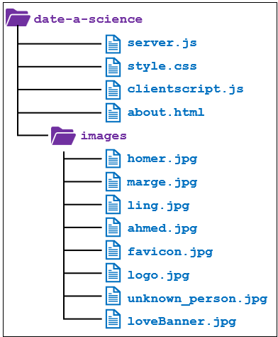
The styles.css file will not be described in our example, but it is mostly specifying spacing, padding, alignment, coloring, rounding corners, over effects, etc..

We will set up our server’s folder structure as shown here
(Assumes we begin with 4 profile images: homer, marge, ling, ahmed).

Below is a basic version of the main server (called server.js). We begin with a fixed array of 4 members, where each member has a name, id, age, photo and array of messages sent to them. Of course, this example can be expanded upon by adding more fields (e.g., friends, posts, etc.). Also, the messages are currently just strings, but the array could be an array of objects. We can then have more state for each message (e.g., creator, likes, views, match history, mutual interests, etc.).

const http = require("http");
const url = require("url");
const fs = require("fs");

let contents = "";
let nextID = 101;
let people = [{name: "Homer", id:nextID++, age: 26, photo:"/images/homer.jpg", messages:[]},
{name: "Marge", id:nextID++, age: 25, photo:"/images/marge.jpg", messages:[]},
{name: "Ling", id:nextID++, age: 27, photo:"/images/ling.jpg", messages:[]},
{name: "Ahmed", id:nextID++, age: 24, photo:"/images/ahmed.jpg", messages:[]}];
let anonImg = "/images/unknown_person.jpg";

// Helper functions for sending specific messages
function respondMainPage(res) {…}
function respondAboutPage(res) {…}
function respondWithProfile(res, id) {…}
function serveStaticFile(filename, res) {…}
function send404(response) {…}

// Listener for incoming client requests
function handleRequest(req, res) {
const parsed = url.parse(req.url, true); // get the query params (for profile pages)
const pathname = parsed.pathname; // get path without query

// Handle all GET requests
if (req.method === "GET") {
if (pathname === "/" || pathname === "/home") {// Return the main page
respondMainPage(res);
} else if (pathname.startsWith("/profile")) { // Return a specific profile
respondWithProfile(res, parsed.query.id);
} else if (pathname.startsWith("/about")) { // Return the about page
serveStaticFile(("./about.html", res);
} else if (pathname === "/clientscript.js") { // Return the client-side javascript
serveStaticFile("./clientscript.js", res);
} else if (pathname.startsWith("/images/")) { // Return an image for a page
serveStaticFile("." + pathname, res);
} else if (pathname === "/style.css") { // Return the style file
serveStaticFile("./style.css", res);
} else { // If anything else ... respond with 404 error
send404(res);
}
} else { // If not a GET request, send 405
res.writeHead(405);
res.end("Unsupported method");
}
}
http.createServer(handleRequest).listen(3000);
console.log("Server running on port 3000");

Notice that the server currently handles just GET requests for when the browser asks for the main page (i.e., "/"), the about page (i.e., "/about"), a particular profile (e.g., "/profile?101"), the client-side JavaScript file (i.e., "/clientscript.js"), the style file (i.e., "/style.css") or an image file (e.g., "./images/homer.jpg"). For any other request, it responds with a 404 message. The code is straight forward, but what goes into the helper functions?

The simplest one is the send404() because it is static:

// Helper function for sending 404 message
function send404(response) {
response.writeHead(404, {"Content-Type": "text/plain"});
response.write("Error 404: Resource not found.");
response.end();
}

The serveStaticFile() is also straight forward because it also is static:

// Send back the specific file requested (html, JavaScript, css, jpg, or plain text)
function serveStaticFile(filename, res) {
fs.readFile(filename, function(err, data) {
if (err) {
res.statusCode = 404;
res.end("File not found");
} else {
res.writeHead(200, {"content-type": lookupMIMEType(filename)});
res.end(data);
}
});
}

… which makes use of another helper function to get the MIME type:


// Return the MIME type given the filename
function lookupMIMEType(filename) {
if (filename.endsWith(".js")) return "application/javascript";
if (filename.endsWith(".css")) return "text/css";
if (filename.endsWith(".jpg") || filename.endsWith(".jpeg")) return "image/jpeg";
if (filename.endsWith(".png")) return "image/png";
if (filename.endsWith(".html")) return "text/html";
return "text/plain";
}

There is nothing new here so far because this is the static content.

The about.html page has no dynamic content, so we can serve it back as a static file:

<!DOCTYPE html>
<html>
<head>
<title>Date-a-Science</title>
<link rel="stylesheet" href="/style.css">
<link rel="icon" href="/images/favicon.jpg" type="image/jpeg">
</head>
<body>
<nav class="navbar">
<div class="nav-left">
<img src="/images/logo.jpg" alt="Logo" class="logo">
<span class="site-title">Date-a-Science</span>
</div>
<ul class="nav-menu">
<li><a href="/">Home</a></li>
<li><a href="/about">About</a></li>
</ul>
</nav>
<div class="container">
<h1>About Date-a-Science</h1>
<p>Date-a-Science is a playful dating platform connecting scientifically curious minds who believe in love through logic, chemistry, and a dash of nerdy fun. Whether you are into molecules or algorithms, we've got a match for you.</p>
</div>
<footer>
<p>&copy; 2025 Date-a-Science</p>
<p>Contact us at <a href="mailto:support@dateascience.com">support@dateascience.com</a></p>
</footer>
</body>
</html>

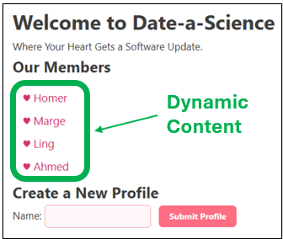
The home page, however, will have non-static content because the members list will grow over time. Also, the profile page is a template that we want to fill in based on the particular member. So, these two pages will have some dynamic content.

Let’s look now at the home page. We need to consider what parts of the page are static and what parts are dynamic. The dynamic content is the unordered list of member names, which will depend on whatever is in the people array variable

Initially, there will be 4 names, but more names will be added by the user. Here is the respondMainPage() function that will build this dynamic page for us:

// Helper function for sending back the main homepage
function respondMainPage(res) {
contents = `
<!DOCTYPE html>
<html>
<head>
<title>Date-a-Science</title>
<link rel="stylesheet" href="./style.css">
<link rel="icon" href="./images/favicon.jpg" type="image/jpeg">
</head>
<body>
<nav class="navbar">
<div class="nav-left">
<img src="./images/logo.jpg" alt="Logo" class="logo">
<span class="site-title">Date-a-Science</span>
</div>
<ul class="nav-menu">
<li><a href="/">Home</a></li>
<li><a href="/about">About</a></li>
</ul>
</nav>
<div class="banner">
<img src="./images/loveBanner.jpg" alt="Love Banner">
</div>
<div class="container">
<h1>Welcome to Date-a-Science</h1>
<p>Where Your Heart Gets a Software Update.</p>

<h2>Our Members</h2>
<ul class="profile-list">
`;
people.forEach(person => {
contents += `<li><a href="./profile?id=${person.id}">&#x2665; ${person.name}</a></li>`;
});
contents += `
</ul>

<h2>Create a New Profile</h2>
<label for="name">Name:</label>
<input type="textbox" id="name">
<button type="button" onclick="submit()">Submit Profile</button>
<script src="/clientscript.js"></script>
</div>

<footer>
<p>&copy; 2025 Date-a-Science</p>
<p>Contact us at <a href="mailto:support@dateascience.com">support@dateascience.com</a></p>
</footer>
</body>
</html>
`;

res.writeHead(200, { "Content-Type": "text/html" });
res.end(contents);
}

Thanks to VSCode’s color scheme, it is easy to identify the static content (as orange), while the dynamic content stands out in different colors. Notice that we use the template literal approach (i.e., the backtick) to specify the HTML contents for the top of the page (i.e., before the list). Then we append to the contents, our dynamic list. Then we append more static contents and send it back in the response. Notice the yellow code. This will insert the clientscript.js code into this location in the code. We will discuss this soon.


The interesting part of the static content is that we are making anchors for each member and then just showing the person’s name. The anchor is the link that will specify the specific profile page that we want to request from the server when we click on the link:

http://localhost:3000/profile?id=101
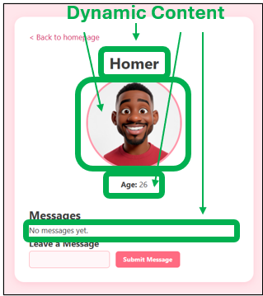
Otherwise, the code should be quite straight forward and familiar to you.

Now… what about the profile page? What is dynamic on it? Well, look at the list item anchors from the code we just wrote:

<li><a href="./profile?id=${person.id}">&#x2665; ${person.name}</a></li>

We can see that we will be requesting the same exact profile page regardless of the person, but the id number (passed as a query) will differ each time. So, we just need to dynamically fill in the name, picture, age and messages for that person based on that id.

Below is the respondWithProfile() function that will build this dynamic page for us. We can quickly identify the dynamic content by the non-orange color:

// Helper function for sending back the profile page
function respondWithProfile(res, id) {
// This is not an efficient way of finding people. You may want to use a HashMap.
let person = null;
for (let i=0; i<people.length; i++) {
if (people[i].id == id) {
person = people[i];
break;
}
}
// If the person is not found, send back an error
if (person === null) {
send404(res);
return;
}

const photo = person.photo || anonImg;
contents = `
<!DOCTYPE html>
<html>
<head>
<title>${person.name} - Date-a-Science</title>
<link rel="stylesheet" href="/style.css">
<link rel="icon" href="/images/favicon.jpg" type="image/jpeg">
</head>
<body>
<div class="container">
<a href="/" class="back-link">< Back to homepage</a>

<div class="profile-card">
<h1>${person.name}</h1>
<img src="${photo}" width="200" alt="${person.name}'s photo">
<p><strong>Age:</strong> ${person.age}</p>
</div>

<div class="messages">
<h2>Messages</h2>`;
if (person.messages.length !== 0) {
person.messages.forEach(msg => {
contents += `<div class="message">${msg}</div>`;
});
} else {
contents += `<p>No messages yet.</p>`;
}
contents += `<h3>Leave a Message</h3>
<input type="textbox" id="msg">
<button type="button" onclick="submitMessage(${person.id})">Submit Message</button>
</div>

<script src="/clientscript.js"></script>
</div>
</body>
</html>
`;
res.writeHead(200, { "Content-Type": "text/html" });
res.end(contents);
}

To start, we look for the person in the array based on the id. We did something simple here, but in a real system, we would likely want to use something like a HashMap to find the person faster. Of course, if the person is not found (i.e., the id was invalid), then we send back the 404 message. Otherwise, we simply insert the person’s name, photo, age and messages into the template literal and write out the response.

Again, notice the same yellow code to insert the clientscript.js code. This JavaScript code will be the code that must run on the client browser. It will have two functions … one to handle the Submit Profile button (from the main home page) and the other to handle the Submit Message button on this profile page.

We will need to send this clientscript.js file from the server to the browser as a static file. The browser will request it because we included <script src="/clientscript.js"></script> in the dynamic HTML code that will get executed on the client browser.

For the Submit Profile button, we need to start off clientscript.js with the following code:

// Function to handle the Submit Profile button on the main page
function submit() {
let name = document.getElementById("name");
if (name.value.length == 0) {
alert("You must enter a name");
} else {
req = new XMLHttpRequest();
req.onreadystatechange = function() {
if (this.readyState == 4) { // 4 means the response has come back
if (this.status == 200) {
alert("Profile Created!");
name.value = "";
window.location.href = "/"; // Tell browser to load main page again
} else {
alert("Error while trying to create profile. Try again.");
}
}
}
let person = {name: name.value};
req.open("PUT", "/newprofile");
req.send(JSON.stringify(person));
}
}

It is standard AJAX request code that ensures there is non-empty name before sending, and then it sends a PUT request to this site: http://localhost:3000/newprofile. We will need to go to the server and update the handleRequest() function to handle this PUT request.

We need to add code before the last send404() else statement to handle this case. The grayed out code below is what was there already and is show for context of where to insert the new code:

// Listener for incoming client requests
function handleRequest(req, res) {
// Handle all GET requests
if (req.method === "GET") {
if (req.url === "/"){ //... code not shown, to save space
} else if (req.url.startsWith("/profile?")) { //... code not shown, to save space
} else if (req.url === "/about") { //... code not shown, to save space
} else if (req.url === "/clientscript.js") { //... code not shown, to save space
} else if (req.url.startsWith("/images/")) {//... code not shown, to save space
} else if (req.url === "/style.css") {//... code not shown, to save space
} else { // If anything else ... respond with 404 error
send404(res);
}
} else if (req.method === "PUT" && req.url === "/newprofile") {
readRequestBody(req, function(body) {
newPerson = JSON.parse(body);
newPerson.id = nextID++;
newPerson.messages = [];
people.push(newPerson); // add profile to the array
res.writeHead(200, { "content-type": "text/plain" });
res.end();
});
} else {
res.writeHead(405);
res.end("Unsupported method");
}
}

The code simply checks if the request's method is PUT and that the URL is "/newprofile" and then reads the request body … which is a JSON object with only the name defined. It then sets the id to be the next available one from the nextID counter and sets the messages array to an empty one. It finally sends back a successful 200 response.

Of course, we need the function to read the request body as it comes in piece-by-piece (although there is likely only one small piece in our case):

// Helper function to read the request body
function readRequestBody(req, callback) {
let body = ""
req.on("data", (chunk) => {
body += chunk;
})
//Once the entire body is ready, process the request
req.on("end", () => {
callback(body);
});
}

Now, let’s handle the Submit Profile button on the profile page. The client request code is similar, but now we will use a POST, along with the message, instead of a PUT:

// Function to handle the Submit Message button on the profile page
function submitMessage(id) {
let msg = document.getElementById("msg");
if (msg.value.length == 0) {
alert("You must enter a message");
} else {
req = new XMLHttpRequest();
req.onreadystatechange = function() {
if (this.readyState == 4) { // 4 means the response has come back
if (this.status == 200) {
alert("Message Sent!");
msg.value = "";
window.location.reload(); // Tell browser to load this page again
} else {
alert("Error while sending message. Try again.");
}
}
}
let messageContent = { message: msg.value, id: id };
req.open("POST", "/message");
req.send(JSON.stringify(messageContent));
}
}

Again, we see standard AJAX request code that ensures there is non-empty message before sending, and then it sends a POST request to this site: http://localhost:3000/message. We will need to go to the server and update the handleRequest() function again to handle this POST request.

We need to add code again, before the last send404() else statement. The grayed out code below is what was there already and is show for context of where to insert the new code:

// Listener for incoming client requests
function handleRequest(req, res) {
// Handle all GET requests
if (req.method === "GET") {
if (req.url === "/"){ //... code not shown, to save space
} else if (req.url.startsWith("/profile?")) { //... code not shown, to save space
} else if (req.url === "/about") { //... code not shown, to save space
} else if (req.url === "/clientscript.js") { //... code not shown, to save space
} else if (req.url.startsWith("/images/")) {//... code not shown, to save space
} else if (req.url === "/style.css") {//... code not shown, to save space
} else { // If anything else ... respond with 404 error
send404(res);
}
}
// Combination of PUT and /newprofile is interpreted as a request to create a profile
else if (req.method === "PUT" && req.url === "/newprofile") {
readRequestBody(req, function(err, body) {
newPerson = JSON.parse(body);
newPerson.id = nextID++;
newPerson.messages = [];
people.push(newPerson); // add profile to the array
res.writeHead(200, { "content-type": "text/plain" });
res.end();
});
// Combination of POST and /message is interpreted as a request to add a message
} else if (req.method === "POST" && req.url === "/message") {
readRequestBody(req, function(body) {
console.log("Adding message: " + body);
let message = JSON.parse(body);
if (addMessage(message)) {
res.writeHead(200, { "content-type": "text/plain" });
res.end();
} else {
send404(res);
}
});
//Any other combination of method/URL is not supported
} else {
res.writeHead(405);
res.end("Unsupported method");
}
}

The code checks for a POST message type and to ensure that the URL is /message and then reads the request body … which is a JSON object which contains the message (defined as a string) as well as the id of the person to send it to.

It then calls addMessage() to add it to the profile’s messages array. The function returns true if it was successful:

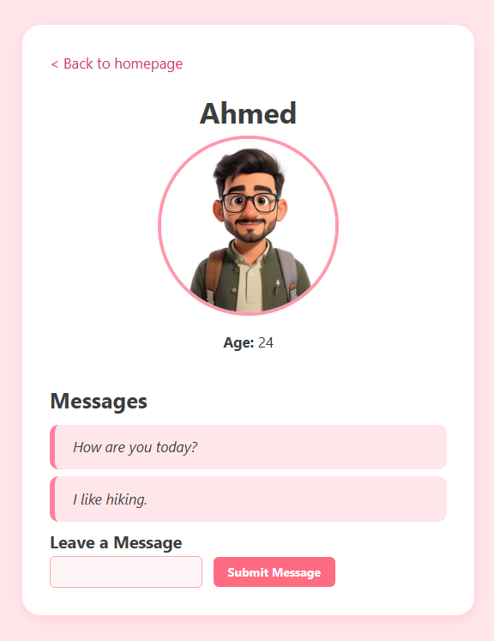
// Helper function to add a message to a person's profile
function addMessage(msg) {
for (let i=0; i<people.length; i++) {
if (people[i].id === msg.id) {
people[i].messages.push(msg.message);
return true;
}
}
return false;
}

That’s it! Messages will appear one after another in a list after we add submit them

So, we now understand that we can write JavaScript functions for generating HTML. But as mentioned earlier, there are downsides to doing things this way.

9.2 Embedded JavaScript Templates (EJS)

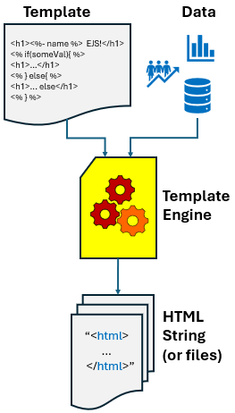
A template engine is a tool that combines HTML with dynamic data to automatically generate web pages in a clean and organized way. Template engines solve the problems mentioned above by providing a cleaner, more structured way to separate application logic
from presentation (HTML).

Template engines allow us to:

- Write HTML templates with placeholders for dynamic data.
- Keep HTML readable and maintainable.
- Prevent common security risks by escaping output by default.
- Speed up development with built-in utilities
(e.g., looping or conditional rendering).

At a high level, a template engine does three things:

- Takes a Template file (e.g., HTML with special syntax for placeholders
representing document structure & generalized contents).
- Combines it with Data from our application (e.g., users, products, etc).
- Produces a final HTML output string to send to the browser.

The template engine combines the data and templates in a process called rendering … producing the view … which is the visual part of the application that users interact with in their browser.

We will talk soon about Express, which is a fast, widely-used, minimal web framework for Node.js that makes it easy to build web servers and APIs. Several template engines work with Express such as Pug, Mustache and EJS.

Template engines are useful when we want to rapidly build web applications that are split into different components … especially when we want to:

- reuse common HTML structures across multiple pages (e.g., headers, footers, navigation bars, sidebars, etc.).
- insert dynamic content into HTML (e.g., usernames, product lists, messages).
- quickly render views in server-side web applications, where the HTML changes based on user requests or data from a database.
- separate our visual specification from data and server logic.
They’re a great choice when we want to build pages that share a consistent layout but display different content. In short: they help us write clean HTML layouts that automatically get filled with the right content when needed.

EJS (Embedded JavaScript) is one of the most popular and lightweight template engines for Node.js. It lets us embed JavaScript code directly in our HTML to dynamically produce portions of the page. To use EJS, we need to ensure that it is first installed using NPM: npm install ejs
and then use require in our server code: const ejs = require("ejs");

EJS supports the idea of partials … which is a piece of an entire “page” that can be re-used
(e.g., headers, footers, menus, etc.)

For example, the home page and about page of our Date-a-Science site both contain the same exact code to start the page, so they have the same header:

<!DOCTYPE html>
<html>
<head>
<title>Date-a-Science</title>
<link rel="stylesheet" href="/style.css">
<link rel="icon" href="/images/favicon.jpg" type="image/jpeg">
</head>
<body>
<nav class="navbar">
<div class="nav-left">
<img src="/images/logo.jpg" alt="Logo" class="logo">
<span class="site-title">Date-a-Science</span>
</div>
<ul class="nav-menu">
<li><a href="/">Home</a></li>
<li><a href="/about">About</a></li>
</ul>
</nav>

We could consider this a partial and place this code into a file called header.ejs. At the moment this is just an HTML file, but we will adjust it to have a small bit of dynamic content in a moment, so we will use the .ejs file extension. Notice that the file is not a completed HTML file because there are no closing tags for the <body> and <html> tags. That is because we will include this code as “partial” code that will be appended to other code, which will have the proper closing of those tags as needed.

In addition, the home and about pages both share the same footer information. So, we can make a footer.ejs file as well:

<footer>
<p>&copy; 2025 Date-a-Science</p>
<p>Contact us at <a href="mailto:support@dateasci.com">support@dateasci.com</a></p>
</footer>
</body>
</html>

Let’s convert our code to make use of the EJS template engine. We will adjust our folder hierarchy to be as shown here on the right. The top portion is the same, but we added a data folder to hold our data, a views folder to hold our dynamic pages, and a partials folder to hold our header.ejs and footer.ejs partials.  We may notice that we have three .ejs files in the views folder. These are mostly made up of HTML but they will have some dynamic EJS content as well. Let’s begin our conversion to EJS by taking a look at the about.html file from before:  <!DOCTYPE html>  <html>  <head>  <title>Date-a-Science</title>  <link rel="stylesheet" href="/style.css">  <link rel="icon" href="/images/favicon.jpg" type="image/jpeg">  </head>  <body>  <nav class="navbar">  <div class="nav-left">  <img src="/images/logo.jpg" alt="Logo" class="logo">  <span class="site-title">Date-a-Science</span>  </div>  <ul class="nav-menu">  <li><a href="/">Home</a></li>  <li><a href="/about">About</a></li>  </ul>  </nav>  <div class="container">  <h1>About Date-a-Science</h1>  <p>Date-a-Science is a playful dating platform connecting scientifically curious minds who believe in love through logic, chemistry, and a dash of nerdy fun. Whether you are into molecules or algorithms, we've got a match for you.</p>  </div>  <footer>  <p>&copy; 2025 Date-a-Science</p>  <p>Contact us at <a href="mailto:support@dateascience.com">support@dateascience.com</a></p>  </footer>  </body>  </html> | 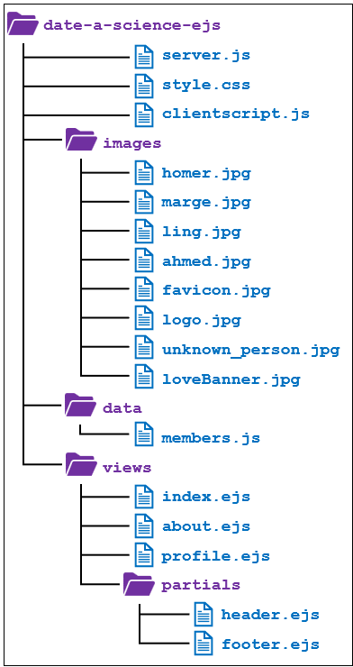  The first thing that we will notice is that all of the yellow code is code that is in our header and footer.  So, for our about.ejs file, we will simply include the header.ejs and footer.ejs files instead of duplicating the code.
To include an EJS partial in another EJS file, we simply use EJS’s include() function which has this format:

<%- include("filename") %>

Here, the filename is the name of the .ejs file that we want to include, but we leave off the file extension. If the file is in the same folder as the one that we write this include statement in, then we do not need to specify a path (e.g., "header"). However, if it is in subfolder or other folder, we need to specify the path relative to where we are (e.g., "partials/header").

So, we can write our about.ejs file (which will replace our previous about.html file) as follows:

<%- include('partials/header') %>

<div class="container">
<h1>About Date-a-Science</h1>
<p>Date-a-Science is a playful dating platform connecting scientifically curious minds who believe in love through logic, chemistry, and a dash of nerdy fun. Whether you are into molecules or algorithms, we've got a match for you.</p>
</div>

<%- include("partials/footer") %>

Notice that the main content of the page looks short & sweet now, since we do not clutter it up with the header and footer code.

The <%- at the beginning of the include call indicates that we want to output …

Unescaped HTML - HTML code that is rendered directly in the browser without converting special characters (e.g., <, >, &, etc..), meaning it produces actual HTML elements (e.g., headings, images, or links) instead of displaying the raw code as plain
text.

We use this if we trust the content being rendered (i.e., we wrote it). We would not use it if we had content that may contain user input (e.g., messages, comments) because it could lead to security risks. In those cases, we would use <%= instead, which will output …

Escaped HTML - HTML code in which special characters (e.g., <, >, &, etc..) are turned into safe text so that they don’t act like real HTML in the browser. It's like putting a disguise on HTML so the browser doesn’t treat it as code and just shows it as plain text.

Escaping protects our site from code injection and keeps user-submitted content safe and harmless.

A nice feature of the include() function is that it allows us to pass in data by supplying a second parameter. So, if we want to pass along some data into our EJS file, we could do it by specifying a second parameter which must be a JavaScript object containing one or more key: value pairs, separated by commas:

<%- include(file, { key1: val1, key2: val2, key3: val3, etc.. }) %>

Let’s try this by passing in the page title to our header.ejs file. This will be useful because the header partial contains the <head> tag which has the page <title> in it … which will be shown as the title of the page on the browser tab. By passing in a title to the header, each page that shares the header will be able to have their own unique page title (e.g., "Date-a-Science – Home", "About – Date-a-Science", "Homer - Date-a-Science", "Marge - Date-a-Science”, etc..)

So, we will adjust the first line of our about.ejs page to be as follows:

<%- include("partials/header", { title: "About - Date-a-Science" }) %>

Then, we can make use of this in our header.ejs file by using this title variable.

<!DOCTYPE html>
<html>
<head>
<title><%= title %></title>
<link rel="stylesheet" href="/style.css">
<link rel="icon" href="/images/favicon.jpg" type="image/jpeg">

etc.

This tells EJS to get the title variable’s value (because there are no quotes around it, it assumes that it is a variable defined). It also tells it to render the value as plain text (i.e., <%= instead of <%-). As we can see, it is quite easy to supply some data when including EJS files inside of others.

Now, what about our main homepage? Well, recall that we had a function in our server for producing the HTML code that did this (highlighted header/footer code in yellow):

contents = `
<!DOCTYPE html>
<html>
<head>
<title>Date-a-Science</title>
<link rel="stylesheet" href="/style.css">
<link rel="icon" href="/images/favicon.jpg" type="image/jpeg">
</head>
<body>
<nav class="navbar">
<div class="nav-left">
<img src="/images/logo.jpg" alt="Logo" class="logo">
<span class="site-title">Date-a-Science</span>
</div>
<ul class="nav-menu">
<li><a href="/">Home</a></li>
<li><a href="/about">About</a></li>
</ul>
</nav>
<div class="banner">
<img src="/images/loveBanner.jpg" alt="Love Banner">
</div>
<div class="container">
<h1>Welcome to Date-a-Science</h1>
<p>Where Your Heart Gets a Software Update.</p>

<h2>Our Members</h2>
<ul class="profile-list">
`;

people.forEach(person => {
contents += `<li><a href="./profile?id=${person.id}">${person.name}</a></li>`;
});

contents += `
</ul>

<h2>Create a New Profile</h2>
<label for="name">Name:</label>
<input type="textbox" id="name">
<button type="button" onclick="submit()">Submit Profile</button>

<script src="/clientscript.js"></script>
</div>

<footer>
<p>&copy; 2025 Date-a-Science</p>
<p>Contact us at <a href="mailto:support@dateascience.com">support@dateascience.com</a></p>
</footer>

</body>
</html>
`;

Instead of putting the homepage in a server function that will produce the HTML code, we will extract it to an index.ejs file and place it in our views folder. Since the header and footer are the same as what is in our partial files, we will begin by replacing those with appropriate include calls and get rid of the backticks and contents variable (which was something specific to our server code):

<%- include("partials/header", { title: "Date-a-Science - Home" }) %>

<div class="banner">
<img src="/images/loveBanner.jpg" alt="Love Banner">
</div>
<div class="container">
<h1>Welcome to Date-a-Science</h1>
<p>Where Your Heart Gets a Software Update.</p>

<h2>Our Members</h2>
<ul class="profile-list">

people.forEach(person => {
<li><a href="./profile?id=${person.id}">${person.name}</a></li>
});

</ul>

<h2>Create a New Profile</h2>
<label for="name">Name:</label>
<input type="textbox" id="name">
<button type="button" onclick="submit()">Submit Profile</button>

<script src="/clientscript.js"></script>
</div>

<%- include("partials/footer") %>

Now what about the dynamic code in the middle? We have to change it slightly because this is JavaScript code, not EJS code.
Notice that it makes use of a people variable. We do not have this available to us here at the moment. However, we can pass the array of members in as some EJS data to this file (i.e., when the EJS engine renders this page) and then we will have access to what we need. So, really, all we need to do is to change the syntax from JavaScript to EJS.

For any code that we want to evaluate, we enclose it within <% %> to indicate that we want to insert a block of code. It does not output anything to the rendered HTML. Instead, it is used for control flow, variable declarations, or any logic we want to run.
So, we replace this:

people.forEach(person => {
<li><a href="./profile?id=${person.id}">${person.name}</a></li>
});

With this:

<% people.forEach(person => { %>
<li><a href="./profile?id=<%= person.id %>"><%= person.name %></a></li>
<% }) %>

Which means …. for our 4 initial sample members … the code that will be rendered is as follows:

<li><a href="./profile?id=1">Homer</a></li>
<li><a href="./profile?id=2">Marge</a></li>
<li><a href="./profile?id=3">Ling</a></li>
<li><a href="./profile?id=4">Ahmed</a></li>

So, here is our completed index.ejs file which has included partials and supports dynamic content:

<%- include("partials/header", { title: "Date-a-Science - Home" }) %>
<div class="banner">
<img src="/images/loveBanner.jpg" alt="Love Banner">
</div>
<div class="container">
<h1>Welcome to Date-a-Science</h1>
<p>Where Your Heart Gets a Software Update.</p>

<h2>Our Members</h2>

<ul class="profile-list">
<% people.forEach(person => { %>
<li><a href="/profile?id=<%= person.id %>">&#x2665; <%= person.name %></a></li>
<% }) %>
</ul>

<h2>Create a New Profile</h2>
<label for="name">Name:</label>
<input type="textbox" id="name">
<button type="button" onclick="submit()">Submit Profile</button>

<script src="/clientscript.js"></script>
</div>
<%- include("partials/footer") %>

For this to work, we need to ensure that we pass in the people data. That brings up an important point. Currently our data is merged with our server code. This is not good because we should really de-couple our content from our logic. So, let’s extract the member-specific data and put it in its own JavaScript file. Here is the current data-specific code from the server file:

let nextID = 101;
let people = [{name: "Homer", id:nextID++, age: 26, photo:"/images/homer.jpg", messages:[]},
{name: "Marge", id:nextID++, age: 25, photo:"/images/marge.jpg", messages:[]},
{name: "Ling", id:nextID++, age: 27, photo:"/images/ling.jpg", messages:[]},
{name: "Ahmed", id:nextID++, age: 24, photo:"/images/ahmed.jpg", messages:[]}];
let anonImg = "/images/unknown_person.jpg";

We will place this in a members.js file under the data folder in our hierarchy. While we are at it, we will adjust the nextID variable to be somewhat private by making a public function that gets us the next id for us so that we can avoid misusing the variable. Here is the completed members.js file:

let nextID = 101;

// Gets the next profile ID available (its just a counter)
export function getNextID() {
return nextID++;
}

// These are sample people for the purposes of demonstration
export let people = [
{ name: "Homer", id: getNextID(), age: 26, photo: "/images/homer.jpg", messages: [] },
{ name: "Marge", id: getNextID(), age: 25, photo: "/images/marge.jpg", messages: [] },
{ name: "Ling", id: getNextID(), age: 27, photo: "/images/ling.jpg", messages: [] },
{ name: "Ahmed", id: getNextID(), age: 24, photo: "/images/ahmed.jpg", messages: [] }
];

// This is the image to show for new profiles that have no uploaded picture
export const anonImg = "/images/unknown_person.jpg";

Notice the use of export to ensure that these are visible and usable to others. We can then just include this file by using require() to ask for this module in our server code as follows:

const { people, anonImg, getNextID } = require("./data/members");

This will give us access to the array, the anonymous image and the function to get the id. But before we adjust our server code, let’s look at how to convert the profile rendering code from our server into a profile.ejs file to place in our views folder. Here is the code that we have in our server:

contents = `
<!DOCTYPE html>
<html>
<head>
<title>${person.name} - Date-a-Science</title>
<link rel="stylesheet" href="/style.css">
<link rel="icon" href="/images/favicon.jpg" type="image/jpeg">
</head>
<body>
<div class="container">
<a href="/" class="back-link">< Back to homepage</a>

<div class="profile-card">
<h1>${person.name}</h1>
<img src="${photo}" width="200" alt="${person.name}'s photo">
<p><strong>Age:</strong> ${person.age}</p>
</div>

<div class="messages">
<h2>Messages</h2>`;
if (person.messages.length !== 0) {
person.messages.forEach(msg => {
contents += `<div class="message">${msg}</div>`;
});
} else {
contents += `<p>No messages yet.</p>`;
}
contents += `<h3>Leave a Message</h3>
<input type="textbox" id="msg">
<button type="button" onclick="submitMessage(${person.id})">Submit Message</button>
</div>

<script src="/clientscript.js"></script>
</div>
</body>
</html>
`;

We will notice that it does NOT have the same header as our other files and it does NOT even have a footer. We will make an adjustment so that we have consistency across our pages by including the same header and footer as the other pages. Notice that the code makes use of a person variable. We will need to ensure that this is passed in as data to this page when we render it. So, we can do what we did for the other EJS pages … replace the yellow highlighted code by including the header and footer in place of them, and then by altering the JavaScript syntax to enclose the dynamic code within <% %> . Here is the resulting profile.ejs file:

<%- include("partials/header", { title: person.name + " - Date-a-Science" }) %>

<div class="container">
<a href="/" class="back-link">&lt; Back to homepage</a>

<div class="profile-card">
<h1><%= person.name %></h1>
<img src="<%= person.photo || anonImg %>" width="200" alt="<%= person.name %>'s photo">
<p><strong>Age:</strong> <%= person.age %></p>
</div>

<div class="messages">
<h2>Messages</h2>
<% if (person.messages.length !== 0) { %>
<% person.messages.forEach(msg => { %>
<div class="message"><%= msg %></div>
<% }) %>
<% } else { %>
<p>No messages yet.</p>
<% } %>

<h3>Leave a Message</h3>
<input type="textbox" id="msg">
<button type="button" onclick="submitMessage(<%= person.id %>)">Submit Message</button>
</div>

<script src="/clientscript.js"></script>
</div>

<%- include("partials/footer") %>


As we can see, EJS files are quite readable, even though they mix code with HTML. I am sure that we will find this easy as we do it more and more. Of course, this code only works if we pass in the person variable data when we render the page.

OK, so we are now ready to adjust our server code. It will be shorter now that we don’t have the HTML rendered code in it since we extracted the code for rendering the main home page and profile page and placed them into EJS files.

These functions will remain the same: send404(), getMimeType(), serveStaticFile(), readRequestBody() and addMessage(). And in the code to handle incoming requests, we only need to update the code in three locations:

// Handle all GET requests
if (req.method === "GET") {
if (pathname === "/" || pathname === "/home") {// Return the main page
renderPage("./views/index.ejs", res, { people });
} else if (pathname.startsWith("/profile")) { // Return a specific profile
respondWithProfile(res, parsed.query.id);
} else if (pathname.startsWith("/about")) { // Return the about page
renderPage("./views/about.ejs", res);
...
}

// Combination of PUT and /newprofile is interpreted as a request to create a profile
else if (req.method === "PUT" && pathname === "/newprofile") {
readRequestBody(req, function(body) {
const newPerson = JSON.parse(body);
newPerson.id = getNextID(); // This used to be nextID++
etc..

Notice that we call a renderPage() function now to do the rendering for the main page and about page. We pass it the particular page to render as well as the response variable and any needed data.

Here is the renderPage() function:

// Render an EJS page
function renderPage(templatePath, res, data = {}) {
ejs.renderFile(templatePath, data, function(err, html) {
if (err) {
console.error(err);
res.writeHead(500);
res.end("Internal Server Error");
} else {
res.writeHead(200, { "Content-Type": "text/html" });
res.end(html);
}
});
}

This function calls the renderFile() function in the imported ejs module … which does all the work for us. The function takes three parameters:

- templatePath - string path to the EJS template file.
- data - an object containing variables to pass into the template.
- callback - a function to call with the rendered result (or error).

Notice that a 500 error is returned if the page cannot be rendered from the server. Otherwise, it returns a 200 along with the rendered html string … which is equivalent to the resulting contents variable that we kept appending to in the non-EJS server version of our code.

The respondWithProfile() function is as follows:

// Handle individual profile
function respondWithProfile(res, id) {
// This is not an efficient way of finding people. You may want to use a HashMap.
let person = null;
for (let i=0; i<people.length; i++) {
if (people[i].id == id) {
person = people[i];
break;
}
}
// If the person is not found, send back an error
if (person === null) {
send404(res);
return;
}
renderPage("./views/profile.ejs", res, { person, anonImg });
}

The code does the same as before to find the person, but now instead of all that code to write out the HTML code, it is all rendered from the profile.ejs file. Notice that we pass in the person and anonImg data so that these can be used within the profile.ejs file's code.

Of course, we need to include these at the top of our server.js file as well now:

const ejs = require("ejs");
const { people, anonImg, getNextID } = require("./data/members");

but we can delete all the data that was at the top of the file because we moved it into the members.ejs file.

If you get a moment, take a look at the FutureTech website code which has been altered to use the EJS Template Engine. Of particular note is the product-data.js file that contains all our data now, just like the members.js contained data for our Date-a-Science site:

export const products = [
{
name: "SkyCore JetPack",
id: 1,
image: "jetPack.jpg",
imageSmall: "jetPack_small.jpg",
desc: "Take to the skies delivering powerful, stable flight that turns gravity into your playground.",
imageAlt: "SkyCore JetPack",
par1: "Experience the future of personal flight with the <strong>SkyCore JetPack</strong> — engineered with next-gen quantum propulsion technology for unparalleled speed, agility, and eco-friendly performance. Designed for thrill-seekers and urban adventurers alike, the AeroX Quantum redefines freedom, allowing you to soar effortlessly above the city skyline or explore rugged terrains with ease.",
par2: "Built with lightweight carbon-titanium alloys and powered by a zero-emission quantum core, this jet pack is not only fast but also sustainable. Integrated AI navigation and safety systems ensure a smooth and secure flight experience, whether you're a beginner or a seasoned pilot.",
features: [
{feature: "Quantum Propulsion Engine", desc:"Silent, ultra-efficient engine offering up to 45 minutes of continuous flight at speeds reaching 120 mph."},
{feature: "AI-Assisted Navigation", desc:"Real-time obstacle detection, automatic stabilization, and route optimization via onboard AI."},

etc..
],
specs: [
{key: "Flight Time", value: "Up to 45 minutes" },
{key: "Maximum Speed", value: "120 mph (193 km/h)"},
{key: "Weight", value: "15 kg (33 lbs)"},
etc..
],
pricing: [
{option: "Standard Package", price: 19999.00, includes: "Jet pack, charger, basic user manual"},
{option: "Advanced Package", price: 24999.00, includes: "Standard + AI flight coach app + extended warranty (3 years)"},
{option: "Premium Package", price: 29999.00, includes: "Advanced + custom design panels + on-site training"}
],
accessories: [
{option: "Solar Charging Pad", price: 499.00},
{option: "Extra Modular Thrusters", price: 799.00},
{option: "Protective Flight Helmet with HUD", price: 1199.00},
{option: "Portable Flight Case", price: 299.00}
]
},

Thus, we were able to get rid of our individual product pages (i.e., product_01.html, product_02.html, etc.. ) and make one product.ejs file that accommodates all our products.

Closing remarks:

Recall that we used this code to look up the person:

let person = null;
for (let i=0; i<people.length; i++) {
if (people[i].id == id) {
person = people[i];
break;
}
}

This is a linear search, which could take a long time. A faster approach would be to use a Hashmap. We could set this up ahead of time:

let peopleById = new Map();
people.forEach(p => peopleById.set(p.id, p));

Then we can replace our search code with this line (remember to convert the string id to a number):

let person = peopleById.get(Number(id));

Alternatively, we could have just used a Hashmap from the start by replacing this:

// These are sample people for the purposes of demonstration
export let people = [
{ name: "Homer", id: getNextID(), age: 26, photo: "/images/homer.jpg", messages: [] },
{ name: "Marge", id: getNextID(), age: 25, photo: "/images/marge.jpg", messages: [] },
{ name: "Ling", id: getNextID(), age: 27, photo: "/images/ling.jpg", messages: [] },
{ name: "Ahmed", id: getNextID(), age: 24, photo: "/images/ahmed.jpg", messages: [] }
];

With this:

export let people = new Map();
let nid;
people.set(nid = getNextID(),
{ name: "Homer", id: nid, age: 26, photo: "/images/homer.jpg", messages: [] });
people.set(nid = getNextID(),
{ name: "Marge", id: nid, age: 25, photo: "/images/marge.jpg", messages: [] });
people.set(nid = getNextID(),
{ name: "Ling", id: nid, age: 27, photo: "/images/ling.jpg", messages: [] });
people.set(nid = getNextID(),
{ name: "Ahmed", id: nid, age: 24, photo: "/images/ahmed.jpg", messages: [] });

We now have a good grasp of writing dynamic server-side code. However, currently, the data is hard-coded into our server. That means we would need to restart the server every time that we want to change the data. Later, we will find out how to get this data from a database and as well be able to modify the data through some other server logic. At that point, we would not need to restart our server when we need to alter the data.

9.3 PUG

Another nice template engine is PUG (it is not an acronym … just a name). Pug is similar to EJS in that both are template engines for Node.js that let us generate dynamic HTML using JavaScript data. They allow us to insert variables, use conditionals (if statements), and loop through data to build HTML pages dynamically. Both ultimately produce standard HTML that is sent to the browser.

The key idea behind both engines is that of separating our layout (i.e., HTML structure) from our logic (i.e., JavaScript code), which makes our web applications more organized and maintainable. While their syntax is different, the main purpose and functionality are essentially the same.

When we think of our EJS code, it has a mix of HTML and JavaScript. In some ways this is good, because we are familiar with it and it is easy to identify the JavaScript tags/code (especially in VSCode). The downside of EJS, however, is that it can get messy and hard to manage, especially as our templates grow. It’s easy to lose track of where the logic ends and the HTML begins. This can make the file harder to read, especially when we are nesting conditionals or loops. Over time, our template can start to look cluttered, with a lot of angle brackets, opening and closing tags, and JavaScript syntax all jammed together. This makes debugging and maintaining our code more difficult, particularly for larger teams or beginners who are still learning how templating works.

In contrast, PUG offers a clean, minimalist syntax that makes templates easier to read and write. By removing the need for closing tags and angle brackets, PUG reduces clutter and helps us focus on the structure of our content. Its indentation-based layout clearly shows nesting, which makes our HTML structure more obvious and less error-prone. Here is a quick side-by-side comparison:

<%- include("partials/header", { title: "Date-a-Science - Home" }) %>  <div class="banner">  <img src="/images/loveBanner.jpg" alt="Love Banner">  </div>  <div class="container">  <h1>Welcome to Date-a-Science</h1>  <p>Where Your Heart Gets a Software Update.</p>  <h2>Our Members</h2>  <ul class="profile-list">  <% people.forEach(person => { %>  <li><a href="/profile?id=<%= person.id %>">&#x2665;  <%= person.name %></a></li>  <% }) %>  </ul>  <h2>Create a New Profile</h2>  <label for="name">Name:</label>  <input type="textbox" id="name">  <button type="button" onclick="submit()">  Submit Profile</button>  <script src="/clientscript.js"></script>  </div>  <%- include("partials/footer") %> | include partials/header.pug  - var title = "Date-a-Science - Home"  .banner  img(src="/images/loveBanner.jpg" alt="Love Banner")  .container  h1 Welcome to Date-a-Science  p Where Your Heart Gets a Software Update.  h2 Our Members  ul.profile-list  each person in people  li  a(href=`/profile?id=${person.id}`) &#x2665; #{person.name}  h2 Create a New Profile  label(for="name") Name:  input#name(type="textbox")  button(type="button" onclick="submit()") Submit Profile  script(src="/clientscript.js")  include partials/footer.pug
PUG Syntax:

PUG uses indentation and whitespace, much like Python, to define structure instead of relying on opening and closing tags. Here is a comparison of HTML vs. PUG:

<!-- HTML -->  <h1>Welcome</h1>  <p>This is a paragraph.</p> | // PUG  h1 Welcome  p This is a paragraph.

Each line represents an HTML element, with the tag name at the beginning:

<img src="/logo.png" alt="Logo"> | img(src="/logo.png" alt="Logo")

The indentation shows the nesting of elements with child elements are indented under their parents:

<ul>  <li>Item 1</li>  <li>Item 2</li>  </ul> | ul  li Item 1  li Item 2

There are no closing tags in PUG. They are handled automatically based on indentation:

<table>  <thead>  <tr>  <th>Name</th>  <th>Age</th>  </tr>  </thead>  <tbody>  <% people.forEach(person => { %>  <tr>  <td><%= person.name %></td>  <td><%= person.age %></td>  </tr>  <% }) %>  </tbody>  </table> | table  thead  tr  th Name  th Age  tbody  each person in people    tr  td= person.name  td= person.age  // Nice ... isn't it?

Notice the = beside the table data (i.e., td=). The = tells PUG to “evaluate the following JavaScript expression and output the result.” That is needed every time we have a variable value to insert. Without the =, PUG would simply write out person.name and person.age as plain text instead of substituting the variable values. Notice as well the difference in the looping constructs. We use each/in to iterate.

We can use three particular operators in PUG:

= Outputs the result of an expression with HTML escaping (i.e., renders as plain text).
Example PUG code: | Resulting HTML output:
p= "Welcome to Date-a-Science!"  p= 3 + 4  p= "Your score is: " + (10 * 2)  p= loggedIn ? "Yes" : "No"  p= "<b>Not bold</b>"  p= "<script>alert("Saved")</script>" | <p>Welcome to Date-a-Science!</p>  <p>7</p>  <p>Your score is: 20</p>  <p>Yes</p>  <p>&lt;b&gt;Not bold&lt;/b&gt;</p>  <p>&lt;script&gt;alert(&quot;Daved&quot;)&lt;/script&gt;</p>

- Runs JavaScript but it outputs nothing directly. Use it for logic, variables, loops, etc..
Example PUG code: | Resulting HTML output:
- var greeting = "Hello, world!"  - var isLoggedIn = true  - var items = ["Apples", "Bananas", "Cherries"]  - var color = "red"  p= greeting  if isLoggedIn  p Welcome back!  else  p Please log in.  ul  each item in items  li= item  p(style="color:" + color)= "This text is red" | <p>Hello, world!</p>  <p>Welcome back!</p>  <ul>  <li>Apples</li>  <li>Bananas</li>  <li>Cherries</li>  </ul>  <p style="color:red">This text is red</p>
!= Outputs the result of an expression without HTML escaping (i.e., renders raw HTML).
Example PUG code:

- var description = "<strong>Astrophysicist</strong> from MIT"
- var bio = "Loves stars<br>Enjoys dark matter theories"
- var video = "<iframe src="https://www.youtube.com/embed/19N1rUBA-Qk"></iframe>"
- var highlight = "<span class="highlight">Quantum Entanglement</span>"

p!= description
p!= bio
div.video!= video
p!= "Topic: " + highlight

Resulting HTML output:

<p><strong>Astrophysicist</strong> from MIT</p>
<p>Loves stars<br>Enjoys dark matter theories</p>
<div class="video">
<iframe src="https://www.youtube.com/embed/19N1rUBA-Qk"></iframe>
</div>
<p>Topic: <span class="highlight">Quantum Entanglement</span></p>

We can also include variables by using:
Interpolation - inserting a variable or expression inside text or markup, so its evaluated result appears in the final output.

This is often used for displaying user names, counts, prices, dates, etc., directly in sentences. We use the #{} notation to indicate that we want the variable’s value inserted there as follows:

Example PUG code: | Resulting HTML output:
- let username = "Unknown"  p= "Username is " + username  p Username is #{username} | <p>Username is Unknown</p>  <p>Username is Unknown</p>
Notice that the first paragraph uses quotations since the = indicates that we are using JavaScript code. The second paragraph allows us to use plain text and have the variable inserted using interpolation. HTML element attributes are specified in parentheses beside the element:

<!-- HTML -->

<a href="/profile?id=123" class="profile-link">View Profile</a>

<div id="main" data-role="page"></div>

<form action="/submit" method="post">
<label for="name">Name:</label>
<input type="text" id="name" name="name">
<label for="age">Age:</label>
<input type="number" id="age" name="age">

<button type="submit">Submit</button>
</form>

<script src="/scripts/app.js" defer></script>

<img src="/images/avatar.jpg" alt="User Avatar" width="100" height="100">

// PUG

a(href="/profile?id=123" class="profile-link") View Profile

div(id="main" data-role="page")

form(action="/submit" method="post")
label(for="name") Name:
input(type="text" id="name" name="name")
label(for="age") Age:
input(type="number" id="age" name="age")

button(type="submit") Submit

script(src="/scripts/app.js" defer)

img(src="/images/avatar.jpg" alt="User Avatar" width="100" height="100")

Classes and IDs can be expressed as attributes or by using a .className and #idName notation. Consider this HTML code that has many element attributes (i.e., light blue):

<!-- HTML -->

<div id="header" class="site-header" data-theme="dark">
<h1 class="title">Welcome</h1>
<p class="subtitle" id="intro-text">Thanks for visiting our site.</p>
</div>
<div class="card featured dark-theme"></div>
<a href="/about" class="nav-link" id="about-link" target="_blank">About Us</a>
<img src="/images/logo.png" alt="Site Logo" class="logo-img" id="main-logo" width="120">
</div>
<script src="/scripts/main.js" async></script>

Here they are expressed as attributes in PUG:

// PUG as attributes only (notice 2nd div has multiple classes)

div(id="header" class="site-header" data-theme="dark")
h1(class="title") Welcome
p(class="subtitle" id="intro-text") Thanks for visiting our site.

div(class="card featured dark-theme")
a(href="/about" class="nav-link" id="about-link" target="_blank") About Us
img(src="/images/logo.png" alt="Site Logo" class="logo-img" id="main-logo" width="120")

script(src="/scripts/main.js" async)

And here they are expressed using . and # notation, which goes after the element tag name:

// PUG using . and # instead (notice 2nd div has multiple classes hence multiple dots are used)

div#header.site-header(data-theme="dark")
h1.title Welcome
p.subtitle#intro-text Thanks for visiting our site.

div.card.featured.dark-theme
a.nav-link#about-link(href="/about" target="_blank") About Us
img.logo-img#main-logo(src="/images/logo.png" alt="Site Logo" width="120")

script(src="/scripts/main.js" async)

The | (pipe) operator can be used to start a line with plain text. It allows us to include multiple lines of text inside an HTML tag, while keeping the code readable and properly indented. It can make long text more readable.

<!-- HTML -->
<p>
This is the first sentence of the paragraph.
It continues on a second line using the pipe operator.
This helps maintain indentation and readability.
</p>

// PUG
p
| This is the first sentence of the paragraph.
| It continues on a second line using the pipe operator.
| This helps maintain indentation and readability.

Without the pipe operator, we get errors:


// PUG – ERROR … thinks This, It and This are tags
p
This is the first sentence of the paragraph.
It continues on a second line using the pipe operator.
This helps maintain indentation and readability.

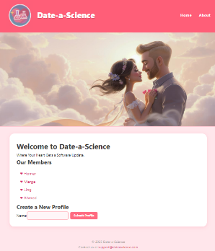
Example:

Let’s look at our EJS version of our Date-a-Science site and convert it to PUG code. One thing that I have noticed is that due to indentation rules in PUG, it gets complicated (with unexpected behavior) if we include the html and body tags in the header because it makes it difficult for nesting. Therefore, we will separate the head tag portion from the nav tag portion to make two separate partials. Here will be the header.pug file:

head
title= title
link(rel="stylesheet" href="/style.css")
link(rel="icon" href="/images/favicon.jpg" type="image/jpeg")

… which is the portion that covered this part of the header.ejs file:

<head>
<title><%= title %></title>
<link rel="stylesheet" href="/style.css">
<link rel="icon" href="/images/favicon.jpg" type="image/jpeg">
</head>

Notice that the title variable is being used, which we will need to pass in when we render the file.
Here will be the nav.pug file:

nav.navbar
div.nav-left
img.logo(src="/images/logo.jpg" alt="Logo")
span.site-title Date-a-Science
ul.nav-menu
li
a(href="/") Home
li
a(href="/about") About

… which is the portion that covered this part of the header.ejs file:

<nav class="navbar">
<div class="nav-left">
<img src="/images/logo.jpg" alt="Logo" class="logo">
<span class="site-title">Date-a-Science</span>
</div>
<ul class="nav-menu">
<li><a href="/">Home</a></li>
<li><a href="/about">About</a></li>
</ul>
</nav>

Here is the footer.pug partial:

footer
p &copy; 2025 Date-a-Science
p
| Contact us at
a(href="mailto:support@dateascience.com") support@dateascience.com

So, now we have our partials. Next, it is important to understand how PUG handles indentation when we use include statements.

In PUG, an include literally injects the included file’s content at that exact indentation level where the include statement appears. The included file’s content is treated as if it were written inline at that spot, respecting the indentation of the include. So, indentation matters because the included content will be nested inside whatever block or tag the include is inside.

Here is the converted index.pug file for the main homepage. We may notice that we took the doctype, html and body tags out from the header.ejs file and put them here. Notice how we included the three partials, which are highlighted:

doctype html
html
include partials/header.pug
body
include partials/nav.pug
div.banner
img(src="/images/loveBanner.jpg" alt="Love Banner")

div.container
h1 Welcome to Date-a-Science
p Where Your Heart Gets a Software Update.

h2 Our Members
ul.profile-list
each person in people
li
a(href="/profile?id=" + person.id) &#x2665; #{person.name}

h2 Create a New Profile
label(for="name") Name:
input#name(type="textbox")
button(type="button" onclick="submit()") Submit Profile

script(src="/clientscript.js")

include partials/footer.pug

Notice that the first include is indented exactly once … which is where the head tag would be placed. By using include, it is as if we pasted the partial file right here at this level of indentation. Similarly, the nav.pug partial is placed within the body tag … which is where the navigation stuff would be placed. Lastly, the footer.pug partial is placed inside of the body and at the end of it. The indentation for these include statements is crucial for PUG to properly render the required HTML nesting.

It is also important that the each person in people code is indented within the ul tag and that the li is within that loop and that the a anchor tags are within the li tags.

Now look at the unordered profile-list. We are using person.id directly to get its value but then we use person.name within #{ } notation. Why the difference for these variables?

In the case of person.id, PUG treats the whole attribute value as JavaScript, so that variable gets evaluated directly. In the case of person.name, we are inside the text content of the tag, not inside an attribute. The #{ } tells PUG to evaluate the variable and insert it as escaped text at that position. So, the difference is that inside the attributes, it is treated as JavaScript, but outside it is treated as text unless we use #{ }.

It is also important to understand that variables behave differently in PUG than in EJS, especially when it comes to includes. In EJS, when we include the header partial like this:

<%- include("partials/header", { title: "Date-a-Science - Home" }) %>

We are passing the variable title just to that partial. If we don’t pass it, the included file has no idea what title is. We have to send it manually each time. This is analogous to passing a parameter to a function.

However, in PUG, when we simply do this:

include partials/header.pug

No variables are specified because PUG automatically shares the current template’s variables with the included file. So, as long as we pass the title to the index.pug file when we render it, then partials that we include (such as header.pug) automatically have access to the title variable. There is no need to pass it again. So, while things are simpler in PUG, we still need to be careful because since all variables are shared, naming conflicts are more likely to occur if we are not organized.

Here is the about.pug file converted from about.ejs:

doctype html
html
include partials/header.pug
body
include partials/nav.pug
div.container
h1 About Date-a-Science
p
| Date-a-Science is a playful dating platform connecting
| scientifically curious minds who believe in love through
| logic, chemistry, and a dash of nerdy fun. Whether you are
| into molecules or algorithms, we've got a match for you.

include partials/footer.pug

We can see the same three included partials. Notice the use of | as well. This allows our text to look nice in the editor without wraparound. The rest is straight forward.

Finally, …here is the profile.pug file converted from profile.ejs:

doctype html
html
include partials/header.pug
body
include partials/nav.pug
div.container
a.back-link(href="/") &lt; Back to homepage

div.profile-card
h1= person.name
img(src=person.photo || anonImg, width="200", alt=person.name + "'s photo")
p
strong Age:
= person.age

div.messages
h2 Messages
if person.messages.length !== 0
each msg in person.messages
div.message= msg
else
p No messages yet.

h3 Leave a Message
input#msg(type="textbox")
button(type="button" onclick="submitMessage(" + person.id + ")") Submit Message

script(src="/clientscript.js")

include partials/footer.pug

Notice that the IF statement has the same indentation as the h2 header. If we had accidentally indented it further, it would have been made part of the header, as well as all the messages under it. This would mess up our styles that we already created.

Notice in the img tag that we separated the attributes by commas, yet in the button tag we did not. Why the difference? Well, for the button tag, the values are complete strings, so PUG has no problem parsing it. But for the img tag, there is confusion due to the || code, so PUG would get confused without the commas. In fact, we could put the commas in all the time, if we would like. Sometimes, it is even clearer to put the items on separate lines (with commas) as follows:

img(
src=person.photo || anonImg,
width="200",
alt=person.name + "'s photo"
)

PUG in the Server:

To use PUG, we need to ensure that it is first installed using NPM: npm install pug and then use require in our server code: const pug = require("pug");

Since Pug and EJS are both template engines, they serve the same purpose: converting data into HTML pages. However, the way they render templates differs slightly, especially in terms of flexibility and performance.
- EJS allows us to pass a callback function when rendering a template. This means rendering can be handled asynchronously, and we can even offload processing (like in a separate thread or worker if needed).
- Pug, on the other hand, doesn’t natively support passing a callback for rendering. It renders synchronously (i.e., directly and immediately ) which can be simpler … but limits threading options and might be less ideal for performance in high-load scenarios.

So, we have to do things a little differently. The callback function in EJS allowed us to be informed if there was an error during rendering (for whatever reason). Since PUG does not have the callback function, we need to take the code from EJS’s the callback function and put it in a try/catch block to handle the potential error. Here, for example, is a comparison of the renderPage() function from our EJS server code, and the PUG version alongside it:

// Render an EJS page  function renderPage(templatePath, res, data = {}) {  ejs.renderFile(templatePath, data, (err, html) => {  if (err) {  console.error(err);  res.writeHead(500);  res.end("Internal Server Error");  } else {  res.writeHead(200, { "Content-Type":  "text/html" });  res.end(html);  }  });  } | // Render a Pug page  function renderPage(templatePath, res, data = {}) {  try {  let html = pug.renderFile(templatePath, data);  res.writeHead(200, { "Content-Type":  "text/html" });  res.end(html);  } catch (err) {  console.error(err);  res.writeHead(500);  res.end("Internal Server Error");  }  }
So, the callback’s err parameter becomes the catch block parameter and its html parameter becomes a local variable. The rest of the code is the same. Other than this function, the remaining server code is the same, with the exception that we alter the file names to have the .pug extension instead of .ejs.

Instead of rendering the PUG template from scratch every time a request comes in, we can compile it once using pug.compileFile(). What does it mean to “compile it”? Well, the function will process the template to determine which HTML parts are static and which parts are dynamic (i.e., will change with incoming data). That way, when the function is called, it will not re-render the static parts of the HTML … just the dynamic parts. This means that we will save time rendering if the function needs to be called more than once but with different data (e.g., when we have many users viewing the same page layout but with personalized content).

Here, for example, is a side-by-side comparison showing how a PUG file would be compiled:
// code from views/profile.pug  doctype html  html  include partials/header.pug  body  include partials/nav.pug  div.container  a.back-link(href="/") &lt; Back to homepage  div.profile-card  h1= person.name  img(  src=person.photo || anonImg,  width="200",  alt=person.name + "'s photo"  )  p  strong Age:  = person.age  div.messages  h2 Messages  if person.messages.length !== 0  each msg in person.messages  div.message= msg  else  p No messages yet.  h3 Leave a Message  input#msg(type="textbox")  button(  type="button"  onclick="submitMessage(" + person.id + ")"  ) Submit Message  script(src="/clientscript.js")  include partials/footer.pug  Assume that we did this:  const f = pug.compileFile("views/profile.pug");  The HTML string on the right would be “hard-coded” into the function f, with the exception of the yellow highlighted code, which would be rendered dynamically when we call f with data. The data being a single JavaScript object.  As we can see, most of the produced code is static and unchanging, so it need not be rendered each time the function is called. | <!DOCTYPE html>  <html>  <head>  <title>Date-a-Science</title>  <link rel="stylesheet" href="/style.css">  <link rel="icon" href="/images/favicon.jpg"  type="image/jpeg">  </head>  <body>  <nav class="navbar">  <div class="nav-left">  <img class="logo" src="/images/logo.jpg" alt="Logo">  <span class="site-title">Date-a-Science</span>  <ul class="nav-menu">  <li><a href="/">Home</a></li>  <li><a href="/about">About</a></li>  </ul>  </div>  </nav>  <div class="container">  <a class="back-link" href="/">&lt;  Back to homepage</a>  <div class="profile-card">  <h1>person.name</h1>  <img  src="person.photo || anonImg"  width="200"  alt="person.name + ' photo'">  <p>  <strong>Age:</strong> person.age  </p>  </div>  <div class="messages">  <h2>Messages</h2>  if person.messages.length !== 0  each msg in person.messages  <div class="message">msg</div>  else  <p>No messages yet.</p>  <h3>Leave a Message</h3>  <input id="msg" type="textbox">  <button type="button"  onclick="submitMessage(person.id)">  Submit Message</button>  </div>  </div>  <script src="/clientscript.js"></script>  <footer>  <p>&copy; 2025 Date-a-Science</p>  </footer>  </body>  </html>
We can do this pre-computation upon startup by adding this code to our server.js:

// Precompiled templates - done at startup
const compiledTemplateFunctions = {};

["./views/index.pug", "./views/about.pug", "./views/profile.pug"].forEach(name => {
compiledTemplateFunctions[name] = pug.compileFile(`${name}`);
});

Then we could re-write our renderPage() function as follows:

// Render function that selects the right compiled template
function renderPage(templatePath, res, data = {}) {
try {
const renderFn = compiledTemplateFunctions[templatePath];
if (!renderFn) { // Make sure that things pre-compiled ok
res.writeHead(404);
res.end("Template Not Found");
return;
}
const html = renderFn(data); // Call the precompiled function

res.writeHead(200, { "Content-Type": "text/html" });
res.end(html);
} catch (err) {
console.error(err);
res.writeHead(500);
res.end("Internal Server Error");
}
}

That’s all for now. To really get the hang of this, we need to practice more.

Here are some more links if you want to learn more about EJS or PUG syntax:

https://ejs.co/
https://pugjs.org/api/getting-started.html
https://codepen.io/mimoduo/post/learn-pug-js-with-pugs

Here are some ideas for expanding our Date-a-Science site. Feel free to practice adding some of these features to ensure that you understand how to do them.

- Add timestamps on messages
  - Just change the message from a string to an object. E.g., { text, time }
  - Then modify the display logic in profile.ejs or profile.pug.

- Emoji or reaction picker
  - Add simple emoji buttons next to messages (e.g., ❤️, 😂, 👍, 🔥, 😍).
  - No backend logic is needed if these are stored on the client-side or in memory.

- Add a "Like" button (with counter) on profile pages
  - Add a button (e.g., ❤️ or 👍) and increment a like counter.
  - Display the number of likes somewhere (e.g., "❤️ 5 Likes")
  - Make sure to send the “like” to the server for storage

- Create a "Daily Featured Profile"
  - Randomly pick one person either upon server start or daily.
  - Display that person at the top of index.ejs or index.pug.

- Keep track of current user (e.g., pretending a member logged in)
  - Let the user choose who they are from a dropdown list on the homepage: "Select Your Profile".
  - Maintain track of who the user is by storing the selected ID in a query parameter (e.g., ?userId=3) passed onto all pages

- Compute Match Percentage (assume current user is selected from above)
  - Add a few profile questions (e.g., "Do you like hiking?", “Quiet Evenings?”, etc.. ).
  - Store each person’s answers as an array: (e.g., ["yes", "no", "yes", "yes"]).
  - Compare the answers of two profiles, count how many match, return a percentage.
  - Add calculated "match score" to each profile view against the current user.
  - Show top few match scores

9.4 Updating the FutureTech Corp. Site

Let’s adjust our FutureTech Corp. site to use PUG. The first step is to decide how we will organize our files. Below, on the left is our current folder structure and on the right is how we will restructure things:
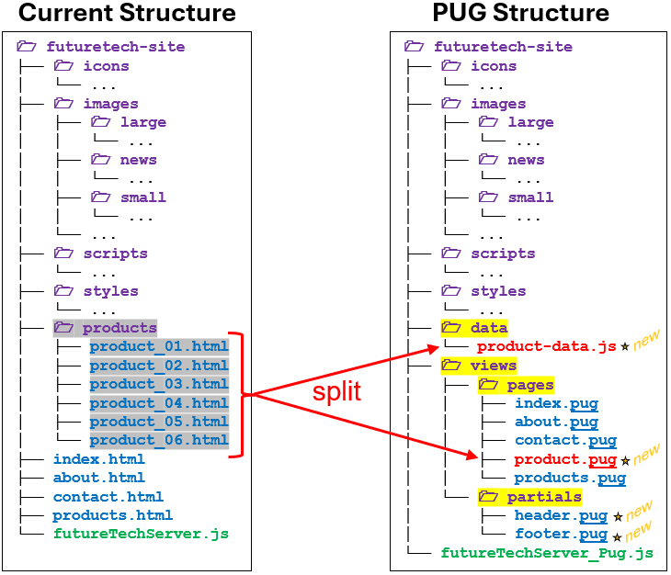

Since we will no longer have static product pages, we will remove those html files and replace them with a single product.pug page. At the same time, we will extract the product data from the static pages and encode it into an array in the product-data.js file. We will be changing our .html page files to have .pug extensions. We will also extract the common header and footer stuff and place them in their own files. Lastly, we will adjust the folder structure to be more organized with the use of the data, views, view/pages and views/partials folders.

Let’s start converting by looking at the shared header on each page. We take this:

<header>
<img src="images/logo.jpg" height=200 alt="FutureTech Corp. Logo">
<nav>
<ul>
<li><a href="index.html" class="active">Home</a></li>
<li><a href="about.html">About Us</a></li>
<li><a href="products.html">Products</a></li>
<li><a href="contact.html">Contact Us</a></li>
</ul>
</nav>
</header>

And convert to this, saving it to /partials/header.pug:

header
img(src="/images/logo.jpg" height=200 alt="FutureTech Corp. Logo")
nav
ul
li
a(href="/" class="#{currentPage === 'home' ? 'active' : ''}") Home
li
a(href="/about" class="#{currentPage === 'about' ? 'active' : ''}") About Us
li
a(href="/products" class="#{currentPage === 'products' ? 'active' : ''}") Products
li
a(href="/contact" class="#{currentPage === 'contact' ? 'active' : ''}") Contact Us

The main difference is that we will now need a variable (i.e., currentPage) to decide if the navigation link should be highlighted (i.e., 'active'). Why? Well, in our static page we hard-coded class='active' for the specific link on each page. But now all pages will share this header, so we need a variable to indicate the page we are on, so we can highlight for that page only.

The common footer on each page is easy to adjust as well. We take this:

<footer>
<p>&copy; 2025 FutureTech. All rights reserved.</p>
<div class="status-bar">
<div id="clock">Loading time...</div>
<button id="darkModeToggle">Switch to Dark Mode</button>
</div>
</footer>

<script src="scripts/time-clock.js"></script>
<script src="scripts/dark-mode.js"></script>

and then convert it to this, saving it to /partials/footer.pug:

footer
p &copy; 2025 FutureTech. All rights reserved.
div.status-bar
div#clock Loading time...
button#darkModeToggle Switch to Dark Mode

script(src="/scripts/time-clock.js")
script(src="/scripts/dark-mode.js")

Nothing new here, except to point out that we only added the two scripts that were specific to the footer, to the /partials/footer.pug file. Now we can do the main /views/pages/index.pug page:

DOCTYPE=html
html(lang="en")

head
meta(charset="UTF-8")
title FutureTech - The Future is Now
link(rel="icon" href="/icons/logo-icon.png")
link(rel="stylesheet" href="/styles/image-slider.css")
link(rel="stylesheet" href="/styles/general-body.css")
link(rel="stylesheet" href="/styles/header-footer.css")

body
include ../partials/header
br
div#quote(style="text-align:center; font-style:italic; padding: 10px;")
div#quoter(style="text-align:center; font-style:italic;")

section.slider-container
div.slider#imageSlider
div.slide
img(src="/images/news/scientists.jpg" alt="Molecular Stabilizer Lab")
div.caption Molecular Stabilizer Lab
div.slide
img(src="/images/news/robotics.jpg" alt="Design and Manufacturing Lab")
div.caption Design and Manufacturing Lab
div.slide
img(src="/images/news/portals.jpg" alt="Portal Experimentation Lab")
div.caption Portal Experimentation Lab
div.slide
img(src="/images/news/android.jpg" alt="Android Development Lab")
div.caption Android Development Lab

div.dots#dotsContainer
span.dot.active(data-slide="0")
span.dot(data-slide="1")
span.dot(data-slide="2")
span.dot(data-slide="3")

include ../partials/footer

// All the JavaScripts to run
script(src="/scripts/quotes.js")
script(src="/scripts/slider-script.js")
script(src="/scripts/captions.js")

When including the header & footer, we must indicate where to find it by backing up a directory first … otherwise the server won’t find them because they are not in the /view/pages folder with this file.

The about.html is similarly converted to /views/pages/about.pug … nothing exciting here:

DOCTYPE=html
html(lang="en")
head
meta(charset="UTF-8")
title About Us
link(rel="icon" href="/icons/logo-icon.png")
link(rel="stylesheet" href="/styles/general-body.css")
link(rel="stylesheet" href="/styles/header-footer.css")

body.about-page
include ../partials/header

main
section
h2 About Us
div(style="text-align: center;")
img(src="/images/headquarters.jpg" alt="FutureTech Corp. Headquarters" width=600)

div.about
p
| At FutureTech Corp., we don't just imagine the future, we invent it.
| ...

p
| Over the past ten years, FutureTech Corp. has combined breakthrough
| ...

p
| As a global leader in high-tech development, we remain committed to
| ...

include ../partials/footer

Also, the contact.html file is easily converted to /views/pages/contact.pug …

DOCTYPE=html
html(lang="en")
head
meta(charset="UTF-8")
title Contact Us
link(rel="icon" href="/icons/logo-icon.png")
link(rel="stylesheet" href="/styles/general-body.css")
link(rel="stylesheet" href="/styles/header-footer.css")

body
include ../partials/header

main
section
h2 Contact Us

table.contact-table
tr
td
h3 Our Office
p
strong FutureTech Corp.
br
| 4567 Hyperion Avenue
br
| Sector 9, NeoCity, CA 94018
br
| United States
p
strong Phone:
| (555) 013-2048
br
strong Email:
a(href="mailto:support@futuretechcorp.com") support@futuretechcorp.com
td
img(src="/images/topview.jpg" width=500 alt="FutureTech Corp. Headquarters")
tr
td.contact-info
div.map-container
h3 Find Us
iframe(
src="https://maps.google.com/maps?q=37.7749,-122.4194&z=14&output=embed",
width="100%",
height="300",
style="border:0;",
allowfullscreen="",
loading="lazy",
title="FutureTech Corp Map")

td.contact-form-box
p
| Feel free to get in touch using the form on the right
| or through the contact information below.

form(action="/contact/message" method="POST" target="")
label(for="name") Name:
br
input#name(type="text" name="name" required)
br
br
label(for="email") Email:
br
input#email(type="email" name="email" required)
br
br
label(for="message") Message:
br
textarea#message(name="message" rows="5" required)
br
br
button(type="submit") Send Message

include ../partials/footer

Notice … we set the action to "contact/message" so that it will now contact our server and we will be able to handle it (more on this later). We also set target to "" to stay on the same page after.

The conversion of products.html to /views/pages/products.pug will now require some additional coding because it used to simply contain hard-coded links to individual static product pages but now we need to go to just one common page (i.e., /views/pages/product.pug). Also, we need to make sure all the products are shown on this page in a dynamic way. That means, this page will now require an incoming variable (we will call it products) representing the array of products. We will also need to give each product an id so that when we select that product to view its page, we will be able to tell the server which product we want it to render on that page.

Let’s first discuss the /data/product-data.js file which will simply contain an array with all the product data (note: in the future, we will replace this with some database logic). We will need to make an object to represent the product. If we were to examine the product pages that we created, we would be able to identify the following common information for each product:


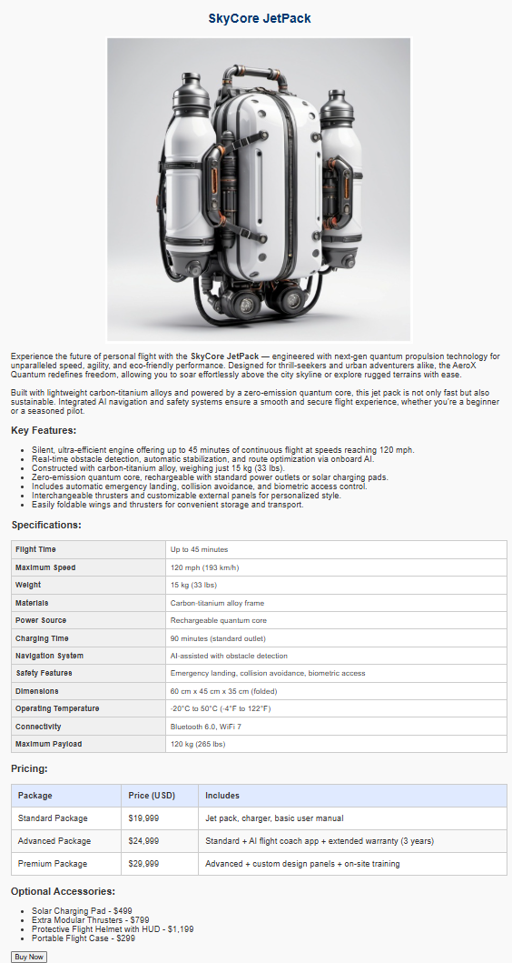
{
name: "",
id: 1,
imageSmall: "?.jpg",
desc: "...",
imageAlt: "...",

image: "?.jpg",
par1: "...",
par2: "...",
features: [
{feature: "...", desc:"..."},
{feature: "...", desc:"..."},
... ],
specs: [
{key: "...", value: "..." },
{key: "...", value: "..."},
... ],
pricing: [
{option: "...", price: 99.00, includes: "..."},
{option: "...", price: 99.00, includes: "..."},
... ],
accessories: [
{option: "...", price: 99.00},
{option: "...", price: 99.00},
... ]
}

So, we just need an array of the above product objects in our /data/product-data.js file that we export as follows:

export const products = [
{ /* product 1 object */ },
{ /* product 2 object */ },
{ /* product 3 object */ },
{ /* product 4 object */ },
{ /* product 5 object */ },
{ /* product 6 object */ }
];

Now we can look at the /views/pages/products.pug page. We will assume that the products variable will be passed into this page when we render it. This page will now need to take the products array and loop through it to create an HTML <div> for each one. Within the <div>, we will need to have a header, an image and a short description so that we can make it look as shown here on the right.

Assume that we loop through each product in products. Then for each product p, we can access the attributes that we need to render this page (i.e., p.name, p.imageSmall, p.imageAlt and p.desc). We will also need the p.id so that we can place a unique ID on each rendered product so that when the user selects the product, we can send that ID to the /views/pages/product.pug page to render the correct product for that page. Here is the code for the /views/pages/products.pug page:

DOCTYPE=html
html(lang="en")
head
meta(charset="UTF-8")
title Our Products
link(rel="icon" href="/icons/logo-icon.png")
link(rel="stylesheet" href="/styles/general-body.css")
link(rel="stylesheet" href="/styles/products-style.css")
link(rel="stylesheet" href="/styles/header-footer.css")

body
header
include ../partials/header

main
section
h2 Our Products
div.product-list
each p in products
div.product(id="product#{p.id}")
h3 #{p.name}
a(href="product?id=" + p.id)
img(src="/images/small/" + p.imageSmall alt=p.imageAlt width="150")
p #{p.desc}

include ../partials/footer

Notice how we use PUG interpolation to insert the product name into the header and description into the paragraph. We also use it to insert the product id number so that the <div> id becomes "product1", "product2", etc.. Lastly, we use inline JavaScript to produce the correct image file path.

Finally, we need to make the /views/pages/product.pug file to represent the page that will render a specific product. To render this page we will assume that a particular product has been passed in as a variable called prod. Here is the code … I highlighted the important things. We will notice that there are 4 loops now, since we need to loop through product features, specs, pricing and accessories.

DOCTYPE=html
html(lang="en")
head
meta(charset="UTF-8")
title Product - FutureTech Corp.
link(rel="icon" href="/icons/logo-icon.png")
link(rel="stylesheet" href="/styles/header-footer.css")
link(rel="stylesheet" href="/styles/general-body.css")
link(rel="stylesheet" href="/styles/details.css")
body
include ../partials/header
main
section.product-detail
h2 #{prod.name}
div(style="text-align: center;")
img(src="/images/large/" + prod.image alt=prod.imageAlt)
p!= prod.par1 != needed to render <strong> tag in the data
p!= prod.par2

h3 Key Features:
ul
each f in prod.features
li
f.feature= f.desc

h3 Specifications:
table.specs-table
tbody
each s in prod.specs
tr
th= s.key
td= s.value

h3 Pricing:
table.pricing-table
thead
tr
th Package
th Price (USD)
th Includes
tbody
each pr in prod.pricing
tr
td= pr.option
td= "$" + pr.price.toLocaleString("en-US", { minimumFractionDigits: 0, maximumFractionDigits: 0 })
td= pr.includes

h3 Optional Accessories:
ul
each a in prod.accessories
li= a.option + " - $" + a.price.toLocaleString("en-US", { minimumFractionDigits: 0, maximumFractionDigits: 0 })

button.buy-button Buy Now

include ../partials/footer

The use of toLocaleString when displaying money has a two-fold purpose. It will allow commas to be displayed (e.g., $499,000) and it will also allow us to specify the number of decimal places (in our case we just want integers shown).

The pages are done! Now we need to adjust the server so that it renders the pages and so that we pass in the needed variables when doing so.
Currently, our server accepts a request for any file (which were all static) and sends it back by using the following code:

function requestListener(req, res) {
let filePath = req.url === "/" ? "/index.html" : req.url; // add index.html if needed
filePath = path.join(__dirname, filePath); // get the absolute path

let ext = path.extname(filePath); // get the file extension
let contentType = mimeTypes[ext] // lookup content type based on ext
|| "application/octet-stream"; // if not there, treat as download

fs.readFile(filePath, (err, data) => { // read file, set data to contents
if (err) { // if error, return 404 Not Found
res.writeHead(404, { "Content-Type": "text/plain" });
return res.end("404 Not Found");
}
res.writeHead(200, { "Content-Type": contentType }); // otherwise send 200 OK and the data
res.end(data);
});
}

Now that we are using dynamic pages, we will need to handle each page. Below is the top portion of our new requestListener. It no longer looks for absolute paths by using (__dirname, but instead will look for each page relative to where the server started. Since we will render each page, we will need to extract the pathname from the request URL. We use url.parse() to extract (i.e., separate) the pathName from the query string.

// Handle incoming requests
function requestListener(req, res) {
let parsedUrl = url.parse(req.url, true); // true parses query string
let pathName = parsedUrl.pathname;
let query = parsedUrl.query;

// Serve static files if the URL matches typical file folders
if (pathName.startsWith("/styles/") || pathName.startsWith("/images/") ||
pathName.startsWith("/icons/") || pathName.startsWith("/scripts/")) {
serveStaticFile(req, res);
return;
}
... more to come ...
}

Notice that we first look for the static files by examining where the files are located in the path. If it is in one of the styles, images, icons or scripts folders, then we know that it will be a static file and we can serve that file easily.

To serve the static file, we call the function shown in the chunk of code below:

function send404(response){
response.statusCode = 404;
response.write("Not Found");
response.end();
}

const mimeTypes = {
".html": "text/html",
".css": "text/css",
".js": "application/javascript",
".png": "image/png",
".jpg": "image/jpeg",
".ico": "image/x-icon"
};

// Serve static files as requested
function serveStaticFile(req, res) {
const filePath = path.join(__dirname, req.url);
const ext = path.extname(filePath);
const contentType = mimeTypes[ext] || "application/octet-stream";

fs.readFile(filePath, (err, data) => {
if (err) {
send404(res);
} else {
res.writeHead(200, { "Content-Type": contentType });
res.end(data);
}
});
}

As we did previously, it just looks at the file extension so that it can create the correct Content-Type header attribute. Then it reads the file and sends it back as before, or sends back a 404 error (we made a helper function for this). There is nothing really new here, since there is no dynamic content.

Let’s continue with the remainder of the requestListener function. It will need to look at the pathName and decide which page to render:

// Handle incoming requests
function requestListener(req, res) {
...
// Render PUG pages
switch (pathName) {
case "/":
case "/home":
case "/index":
renderPage("./views/pages/index.pug", res, "home");
break;
case "/about":
renderPage("./views/pages/about.pug", res, "about");
break;
case "/contact":
renderPage("./views/pages/contact.pug", res, "contact");
break;
case "/products":
renderPage("./views/pages/products.pug", res, "products");
break;
case "/product":
if (query.id)
renderProductPage("./views/pages/product.pug", res, query.id);
else
send404(res);
break;
default:
send404(res);
}
}

Notice a couple of things. First, all pages are rendered with the same function, which we will discuss in a moment, except for the one for rendering a particular product (which has a different function that will require the id of the product to be rendered, which we get from the extracted query.id).

Notice as well that the pages to be rendered are specified relative to the current directory (i.e., "./"). Now … let's look at the functions to render the pages. We will pre-compile the pages as we did with our Date-a-Science site:

// Precompiled templates - done at startup
const compiledTemplateFunctions = {};
["./views/pages/index.pug", "./views/pages/about.pug", "./views/pages/contact.pug",
"./views/pages/product.pug", "./views/pages/products.pug"].forEach(name => {
compiledTemplateFunctions[name] = pug.compileFile(`${name}`);
});

We will also render the pages the same way as our Date-a-Science site:

// Render a PUG file as requested
function renderPage(fileName, res, pageName) {
try {
const renderFn = compiledTemplateFunctions[fileName];
if (!renderFn) { // Make sure that things pre-compiled ok
res.writeHead(404);
res.end("Template Not Found");
return;
}
const html = renderFn({products: products, currentPage: pageName});
res.writeHead(200, { "Content-Type": "text/html" });
res.end(html);
} catch (err) {
console.error(err);
res.writeHead(500);
res.end("Internal Server Error");
}
}

Notice in the pre-compiled render function (i.e., renderFn) we pass in an object that contains products and currentPage attributes. The products will be from our products array that we exported from our product-data.js file, so we will need this at the top of our server code:

const { products } = require("./data/product-data.js");

The currentPage is set to the pageName that was passed in as a parameter from our routing code in the requestListener function (e.g., "./views/pages/about.pug" ).

The call to this renderFn() will do the PUG rendering for us by producing the dynamic pages that we need, based on the passed-in parameters 😊. In a similar way, we can write the function that will render an individual product page:

// Render a product PUG file as requested
function renderProductPage(fileName, res, id) {
try {
const renderFn = compiledTemplateFunctions[fileName];
if (!renderFn) { // Make sure that things pre-compiled ok
res.writeHead(404);
res.end("Template Not Found");
return;
}
const html = renderFn({prod: products[id-1], currentPage: "products"});
res.writeHead(200, { "Content-Type": "text/html" });
res.end(html);
} catch (err) {
console.error(err);
res.writeHead(500);
res.end("Internal Server Error");
}
}

Notice that the id is passed in as a parameter. It was obtained from the query id value (i.e., http://localhost:3000/product?id=2). Otherwise the code should be easily understood at this point. So, now we have our converted PUG server code for our site.
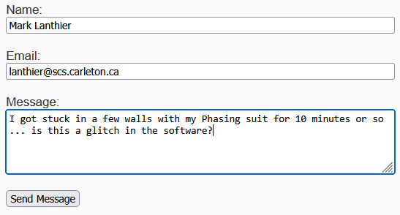
At this point, though, our Contact Us page sends our form to
http://localhost:3000/contact/message

At the moment, our server doesn’t handle the post, so let’s add that now. What do we do with the data? We will store the data in an array, and assume that someone will process them later. Ultimately, a database would be used to store these. Let’s add this to our product-data.js file:

// Store all incoming messages like this:
// messages = [
// {name: "Mark", email: "mark@somewhere.com", message: "This is my message."}
// {name: "Jen", email: "jen@somewhere.com", message: "My message is better."}
// ...
// ];
export const messages = [ ];
export let messageCount = 0;

Then we will add this to the top of our server code:

let { messages, messageCount } = require("./data/product-data.js");

Now we have a location for the incoming messages from our Contact Us form. We just need to handle the POST requests coming in from "contact/message" (which is the action that we set for our form).

We can add this case to our switch statement at the end of our requestListener() function:

case "/contact/message":
handlePost(req, res);
break;

and add this function:

function handlePost(req, res) {
console.log("got it");
}

We can do a quick test to see if it worked by going to http://localhost:3000/contact/message, filling out the form, and then submitting it. We should see the “got it” message appear, but the browser will hang because we are not sending anything back yet.

Now, let’s store the data and send back an OK by adjusting the handlePost() function. We will need to read the body, so we will use the same helper code as our Date-a-Science site to do this:

// Helper function to read the request body
function readRequestBody(req, callback) {
let body = ""
req.on("data", (chunk) => {
body += chunk;
})
//Once the entire body is ready, process the request
req.on("end", () => {
callback(body);
});
}

Now let’s adjust the handlePost() to store the incoming message. With a POST, the data is sent in the request’s body. It will be a URL-encoded string like this, for example:

"name=Mark%20Lanthier&email=lanthier%40scs.carleton.ca&message=I%20got%20stuck%20in%20a%20few%20walls%20with%20my%20Phasing%20suit%20for%2010%20minutes%20or%20so%20%E2%80%A6%20is%20this%20a%20glitch%20in%20the%20software%3F"

We will parse this into an object by making use of the Node.js querystring module, so we add this to the top of our code:

const querystring = require("querystring");

Then we can convert this string into a message object that we can store in our array by using the parse function. Once we have the object, we can add it to our messages, then send back an acknowledgement page:

// Handle the message post
function handlePost(req, res) {
readRequestBody(req, function(body) {
const mesgObj = querystring.parse(body);
messages.push(mesgObj);
messageCount++;
renderPage("./views/pages/messageReceived.pug", res, "contact/message")
});
}

The message being returned is stored in /views/pages/messageReceived.pug. We can pre-compile it as we did with the others by adding it to our initializing code:

const compiledTemplateFunctions = {};
["./views/pages/index.pug", "./views/pages/about.pug", "./views/pages/contact.pug",
"./views/pages/product.pug", "./views/pages/products.pug", "./views/pages/messageReceived.pug"].forEach(name => {
compiledTemplateFunctions[name] = pug.compileFile(`${name}`);
});

The page itself is simple in that it just acknowledges that the message was received at the server:

DOCTYPE=html
html(lang="en")
head
meta(charset="UTF-8")
title Thank You
link(rel="icon" href="/icons/logo-icon.png")
link(rel="stylesheet" href="/styles/general-body.css")
link(rel="stylesheet" href="/styles/header-footer.css")

body.received-page
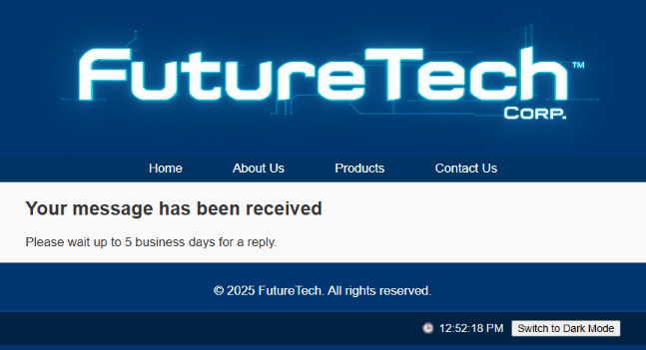
include ../partials/header

main
section
div.mrecv
h1 Your message has been received
p Please wait up to 5 business days for a reply.

include ../partials/footer

Although we will add this to the general-body.css to indent the text a little:

/* For the "message received" page */
.mrecv {
margin-left: 40px; /* push it right from the left */
}

